PROJECT INFORMATION
Bridge Name and Number:
WIN: | [Status]
Project Manager:
Town(s):
Route Carried: | Route 16 and 27
Feature Intersected: | Reed Brook
Programmed Scope: | Bridge Replacement

Recommended Scope:
☒ Bridge Replacement
☐ Bridge Improvement
☐ Preservation/Rehabilitation
☐ Deck Replacement
☐ Superstructure Replacement
☐ Other:

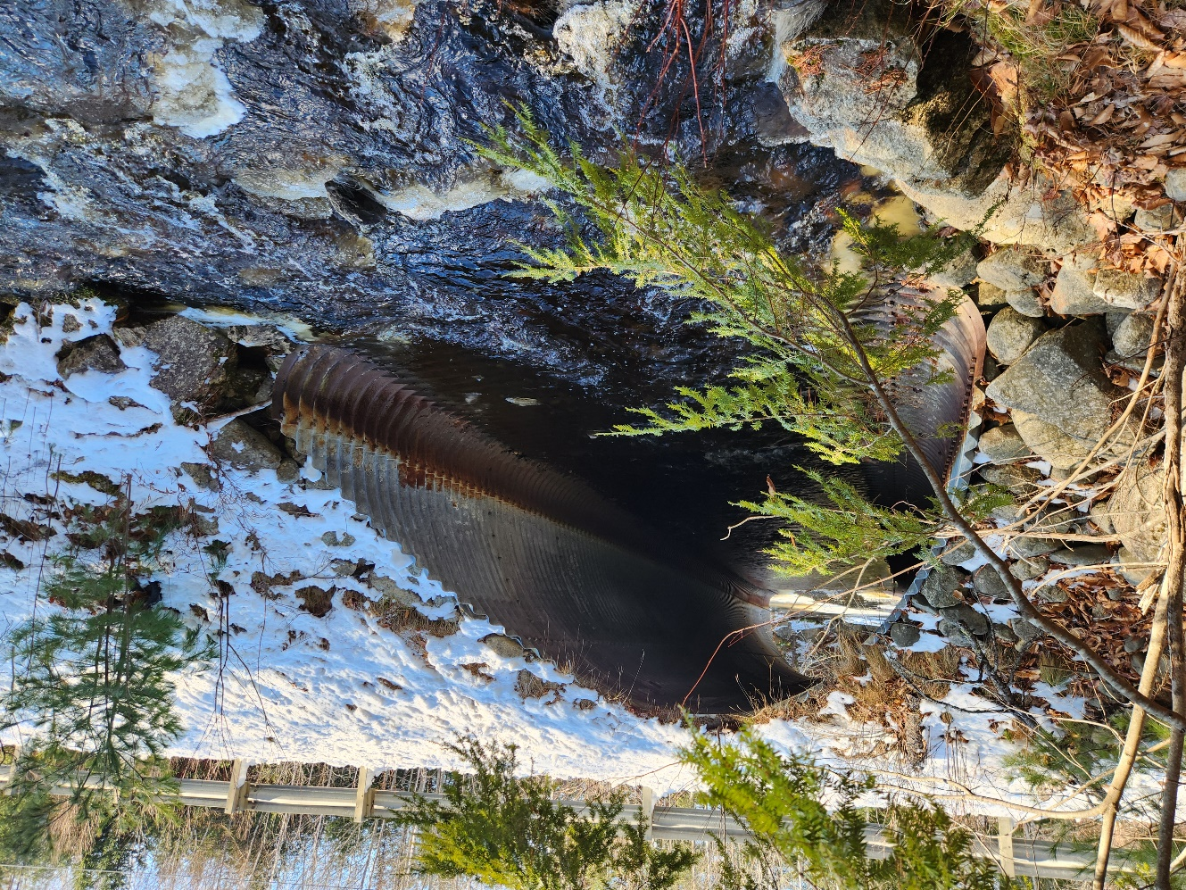

ROADWAY
Design Speed (mph): | 55
Corridor Priority (1-5): | 2
NHS: | No
Current AADT: | 3630
Approach Lane: | 11’ paved
Approach Shoulder: | 3’ gravel
Sidewalk(s): | 4’ north side
Alignment: | (Currently meets XX mph) (Note deficiencies)

EXISTING BRIDGE DATA
Span Layout: | 15’
Rail-to-Rail Width: | 32’
Vertical Clearance: | 2-feet above pipe @ Q50 (or Hw/D if not full)
Year Built: | 1972
Culvert Type: | Corrugated steel pipe arch
Condition Ratings: | Deck |  | Superstructure |  | Substructure
 | Scour |  | Culvert | 4
Maintenance Issues: | (Debris, scour, deformed inlet, etc.)
Additional Comments:

OTHER DATA
Purpose & Need: | (provided by ENV in cooperation with Bridge Program*)
ENV Sizing Criteria: | 18’ BFW, 22’ recommended to meet 1.2x BFW
Geotechnical Summary: | (General subsurface material and depth to bedrock)
Additional Borings Required ☐ Additional Geotechnical Evaluations Required ☐
Other:

*Most projects can use the following Purpose: To address the structural condition of the bridge and improve safety at the site.

PROPOSED BRIDGE DESIGN CRITERIA
Structure Type: | Precast concrete 3-sided frame
Span and Rise: | 24’ x 6’
Skew: | 20
Rail-to-Rail Width: | 33’
Sidewalk Width(s): | 5’
Vertical Clearance: | Hw/D
Alignment Changes: | 1.25’ vertical increase to improve sight distance (meets comfort criteria)
Foundation Type: | Concrete stem wall and footings on bedrock (type of bedding for 4-sided box)
Wearing Surface Type: | HMA
Railing Type: | Guardrail anchored to frame
Design Load: | HL-93 mod.

PROJECT DETAILS
Complete Streets: | Adding width to meet ADA sidewalk requirements
ROW Impacts: | (yes or no)
Utility Impacts: | (relocate waterline; relocate aerials)
MoT Method: | One lane temporary bridge
Construction Duration: | One season plus final paving and landscaping the following spring
Design Exceptions:
Public Involvement: | (note what level or strategy will be used)
Municipal Agreement(s): | (yes or no, list which ones)
Forecast Advertise: | Q3 2026
Other:

ADDITIONAL COMMENTS:

- Here, we could also list other alternatives broadly considered and dismissed

- We could also include any rough plans if available

ENVIRONMENTAL COORDINATION

[INSERT HERE]

This would be the standard sheet from the Environmental Office.
PROJEX FINANCE SUMMARY

[PASTE HERE]

Once the PM updates the estimate in Projex, this would be a screen shot of that page cropped to fit.

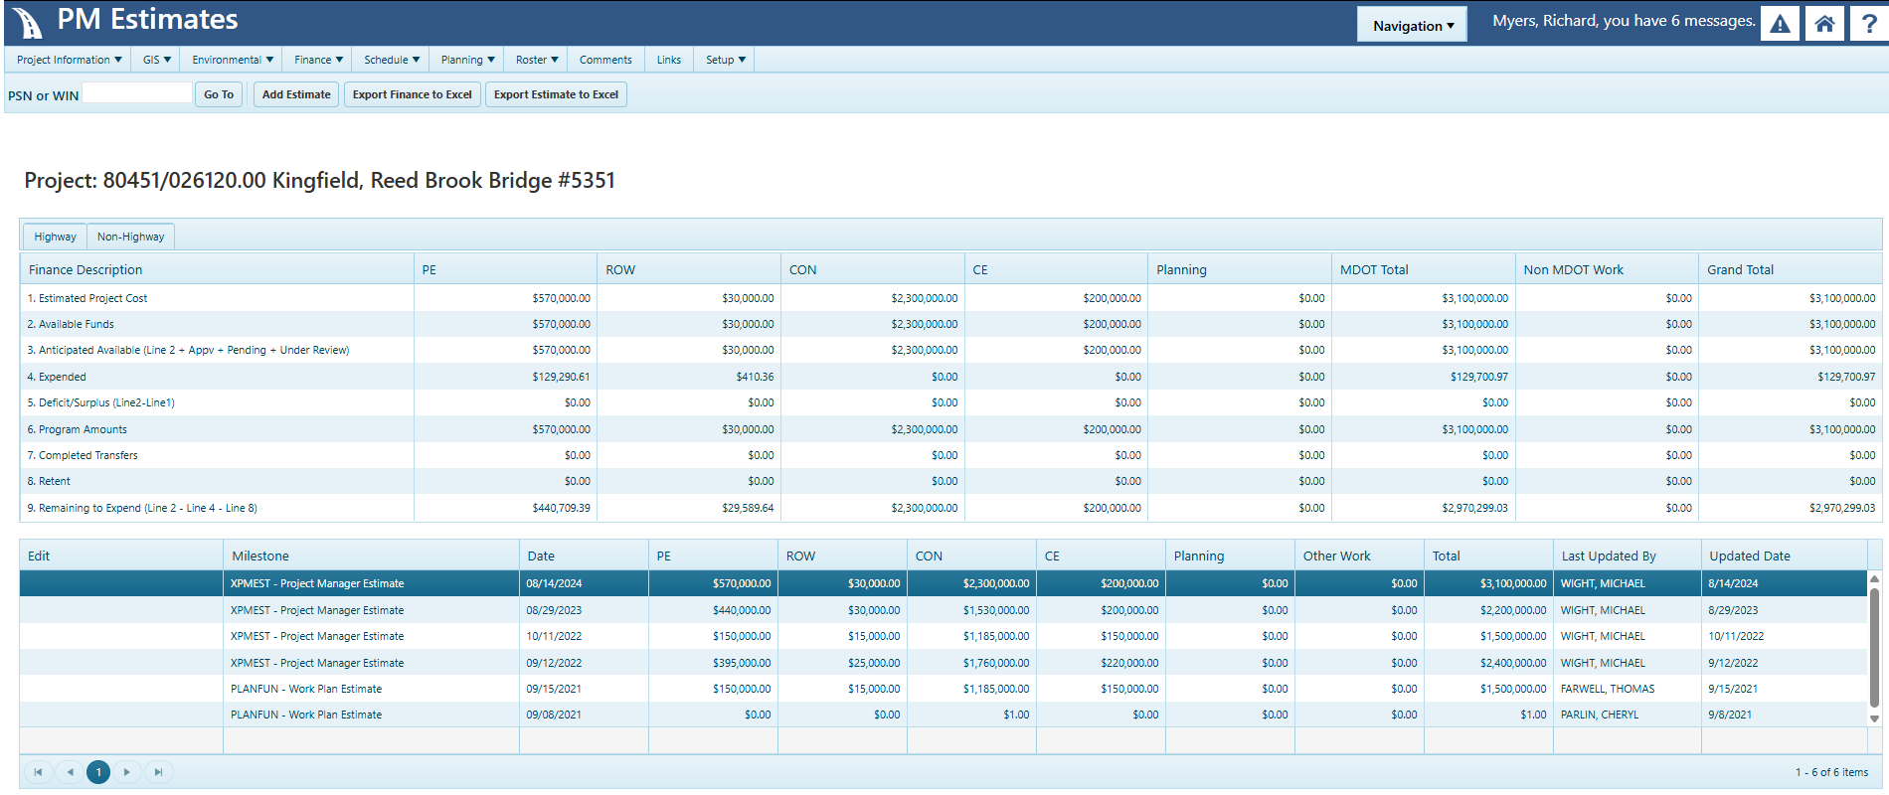

APPROVAL:
☒ Proceed to PIC ☐ Develop PDR _________________________________________________________
Assistant Bridge Program Manager Date

