PROJECT INFORMATION
Bridge Name and Number:
WIN: | [Status]
Project Manager:
Town(s):
Route Carried: | Route 16 and 27
Feature Intersected: | Reed Brook
Programmed Scope: | Bridge Deck Replacement

Recommended Scope:
☐ Bridge Replacement
☒ Bridge Improvement
☐ Preservation/Rehabilitation
☒ Deck Replacement
☐ Superstructure Replacement
☐ Other:

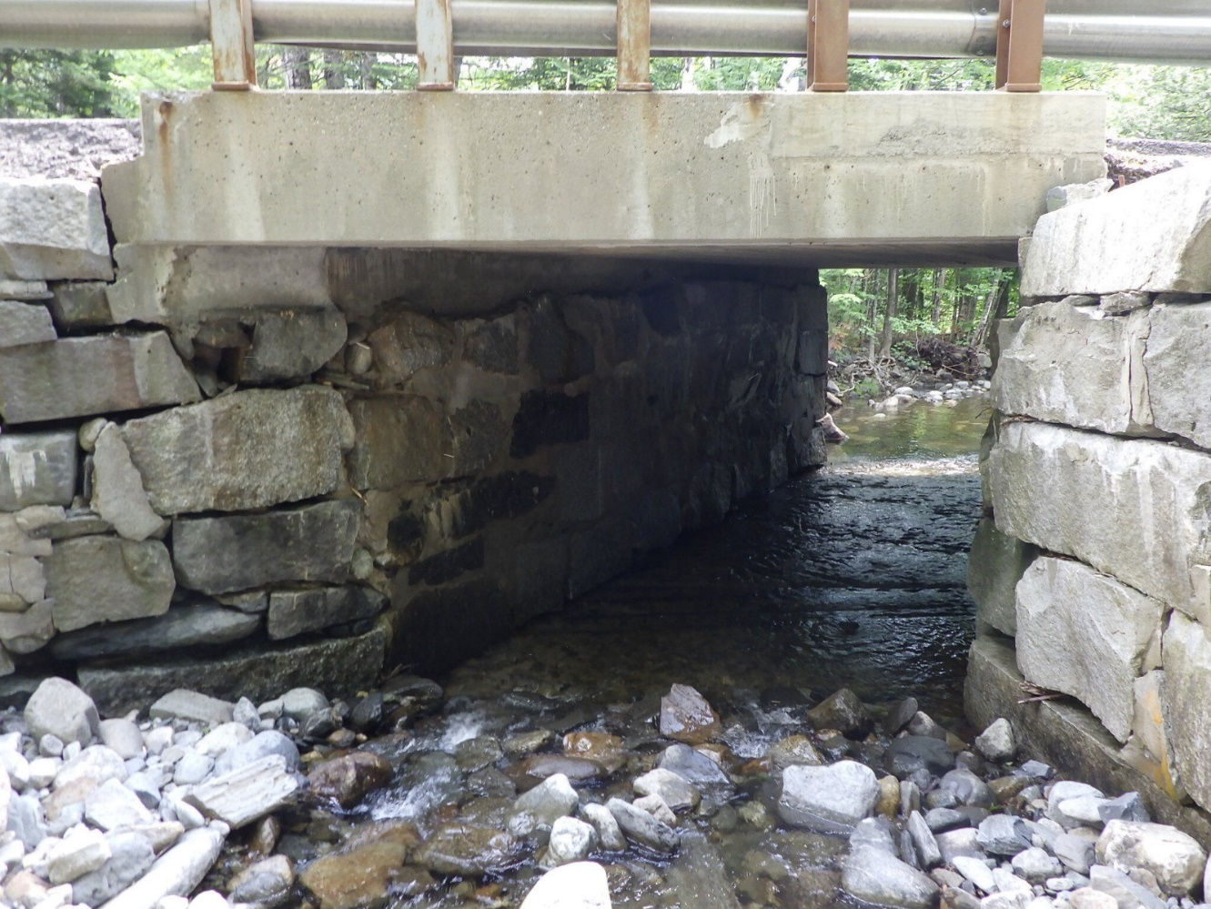
Do not remove this line
ROADWAY
Design Speed (mph): | 55
Corridor Priority (1-5): | 2
NHS: | No
Current AADT: | 3630
Approach Lane: | 11’ paved
Approach Shoulder: | 3’ gravel
Sidewalk(s): | 4’ north side
Alignment: | (Currently meets XX mph) (Note deficiencies)

EXISTING BRIDGE DATA
Span Layout: | 15’
Curb-to-Curb Width: | 28’
Vertical Clearance: | 6-inches above low chord @ Q50
Year Built: | 1939
Superstructure Type: | Concrete slab
Substructure Type(s): | Gravity stone retaining wall
Condition Ratings: | Deck | 4 | Superstructure | 4 | Substructure | 4
 | Scour | 6 | Culvert
Load Rating (Posted?): | (Controlling RF, which configuration, and posted load if applicable)
Maintenance Issues: | (Debris, scour, continual wearing surface deterioration, etc.)
Additional Comments:

OTHER DATA
Purpose & Need: | (provided by ENV in cooperation with Bridge Program*)
ENV Sizing Criteria: | N/A
Geotechnical Summary: | (General subsurface material and depth to bedrock)
Additional Borings Required ☐ Additional Geotechnical Evaluations Required ☐
Other:

*Most projects can use the following Purpose: To address the structural condition of the bridge and improve safety at the site.

Do not remove this line
PROPOSED BRIDGE MODIFICATIONS
Out-to-Out Width:
Curb-to-Curb Width:
Sidewalk Width(s):
Vertical Clearance: | No change
Alignment Changes: | Raise in grade of 2″
Superstructure Repairs: | Deck replacement
Abutment Repairs: | Replace backwall and repair bearing seats
Pier Repairs: | N/A
Bearing Repairs: | Replace fixed bearings in kind
Wearing Surface Type: | HMA
Joint Type(s): | None
Railing Type: | No change
Design Load: | HL-93, RPV 10

PROJECT DETAILS
Complete Streets: | Matching existing corridor
ROW Impacts: | (yes or no)
Utility Impacts: | (relocate waterline; relocate aerials)
MoT Method: | One lane temporary bridge
Construction Duration: | One season plus final paving and landscaping the following spring
Design Exceptions:
Public Involvement: | (note what level or strategy will be used)
Municipal Agreement(s): | (yes or no, list which ones)
Forecast Advertise: | Q3 2026
Other:

ADDITIONAL COMMENTS:

- Here, we could also list other alternatives broadly considered and dismissed

- We could also include any rough plans if available

Do not remove this line
ENVIRONMENTAL COORDINATION

[INSERT HERE]

This would be the standard sheet from the Environmental Office.

Do not remove this line

PROJEX FINANCE SUMMARY

[PASTE HERE]

Once the PM updates the estimate in Projex, this would be a screen shot of that page cropped to fit.

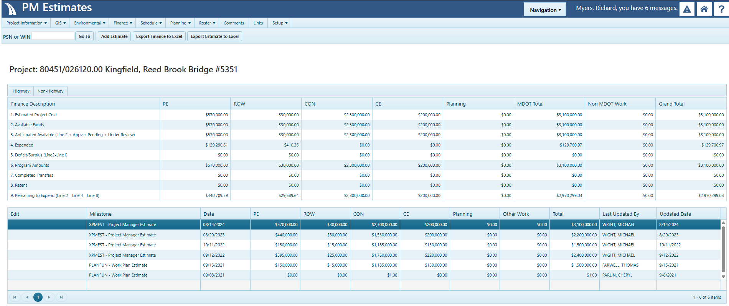

APPROVAL:
☒ Proceed to PIC ☐ Develop PDR _________________________________________________________
Assistant Bridge Program Manager Date

