The federal Summer Food Service Program is an equal opportunity provider. In accordance with federal law, U.S. Department of Agriculture policy, and state law, this institution is prohibited from discrimination on basis of race, color, national origin, sex, age, sexual orientation or disability.

**The Summer Food Service Program is sponsored by the**

**MSAD School Department Food Service Program.**

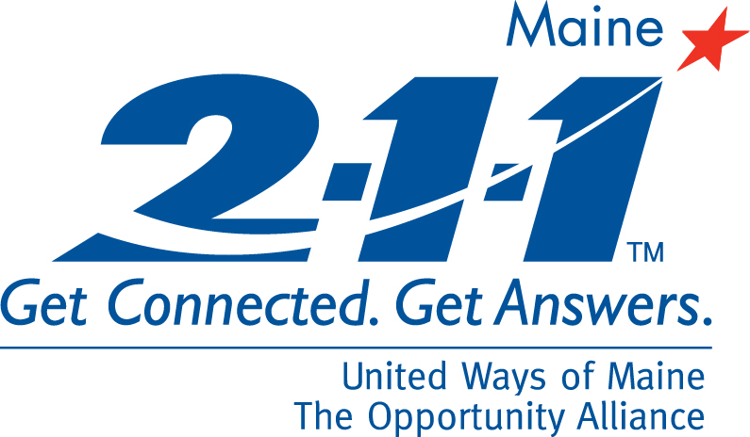

**Lunch served day through day**

**Beginning date and end date**

Note if there is a day no meals will be served such as July 4th

sllogo.jpg

**FREE SUMMER LUNCH**



**Want to volunteer?**

**For more information contact**

**MSAD Food Service Supervisor**

**Name**

**Phone Number or email**

**For additional resources call 2-1-1**

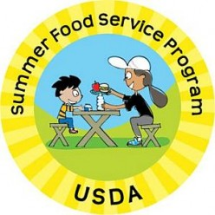

**All children age 18 and under are welcome.**

**All meals must be eaten on-site! No application needed.**

|  |  |
| --- | --- |
| **Site Name** | **Site Name** |
| Address start and end time | Address  Start and end time |

