Bangor Recruit/Retain 1 June 13, 2019
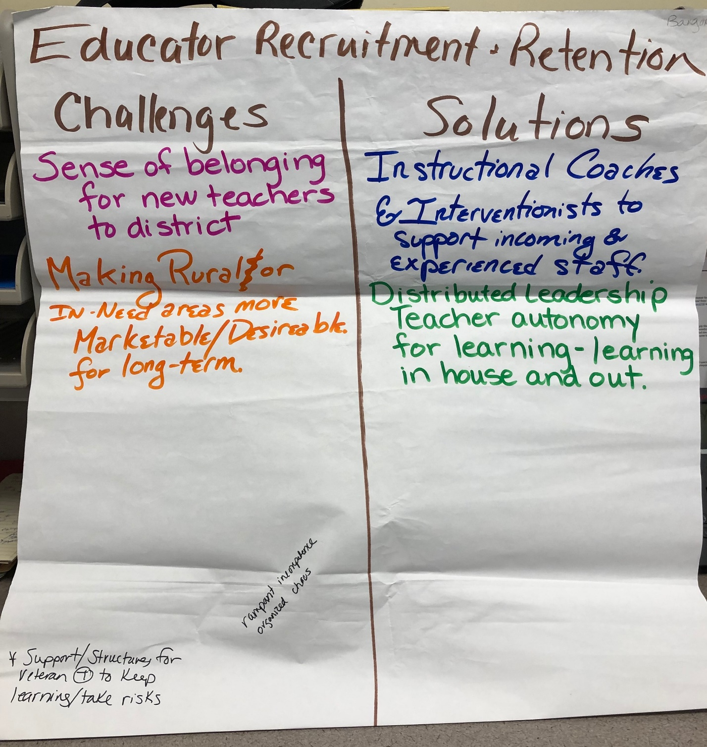
Educator Recruitment and Retention  Challenges  Sense of belonging for new teachers to district  Making Rural or in-need areas more marketable/desirable for long-term.  Rampant incompetence  Organized chaos | Solutions  Instructional coaches and Interventionists to support incoming & experienced staff  Distributed leadership/teacher autonomy for learning –learning in house and out.

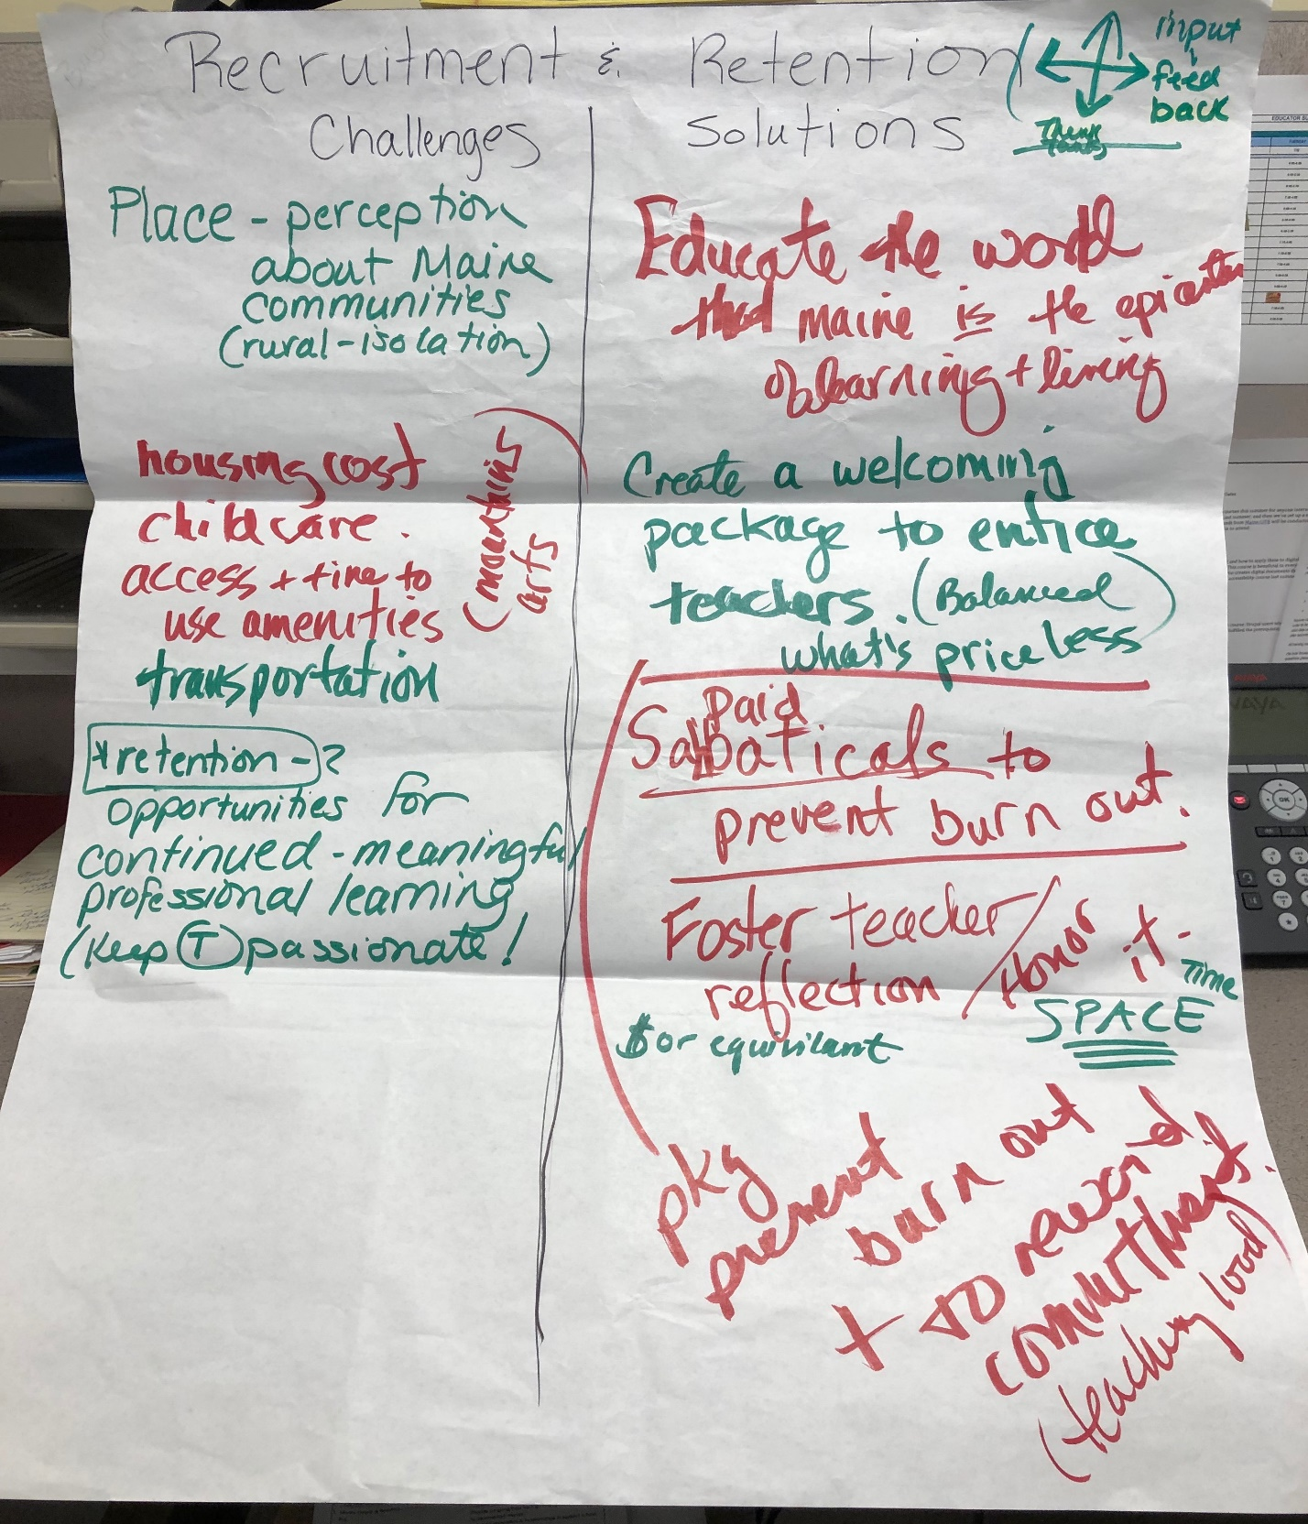
Bangor Recruit & Retain 2 6/13/19

- Recruitment and Retention  - Challenges  - Place – perception about Maine communities (rural – isolation)  - Housing cost  - Childcare  - Access and time to use amenities (mountains, arts)  - Transportation  - Retention:  - Opportunities for continued meaningful professional learning – keeps T passionate! | Solutions  Educate the world that Maine is the epicenter of learning and living  Create a welcoming package to entice teachers (Balanced what’s priceless)  Package the following to prevent burnout and to reward commitment (teaching load):  - Paid sabbaticals  - Foster teacher reflection/honor it  - $ or equivalent  - Time and space

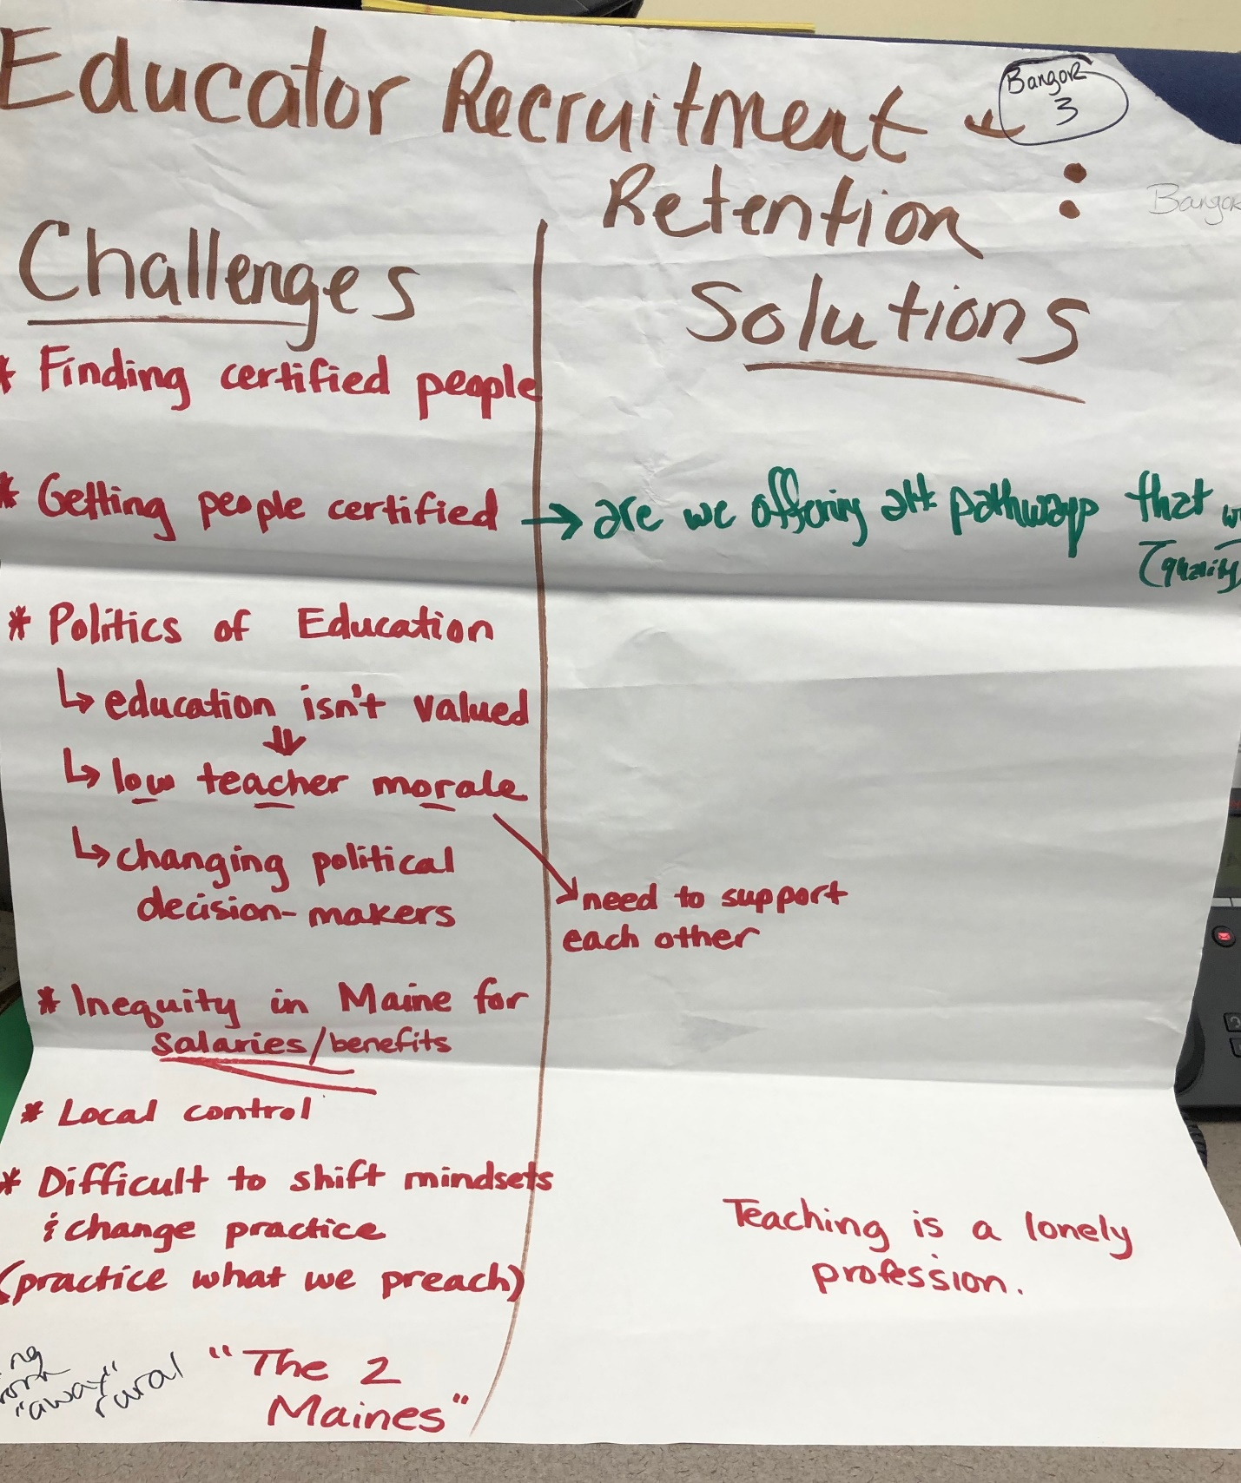

Bangor Recruit/Retain 3 June 13, 19

Educator Recruitment and Retention:  Challenges  Finding certified people  Getting people certified →→→→→→→→→→→  Politics of Education:  Education isn’t valued  ↓  Low teacher morale →→→→→→→→→→→→  Changing political decision-makers  Inequity in Maine for salaries/benefits  Local control  Difficult to shift mindsets & change practice  (practice what we preach)  Being from “away” – rural  “The two Maines” | Solutions  Are we offering alt pathways that work (quality)?  We need to support each other  Teaching is a lonely profession

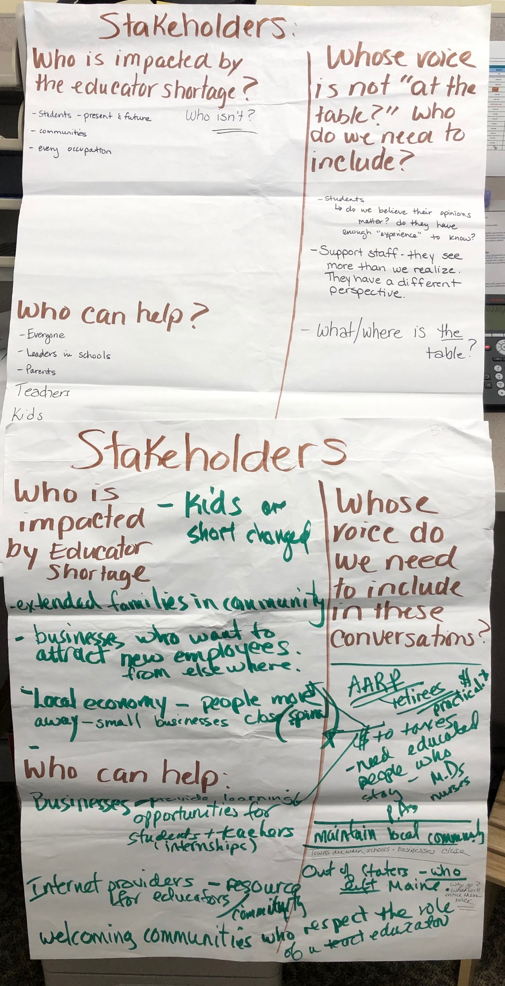
Bangor Stakeholders 4 June 13, 2019

Stakeholders

Who is impacted by the educator shortage?

- Students – present and future
- Communities
- Every occupation
- Kids are shortchanged
- Extended families in communities
- Businesses who want to attract new employees from elsewhere
- Local economy – people move away, small businesses close (spiral)

Who can Help?

- Everyone
- Leaders in school
- Parents
- Teachers
- Kids
- Businesses: provide learning opportunities for students and teachers – internships
- Internet providers: resource for educators/community
- Welcoming communities who respect the role of education

Whose voice is not “at the table?” Who do we need to include?

- Students -do we believe their opinions matter? Do they have enough “experience” to know?
- Support staff-they see more than we realize. They have a different perspective.
- What/Where is the table?
- AARP – retirees $ practical to taxes, need educated people who stay, M.D.s, P.A.s, nurses – maintain local community: towns die when businesses close
- Out of staters who left Maine – why go? What will entice them back?

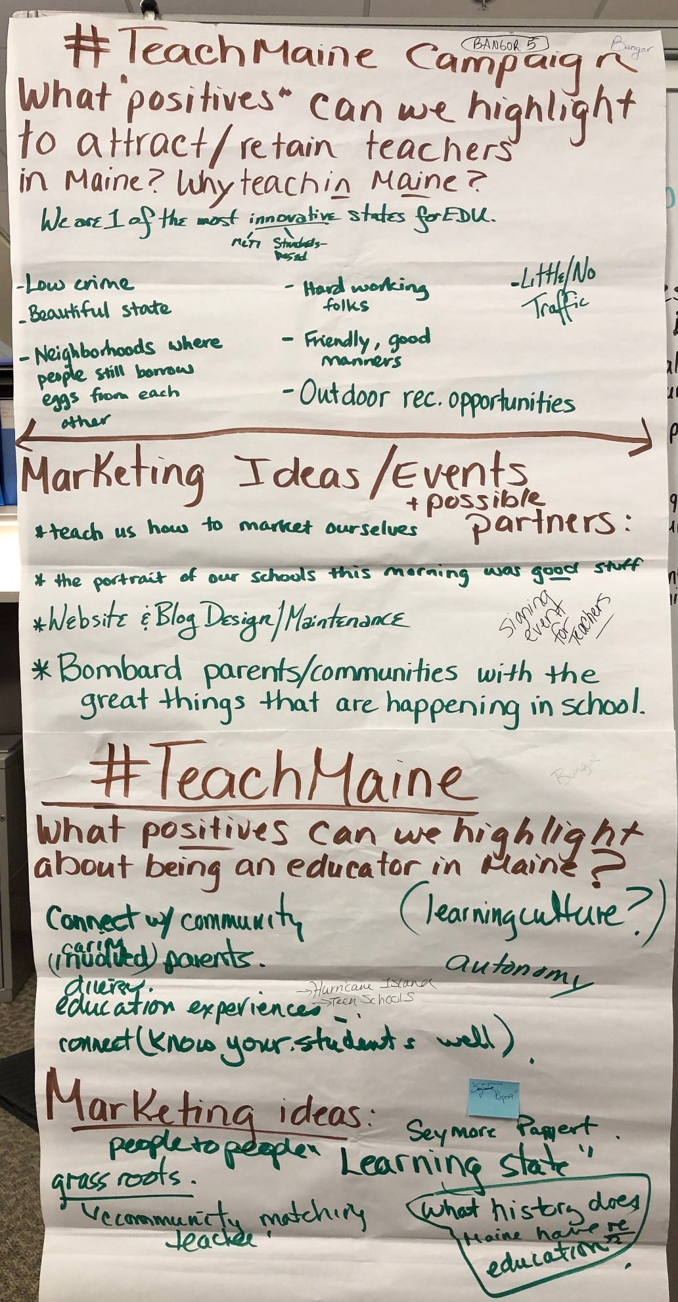
Bangor #TeachMaine 5 June 13, 2019

#TeachMaine Campaign

What “Positives” can we highlight to attract/retain teachers in Maine? Why teach in Maine?

We are one of the most innovative states for EDU (MLTI – Standards-based)
Low crime
Beautiful state
Neighborhoods where people still borrow eggs from each other
Hardworking folks
Friendly, good manners
Outdoor recreation opportunities
Little/no traffic
Connect with community
Caring, involved parents
Diverse education experiences (Hurricane Island, Teen Schools)
Connect – know your students well
Learning culture
Autonomy

Marketing Ideas

Teach us how to market ourselves
The portrait of our schools this morning was good stuff (School Success Think Tank)
Website and blog design- maintenance
Bombard parents/communities with the great things that are happening in school.
People to people- grassroots – community matching teacher
Maine is a “learning state” – Seymour Papert- what history does Maine have in education?

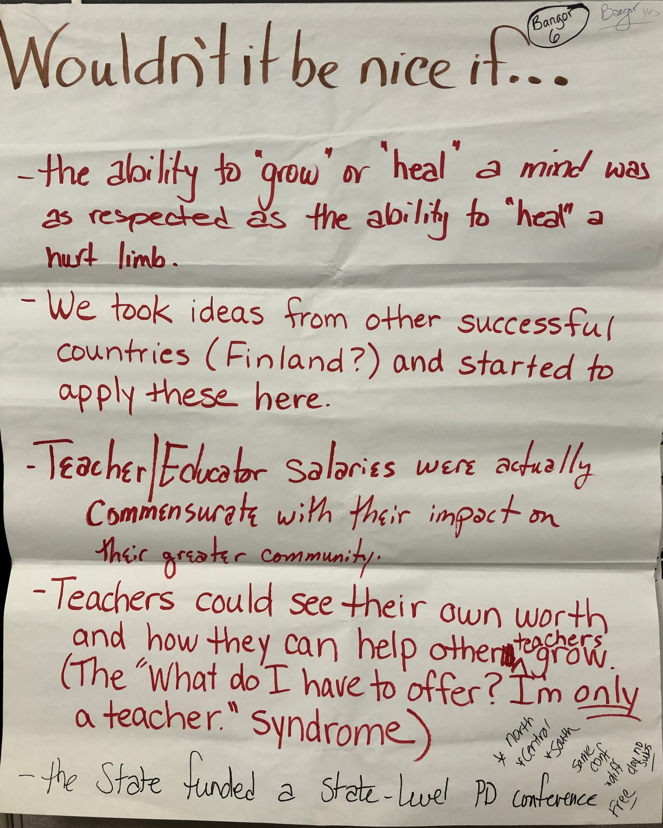

Bangor Nice If . . . 6 June 13, 2019

Wouldn’t it Be Nice If . . .

- The ability to “grow’ or “heal” a mind was as respected as the ability to “heal” a hurt limb.
- We took ideas from other successful countries (Finland?) and started to apply these here.
- Teacher/Educator salaries were actually commensurate with their impact on their greater community
- Teachers could see their own worth and how they can help other teachers grow. (The “What do I have to offer? I’m only a teacher.” Syndrome).
- The state funded a state-level conference – PD Conference Free - *North *Central *South – same conference, diff day – no subs

