Getting More Bang for Your Book!
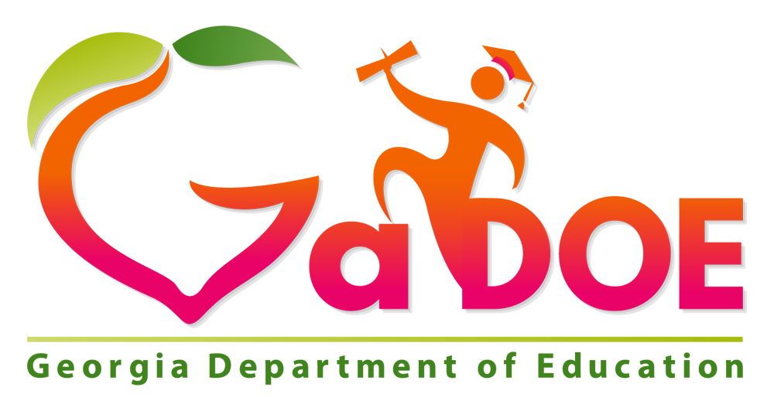
*These books were referenced by the presenter during the GaDOE sessions.
As always, you should read any book yourself before sharing with your students to determine appropriateness.
Titles Specifically Recommended for Grades K-2
Name of Book | How/why do you use it?
A Spot of Kindness | Teaching kindness in PreK - when kids are spotted being kind after we’ve read the story, they get their own “spot of kindness” (circle label sticker on their hand)
Have You Filled A Bucket Today? | Civic Action, Giving, Sharing, Caring
The Angry Dragon | Civic Action, Feelings and Emotions
My Mouth is a Volcano | Civic Action, Choices, Emotions
When Sophie Gets Angry: Really, Really Angry | Civic Action, Feelings
How Full is Your Bucket | Civic action, Giving, Sharing, Caring
*Spaghetti in a Hotdog Bun: Having the Courage to Be Who You Are | Civic Action, Courage, Kindness
We are all Wonders | Civic Action, Empathy, Kindness
Fill a Bucket | Civic Action, Kindness, Caring
All Are Welcome | Diversity, Encouragement, Valuing differences
Even Steven, Odd Todd | Math concepts, Opposites
*I Walk With Vanessa | Civic action, Kindness
*Be Kind | Civic action, Kindness
*The Invisible Boy | Civic action, Kindness
*Each Kindness | Civic action, Kindness
* If you Plant a Seed | Civic action, Kindness
* One | Civic action, Kindness
*What Pet Should I Get? | Scarcity, Making choices
*What if Everybody Did That? | Civic Action, Making choices
*I Have a Dream Martin | Martin Luther King Jr., Civic Action, Choices, Civil Rights, Courage
*All The Way to the Top | Civic Action, Courage
*I Want My Hat Back | Economics, Scarcity, Choices
*This is Not My Hat | Economics, Scarcity, Choices
*We Found a Hat | Economics, Scarcity, Choices
*Blue Sky White Star | Patriotism
*Thomas Jefferson: Life, Liberty, and the Pursuit of Everything | Thomas Jefferson
*Looking at Lincoln | Abraham Lincoln
*Fireboat | September 11th, Civic Action
*Now and Ben: The Modern Inventions of Benjamin Franklin | Benjamin Franklin, Inventors
*Thomas Jefferson Builds a Library | Thomas Jefferson, Civic Action
*Water and Land: Land and Water Forms Around the World | Geography, Landforms
*Miss Pinkeltink’s Purse | Civic Action, Kindness
*The United States V. Jackie Robinson | Jackie Robinson, Civil Rights
*How to Build a Hug | Empathy, Kindness
Titles Specifically Recommended for Intermediate Grades
Name of Book | How/why do you use it?
The Other Side by Jacqueline Woodson | Racial Segregation
The Wall | Vietnam War, Memorials
Kweeks of Kookatumdee | Scarcity
The Poppy Lady | WWI, Civic Action, Veterans Day
H Is for Honor: A Military Family Alphabet | Veterans Day, Patriotism
Ruth and the Green Book by Calvin A. Ramsey | Equality, Segregation, Civil Rights, Jim Crow Laws
*Maya Lin: Artist-Architect of Light and Lines Designer of the Vietnam Veterans Memorial | Vietnam War, Memorials, Civic Action, Art Integration/Visual Literacy
*Rolling Thunder | Vietnam War, Memorials, Patriotism, Civic Action
*Dazzleships | Art of War, WWI, Art Integration/Visual Literacy
*All Different Now | Juneteenth, Civil War, Slavery
*Molly Bannaky | Colonial Times, Slavery, Indentured Servitude
*We are Grateful Otsaliheliga | Native American life
*The Undefeated | Poetry, Slavery, Civil Rights
*The Great Fuzz Frenzy | Scarcity, Choices
*Water and Land: Land and Water Forms Around the World | Geography, Landforms
*Follow the Moon Home: A Tale of One Idea, Twenty Kids, and a Hundred Sea Turtles | Civic Action
*Trouper | Differences, Empathy
*Each Kindness | Civic Action, Kindness, Choices
Titles Specifically Recommended for Grades 6-12
Name of Book | How/why do you use it?
Occurrence at Owl Creek Bridge | Civil War
The Butterfly | World History, Holocaust
Children of the Dust Bowl: The True Story of the School at Weedpatch Camp | Dust Bowl, Primary Sources, Migrant workers (Other books by Jerry Stanley were mentioned)
I am an American | World History, Japanese Internment
Beyond Lies The Wub | Science Fiction
How to Write About Africa | Africa, Preconceptions
Terrible Things: An Allegory of the Holocaust | World History, Holocaust
*Yertle the Turtle | Governance, Conflict/Rebellion
*The Butter Battle Book | Democracy vs Communism, Cold War
*Horton Hears a Who | Civic Action
*The Sneetches | Haves/Have nots, Some Economic Concepts
*The Lorax | Economics, Robber Barons, Early Industry
The Water Princess | Scarcity of water
From Slave Ship to Freedom Road | Slavery
The Winter Horses | WWII, Holocaust, Great to pair with Faithful Elephants
*What Pet Should I Get? | Scarcity, Making choices
*Nya’s Long Walk: A Step at a Time | Scarcity of water, Picture book companion to A Long Walk to Water
Shin’s Tricycle | Hiroshima, WWII
*Dazzleships | Art of War, WWI, Art Integration/Visual Literacy
*The Poppy Lady | WWI, Civic Action , Veterans Day
*Ruth Bader Gingsburg: The Case of RBG vs. Inequality | Inequality, Antisemitism, Developing Claims and Using Evidence
*Maya Lin: Artist-Architect of Light and Lines Designer of the Vietnam Veterans Memorial | Vietnam War, Memorials, Civic Action, Art Integration/Visual Literacy
*Rolling Thunder | Vietnam War, Memorials, Patriotism, Civic Action
*The United States v. Jackie Robinson | Jackie Robinson, Inequality, Civil Rights
*Knit Your Bit: A World War I Story | WWI, Civic Action
*Abraham Lincoln’s Dueling Words | Abraham Lincoln
*Dadblamed Union Army Cow | Civil War, Persistence
*Through My Eyes | Ruby Bridges, Inequality, Civil Rights
*My Rows and Piles of Coins | Economics
*Weslandia | Economics
*Uncle Jed’s Barbershop | Economics
*The Harmonica | World History, Holocaust
*A Single Shard | World History
*Sunjata | World History
*Persepolis: The Story of a Childhood | World History
*Dear Primo: A Letter to My Cousin | World History/Geography, Cultural Comparison
*The Great Kapok Tree | World History, Geography
*The Red Pencil | World History, Geography
*Faithful Elephants | World History, Geography
*Planting the Trees of Kenya: The Story of Wangari | World History, Geography
*14 Cows For America | World History, Geography
*A Long Walk to Water | World History, Geography
*One Plastic Bag: Isatou Ceesay and the Recycling Women of Gambia | World History, Geography, Civic Action
*Give a Goat | World History, Geography, Civic Action
*The Boy Who Harnessed the Wind | World History, Geography, Civic Action
*We are Grateful Otsaliheliga | Native American life
*All Different Now | Juneteenth, Civil War, Slavery
*Molly Bannaky | Colonial Times, Slavery, Indentured Servitude
*Freedom Summer | Civil Rights, Friendship
*She Stood for Freedom: The Untold Story of a Civil Rights Hero | Civil Rights, Civic Action
*Follow the Moon Home: A Tale of One Idea, Twenty Kids, and a Hundred Sea Turtles | Civic Action
*Dangerous Jane | Civic Action, WWI, Reform Movement, Early 20th Century
*Separate is Never Equal: Sylvia Mendez and Her Family’s Fight for Desegregation | Desegregation, Civil Rights

Social Studies Titles and Poetry
Name of Book | How/why do you use it?
Martin Rising: Requiem for a King | Final months of Martin Luther King’s life and assassination
Memphis, Martin, and the Mountaintop: The Sanitation Strike of 1968 | Martin Luther King, Civil Rights, Civic Action
Fry Bread: A Native American Family Story | Native American, Culture, Family
Got Geography! | Geography, Landforms, Continents, Oceans, Location
Jumping Off Library Shelves | Library, Story, Reading
Amazing Places Poems Selected by Lee Bennett Hopkins | Location, Diversity
A Poem for Peter | Ezra Jack Keats, Determination, Persistence
Boycott Blues: How Rosa Parks Inspired a Nation | Rosa Parks, Civil Rights, Civic Action
The Day You Begin | Diversity, Feelings
The Undefeated by Kwame Alexander | Slavery, Civil Rights
The Crossover by Kwame Alexander | Sports, Family, Choices
*The Red Pencil | Courage, Persistence
Professional Titles Collection
Name of Book | How/why do you use it?
*Reading to Make a Difference: Using Literature to Help Students Speak Freely, Think Deeply, and Take Action | Incorporating diverse literature into classrooms
*Igniting a Passion for Reading: Successful Strategies for Building Lifetime Readers | Developing readers not only motivated to read but to also love reading
*The Ramped-Up Read Aloud: What to Notice As You Turn The Page | Two page read aloud experiences for 101 picture books focusing on what to notice, say, and wonder
*Reading Aloud Across the Curriculum: How to Build Bridges in Language Arts, Math, Science, and Social Studies | How to make the read aloud a strong supporting structure for literacy learning across the day
*Unwrapping the Read Aloud: Sustaining Best Practice | Making read alouds intentional by purposely selecting texts and inspiring students to read and write across the curriculum
*In Defense of the Read-Aloud: Sustaining Best Practice | Supporting, sustaining, and celebrating the power of the read aloud
*The Book Whisperer: Awakening the Inner Reader inner Reader in Every Child | Helping students navigate the word of literature and giving students time to read and pick out books themselves
*The Ultimate Read-Aloud Resource | Guidelines, lessons, and resources for making every read aloud experience intentional and instructional
*Every Book is a Social Studies Book | Collection of lessons and activities for picture books putting an emphasis on Social Studies
*Notable Books, Notable Lessons | Strategies, lesson plans, and activities that use literature for Social Studies lessons

