Virtual Content Coaching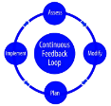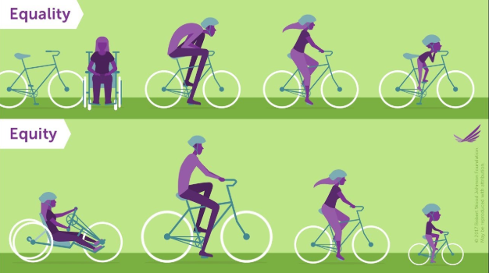
What do you stand to gain?  - Receive individualized, non-evaluative support from a coach with expertise in your content area.  - Develop a strong reflective practice as you deepen your “noticing” skills and instructional prowess.  - Customize your professional development by setting your own goals and receiving support in reaching them.  - Take meaningful and lasting steps toward becoming the teacher you’ve always wanted to be.  - Sample Areas to Explore through Coaching:  - Classroom culture and student investment  - Deepening instructional rigor  - Proficiency-based teaching and learning  - Instructional strategies | How does it work?  - Every other week, upload 15 minutes of footage from your classroom and receive feedback from your coach via a private “room” in an online platform (link).  - The next week, participate in an hour long coaching conversation by phone or video chat with your coach.  - Each quarter, reflect in writing on the impact coaching is having on your instructional practice and discuss plans for the upcoming quarter with your coach.  - At the end of the year, reflect with your coach on the incredible transformation you’ve seen in your practice!

Expected Time Commitment: Approx. 2.5 hours/month
Tentative Program Dates: November 26, 2018 – June 1, 2018
Deadline to Enroll: November 16, 2018
Enrollment is on a first-come, first-served basis until all spots are filled. To enroll, complete this survey.

Questions? Contact the World Language Specialist at: lavinia.m.rogers@maine.gov

