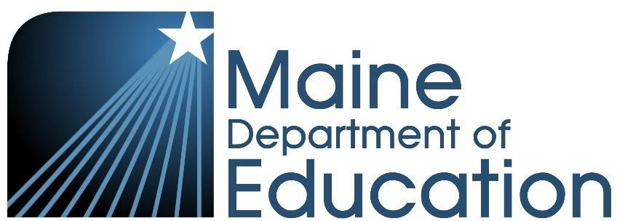

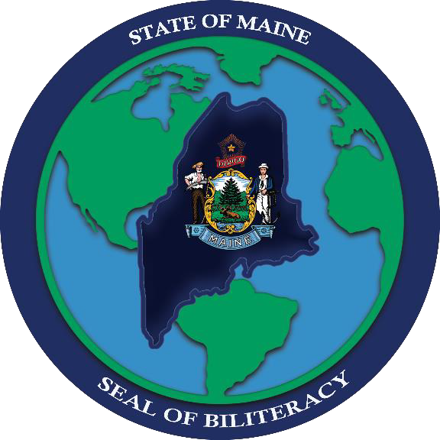
Maine Seal of Biliteracy Coordinator Guide
2022-23

Contents
About the Seal of Biliteracy 3
Seal of Biliteracy Coordinator 4
Awarding Process 4
Eligibility Criteria 5
Determining a Student’s Overall Proficiency Level 6
ACTFL Assessments 7
Advanced Placement (AP) Exams 8
ALTA 8
Avant Assessments 8
European Exams 9
Frequently Asked Questions 10
When is the best time of year to schedule language proficiency assessments? 10
Does the student have to be assessed in their graduating year? 10
Are sample tests available so students can practice? 10
How much do language proficiency assessments cost? 11
What if a student’s language does not have a written form, or the written form is not commonly
used? 11
If the only standardized assessment available for a given language measures oral skills only, will we need to find another way for the student to demonstrate reading and writing skills? 11
Can a student earn the Seal of Biliteracy in multiple languages? 12
Can a student retake an entire test or individual domain if they did not meet the minimum score the first time? 12
How can students type their responses for a language with a different alphabet? 12
Appendix A: Ordering 13

About the Seal of Biliteracy

The Seal of Biliteracy is an award that recognizes graduating students for having a high degree of skill in English and one or more additional languages. Nearly all states in the United States now offer this award, celebrating multilingualism and giving students an edge for their post-secondary studies and/or future careers.
Established in 2019, the Maine Seal of Biliteracy has been awarded to hundreds of students across the state, including students who speak or sign languages other than English in their homes and communities and students who have studied a language in school or other settings.
Until this year, students or their teachers needed to submit an application to the Maine Department of Education in order to obtain the Seal of Biliteracy. In order to streamline the awarding process and put greater control in the hands of students and their teachers, starting in school year 2022-23 schools will be awarding the Seal of Biliteracy to students directly, and no application will be necessary.

Seal of Biliteracy Coordinator

Each high school that wishes to participate in the Seal of Biliteracy must designate a local Seal of Biliteracy Coordinator. While multiple teachers or other staff members in a school may support students in earning the Seal of Biliteracy, the Coordinator will serve as the primary contact with the Department and ensure that all policies and procedures are adhered to by the school.
A Seal of Biliteracy Coordinator may be a world language teacher, multilingual learner teacher, school counselor, principal, or any other staff member.
Designate a Seal of Biliteracy Coordinator for your School

Awarding Process

Each participating high school will follow the process outlined below, ensuring collaboration between the Seal of Biliteracy Coordinator and any other teachers or staff members who may be supporting students in obtaining the Seal of Biliteracy.

Required Steps:
- Read and understand this Maine Seal of Biliteracy Coordinator Guide.
- Designate a local Seal of Biliteracy Coordinator via the online form.
- Schedule and administer language assessments, aligning to the required state-established Seal of Biliteracy eligibility criteria.
- Coordinate with school counselors to ensure that the Seal of Biliteracy is recorded on each
recipient’s transcripts, including the language(s) and proficiency level(s). (This step is essential to ensuring that credit can be awarded to students attending institutes of higher education that accept the Maine Seal of Biliteracy for credit.)
- Compile data on your school’s Seal of Biliteracy recipients in the required spreadsheet template.
- Submit the completed spreadsheet (in Excel or CSV format) to the Department via the required secure online form annually by July 30th. (Do not submit by email as the spreadsheet contains confidential student data.)
- Ensure that parent/guardian* of each awardee completes the Seal of Biliteracy Signature Collection Form by July 30th. (*The student may complete this form if 18 or older.) This allows the Department to publicly recognize schools for supporting students in earning the Seal.

Optional Steps:

- Print Seal of Biliteracy certificates and diploma stickers, if desired. (The Maine DOE will provide printable templates.)
- Purchase sashes, ribbons, and/or medals for students to wear at graduation. See Appendix A for ordering information.

Eligibility Criteria

To be eligible to earn the Seal of Biliteracy, students must be in their graduating year of high school.

This year there has been a change to the eligibility criteria when it comes to demonstrating skill in English. Students are now considered to have met the requirement if they have fulfilled (or are on track to fulfill, as of the start of their graduating year) their school’s English language arts requirements for graduation.

For languages other than English, individual language domain (listening, speaking, reading, and writing) scores must be at intermediate mid proficiency or above, based on the 2012 ACTFL proficiency guidelines. If a given test does not provide individual domain scores, the overall score must be at intermediate mid proficiency or above.

Students whose primary/home language is other than English may be eligible for an exemption from the reading and writing domains if they have not had sufficient educational opportunity to become literate in their language. Students who are deaf or hard of hearing may be eligible for an exemption from the listening and/or speaking domain. For such students, the school’s Seal of Biliteracy Coordinator will determine whether an exemption is to be granted. The Maine Department of Education Seal of Biliteracy Coordinator is available to advise in any cases that are unclear.

Language | Minimum Evidence of Proficiency
English | The student must have fulfilled (or be on track to fulfill, as of the start of their graduating year) the school’s English Language Arts requirements for graduation.
Additional Language | One of the following:  Tests Available in Multiple Languages (Click on the links to see languages offered.)  - Score of 3 or above on World Language AP exam  - Score of 4 on IB World Language Exam B SL or HL exam  - Score of I2 or above on ACTFL Assessment of Performance Toward Proficiency in Languages (AAPPL) form B  - Achieve a proficiency rating of Intermediate-Mid or higher on ACTFL Oral Proficiency Interview (OPI/OPIc)**  - Score of 5 or above on Avant STAMP 4S  - Score of 5 or above on Avant STAMP WS (formerly WorldSpeak)  - Score of 4 on National Examinations in World Languages (NEWL)  - Score of 6 or ILR 1+ on ALTA Language Test

Language | Minimum Evidence of Proficiency
Language-Specific Tests

- Score of 3 on American Sign Language Proficiency Interview (ASLPI)
- Score of Intermediate Plus on Sign Language Proficiency Interview (SLPI)
- Score of 5 on Avant Arabic Proficiency Test (APT)
- Score of CEFR B1 on Diplôme d’Etudes en Langue Française/Diplôme Approfondi de Langue Française (DELF/DALF)
- Score of CEFR B1 on Deutsches Sprachdiplom I (DSD)
- Score of CEFR B1 on Ellinomatheia
- Score of I2 on the ACTFL Latin Interpretive Reading Assessment (ALIRA)
- Score of Silver (Maximum Cum Laude) on the National Latin Exam: Intermediate Reading Comprehension Exam
- Score of 5 on Avant Spanish Heritage Language Test (SHL)
- Score of CEFR B1 on Diplomas of Spanish as a Foreign Language (DELE)
- Score of CEFR B1 on Goethe-Institut German Exam

Additional Pathways

- Provide transcripts from a school outside of the United States showing at least
three years of instruction in the student’s primary/home language in 8th grade or beyond, with an equivalent grade average of B or higher.
- For less commonly taught world languages and indigenous languages without standardized testing options, please reach out to the Maine DOE Seal of Biliteracy coordinator, April Perkins, at april.perkins@maine.gov to establish an appropriate measure of intermediate-mid proficiency based on the ACTFL Proficiency Guidelines.
**Students seeking the Seal of Biliteracy through the ACTFL OPI may be required to show proficiency in other available language modalities using the ACTFL Listening (LPT), Reading (RPT), and/or Writing (WPT) tests.

Determining a Student’s Overall Proficiency Level

In order to obtain the Seal of Biliteracy, a student must demonstrate intermediate mid proficiency or higher in each assessed domain, according to the ACTFL Proficiency Guidelines, in a language other than English. Some of the permissible assessments, as outlined in the Eligibility Criteria section of this guide, provide an overall proficiency level score. Others, however, provide individual domain scores only. Also, not all assessments produce scores that are expressed in the same proficiency level categories as the ACTFL Proficiency Guidelines,

For assessments that provide scores only for individual domains, it will be necessary to determine the
student’s overall composite proficiency level. To do so, follow the assessment-specific guidelines

provided below. If a student is using an assessment that is not represented here, contact the Maine DOE Seal of Biliteracy Coordinator, Rebecca Carey, rebecca.carey@maine.gov to determine the overall score.

ACTFL Assessments

ACTFL assessments, such as AAPPL and the Oral Proficiency Interview (OPI), provide scores aligned with the ACTFL proficiency guidelines. (OPI yields a single score, which may be all a student needs if they have received an exemption from the reading and writing domains.) However, students who take AAPPL will not receive an overall proficiency level score. The overall score is to be calculated based on an average of the four domains: interpersonal listening and speaking (ILS), interpretive reading (IR), interpretive listening (IL), and presentational writing (PW). Remember that a student must score at intermediate mid proficiency (at least I-2) in each domain.
To find the average of the four domains, add the four numbers from each domain score (A-1 is represented as 6) and calculate the average. See the following examples:

 | ILS | IR | IL | PW | Average Calculated | Overall
Student A | I-4 | I-5 | I-4 | I-5 | 4 + 5 + 5 + 4 =20  20/4 = 5 | I-5, Intermediate High
Student B | I-2 | I-3 | I-2 | I-2 | 2 + 3 + 2 + 2 = 9  9/4 = 2  (rounded down from 2.25) | I-2, Intermediate Mid
Student C | A-1 | I-5 | A-1 | I-3 | 6 + 5 + 6 + 3 = 20  20/4 = 5 | I-5, Intermediate High
Student D | I-5 | A-1 | A-1 | I-5 | 5 + 6 + 6 + 5 = 22  22/4 = 6  (rounded up from 5.5) | A-1, Advanced Low

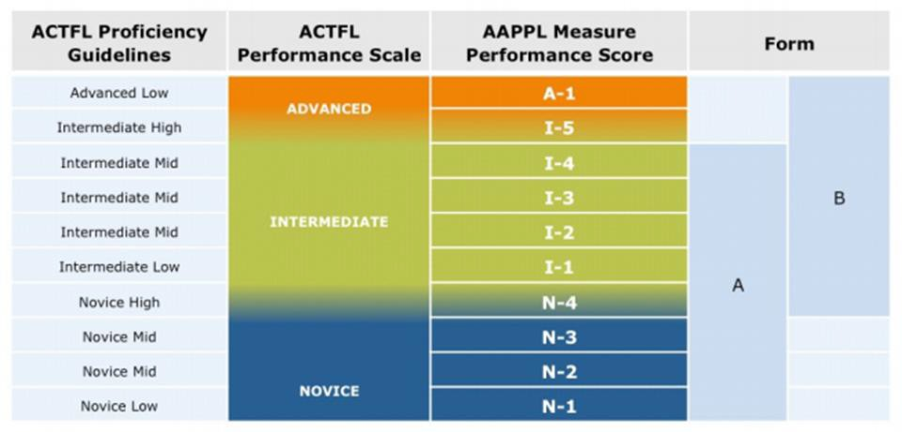

Advanced Placement (AP) Exams

AP Exam Score | Proficiency Level Equivalence
3 | Intermediate Mid
4/5 | Intermediate High
5 | Advanced

ALTA

ALTA Score | Proficiency Level Equivalence
12+ | Native
12 | Distinguished
11 | Distinguished
10 | Superior
9 | Superior
8 | Advanced Plus
7 | Advanced
6 (minimum score) | Intermediate- High

Avant Assessments

Avant assessments provide scores that correlate to the ACTFL proficiency levels. STAMP 4S and the Arabic Proficiency Test provide scores in each of the four domains, while STAMP WS (formerly WorldSpeak) provides score in writing and speaking only. The Spanish Heritage Language Test provides scores in vocabulary, reading, grammar, writing, and speaking.
To determine the overall composite proficiency score, find the average of all available domain scores. Level 5 in each domain is the minimum required score.
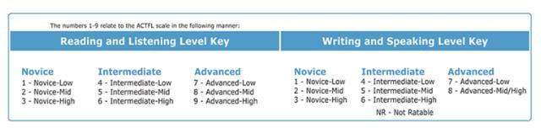

European Exams

For European exams that provide scores aligned with the Common European Framework of Reference, use the following chart. B1 is the minimum required score.
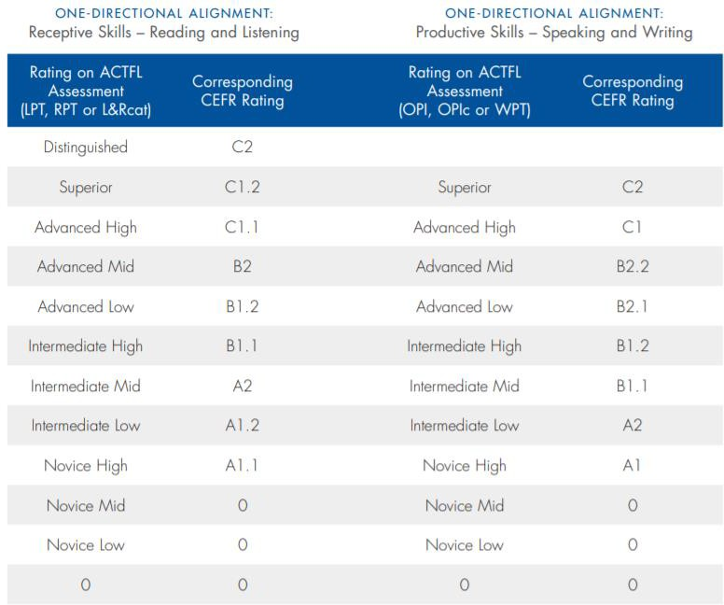

Frequently Asked Questions

When is the best time of year to schedule language proficiency assessments?

It can take several weeks or more for assessment results to arrive. It is recommended to administer assessments to students as far in advance of graduation as possible to ensure adequate time to go through all the steps of the awarding process.

Does the student have to be assessed in their graduating year?

No. As long as the language proficiency assessment was administered while the student is enrolled in high school, it can be used for the purposes of the Seal of Biliteracy.

Are sample tests available so students can practice?

The sample/practice resources available vary by test. Visit the links below for more information.

Tests | Links to Resources
AP EXAM | See College Board's site for specific language exams.
IB EXAM | https://www.ibo.org/programmes/diploma-programme/assessment-and-exams/sample-exam-papers/
AAPPL | https://www.languagetesting.com/aappl-demo
ACTFL OPI | https://www.languagetesting.com/oral-proficiency-interview-opi/
STAMP 4S | https://www.update.avantassessment.com/sample-tests#4S_Sample
ASLPI | https://www.ets.org/praxis/ct/aslpi/
AVANT APT | https://avantassessment.com/apt
DELF/DAL F | http://www.ciep.fr/en/delf-scolaire
ALIRA | https://www.languagetesting.com/actfl-latin-interpretive-reading-assessment
AVANT SHL | https://avantassessment.com/shl
DELE | https://www.dele.org/?page=dele/intermediate-mid-threshold-level
NLE | https://www.nle.org/Portals/0/Intermediate%20Latin%20Reading%20Comprehension%20Exam%202022%20FINAL. pdf

How much do language proficiency assessments cost?

There is a wide range of prices on the approved tests. It is strongly suggested to consult the websites listed below for the most up to date pricing and to choose one that is within your budget.

Tests | Link to Pricing
AP Exam | https://apstudent.collegeboard.org/takingtheexam/exam-fees
IB Exam | https://www.ibo.org/become-an-ib-school/fees-and-services/assessment-fees-and-services/
AAPPL | https://www.languagetesting.com/aappl
ACTFL OPI | https://www.languagetesting.com/oral-proficiency-interview-opi/
STAMP 4S | https://avantassessment.com/stamp4s/frequently-asked-questions
WorldSpeak | https://avantassessment.com/worldspeak
NEWL | https://www.americancouncils.org/newl-dates-deadlines-fees
ALTA | https://www.altalang.com/language-testing/faq/
ASLPI | https://www.ets.org/praxis/ct/aslpi/
AVANT APT | https://avantassessment.com/apt/faq
ALIRA | https://www.languagetesting.com/actfl-latin-interpretive-reading-assessment
AVANT SHL | https://avantassessment.com/shl
NLE | https://www.nle.org/Exams/General-Information

What if a student’s language does not have a written form, or the written form is not commonly

used?

We recognize that not all languages and cultures are print-based. This does not prevent students from applying for the Maine Seal of Biliteracy. Students are encouraged to take one of the tests that will allow them to demonstrate their oral and verbal comprehension skills. If there is no test available, please reach out to the Seal of Biliteracy Coordinator at the Maine Department of Education to discuss alternative ways to demonstrate proficiency.

If the only standardized assessment available for a given language measures oral skills only, will we need to find another way for the student to demonstrate reading and writing skills?

No. If there is no standardized assessment available to measure reading and writing skills, the test of oral skills will suffice as evidence of proficiency.

Can a student earn the Seal of Biliteracy in multiple languages?

Yes. There is no limit to the number of languages for which a student may earn be recognized.

Can a student retake an entire test or individual domain if they did not meet the minimum score the first time?

Yes. Students may retake assessments as many times as they wish.

How can students type their responses for a language with a different alphabet?

Computers and other devices have keyboard settings that allow for many languages with varying alphabets. Students may also benefit from using a silicone keyboard skin for their language(s).

Appendix A: Ordering

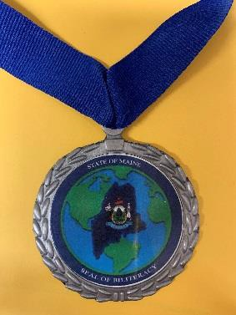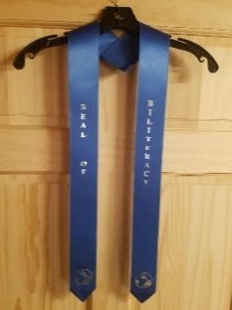Schools have the option of ordering ribbons, stoles, or medals for students earning the Maine Seal of Biliteracy from Norogala Show Ribbons/Northeast Trophy in Presque Isle, Maine. The Department of Education and Norogala Show Ribbons/Northeast Trophy have worked together to offer the same unit price to all schools, regardless of the number of items ordered.

* | Ribbon  Blue with silver print  2”x8”  $1.50/unit  *Shown on a yellow backdrop
* | Medal  Silver, Maine Seal of Biliteracy in color, blue ribbon  2 1/2” in diameter, 28” ribbon  $4.50/unit  *Shown on a yellow backdrop
* | Stole  Blue with silver print  $10.00/unit  *”Seal of” on right side, “Biliteracy” on the left side, globe at the bottom on each side,  pointed tips

To Place an Order, Contact:
Norogala Show Ribbons/Northeast Trophy Toll Free: 1-866-499-1450
Local: 207-764-0555
Fax: 207-764-0597
norogalaribbons@gmail.com 79 Fort Road
Presque Isle, ME 04769

