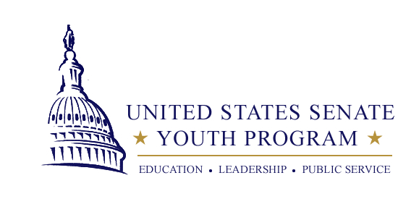

Maine’s United States Senate Youth Program
Nomination Form 2020-21

Note: High school principals may nominate one eligible student for consideration.

Required materials to be submitted as part of the application packet:

1. This form, completed by a school official.

2. A statement of recommendation for the student, not to exceed one typed page. The letter may be written by anyone the student chooses. The letter should describe the student’s leadership qualities, civic-mindedness and dedication to learning.

3. Completion of Maine’s USSYP Scholarship Application by the student. Guidelines can be found at: https://www.maine.gov/doe/learning/content/social/USSYP

4. Submit all required materials by email to Joe Schmidt at joe.schmidt@maine.gov no later than December 2, 2020.

Mailed applications will not be accepted this year. Incomplete application submissions will not be considered, and applicants will not be contacted to ask for missing materials.

The selection of finalists will be completed by February 5, 2021, and finalist names will be forwarded to the William Randolph Hearst Foundation for official announcement by mid-February.

Contact Information, please print:

Name of High School: _____________________________________

Principal:________________________________________________

Principal’s Email: _________________________________________
School Phone: ___________________________________________

Contact information for staff member coordinating USSYP, if different than above:
Name: _________________________________________________

Title: ___________________________________________________

Email: __________________________________________________

Applicant, please print:
Name of student applicant: _________________________________

Applicant’s email: ________________________________________

Applicant’s grade: ______ High school graduation year: ________

Leadership position(s) elected or appointed to for 2020-21:

_______________________________________________________

Signatures:
I certify that I am an eligible applicant and all the information in this application is correct and not plagiarized. I understand attendance during the Washington Week program is required to receive the financial scholarship.

_______________________________________________________
Applicant’s Signature Date

I certify that, to the best of my knowledge, all of the information in this application is correct and the student meets eligibility requirements.

_______________________________________________________
Principal’s Signature Date

