How to Take - A Maine Bright Track Course

- To start, click on a lesson to open it.
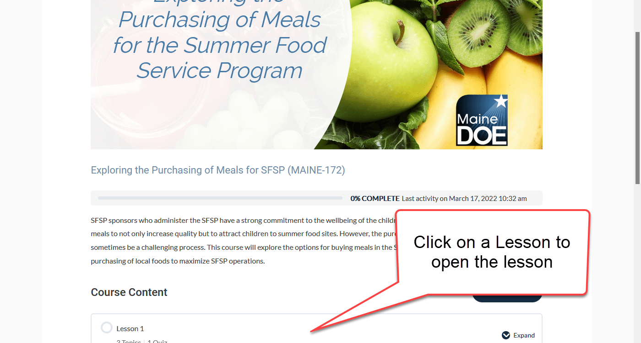

- From the lesson page, you can access each topic in the lesson. Click on a topic to open it.
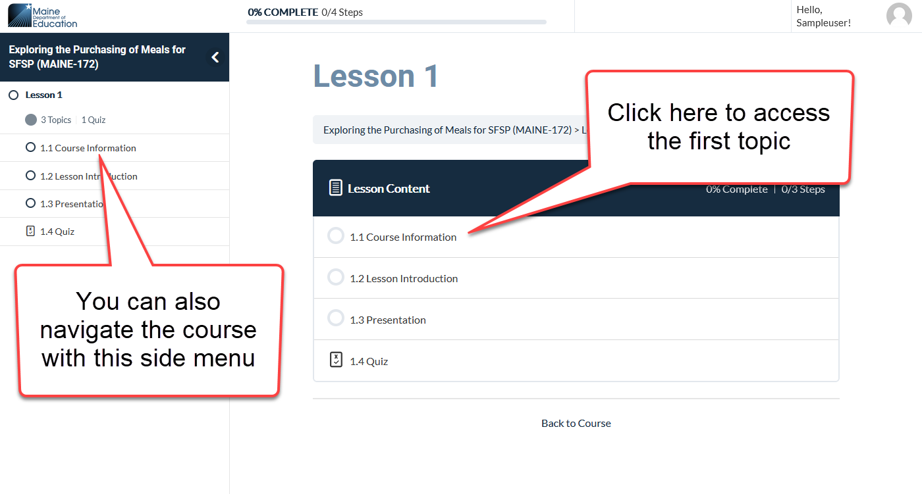

The side menu will allow you to quickly navigate to any lesson, topic, or quiz in the course.

- As you go through each topic, you will need to click on the “Mark Complete” button to track your progress.
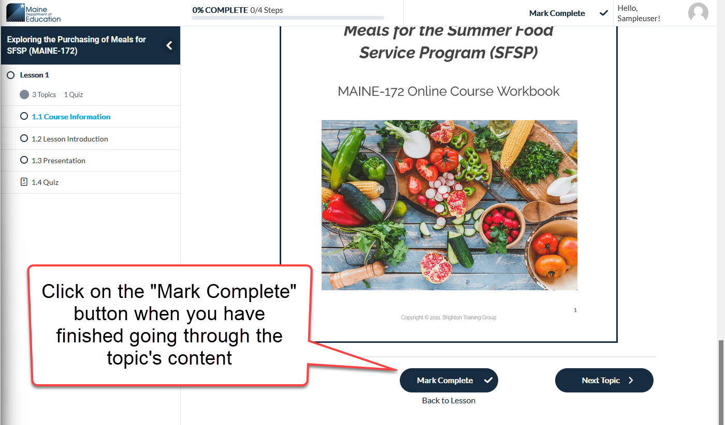

- For presentation topics, click on the image or link to start the presentation.
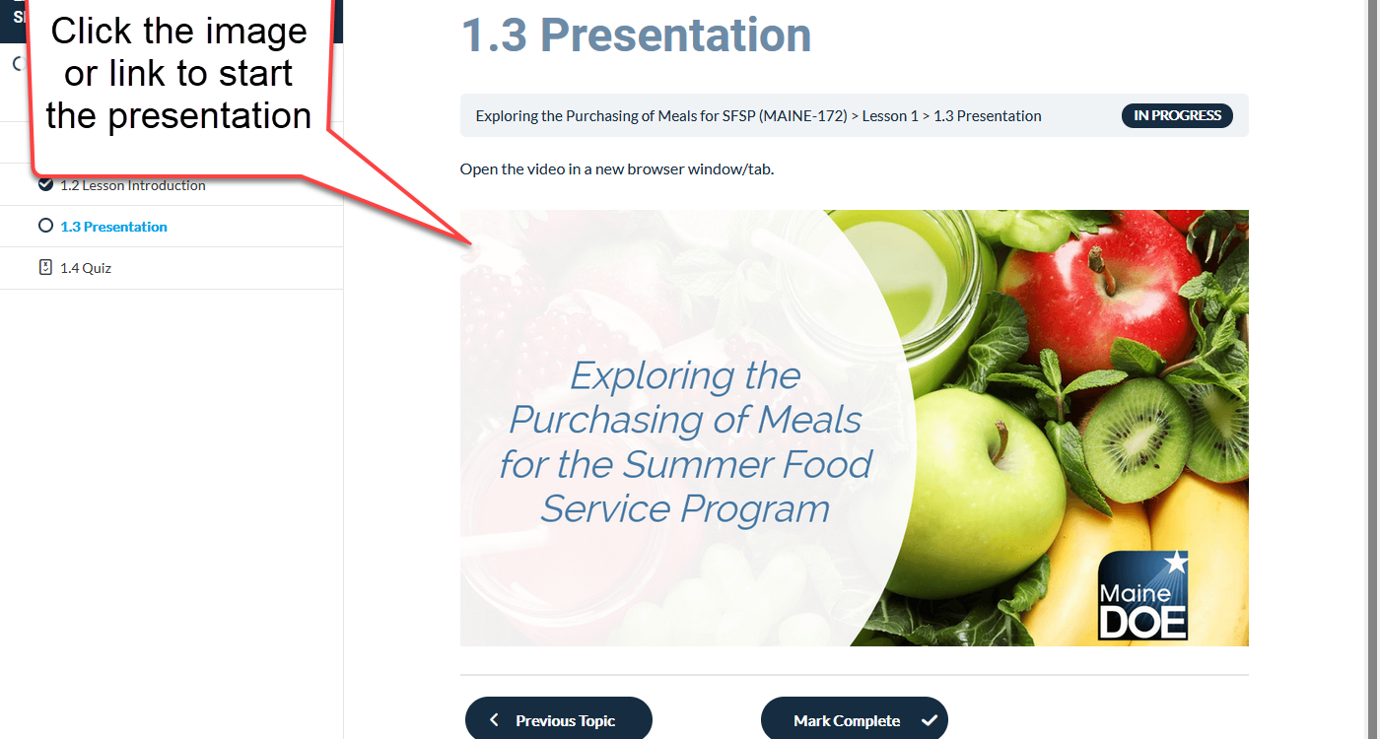

- At the end of each lesson there will be a quiz. Each quiz will require a grade of 80% or higher in order to pass. You can access the quiz by clicking on it in the lesson menu or the side navigation menu.
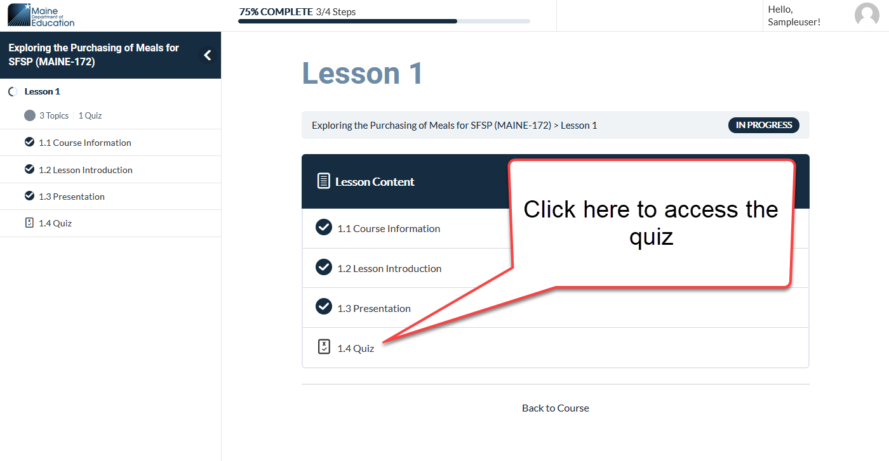

- Once you have completed all of the course’s content and passed each quiz, you will be able to access your certificate from the main page of the course.
