TITLE IA PRIVATE SCHOOL Q & A SHEET
Private School Non-Regulatory Guidance:
https://www2.ed.gov/about/inits/ed/non-public-education/files/equitable-services-guidance-100419.pdf
- What are the FREE/REDUCED lunch income guidelines?
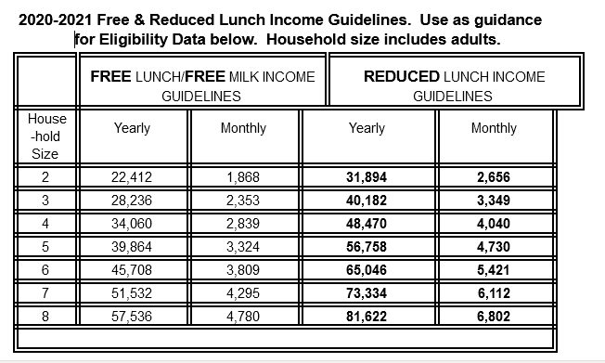
2. Who determines the amount of funding for the private schools?
The state sends a survey to private schools to identify the number of low-income students with their residential addresses and the schools they would attend based on their residence. The state uses this information to determine the minimum equitable service level for each private school. A new requirement states that the equitable service level must be based on the total amount of Title I funds received by an Local Educational Agency (LEA). Previously, the amounts were based on a school’s per pupil amount.

3. What are the regulatory requirements for LEA consultation with private schools?

Under §200.63 of the Title I regulations consultation must, at a minimum, address the following issues:
- How the LEA will identify the needs of eligible private school children.
- What services the LEA will offer to eligible private school children.
- How and when the LEA will make decisions about the delivery of services.
- How, where, and by whom the services will be provided to eligible private school children.
- How the LEA will assess academically the services to private school children, and how the LEA will use the results of that assessment to improve Title I services.
- The size and scope of the equitable services that the LEA will provide to eligible private school children, the proportion of its Title I funds that the LEA will allocate for these services, and how the proportion of funds is determined.
- The method or sources of data used to determine the number of children from low-income families in participating school attendance areas who attend private schools.
- The services the LEA will provide to teachers and families of participating private school children.
Consultation must also include – –
- Discussion whether the LEA will provide services directly or will use a separate government agency, consortium, entity, or third-party contractor,
- Thorough consideration and analysis of the views of the private school officials on whether the LEA should contract with a third-party provider. If the LEA disagrees with the views of the private school officials on that issue, the LEA must provide in writing to those officials the reasons why the LEA has chosen not to use a third-party contractor.
- Information on when, including the approximate time of day, services will be provided; and
- Whether to pool private school resources or not;
- Whether to consolidate and use other equitable service funds under applicable programs to support Title I students.

The agreed upon outcomes of these items should be in writing as part of a formal agreement between the public and non-public entities.

4. What types of services are available for private school students?
Services for participating private school children include, but are not limited to, the following: Instructional services; extended day services; family literacy programming; counseling programs; computer aided instruction; home tutoring; instruction using take-home computers. All services must be provided by public school employee(s) or third party contractor(s) who are hired and directed by the public school.

5. Who hires staff to provide Title IA services at a private school?

The LEA hires and pays the staff person and directs the activities of the person based on the agreement developed in consultation with the private school.

6. Who can provide Title IA services at a private school?

Certified LEA teachers, Ed Techs who are under the direct supervision of an LEA teacher while both are at the private school, OR a third party contractor that is under the direction and supervision of the LEA.

7. Which private school students are eligible for Title IA services?

To be eligible for Title IA services a private school student must meet the educational selection criteria agreed upon in consultation with the private school AND would attend a Title IA school based on the student’s residence.

8. Can Title IA services be delivered at the private school in the general educational classroom?

No, Title IA instructional services must not be provided in the general educational classroom nor to a non-identified Title IA student. The funds are for use with identified and eligible Title IA students only. The regulations prohibit the use of Title I funds for the needs of the private school or the general needs of the children in the private school.

9. Do private school officials have the right to complain?

If the LEA disagrees with the views of the private school officials with respect to the consultation topics, the LEA is required to provide in writing to the private school officials why the LEA disagrees.
In addition, private school officials have the right to complain to the SEA if they believe that an LEA did not engage in timely and meaningful consultation, did not consider their views, or did not make a decision that treats the private school students equitably. The SEA complaint procedure is located at https://www.maine.gov/doe/sites/maine.gov.doe/files/inline-files/Private%20School%20Complaint%20Process%202018.doc

10. How is fiscal control maintained?

The control of funds used to provide services for private school students and title to materials, equipment, and property purchased with those funds, shall be with the LEA and are available on loan at the private school for the duration of the project. Reimbursement to the private school for expenses incurred by the private school is not allowed. The LEA is fiscally responsible for payment to vendors and staff.

Sharepoint:FY22/Private School/Title IA Q-A w-Sample Survey

(SAMPLE SCHOOL SURVEY TO PARENTS)
PRIVATE SCHOOL PARENT/GUARDIAN TITLE IA SURVEY

Dear Parents/Guardians:

This survey will provide information needed by the State Department of Education to determine the amount of instructional funds available for Title IA supplemental educational services for children in this private school. If you have any questions, please call ___________________________________ at ________________. The due date to return this survey to your school administrator is March/April ___, 2021. Thank you for your cooperation.

Sincerely,

2020-2021 Free & Reduced Lunch Income Guidelines. Use as guidance
for Eligibility Data below. Household size includes adults.
 | FREE LUNCH/FREE MILK INCOME GUIDELINES |  |  | REDUCED LUNCH INCOME GUIDELINES
House-hold  Size | Yearly | Monthly | Yearly |  | Monthly
2 | 22,412 | 1,868 | 31,894 |  | 2,656
3 | 28,236 | 2,353 | 40,182 |  | 3,349
4 | 34,060 | 2,839 | 48,470 |  | 4,040
5 | 39,864 | 3,324 | 56,758 |  | 4,730
6 | 45,708 | 3,809 | 65,046 |  | 5,421
7 | 51,532 | 4,295 | 73,334 |  | 6,112
8 | 57,536 | 4,780 | 81,622 |  | 6,802

Example of Eligibility Criteria for 5(b):
If a family of 4 earns $40,555 yearly AND receives tuition assistance to attend the private school, this family WOULD MEET eligibility criteria #5(b) since the yearly family income is less than $48,470. The family would not meet eligibility criteria #5(a) because the yearly income is more than $34,060.
Student Address | CurrentGrade | Check All Eligibility Data Criteria Met | Name of District & School Child Would Attend If Not Enrolled in Private School
Child #1  Street _______________________  City _______________________  Zip _______________________ |  | ___(1) Meets Free Lunch Income  ___(2) Meets Reduced Lunch Income  ___(3) Receives Food Stamps  ___(4) Receives Medicare  ___(5a) Receives Tuition Assistance based upon Free Lunch Income Above  ___(5b) Receives Tuition Assistance based upon Reduced Lunch Income Above | District:________________________  School:________________________
Child #2  Street _______________________  City _______________________  Zip _______________________ |  | ___(1) Meets Free Lunch Income  ___(2) Meets Reduced Lunch Income  ___(3) Receives Food Stamps  ___(4) Receives Medicare  ___(5a) Receives Tuition Assistance based upon Free Lunch Income Above  ___(5b) Receives Tuition Assistance based upon Reduced Lunch Income Above | District:________________________  School:________________________
Child #3  Street _______________________  City _______________________  Zip _______________________ |  | ___(1) Meets Free Lunch Income  ___(2) Meets Reduced Lunch Income  ___(3) Receives Food Stamps  ___(4) Receives Medicare  ___(5a) Receives Tuition Assistance based upon Free Lunch Income Above  ___(5b) Receives Tuition Assistance based upon Reduced Lunch Income Above | District:________________________  School:________________________

Use back side for additional children. Return this form to your school administrator by March/April____, 2021

