Think Tank Artifacts Augusta
Maine Defines School Success: A Statewide Conversation led by the Maine Department of Education
Goals of Maine Defines School Success
- Identify authentic, relevant indicators of a successful school—locally and statewide
- Qualify the indicators to give them value and meaning
- Design and implement a framework for the indicators as representing the success of schools

Think Tank session debrief: Each Maine Defines School Success think tank session was attended by a group of educators whose expertise and contributions have helped tremendously in charting the way toward achieving the goals statewide. In an adaptation of the Human Centered Design approach to solutions, participants were invited to

- Explore the current challenges through analogy and discussion;
- Provide feedback on a solution prototype;
- Identify the characteristics that makes schools successful through stories and conversation; and
- Offer suggestions and insights as to how we can involve every school community in identifying the indicators of successful schools
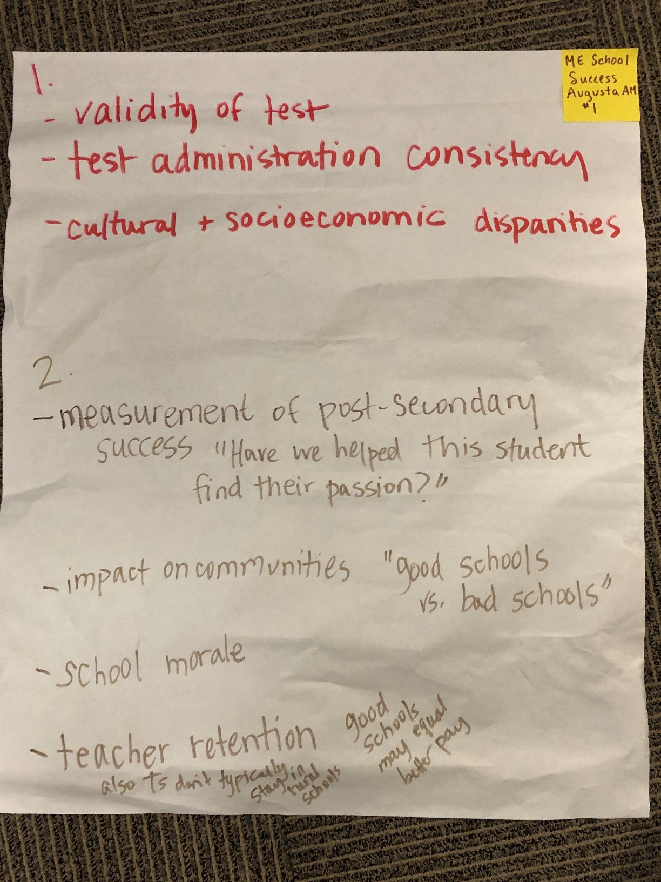
Sheet #1
- Implication of Assumptions
  - Validity of test
  - Test administration consistency
  - Cultural and socioeconomic disparities
- Consequences of Assumptions
  - Measurement of post-secondary success--we must ask “have we helped this student find their passion?”
  - Impact on communities--“good schools vs. bad schools”
  - School morale
  - Teacher retention--good schools may equal better pay and teachers don’t typically stay in rural schools

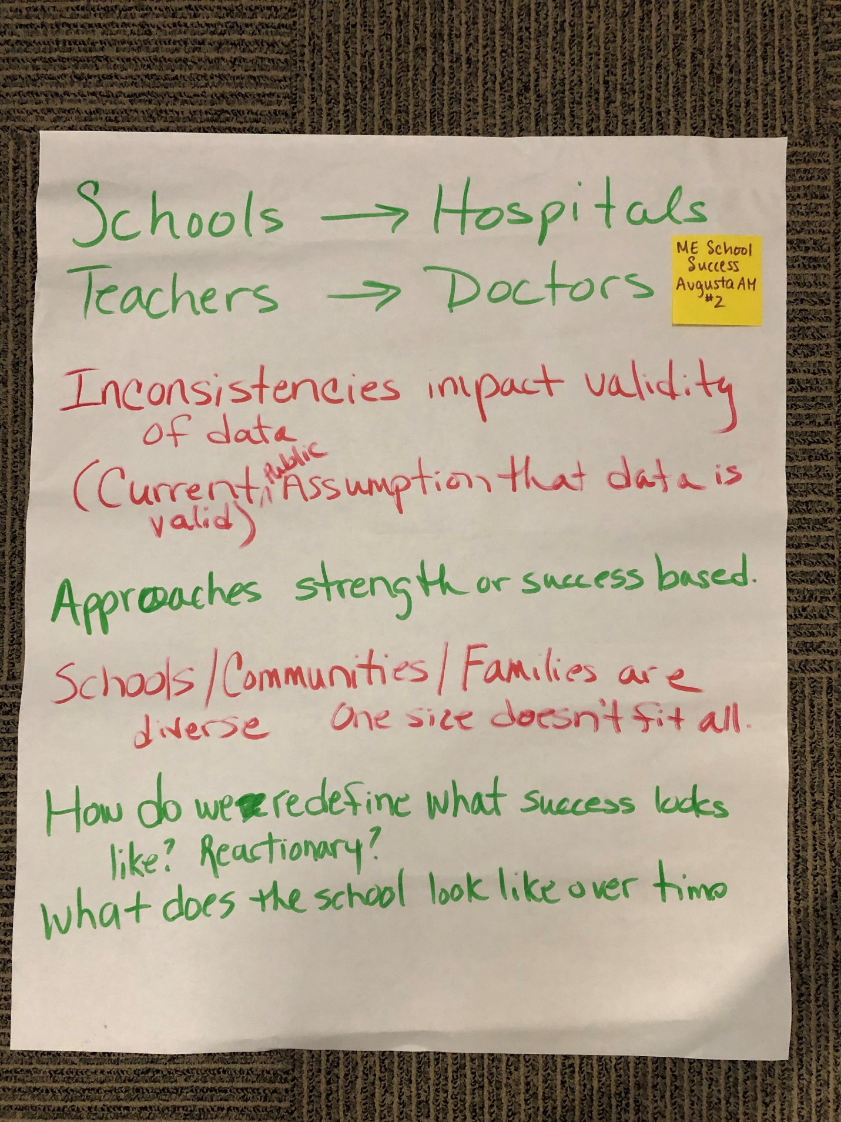Sheet #2
- Analogies
  - Schools = Hospitals
  - Teachers = Doctors
- Inconsistencies impact validity of data--(current public assumption that data is valid)
- Approaches strength or success based
- Schools/communities/families are diverse--one size doesn’t fit all
- How do we redefine what success looks like? Is it reactionary?
- What does the school look like over time?
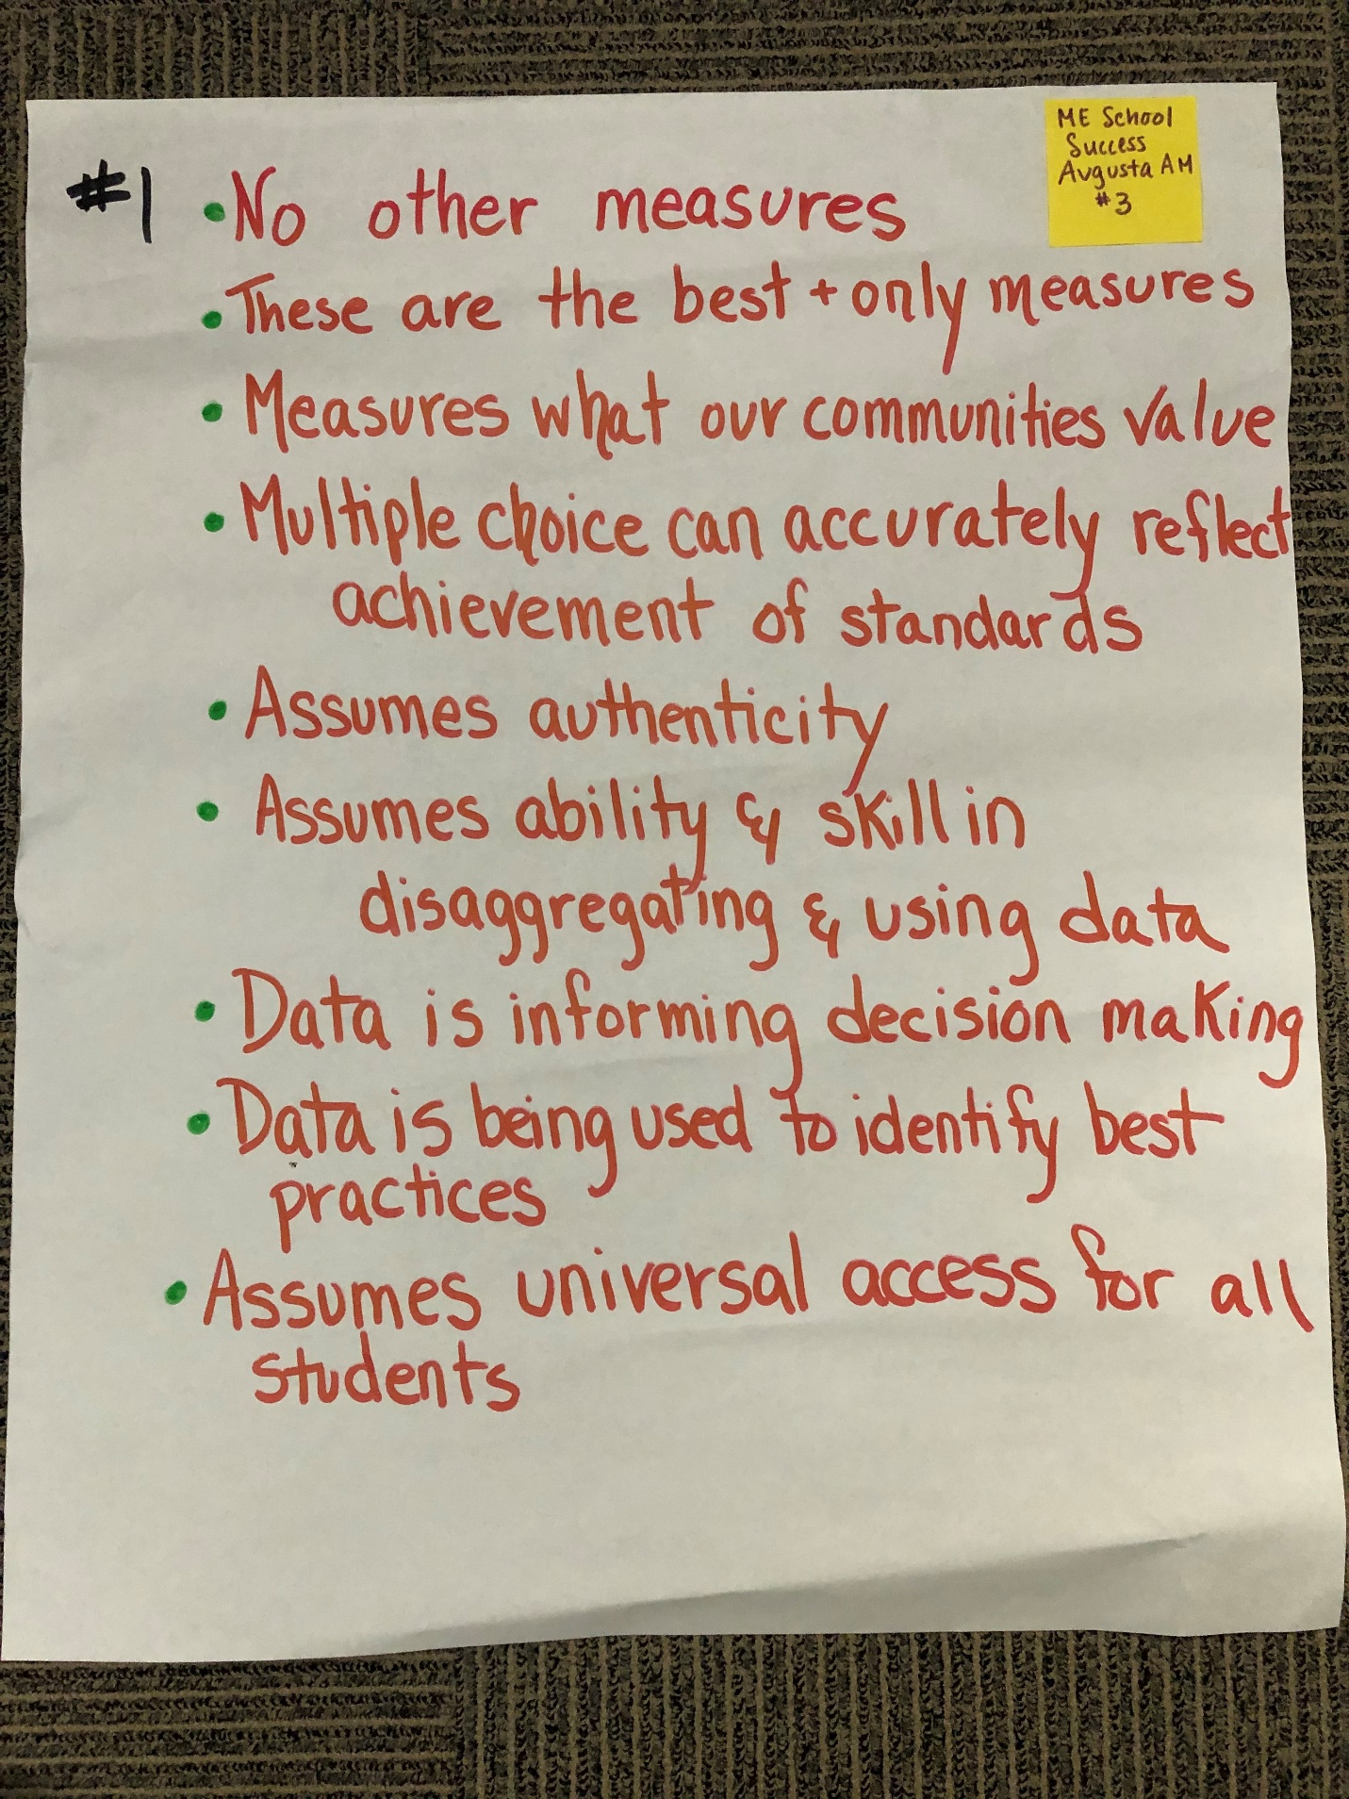Sheet #3
- Implication of Assumptions
  - No other measures
  - These are the best and only measures
  - Measures what our communities value
  - Multiple choice can accurately reflect achievement of standards
  - Assumes authenticity
  - Assumes ability and skill in disaggregating and using data
  - Data is informing decision making
  - Data is being used to identify best practices
  - Assumes universal access for all students
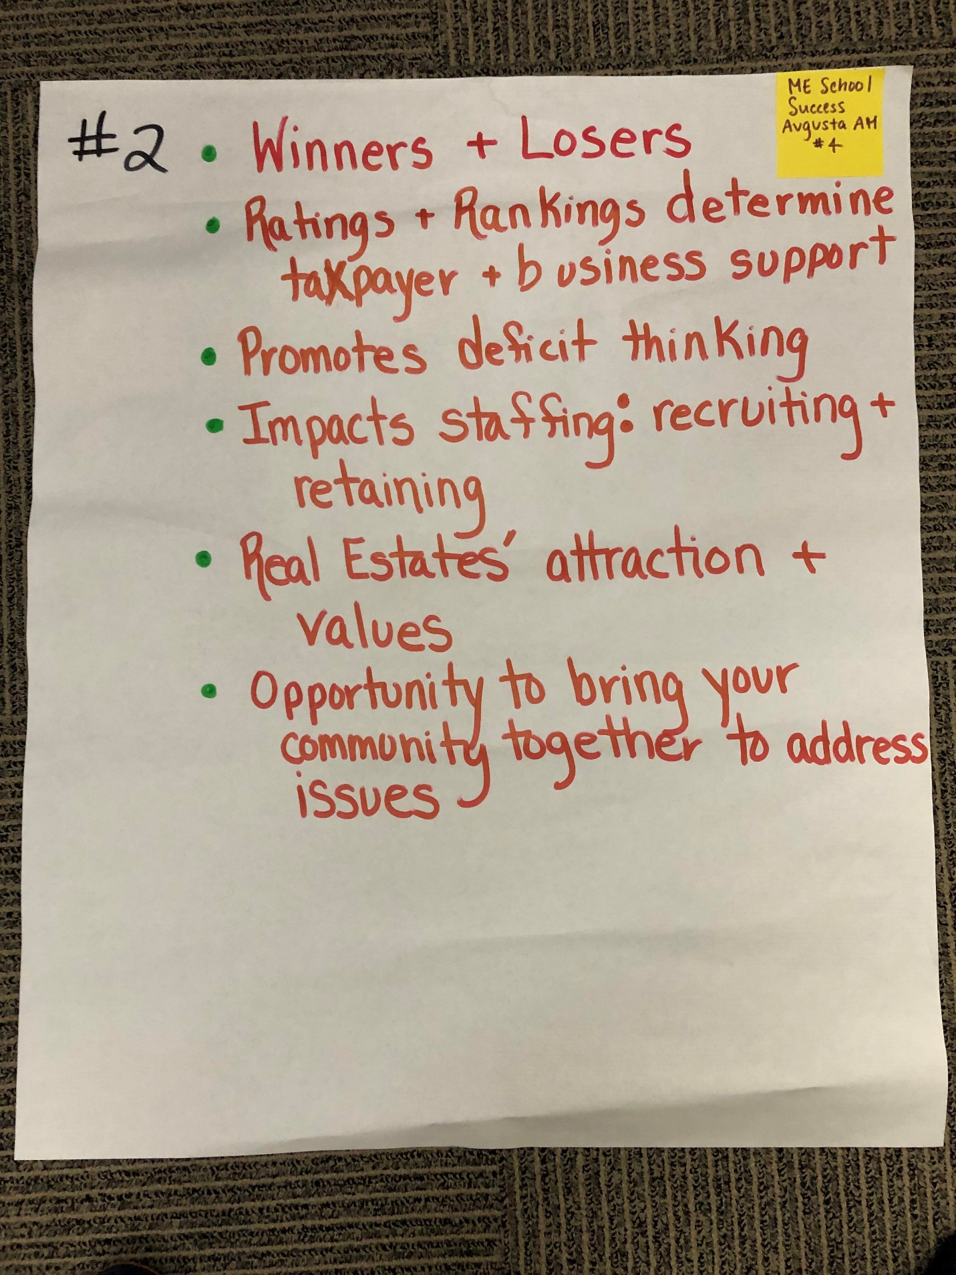Sheet #4
- Consequences of Assumptions
  - Winners and losers
  - Ratings and rankings determine taxpayer and business support
  - Promotes deficit thinking
  - Impacts staffing: recruiting and retaining
  - Real estates’ attraction and values
  - Opportunity to bring your community together to address issues
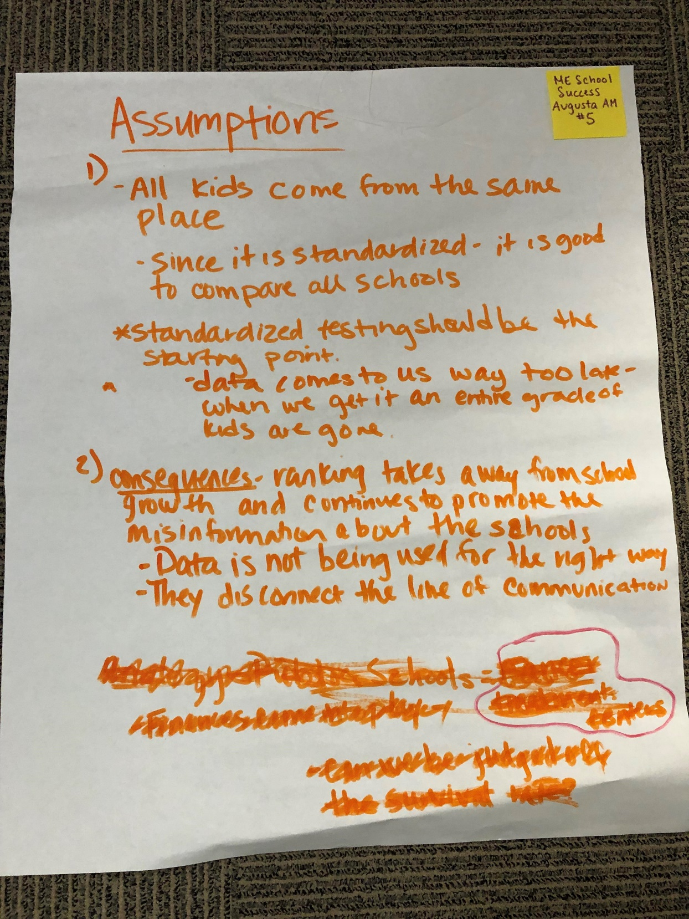
Sheet #5
- Implication of Assumptions
  - All kids come from the same place
  - Since it is standardized—it is good to compare all schools
  - Standardized testing should be the starting point
    - Data comes to us way too late—when we get it an entire grade of kids are gone
- Consequences of Assumptions
  - Ranking takes away from school growth and continues to promote the misinformation about the schools
    - Data is not being used correctly
    - They disconnect the line of communication
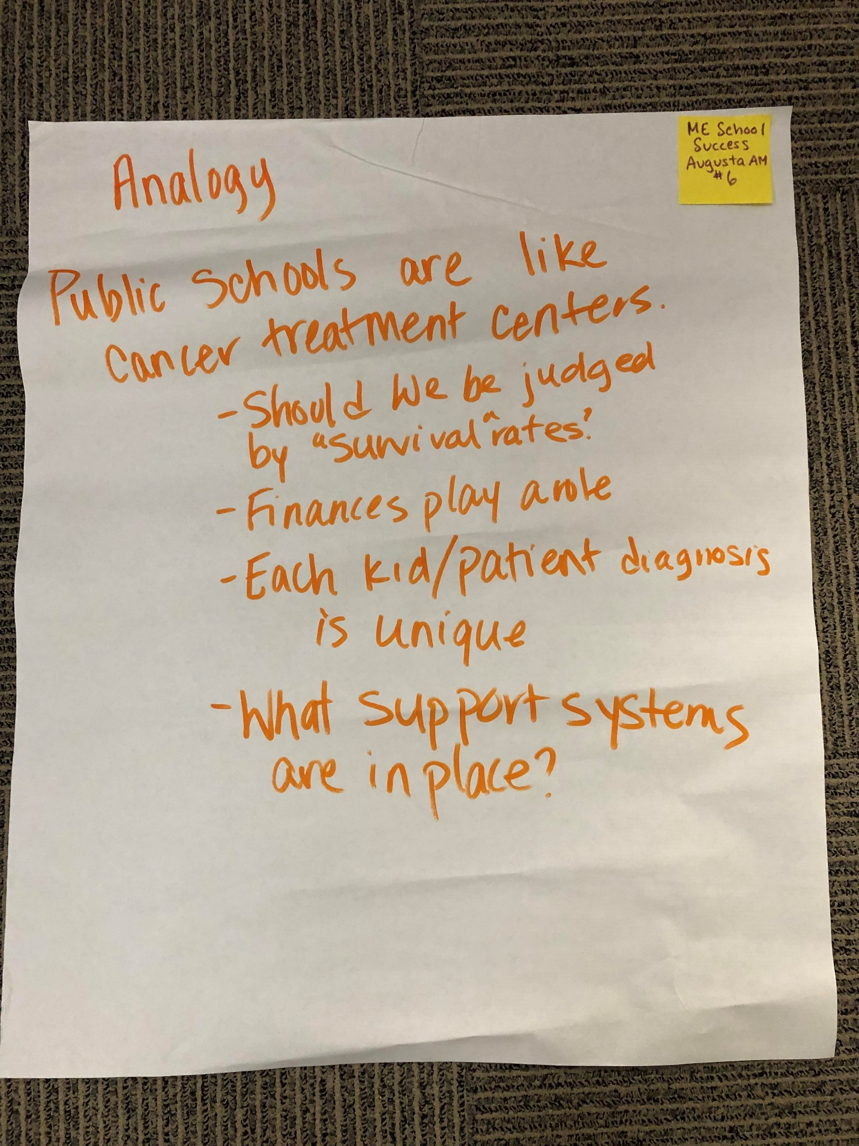Sheet #6
- Analogies
  - Public schools are like cancer treatment centers
    - Should we be judged by “survival rates”
    - Finances play a role
    - Each kid/patient diagnosis is unique
    - What support systems are in place?
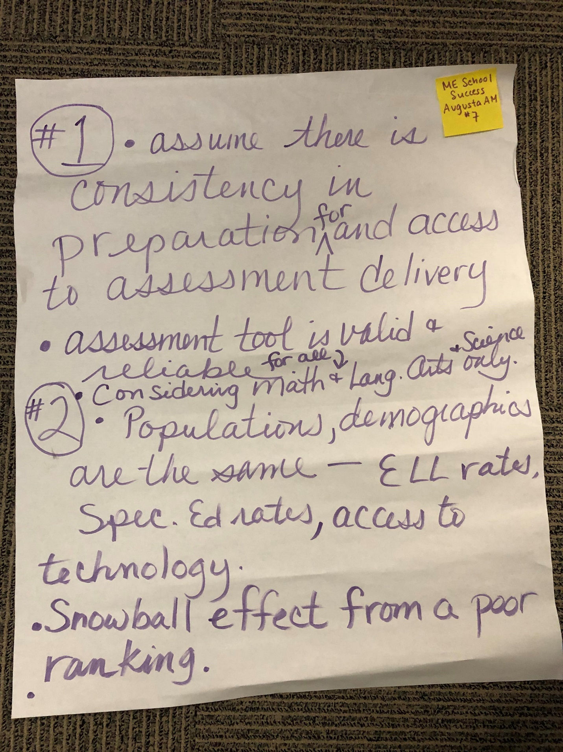Sheet #7
- Implication of Assumptions
  - Assume there is consistency in preparation for and access to assessment delivery
  - Assessment tool is valid and reliable for all
  - Considering math, language arts, and science only
- Consequences of Assumptions
  - Populations, demographics are the same—ELL rates, special education rates, access to technology
  - Snowball effect from a poor ranking
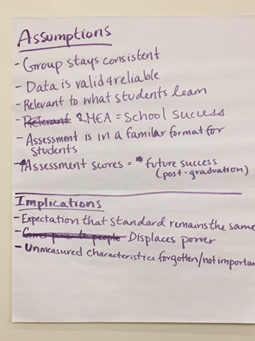
Sheet # 8
Assumptions:
- Group stays consistent
- Data is valid & reliable
- Relevant to what students learn
- MEA = school success
- Assessment is in a familiar format for students
- Assessment scores = future success (post-graduation)
Implications:
- Expectation that standard remains the same
- Displaces power
- Unmeasured characteristics forgotten/not important

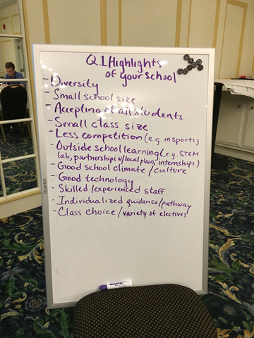
Sheet # 9
Highlights of your school
- Diversity
- Small school size
- Accepting of all students
- Small class size
- Less competition (e.g. in sports)
- Outside school learning (e.g. STEM lab, partnerships w/local places, internships)
- Good school climate/culture
- Good technology
- Skilled/experienced staff
- Individualized guidance/pathway
- Class choice/variety of electives

