Teaching Literacy in the Visible Learning Classroom
Grades 6-12
Learning Outcomes:
- Learn methods of targeting instruction to improve student learning that will support catch-up growth and close achievement gaps
- Understand and use Hattie’s impact formula to determine effectiveness of instruction
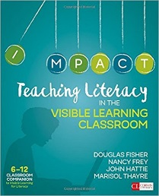
Visible Learning for Literacy is based on the work of Dr. John Hattie who analyzed data from thousands of studies to determine the strategies, actions, and influences that result in significant impact on student learning. Hattie’s work provides teachers an opportunity to focus on those aspects of literacy instruction that are critical for students’ success.
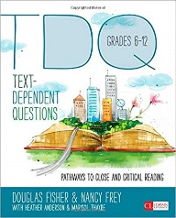
Morgan Dunton, secondary ELA specialist for Maine DOE, will facilitate continued support of Visible Learning through a series of sessions. In the first, participants will receive the 6-12 Classroom Companion for Teaching Literacy in the Visible Learning Classroom. Close reading and effective strategies during the session will provide immediate experiences and resources to impact the classroom.
In the second session, participants will receive Text-Dependent Questions: Pathways to Close and Critical Reading in grades 6-12. This text provides standards-based approaches to develop analytic reading and thinking. It pairs nicely with Visible Learning to provide specific, targeted strategies for high impact learning and improved outcomes.
Participants will provide input about planning a third session (late school year or summer) to complete the Visible Learning text with a focus on tracking student growth using Hattie’s method of determining impact.
Session 1: April 4 | Session 2: May 2
The registration for sessions 1 & 2 is $40
which includes both texts, lunch on both days, and handouts.
Both sessions are at Cross Office Building, 111 Sewall Street, Augusta
Room 600
Events begin at 8:30 and end at 3:00 | 6 Contact hours will be awarded for attendance at the end of each session.

