Summary NEO Instructions for Superintendents or Designees entering information on the Home Instruction Portal

Please also see the Home Instruction Statutes and Information, which provides more information and context.
*NEW IN 2023-2024. Superintendent offices and charter schools now have access to the statewide listing screen, and editing is now available to resident units for [only] records in their own unit. This document contains updated instructions for the editing functionality. For instructions on editing, please see #s 7a-7c below.
- In the Student Data section of NEO, click on Home Instruction. You must be logged in with appropriate credentials in order to check the Home Instruction Students Listing or to enter a new form on behalf of a parent.
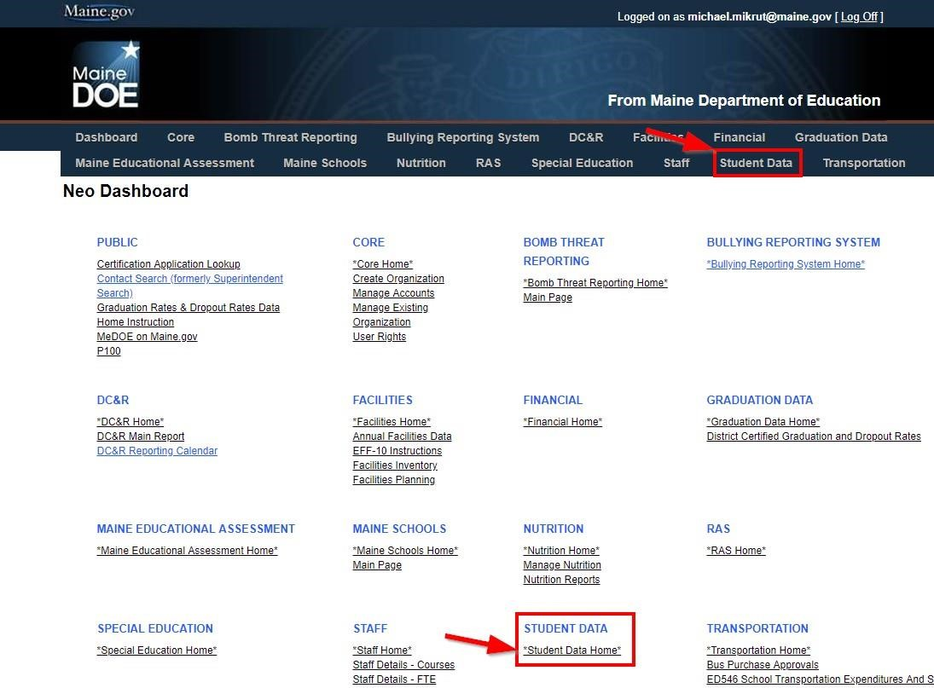
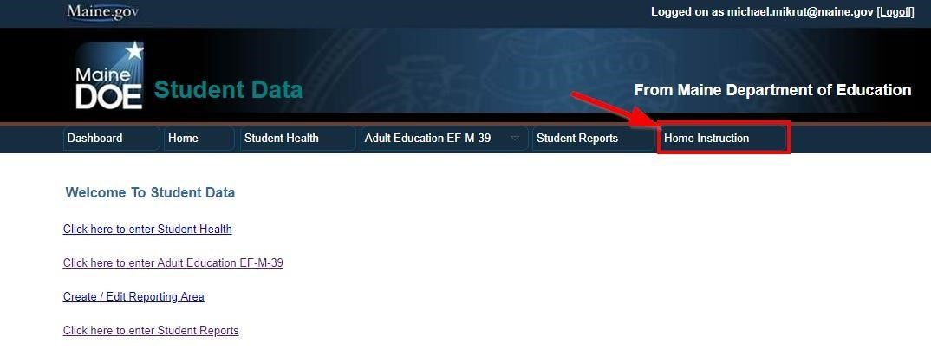
- For each paper form or letter submitted, check to ensure that all required information has been included. If all information has not been included, please notify the parent by mail, phone or email. After appropriate follow-up, if there is no response the paper forms should be returned to the sender with a note; or you may choose to submit the portion that you can, and file the paperwork in a pending file.

2a. Important! Check the NEO Home Instruction Students Listing prior to entry in order to ensure that the entry is not a duplicate. There may be only one annual Notice for each student, regardless of movement in/out of a public school or to another unit. It is important to distinguish duplicates from prior year records, which may look like duplicates. To perform a duplicate check, you may choose to filter the Listing by school year from the top of the screen, or you may wish to view multiple years by search term.
*Please note: as of April 1, 2023 school administrative units and charter schools have view only access to the list of home instruction students outside their own SAU, and edit functionality for those within their own SAU. If a home instruction family moves to another SAU during the school year, the initial SAU of residence may update to the new address, whereupon the action will transfer edit rights to the new SAU of residence. Direct communication is encouraged between two SAUs/superintendent offices for any questions or changes that involve both.
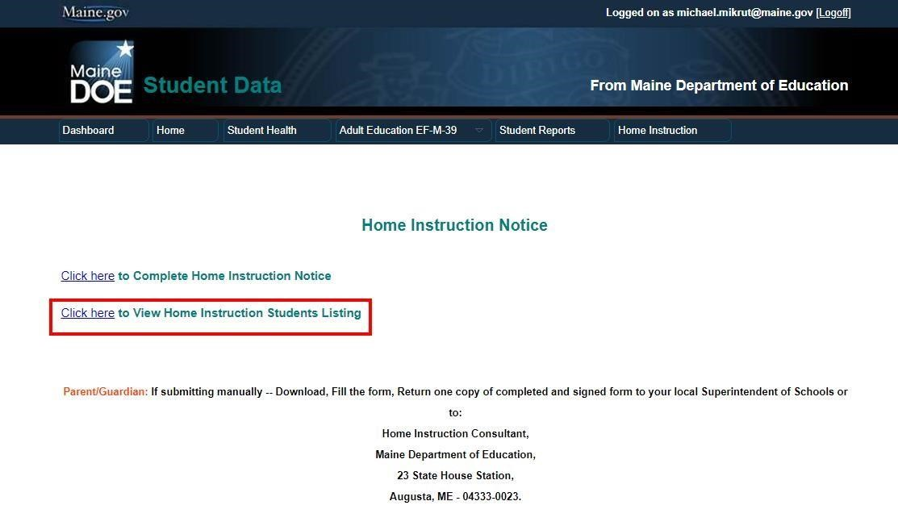

2b. CREATE NEW BUTTON. SAUs are encouraged to search the previous year for a record, and use that to start a new record using the CREATE NEW button. When you navigate to View Home Instruction Students Listing you can choose to create a new form for the next school year directly from this list without going back to the main home instruction page. Any student that has a record from the year immediately preceding the year of entry will have an active CREATE NEW button that can be used to start a form for the next year for the same student, with most of the information from the previous year pre-populated, making entry much quicker. Current paper notices and assessments will still need to be pre-scanned and uploaded, as the uploaded forms will remain with the year submitted.

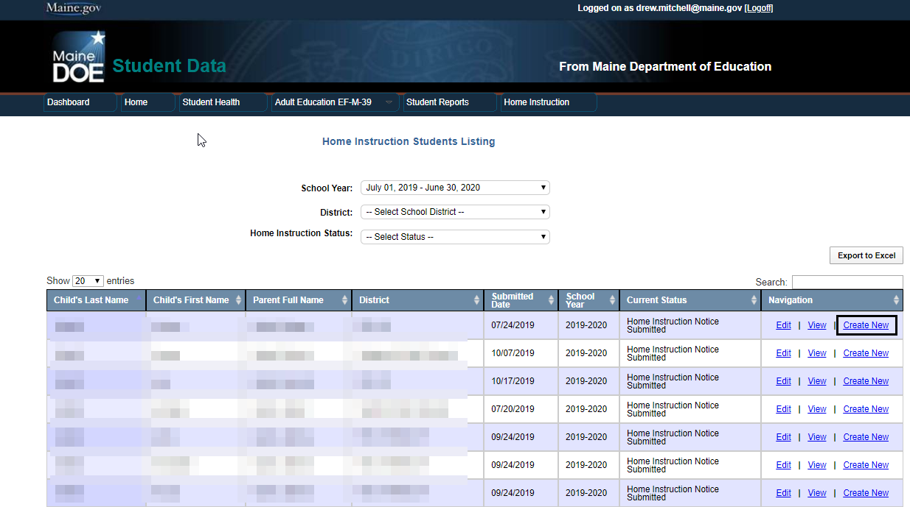

- Prepare your information: prior to entering new forms please ensure that electronic copies of the Notice and any prior year required assessments are available for the upload process in pdf, word, or jpg format. Superintendents/SAU Points of Contact entering the information on behalf of the parent must have an electronic scan of the paper Notice of Intent to Provide Home Instruction form which has been appropriately completed and signed by the parent/guardian.
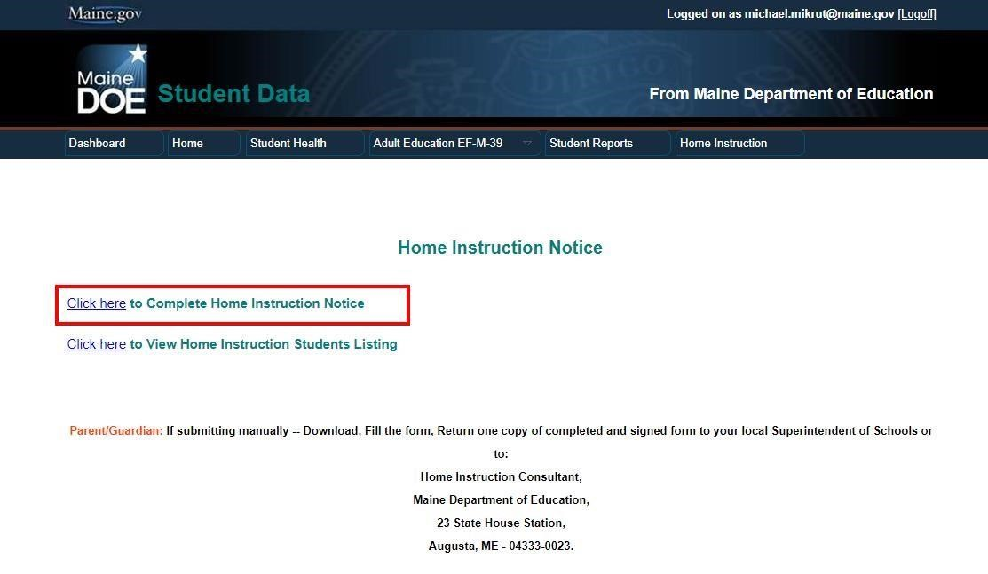

- Complete the parent/guardian information and then add each child’s information as appropriate. Upload required prior year assessments for each subsequent year student.
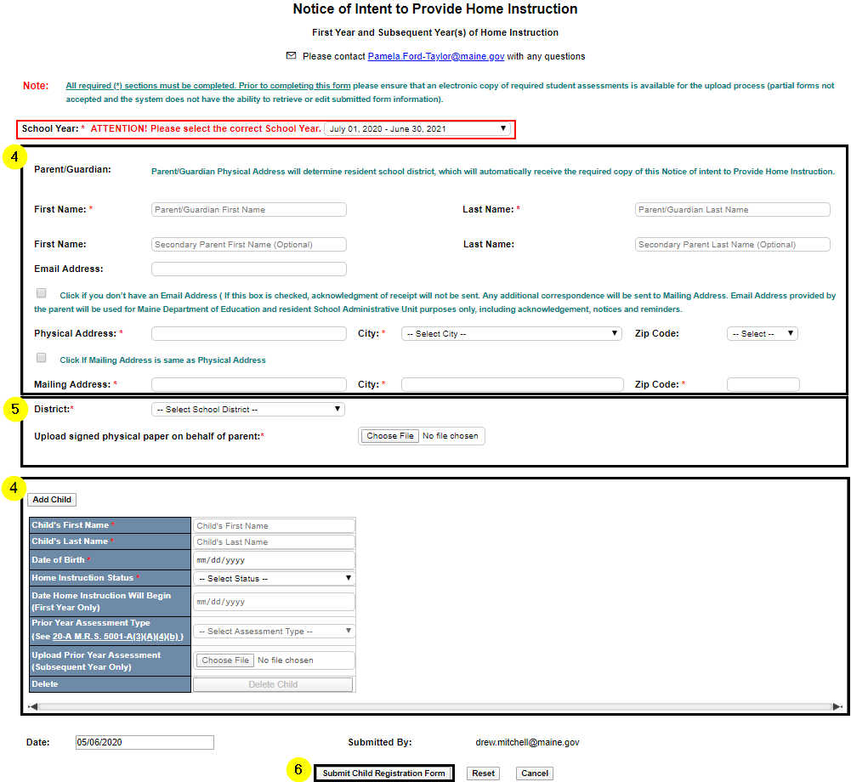
- Upload the signed and scanned Notice of Intent to Provide Home Instruction form. There is a limit of 3 document uploads in the parent section and 5 document uploads per child in the child section.
- Submit the form. An acknowledgement will be sent to parents who have provided a valid email address, and notification/acknowledgement will be sent to the Superintendent.
- As of April 1, 2023, school administrative units now have access to the “edit” and “delete” functions of the NEO home instruction module. Please see below for instructions for the new functionality.

7a. To edit a student or family record, first follow the search instructions as outlined in #2b, selecting the correct year, and the school administrative unit to which you have authorized access. Be sure to have a scanned email or other authorized documentation scanned and ready to upload, as the protocol requires an upload as backup for any changes/edits made to a record. Once you find the correct record, click the edit button. Make the edits required, ensuring that the Source/Note field in the child record is populated if appropriate (e.g. with old address and date moved, for example), upload the supporting documentation to parent and/or child section, and click the “Update Child Registration Form.” The form will immediately update with no warning message, so it is recommended to double-check before the Update button is pushed.

7b. To delete a single child that is part of a family record that contains other children, enter the record with the edit function as described in #7a. Under the child that needs to be deleted, find the “Delete Child” button. Attach supporting documentation to the parent section, , and click the “Update Child Registration Form.” The form will immediately update with no warning message, so it is recommended to double-check before the Update button is pushed.

7c. To delete a family record that contains one or more children, enter the record with the edit function as described in #7a. Click the “Delete Child Registration Form” button at the bottom. There will be a warning message prior to final deletion. Keep any authorization records of this change in the paper files according to the retention schedules of your specific school administrative unit.

7d. Transitioning to current functionality. The State will continue to receive update requests from parents via the xxxxxxx link on the webpage for the 2023-2024, as SAUs develop their own functionality for collecting information regarding graduation, relocation, etc. Future messaging will refer such changes to the SAU, where contacts are encouraged to manage the edits, ensuring that proper backup is uploaded as per the instructions.

For questions about Home Instruction please contact Pamela Ford-Taylor, School Enrollment Consultant at 207-624-6617 or email SchoolQuestions.DOE@maine.gov
For NEO questions or technical issues, contact the MEDMS Help Desk at 207-624-6896 or email the helpdesk at MEDMS.Helpdesk@maine.gov

