Summary NEO Instructions for Superintendents or Designees entering information on the Home Instruction Portal

Please also see the Home Instruction Statutes and Information, which provides more information and context.
- In the Student Data section of NEO, click on Home Instruction. You must be logged in with appropriate credentials in order to check the Home Instruction Students Listing or to enter a new form on behalf of a parent.
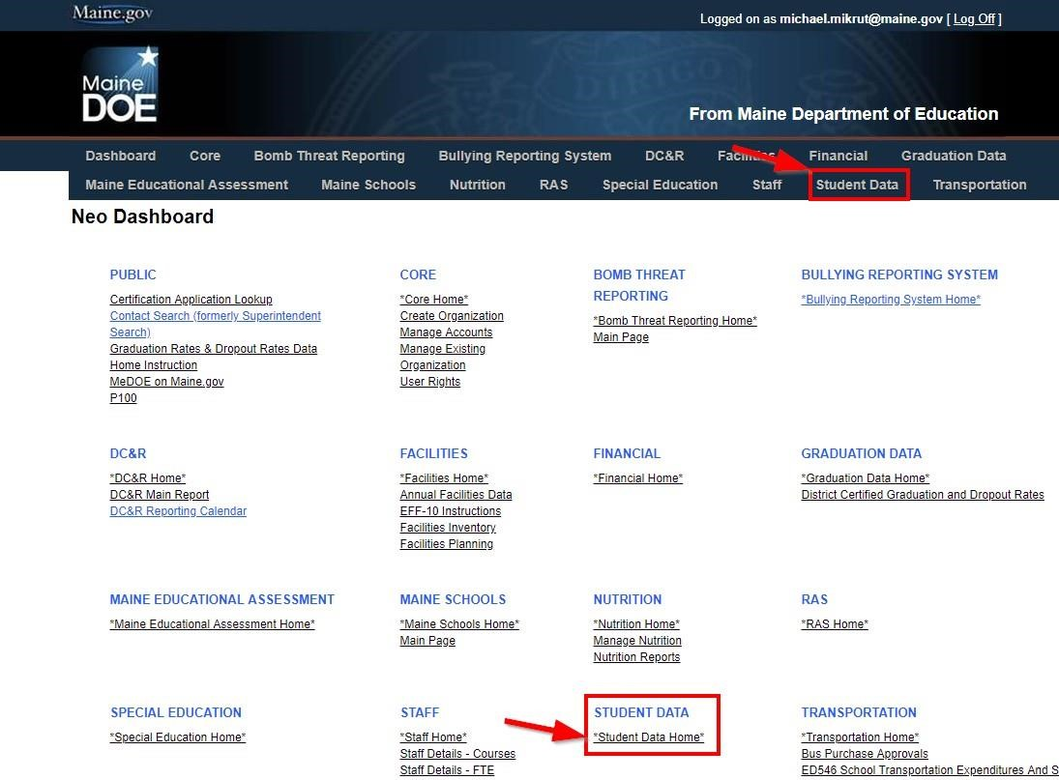
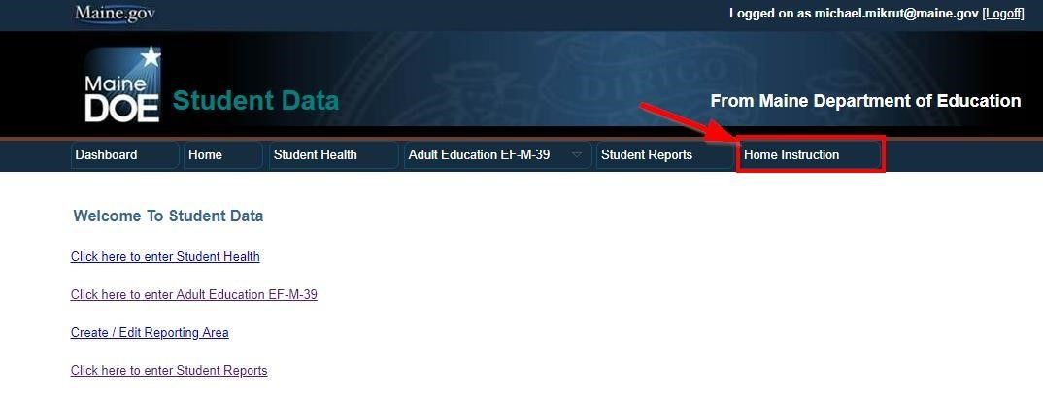
- For each form or letter submitted, check to ensure that all required information has been included. If all information has not been included, please notify the parent by mail, phone or email that their Notice is missing. After appropriate follow-up, if there is no response the paper forms should be returned to the sender.

2a. Important! Check the NEO Home Instruction Students Listing prior to entry in order to ensure that the entry is not a duplicate. It is important to distinguish duplicates from prior year records, which may look like duplicates. You may choose to filter the Listing by school year from the top of the screen, or you may wish to view multiple years by search term.
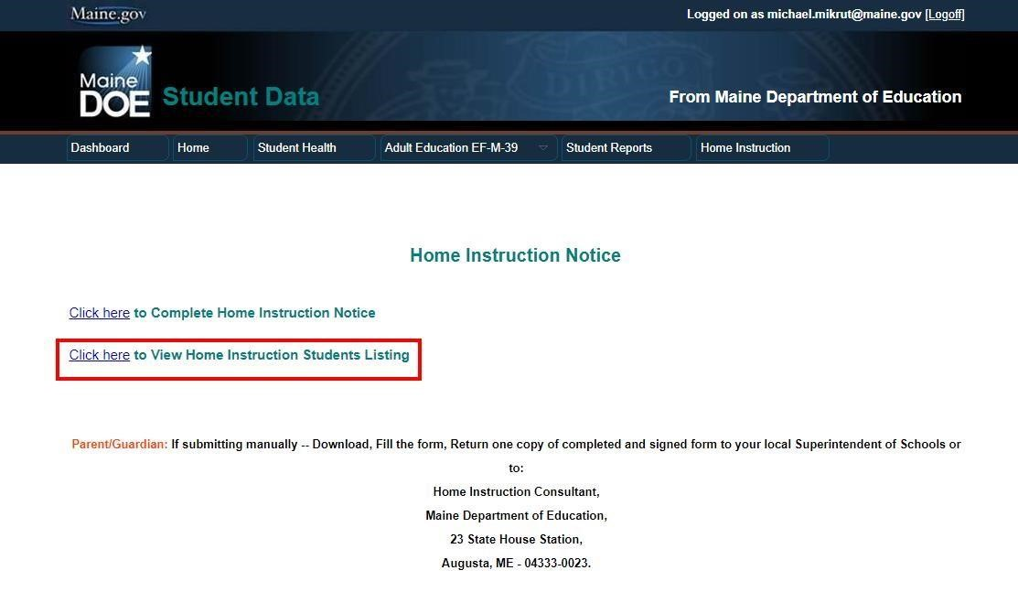

2b. CREATE NEW BUTTON. SAUs are encouraged to search the previous year for a record, and use that to start a new record using the CREATE NEW button. When you navigate to View Home Instruction Students Listing you can choose to create a new form for the next school year directly from this list without going back to the main home instruction page. Any student that has a previous year record will have an active CREATE NEW button that can be used to start a form for the next year for the same student, with most of the information from the previous year pre-populated, making entry much quicker. Current paper notices and assessments will still need to be pre-scanned and uploaded, as the uploaded forms will remain with the year submitted.

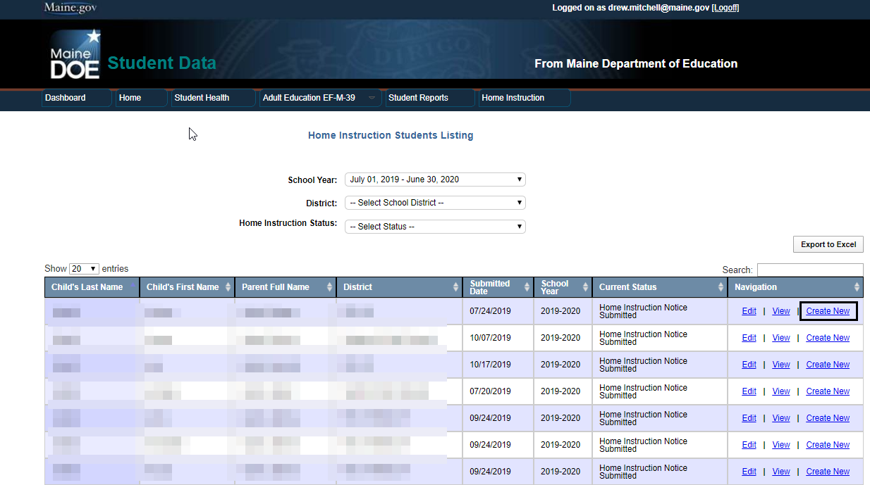

- Prepare your information: prior to entering new forms please ensure that electronic copies of the Notice and any prior year required assessments are available for the upload process in pdf, word, or jpg format. Superintendents/SAU Points of Contact entering the information on behalf of the parent must have an electronic scan of the paper Notice of Intent to Provide Home Instruction form which has been appropriately completed and signed by the parent/guardian.
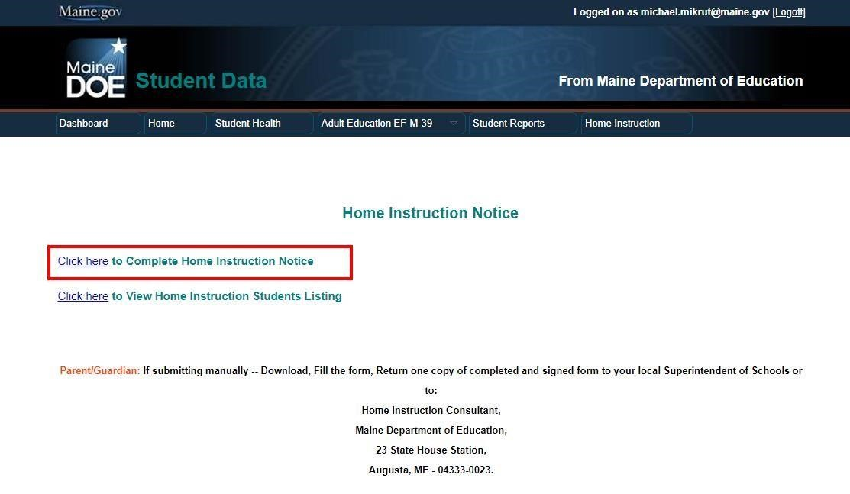

- Complete the parent/guardian information and then add each child’s information as appropriate. Upload required prior year assessments for each subsequent year student.
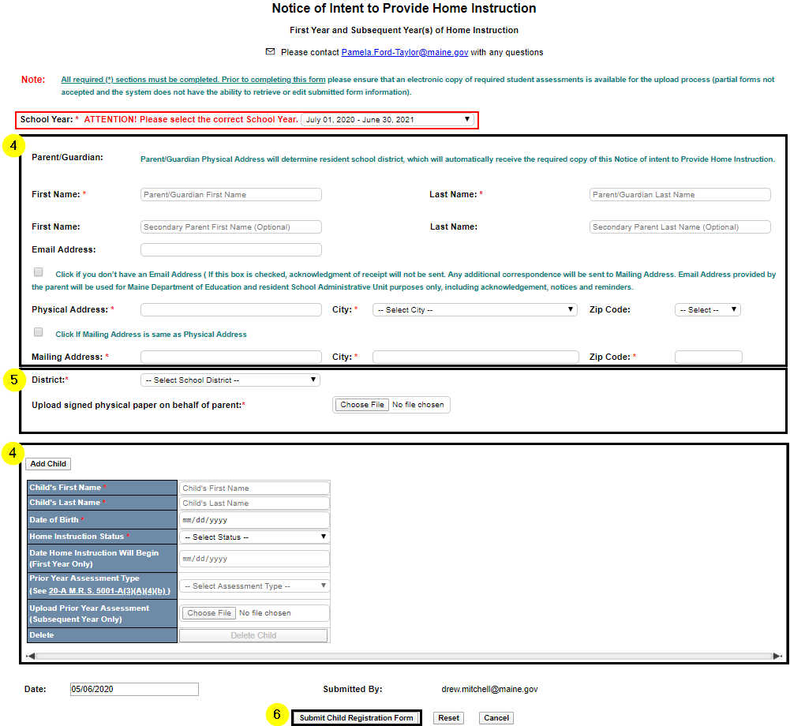
- Upload the signed and scanned Notice of Intent to Provide Home Instruction form.
- Submit the form. An acknowledgement will be sent to parents who have provided a valid email address, and notification/acknowledgement will be sent to the Superintendent.

For questions about Home Instruction please contact Pamela Ford-Taylor, School Enrollment Consultant at 207-624-6617 or email SchoolQuestions.DOE@maine.gov
For NEO questions or technical issues, contact the MEDMS Help Desk at 207-624-6896 or email the helpdesk at MEDMS.Helpdesk@maine.gov

