Characteristics of Effective IEP Meetings Saco AM

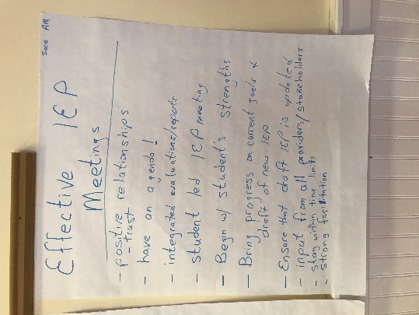
- Positive relationships/trust
- Have an agenda
- Integrated evaluations/reports
- Student let IEP meeting
- Begin with student’s strengths
- Bring progress on current goals & a draft of new IEP
- Ensure that draft IEP is updated
- Input from all providers/stakeholders
- Stay within time limits
- Strong facilitation

Saco PM

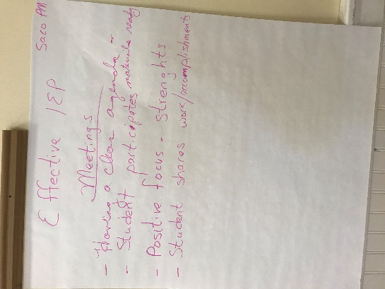
- Having a clear agenda and materials ready
- Student participates
- Positive focus – strengths
- Student shares work/accomplishments

Most Challenging Aspect of IEP Process
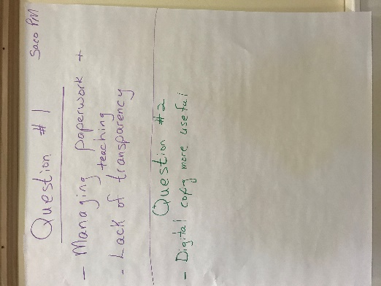
Saco PM
- Managing paperwork & teaching
- Lack of transparency

Are MUSER user friendly? Why or why not?

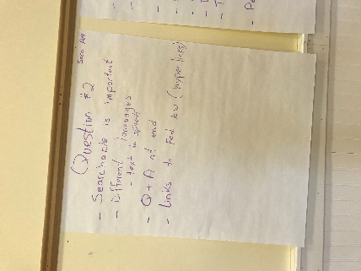
Saco AM
- Searchable is important
- Different languages – speech to text
- Q & A at end
- Links to fed law (hyperlinks)

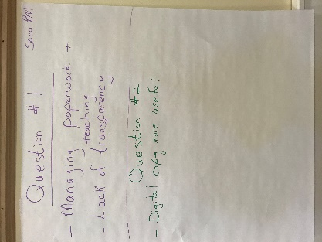
Saco PM
- Digital copy more useful
How Can the DOE support SAUs?

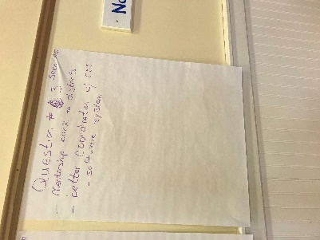
Saco AM
- Mentorship back to districts
- Better coordination of CDS software system

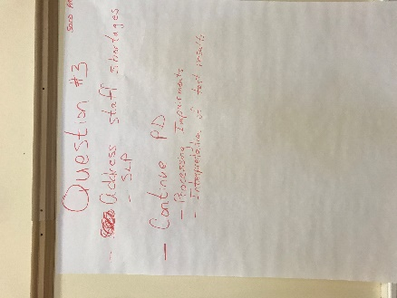
Saco PM
- Address staff shortages – SLP
- Continue PD
      - Processing Impairments
      - Interpretation of test results

Technical Assistance/Training Topics

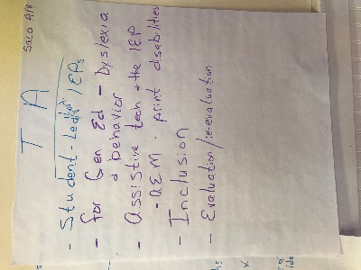
Saco AM
- Student-led IEPs
- For gen ed – dyslexia & behavior
- Assistive tech & the IEP, AEM – print disabilities
- Inclusion
- Evaluation/re-evaluation

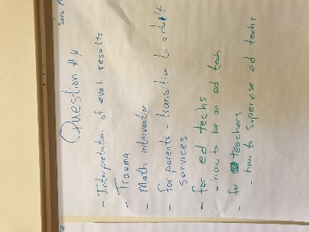
Saco PM
- Interpretation of eval results
- Trauma
- Math intervention
- For parents – transition to adult services
- For ed techs – how to be an ed tech
- For teachers – how to supervise ed techs

Are there practices/policies that create barriers for students with disabilities?

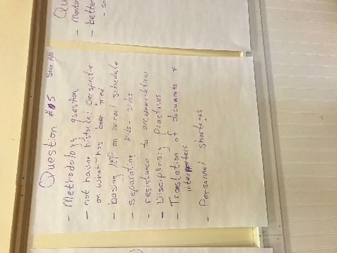
Saco AM
- Methodology question
- Not having historical perspective on what has been tried
- Basing IEP on school schedule
- Separating kids – silos
- Resistance to accommodations
- Disciplinary practices
- Translation of documents & interpreters
- Personnel shortages

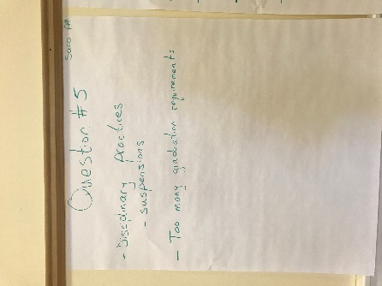
Saco PM
- Disciplinary practices – suspensions
- Too many graduation requirements

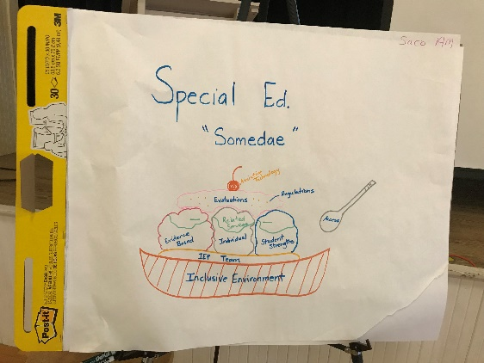
Saco AM
Special Ed “Somedae”

Ingredients:

Evaluations Related services
Regulations Student strengths
Assistive technology IEP team
Evidence-based Access
Individual Inclusive environment

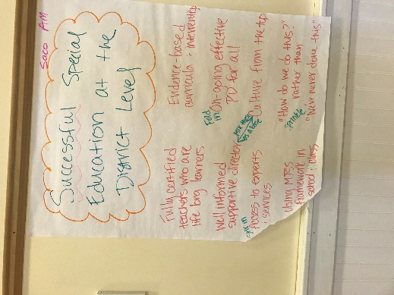
Saco AM
Successful Special Education at the District Level

- Fully certified teachers who are lifelong learners
- Evidence-based curricula & interventions
- Well informed supportive director
- Fold in: On-going effective PD for all
- Stir in: Access to experts & services
- Mix in as a base: Culture from the top
- Using MTSS framework in school: class
- Sprinkle: “How do we do this?”
- “We’ve never done this”

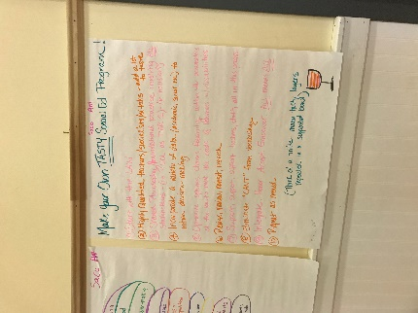
Saco AM
Make Your Own Tasty Special Ed Program!
1. Start with the law
2. Highly qualified teachers/specialists/ed techs – add a lot to taste
3. Shared philosophy/foundational practice involving all stakeholders – (i.e. UDL as Tier 1) – (i.e. inclusion)
4. Incorporate a variety of data (academic, social, etc.)
5. Optimize options, choices, flexibility, within the parameters of the law to meet the needs of learners w/disabilities
6. Revise, review, revisit, research
7. Support, support, support teachers, staff, all in this process
8. Eliminate “can’t” from vocabulary
9. Integrate, honor, accept, empower. All means all
10. Repeat as needed

(Think of a trifle – many tasty layers repeated n a supportive bowl)

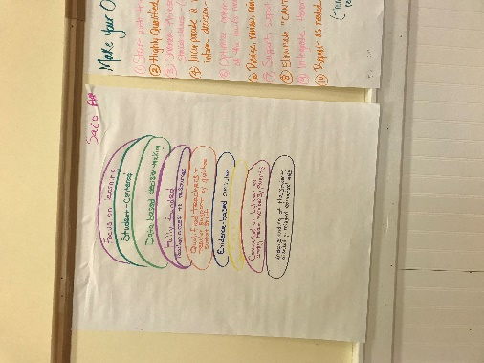
Saco AM

- Focus on learning
- Student-centered
- Data-based decision-making
- Fully funded
- Teacher access to resources
- Qualified teachers + teacher support by qualified support staff
- Evidence-based curriculum
- Flexibility
- Communication between and among team members/parents
      - Understanding of the student’s disability-related educational needs

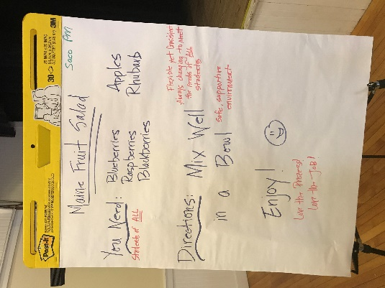
Saco PM
Maine Fruit Salad

You need:
Blueberries Apples
Raspberries Rhubarb
Blackberries
(Students of all)

Directions:
Mix well in a bowl
Enjoy!

- Flexible yet consistent
- Always changing to meet the needs of all students
- Safe, supportive environments
- Love the process, love the job
Saco PM
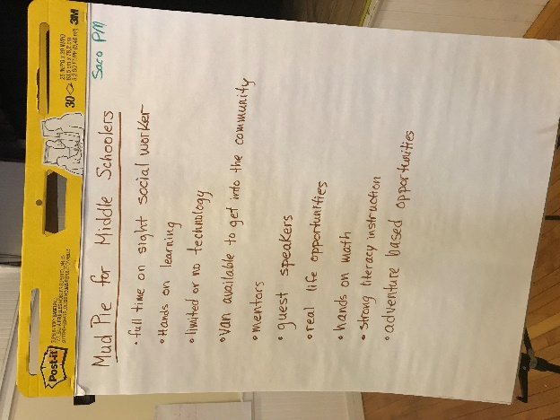
Mud Pie for Middle Schoolers

- Fulltime on-site social worker
- Hands-on learning
- Limited or no technology
- Van available to get into the community
- Mentors
- Guest speakers
- Real-life opportunities
- Hands-on math
- Strong literacy instruction
- Adventure-based opportunities

