CNP Web – User Quick Guide
Administrative Review Tool
Access the CNP Web site here: https://me.cnpus.com/cnp/Login
Off-site Assessment Tool
Completing the off-site questions:
Step 1: Sign in by entering your User Id and Password on the CNP Web homepage.

Step 2: Select “SNP” under “Program Selection.”
Step 3: Select the school year being reviewed under “Program Year Selection.”

Step 4: Click “E-Reviews” in the top left hand corner of the screen and select “E-Review Log by Sponsor.”
Step 5: Click on the symbol under “E-Review Log”. This will open up the Review Summary Page.

Step 6: Click the “Content” section on the left side of the screen. This will open additional sections to complete:

Resource Management – 1) Click “Resource Management” to open questions 700-712.
2) There are four tabs (Non-Profit FS Account, Paid Lunch Equity, Nonprogram Foods Revenue, and Indirect Costs) that each must be selected and contain questions to anwser. Paid Lunch Equity is not required this year due to a USDA waiver. Please enter N/A. Don’t forget to save after you answer each question. As each question is answered and saved, the red box with the pencil will turn green to indicate completion.
Step 7: District level off-site questions: 1) Click on the symbol under the blue portion of “Review Listing” to answer the district level questions.
2) There are five categories: Certification and Benefit Issuance, Verification, Meal Counting & Claiming, General Program Compliance, and IX Special Provision Options. As you anwser and save questions in each area, the red bar will change to green.

Step 8: Completing the Meal Compliance Risk Assessment
1) Click the “Content” section on the left side of the screen. This will open additional sections to complete:

2) Click on “Meal Compliance Risk Assessment.” The “Meal Compliance Assesement Tool” will open. Note: this will only need to be completed for districts that have more than one site being reviewed.
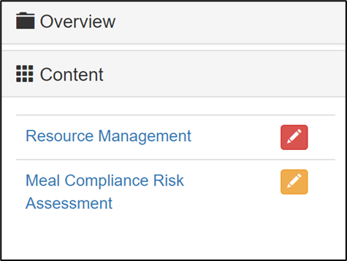

3) Click on each reviewed school, and answer questions #1-10.
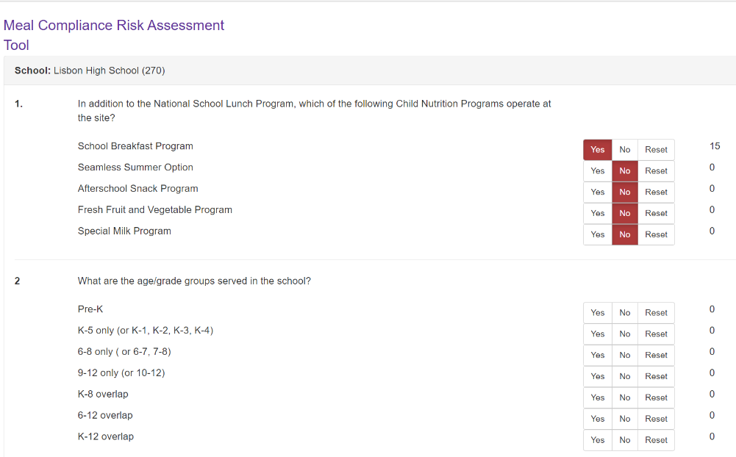
Uploading Requested Documents
Step 1: Sign in by entering your User Id and Password on the CNP Web homepage.

Step 2: Select “SNP” under “Program Selection.”
Step 3: Select the school year being reviewed under “Program Year Selection.”

Step 4: Click “E-Reviews” in the top left hand corner of the screen and select “E-Review Log by Sponsor.”
Step 5: Click on the symbol under “E-Review Log”. This will open up the Review Summary Page.

Step 6: Click on the symbol to the right of the screen. This is where you will upload requested documents.

Submitting Corrective Action
Step 1: Click “E-Reviews” in the top left hand corner of the screen and select “Corrective Action Responses.”
Step 2: This is the Corrective Action Responses navigation page. Here, School Nutrition Department and Maine State Agency staff can work together on Corrective Action needs.

- For each finding, select the pencil box to add a Corrective Action response.
- Each finding includes a description of the finding and Corrective Action needs.
- Enter your Corrective Action response.
- To upload supporting documentation if needed, click on the blue folder at the top right corner of the screen.
- Click “Upload Document(s) and select the file you wish to attach.
5) Click “Upload Document(s) and select the file you wish to attach.

6) Be sure to save after the response and file has been uploaded.

Step 3: If you need to upload general files to support Corrective Action, click the blue folder in the upper right hand corner of the Corrective Action Page.
Click “Upload Document(s) and select the file you wish to attach.

