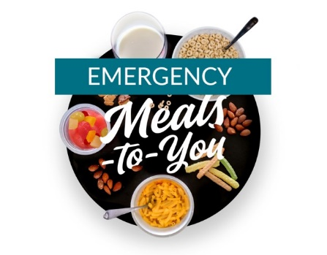**Emergency Meals to You: Baylor Collaborative on Hunger and Poverty**

[Meals-to-You is an alternative method available to school districts to provide meals during unanticipated school closures lasting four weeks or longer. This program is directed towards rural families, for whom traditional Summer Food Service Program (SFSP) options are a challenge due to distance and transportation. Eligible students are reached by mailing two weeks’ worth of shelf stable, nutritious breakfasts and lunches right to their door step that children can prepare on their own. The program is at no cost to the school district.](https://nam03.safelinks.protection.outlook.com/?url=https%3A%2F%2Fmaine.us2.list-manage.com%2Ftrack%2Fclick%3Fu%3Da582edd6473e477ef6307c769%26id%3D6571c04c7e%26e%3Ddb6b5eb8ff&data=02%7C01%7Cstephanie.stambach%40maine.gov%7C6f04ae62a6c147bad63708d7d27495ef%7C413fa8ab207d4b629bcdea1a8f2f864e%7C0%7C0%7C637209270492066740&sdata=ibZUVPHr4grj%2FwbaCDkOAr20yzBGInS44u9R2KZGLvw%3D&reserved=0)

* Eligibility requirements: available to school districts that meet all of the following:
  + Schools having at least 50% or more students eligible for free and reduced price meals
  + Schools located in rural areas in Maine
    - [Click here to check if your district meets this rural criteria](https://nam03.safelinks.protection.outlook.com/?url=https%3A%2F%2Fmaine.us2.list-manage.com%2Ftrack%2Fclick%3Fu%3Da582edd6473e477ef6307c769%26id%3D6571c04c7e%26e%3Ddb6b5eb8ff&data=02%7C01%7Cstephanie.stambach%40maine.gov%7C6f04ae62a6c147bad63708d7d27495ef%7C413fa8ab207d4b629bcdea1a8f2f864e%7C0%7C0%7C637209270492066740&sdata=ibZUVPHr4grj%2FwbaCDkOAr20yzBGInS44u9R2KZGLvw%3D&reserved=0)
* Website: <https://mealstoyou.org/emergency-meals-to-you-school-districts/>
* Contact Information: Stephanie Stambach, [stephanie.stambach@maine.gov](mailto:stephanie.stambach@maine.gov)

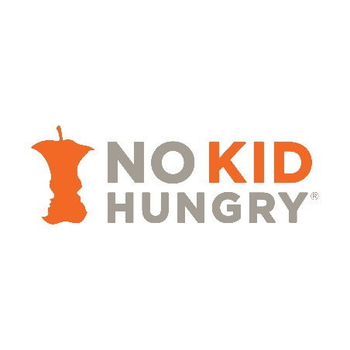**No Kid Hungry Emergency Relief Grants**

No Kid Hungry is offering real time funding and assistance for schools and community organizations that are finding new, innovative ways to make sure kids have access to the meals they need as schools close due to coronavirus. No Kid Hungry is providing emergency grants to support these local efforts like home delivered meals, grab and go meals programs, school and community pantries, backpack programs, and other steps to help reach children and families who lose access to meals. $1 million in emergency grants is being provided immediately.

* Eligibility requirements: available to school districts and nonprofit organizations
* Website:  [https://www.nokidhungry.org/coronavirus-grant-request](https://nam03.safelinks.protection.outlook.com/?url=https%3A%2F%2Fwww.nokidhungry.org%2Fcoronavirus-grant-request&data=02%7C01%7Cstephanie.stambach%40maine.gov%7C96302a781be14ca8ba2608d7d2839b82%7C413fa8ab207d4b629bcdea1a8f2f864e%7C0%7C0%7C637209334999563036&sdata=pt5%2BQkAKxv2bUZhTyqM3ZQ%2Bn%2FRFeVo8ecaqWibVn3kY%3D&reserved=0)
* Contact Information: see website

**Maine Dairy and Nutrition Council**

The Maine Dairy and Nutrition Council is providing Fuel Up to Play 60 soft sided, insulated coolers during the unanticipated school closure.

Eligibility requirements: available to school districts

Website: <http://drinkmainemilk.org/category/schools/>

Contact Information: Katie Hoffmann, [catherine@drinkmainemilk.org](mailto:catherine@drinkmainemilk.org)

**Full Plates Full Potential Emergency Fund**

As schools shut down during the COVID-19 emergency, around 80,000 Maine kids will struggle to access meals. Full Plates Full Potential has established an emergency fund to support any public school in Maine that closes due to the pandemic. These emergency funds will help schools pay for increased meals, packaging breakfast and lunch meals, transporting the food to eligible sites and more. If your school has closed, please apply. This funding is available every two weeks to all public schools in Maine regardless of eligibility and to any approved SFSP sponsor organizations on a first come first serve basis.

* Eligibility requirements: available to any public school and approved SFSP sponsors
* Website**:** <https://www.fullplates.org/emergency-funding/>
* Contact Information:Anna Korsen**,** [akorsen@fullplates.org](mailto:akorsen@fullplates.org)

**GENYOUth COVID-19 Emergency School Nutrition Funding Grant**

GENYOUth is providing grants of up to $3,000 per school to supply much-needed resources for meal distribution and delivery efforts to get food to students during #COVID_19. From soft-sided coolers, bags and containers for individual servings, to protective gear for food service sanitation and safety, this equipment will help ensure all our children continue to receive the nutritious meals they need, now more than ever, while schools across the nation are closed.

Eligibility requirements: available to school districts

Website: <https://www.genyouthnow.org/news/covid-19-emergency-school-nutrition-funding-grant-applications-open>

Contact Information: see website