Student Name: ________________________________________________________________________
Read to Ride Passport

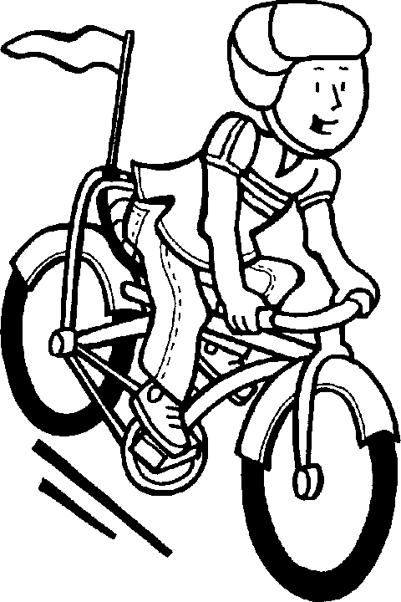

Date | Number of Minutes Read | Text Title(s)
Date | Number of Minutes Read | Text Title(s)
Total Minutes

Please attach additional pages to document reading if more are needed. Return signed passport to your school principal no later than September 6, 2019.

Parent Signature: ________________________________________________________________________
Date:____________________________________________________

