Read to Ride
Summer Reading Challenge

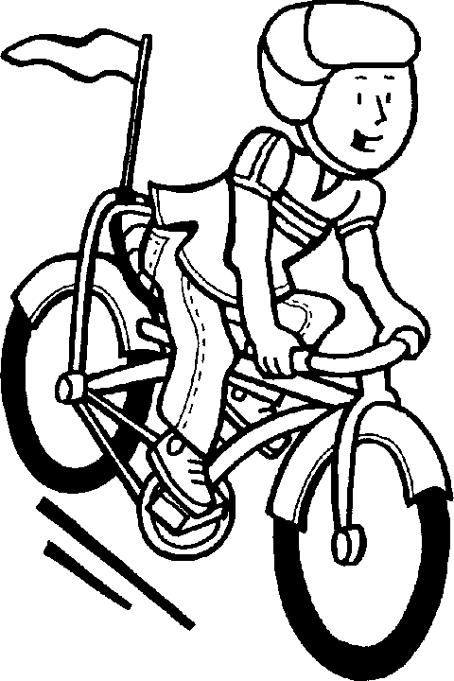
Summer 2020
Summer is the perfect time to explore the world through books—learn about topics of interest, escape to real and imaginary places and let your mind explore new worlds. To make summer reading even more fun, take the Read to Ride Summer Reading Challenge. Read at least 500 minutes this summer to qualify for a chance to win one of 48 bikes and helmets generously donated by the Maine Freemasons.
Follow these simple steps to complete the challenge:
- Read (or for young learners, be read to) at least 500 minutes this summer—that’s just 20 minutes a day for 25 days.
- Record your reading on the Read to Ride Passport.
- Ask your parent/guardian to document your reading by signing your passport.
- Return your passport to your school principal by September 4, 2020.
All completed passports will be entered into a school level drawing. Two students from each participating school will have their names entered in the Maine Department of Education’s drawing to be held on September 25, 2020. Winners will be notified on September 25, 2019.
Note: If your school participates in Scholastic Summer Read A-Palooza, it is an allowable method for logging and documenting your reading minutes. Follow your school’s instructions for documenting you have completed at least 500 minutes of reading.

Student Name: ________________________________________________________________________
Read to Ride Passport

Date | Number of Minutes Read | Text Title(s)
Date | Number of Minutes Read | Text Title(s)
Total Minutes

Please attach additional pages to document reading if more are needed. Return signed passport to your school principal no later than September 4, 2020.

Parent Signature: ________________________________________________________________________
Date: ____________________________________________________

