Read to Ride
Summer Reading Challenge 2020

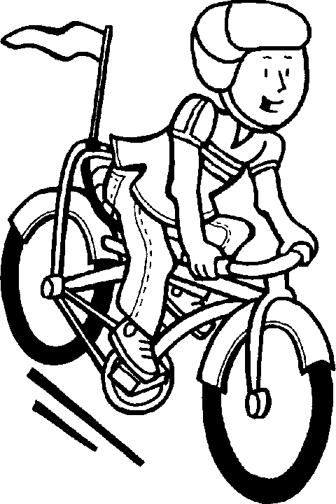
Guidance for School Principals
- Review the 2020 Read to Ride Summer Reading Challenge information sheet.

- Register your school through this link by June 19, 2020: Read to Ride Registration

- Disseminate the challenge information to any PK-8 students in your school. Consider including a link from your school website to the Read to Ride Summer Reading Challenge link on the Maine Department of Education website.

- Feel free to tailor this opportunity to fit your local context. Combine this opportunity with any other summer reading program/challenge in which your students may participate through your school and/or community (e.g. Scholastic’s Summer Read-A-Palooza, public libraries, etc.). Consider soliciting local level prizes to award to students for participation in this challenge, such as books, memberships to YMCAs and Boys & Girls Clubs, movie tickets, etc.

- Collect passports from students by September 4, 2020.

- Hold the school level drawing. Separate entries into boys and girls and draw one boy and one girl winner from your school. Tally the total number of minutes read by students in your school during the summer. Complete the online survey (link will be sent to registered schools on August 27, 2019) to report your school level. Surveys must be completed by September 20, 2020 at 5:00 p.m.

- The state level drawing will be held on September 25, 2020 and schools will be notified of prize winners on October 2, 2020.

