Read to Ride
Summer Reading Challenge 2019

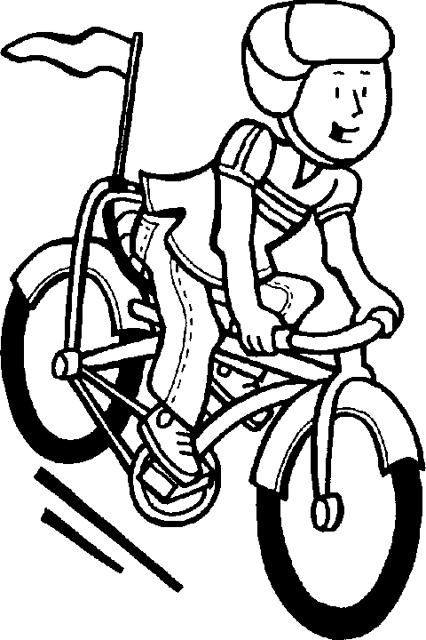
Guidance for School Principals
- Review the 2019 Read to Ride Summer Reading Challenge information sheet.

- Register your school through this link by June 14, 2019: https://www.surveymonkey.com/r/YHNLWKF

- Disseminate the challenge information to any PK-8 students in your school. Consider including a link from your school website to the Read to Ride Summer Reading Challenge link on the Maine Department of Education website.

- Feel free to tailor this opportunity to fit your local context. Combine this opportunity with any other summer reading program/challenge in which your students may participate through your school and/or community (e.g. Scholastic’s Summer Reading Challenge, public libraries, etc.). Consider soliciting local level prizes to award to students for participation in this challenge, such as books, memberships to YMCAs and Boys & Girls Clubs, movie tickets, etc.

- Collect passports from students by September 6, 2019.

- Hold the school level drawing. Separate entries into boys and girls and draw one boy and one girl winner from your school. Tally the total number of minutes read by students in your school during the summer. Complete the online survey (link will be sent to registered schools on August 27, 2019) to report your school level. Surveys must be completed by September 13, 2019 at 5:00 p.m.

- The state level drawing will be held on September 20, 2019 and schools will be notified of prize winners on September 27, 2019.

