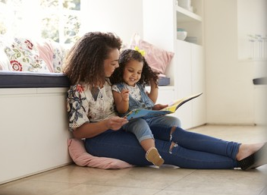
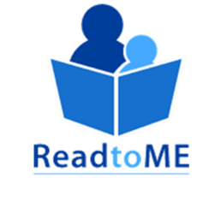

15 minutes a day for literacy

TAKE THE #ReadtoME
CHALLENGE

The Read to ME Challenge is a Maine Department  of Education public awareness campaign to promote childhood literacy. | HOW DO I PARTICIPATE?  - Read with a child or children for at least 15 minutes during the month of February.  - Take a photo or short video of you reading to/with a child.  - Post it on Facebook, Twitter, Instagram, or another social network with #ReadtoME and #ReadaloudME.  - Tag your friends in your post to take the challenge!  Visit www.maine.gov/doe/readtome to learn more.

