Most Challenging Aspect of IEP Process
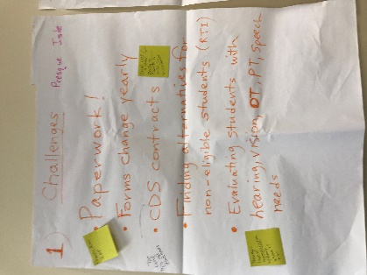
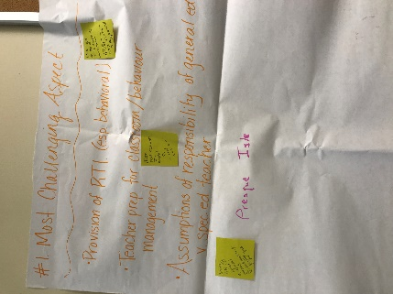
Presque Isle

- Paperwork!
- Forms change yearly
- CDS contracts
- Finding alternatives for non-eligible students (RTI)
- Evaluating students with hearing, vision, OT, PT, Speech
needs
            - Provision of RTI (esp, behavioral)
            - Assumption of responsibility of general ed vs. special ed teacher

Are MUSER user friendly? Why or why not?
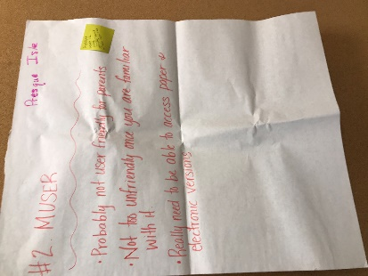
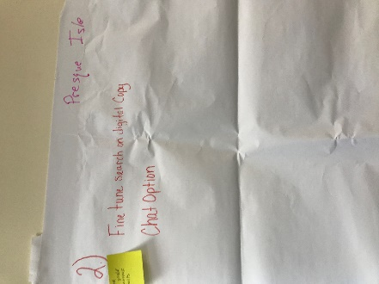
Presque Isle
- Fine tune search on digital copy
- Chat option
- Probably not user friendly for parents
- Not too unfriendly once you are familiar with it

How Can the DOE support SAUs?
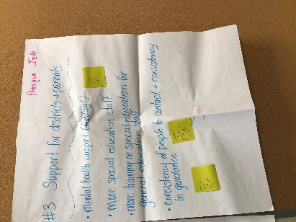
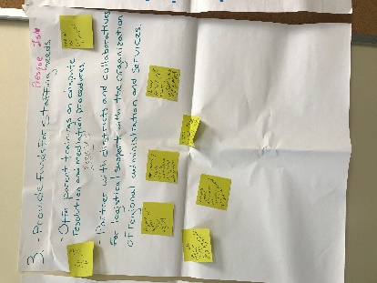
Presque Isle
- Provide funds for staffing needs
- Offer parent trainings on dispute resolution and mediation procedures
- Partner with districts and collaboratives for logistical support with the organization of regional administration and services
- Mental health support (funding)
- More special education staff
            - More training on special education for gen ed staff
            - Consistency of people to contact & consistency in guidance

Technical Assistance/Training Topics
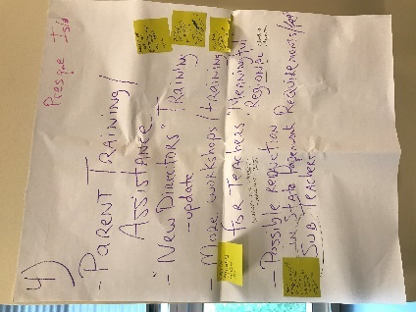
Presque Isle
- Parent training/assistance
- “new directors” training – update
- More workshops/training for teachers – “meaningful regional” – north of Augusta
- Possible reduction in state paperwork
- Sub teachers
- Requirements/fees

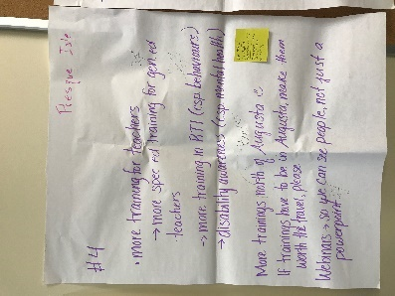
Presque Isle
- More training for teachers
  - More spec ed training for gen ed teachers
  - More training in RTI (esp. behaviors)
  - Disability awareness (esp. mental health)
- More trainings north of Augusta
- If trainings have to be in Augusta, make them worth the travel please
- Webinars – so we can see people, not just a PowerPoint

Are there practices/policies that create barriers for students with disabilities?

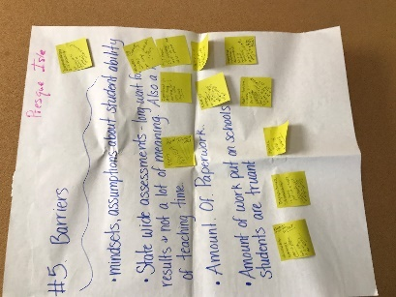
Presque Isle
- Mindsets, assumptions about student ability
- Statewide assessments -long wait for results & not a lot of meaning – also a waste of teaching time
- Amount of paperwork
- Amount of work put on schools when students are truant

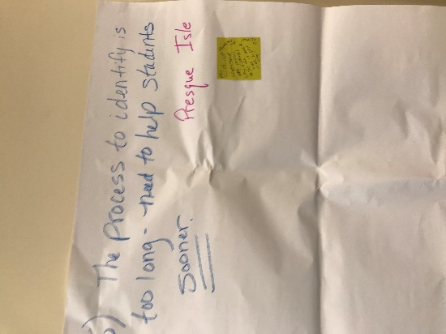
Presque Isle
- The process to identify is too long – need to help students sooner
Parking Lot

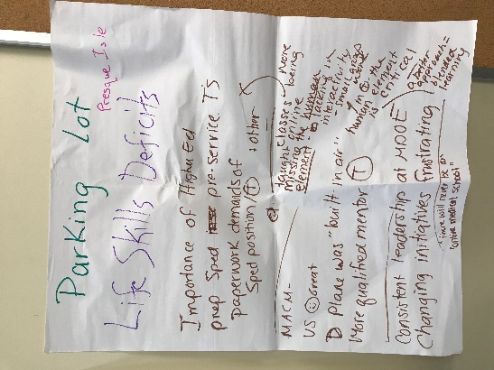
Presque Isle
- Life skills deficits
- Importance of higher ed
- Prep sped pre-service teachers
- Paperwork demands of sped position /other
- MACM – more classes being taught online – missing the human element – lacking in interactivity; human element is critical – a better approach – blended learning – there will never be an online medical school
- Plane was “build in air”
- More qualified mentor
- Consistent leadership at MDOE
- Changing initiatives frustrating

