Dear Parent/Guardian:
School meals will be available to students at no charge this year, regardless of household income. However, we ask that families still complete a Meal Benefit Application as this provides data for key funding for academic resources and may also connect your family to additional benefits. To apply, complete the enclosed SY 2023 Household Application for Free and Reduced Price School Meals and return to: [insert address].
If you prefer, you may complete the application online at [insert website for online application if available]. A new application must be submitted each school year.
Our school offers healthy meals every school day. Meals meet nutrition standards established by the U.S. Department of Agriculture. If a child has a disability, as determined by a licensed medical authority, and the disability prevents the child from eating the regular school meal, substitutions may be made as prescribed by a licensed medical authority. If a substitution is needed, there will be no extra charge for the meal. Please note, however, that the school is not required to make a substitution, unless it meets the definition of disability and supported by a complete medical statement form signed by the local medical authority.
Who can get free or reduced-price school meals? Any student enrolled in a Maine public school can get school meals at no charge!
Will information on my application be kept confidential? We will use the information on your form to decide if your child is eligible for free or reduced-price meals. We may inform officials connected with other child nutrition, health and education programs of the information on your form to determine benefits for those programs or for funding and/or evaluation purposes.
How do I know if my children qualify as homeless, migrant, or runaway? Do the members of your household lack a permanent address? Are you staying together in a shelter, hotel, or other temporary housing arrangement? Does your family relocate on a seasonal basis? Are any children living with you who have chosen to leave their prior family or household? If you believe children in your household meet these descriptions and haven’t been told your children will get free meals, please call or e-mail [school, homeless liaison, or migrant coordinator].
Do I need to fill out an application for each child? No. Use one Application for all students in your household. We cannot approve an application that is not complete, so be sure to fill out all required information.
My child’s application was approved last year. Do I need to fill out a new one? Yes. A new application must be submitted each school year unless the school told you that your child is eligible for the new school year.
Will the form be verified? Your eligibility may be checked at any time during the school year. School officials may ask you to send written evidence.
Can I complete the Meal Benefit Application later? Yes, but we request that the application is completed by [date], so that our offices can submit family income data and apply to receive grants and academic funding.
Should I complete the application if someone in my household is not A U.S. citizen? Yes. You, your children, or other household members do not have to be U.S. citizens to apply for free or reduced-price meals.
What if my income is not always the same? List the amount that you normally receive. For example, if you normally make $1000 each month, but you missed some work last month and only made $900, put down that you made $1000 per month. If you normally get overtime, include it, but do not include it if you only work overtime sometimes. If you have lost a job or had your hours or wages reduced, use your current income.
What if some household members have no income to report? Household members may not receive some types of income we ask you to report on the application or may not receive income at all. Whenever this happens, please write a 0 in the field. However, if any income fields are left empty or blank, those will also be counted as zeroes. Please be careful when leaving income fields blank, as we will assume you meant to do so.
We are in the military. Do we report our income differently? Your basic pay and cash bonuses must be reported as income. If you get any cash value allowances for off-base housing, food, or clothing, it must also be included as income. However, if your housing is part of the Military Housing Privatization Initiative, do not include your housing allowance as income. Any additional combat pay resulting from deployment is also excluded from income.
What if there isn’t enough space on the application for my family? List any additional household members on a separate piece of paper and attach it to your application.
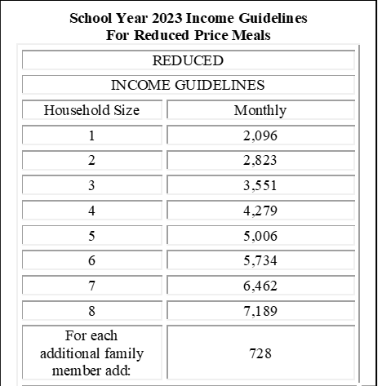
My family needs more help. Are there other programs we might apply for? One main reason we are emphasizing the importance of the Meal Benefit Application is because it may connect you to other benefits––such as Pandemic EBT funds. For information about Food Supplement, Health Care, Cash Assistance and/or apply for Maine's Child Care Subsidy, go to My Maine Connection found online at https://www1.maine.gov/benefits/account/login.html. For low cost health insurance information, contact Consumers for Affordable Health Care (CAHC) at 1-800-965-7476.
If you have other questions or need help, call [phone number].

Sincerely,
[signature]
In accordance with federal civil rights law and U.S. Department of Agriculture (USDA) civil rights regulations and policies, this institution is prohibited from discriminating on the basis of race, color, national origin, sex (including gender identity and sexual orientation), disability, age, or reprisal or retaliation for prior civil rights activity. Program information may be made available in languages other than English. Persons with disabilities who require alternative means of communication to obtain program information (e.g., Braille, large print, audiotape, American Sign Language), should contact the responsible State or local Agency that administers the program or USDA’s TARGET Center at (202) 720-2600 (voice and TTY) or contact USDA through the Federal Relay Service at (800) 877-8339.To file a program discrimination complaint, a Complainant should complete a Form AD-3027, USDA Program Discrimination Complaint Form which can be obtained online at: https://www.usda.gov/sites/default/files/documents/USDA-OASCR%20P-Complaint-Form-0508-0002-508-11-28-17Fax2Mail.pdf, from any USDA office, by calling (866) 632-9992, or by writing a letter addressed to USDA. The letter must contain the complainant’s name, address, telephone number, and a written description of the alleged discriminatory action in sufficient detail to inform the Assistant Secretary for Civil Rights (ASCR) about the nature and date of an alleged civil rights violation. The completed AD-3027 form or letter must be submitted to USDA by:
(1) mail:
U.S. Department of Agriculture
Office of the Assistant Secretary for Civil Rights
1400 Independence Avenue, SW
Washington, D.C. 20250-9410; or
(2) fax: (833) 256-1665 or (202) 690-7442; or
(3) email: program.intake@usda.gov
This institution is an equal opportunity provider.

The Maine Human Rights Act prohibits discrimination because of race, color, sex, sexual orientation, age, physical or mental disability, genetic information, religion, ancestry or national origin.
Complaints of discrimination must be filed at the office of the Maine Human Rights Commission, 51 State House Station, Augusta, Maine 04333-0051. If you wish to file a discrimination complaint electronically, visit the Human Rights Commission website at https://www.maine.gov/mhrc/file/instructions and complete an intake questionnaire. Maine is an equal opportunity provider and employer.
(Federal Statement Revised 5/2022)

