Special Education
Required Forms
Procedural Manual

Updated 08/01/2019
Table of Contents
 | Page
Advance Written Notice . . . . . . . . . . . . . . . . . . . . . . . . . . . . . . . . . . . . | 3
Determination of Adverse Effect . . . . . . . . . . . . . . . . . . . . . . . . . . . . | 6
Documentation of Agreement of Non-Attendance for IEP/IFSP Team member whose Curriculum Area IS NOT being Discussed . . . . . . . . . | 12
Documentation of Agreement of Non-Attendance for IEP/IFSP Team member whose Curriculum Area IS being Discussed . . . . . . . . . . . . . | 13
Individualized Education Program . . . . . . . . . . . . . . . . . . . . . . . . . . . . | 14
Parental Consent for Evaluation . . . . . . . . . . . . . . . . . . . . . . . . . . . . . . | 43
Parental Consent to Invite Other Agencies to IEP Meetings – Postsecondary Goals & Transition Services . . . . . . . . . . . . . . . . . . . . | 47
Referral for Special Education Services. . . . . . . . . . . . . . . . . . . . . . . .. | 49
Revocation of Special Education Services. . . . . . . . . . . . . . . . . . . . . . | 60
Seven Day Waiver. . . . . . . . . . . . . . . . . . . . . . . . . . . . . . . . . . . . . . . . . | 61
Specific Learning Disability Eligibility Form . . . . . . . . . . . . . . . . . . . | 62
Speech or Language Impairment Eligibility Form . . . . . . . . . . . . . . . . | 74
Summary of Performance . . . . . . . . . . . . . . . . . . . . . . . . . . . . . . . . . . . | 82
Written Notice . . . . . . . . . . . . . . . . . . . . . . . . . . . . . . . . . . . . . . . . . . . | 87

The IEP Committee:
Patricia Block, RSU #12
Mary Adley, Maine DOE
Laurie Lemieux, Winthrop School Dept.
Roberta Lucas, Maine DOE
Kris Michaud, CDS
Shelby Thibodeau, Augusta School Dept.
Dan Hemdal, Maine DOE
Ryan Meserve, RSU #38
Riley Donovan, RSU #64
Advance Written Notice

This form is used to:
- Provide notice to parties of an upcoming IEP/IFSP Team Meeting.
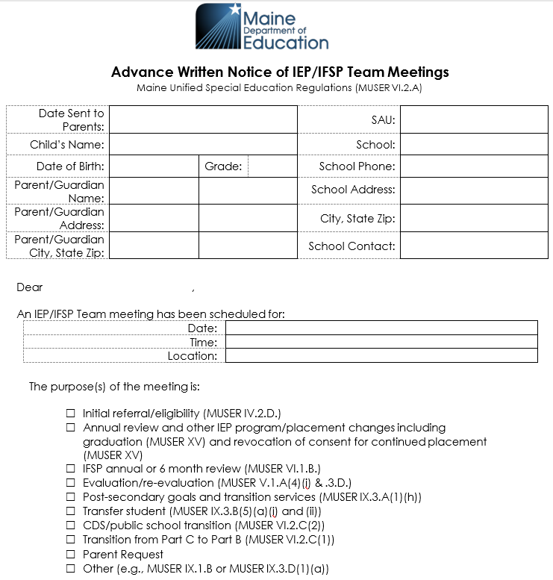
This section is used to:
- Document the pertinent child-related information.
- Document the date, time and location of the IEP meeting.
- Identify the purpose(s) of the IEP meeting.
Directions:
- At least one box must be checked but check each box that applies to the purpose(s) of the IEP meeting.
- “Other” might include Ch.33 meeting, manifestation determination review, or 30-day review for out-of-unit placements. If “Other” is checked, the specific purpose should be listed.
- If the child is of transition age (9th grade or 16 years or older) then, the child should be invited to the meeting and included in the salutation.
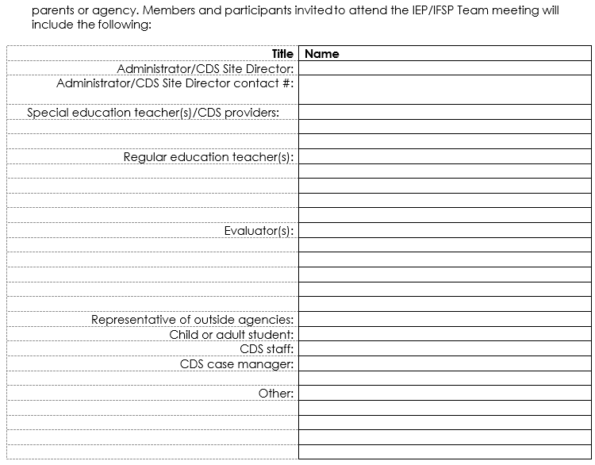
This section is used to:
- Identify the participants who are invited to the IEP meeting.
Directions:
- Attendees should be identified by name as well as role.
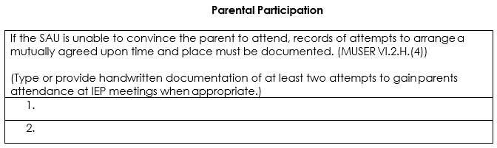
This section is used to:
- Document the SAU’s attempts to promote parent(s) participation and attendance.
Directions:
- Schools must make reasonable efforts to schedule the IEP meeting at a mutually agreed on time and place.
- As a rule of thumb, if the SAU is having difficulty convincing a parent to attend, it should make multiple attempts in addition to sending the AWN to schedule the IEP meeting so that parents have an opportunity to attend.
- If the SAU makes these attempts and the parents do not attend, the SAU may proceed to hold the IEP meeting.

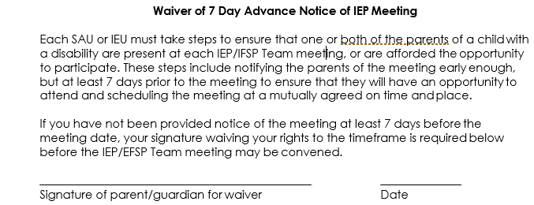
This section is used to:
- Document the parent’s willingness to waive the 7-day notice of the IEP meeting.

Parents must sign here whenever the IEP meeting is held less than 7 days from when notice was provided.

This section is used to:
- Identify the enclosures, if any, included with the Advanced Written Notice.
Directions:
- If Procedural Safeguards, evaluation reports or other items are enclosed with the AWN, record that information here.

Determination of Adverse Effect
This form is used to:
- Provide a written record regarding the determination of adverse effect on educational performance.

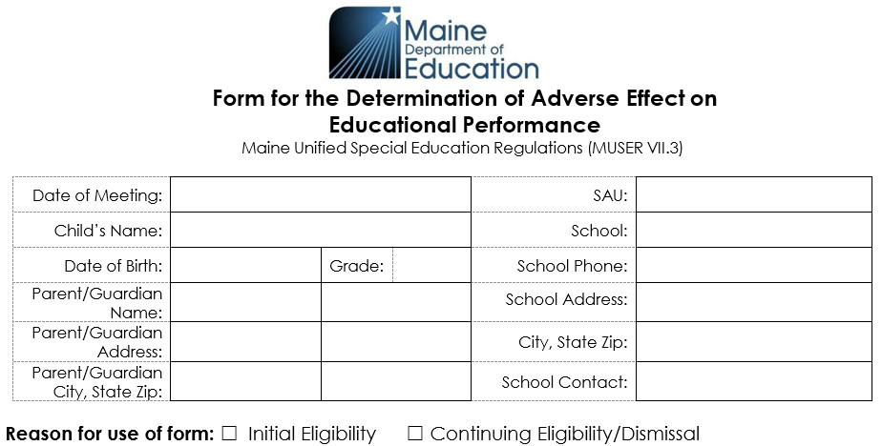

Definition – Adverse effect/adversely effects: The word “adverse” commonly means “harmful, impeding, obstructing, or detrimental.” To “adversely affect” means to have a negative impact that is more than a minor or transient hindrance, evidenced by findings and observations based on data sources and objective assessments with replicable results. An adverse effect on educational performance does not include a developmentally appropriate characteristic of age/grade peers in the general population.

Directions:
- The use of the form is limited to:
  - Determination of eligibility for special education services.
  - Consideration of a change in eligibility for special education services.
  - Dismissal from special education services.

The procedure for determination of adverse effect applies only to the following eligibility categories: Autism, Deafness, Developmental Delay, Emotional Disturbance, Hearing Impairment, Intellectual Disability, Orthopedic Impairment, Other Health Impairment, Traumatic Brain Injury, and Visual Impairment including Blindness.

Section 1.A – Assessment/Data Sources
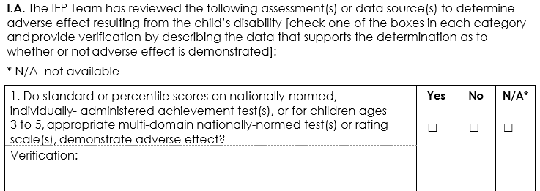
This section is used to:
- Document data considered and indicate whether it supports a determination of adverse effect.

Directions:
- Examples of data sources for category 1:
  - For 3-5 year-olds - Wechsler Preschool and Primary Scale of Intelligence- Fourth Edition™ (WPPSI-IV), Autism Diagnostic Observation Schedule™ (ADOS™);
  - Grades K-12 - Woodcock Johnson, Wechsler Individual Achievement Test, Oral and Written Language Scale, Gray Oral Reading Test, Test of Word Reading Efficiency.

The IEP Team’s determination of adverse effect is based upon the results of assessments and/or data sources determined by the Team to be necessary to verify the effect of the disability on educational performance. In most situations, the Team will consider multiple assessments and/or data sources for determination of adverse effect.

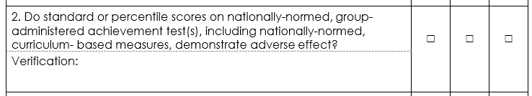
- Examples of data sources for category 2:
  - NWEA, PSAT, SAT.

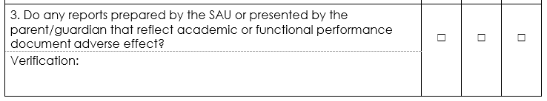
- Examples of data sources for category 3:
  - 3-5-year-olds - Adaptive Behavior Assessment System®-Second Edition (ABAS®-II), CDS Eligibility Observation Summary
  - Grades K-12 - Vineland scores, Adaptive Behavior Assessment System scores, academic grades, reports by parent or outside providers, reports of whether the child meets standards in standards-based system.

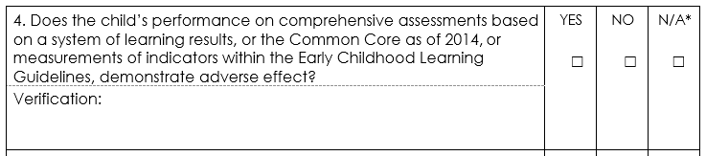
- Examples of data sources for category 4:
  - 3-5-year-olds - Assessment, Evaluation, and Programming System for Infants and Children (AEPS®), Second Edition, HighScope® Child Observation Record
  - Grades K-12 - MEAs, NWEAs, writing prompts, and curriculum-based measures such as DRA, DIBELS, Everyday Math, AIMSweb, Curriculum Unit Tests (Envisions Math).

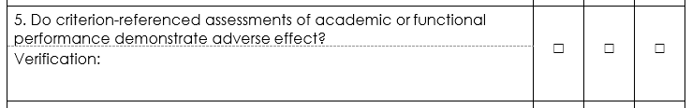
- Examples of data sources for category 5:
  - VB-MAPP, ABLLS, Brigance Inventory of Early Development, School Function Assessment, NWEAs, MEAs, Classroom test scores.

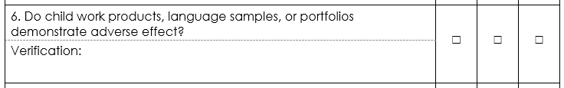
- Examples of data sources for category 6:
  - Writing prompts, handwriting samples, portfolios of work, classroom work samples.

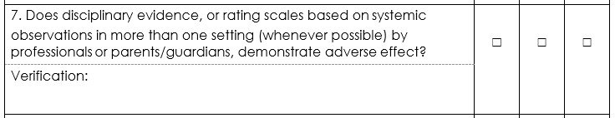
- Examples of data sources for category 7:
  - Disciplinary reports/office referrals, Functional Behavioral Assessment (FBA), BASC Rating Scales, BRIEF, behavior data sheets/logs, classroom observation(s).

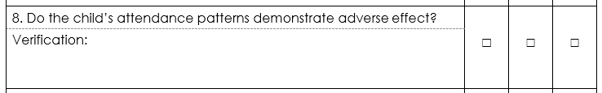
- Examples of data sources for category 8:
  - Attendance records (school, program and/or class).

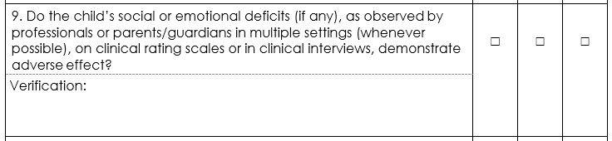
- Examples of data sources for category 9:
  - BASC, BRIEF, Achenbach, Connors Rating Scales, Multidimensional Anxiety Scale for Children, Piers-Harris Self-Concept Scale, Autism Rating Scales, observation.

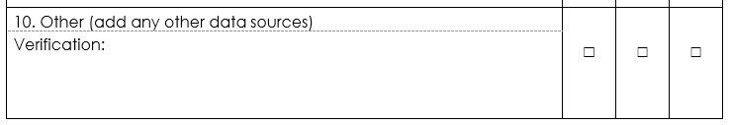

Section 1.B. – SINGLE ASSESSMENT
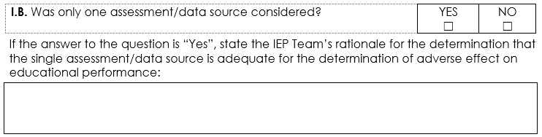
This section is used to:
- Indicate whether only one assessment or data source was considered and, if so, explain why that was adequate.

Section 2- DETERMINATION OF ADVERSE EFFECT
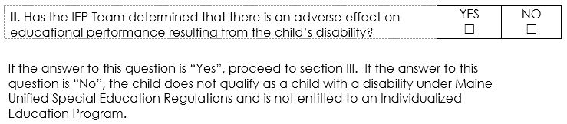
This section is used to:
- Indicate whether the IEP Team has determined that there is an adverse effect on educational performance.

Directions:
- Having completed Section I and considering the findings in each of the data source categories, the Team now determines whether the child’s disability results in an adverse effect on educational performance.
  - If the answer to this question is “Yes”, proceed to section III.
  - If the answer to this question is “No”, the child does not qualify as a child with a disability under Maine Unified Special Education Regulations (MUSER) and is not entitled to an Individualized Education Program.

Only complete Section 3 if the answer to Section 2 is “yes”.

Section 3 – NEED FOR SPECIAL EDUCATION
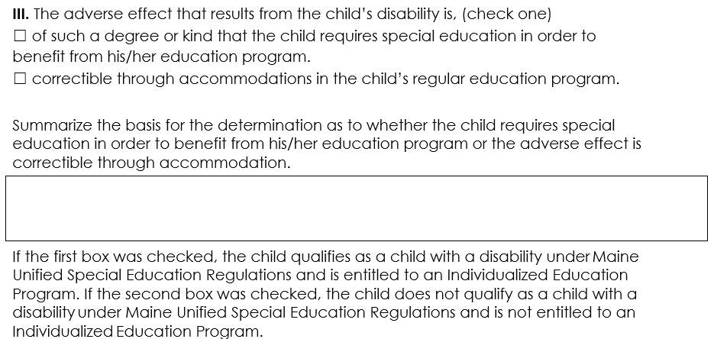
This section is used to:
- Indicate whether the child requires special education.
- Summarize the basis for that determination.

Directions:
- The IEP Team should explain its decision regarding whether the child needs specialized instruction or whether their needs can be addressed through general education accommodations. The Team should not merely reproduce verbatim the information recorded in Section 1 but should summarize how the culmination of data sources support the Team’s determination. This summary should include how the collected data shows an adverse impact on the educational performance of the child.

Documentation of Agreement of Non-Attendance for IEP/IFSP Team Member Whose Curriculum is Not Being Discussed
This form is used to:
- Document parents’ consent whenever a required member of the IEP Team whose area is not expected to be discussed is unable to attend the IEP meeting or will be leaving before the end of the IEP meeting.

The parent’s signed consent for excusal should be obtained on this form before the IEP meeting.

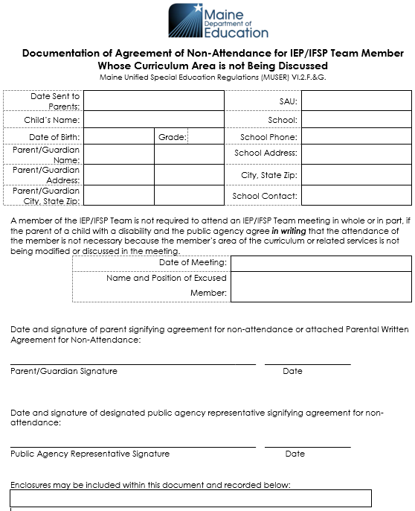

Directions:
- Written input from the excused Team member may be included with this form and documented in the enclosures.
Documentation of Agreement of Non-Attendance for IEP/IFSP Team Member Whose Curriculum is Being Discussed
This form is used to:
- Document parents’ consent whenever a required member of the IEP Team whose area is expected to be discussed is unable to attend the IEP meeting or will be leaving before the end of the IEP meeting.
- This form would be needed for regular or special education teacher for the child.

The excused member must, in writing to the parent and IEP Team, provide input into the development of the IEP prior to the meeting.

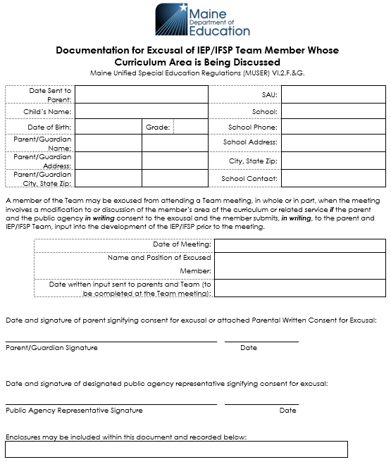
Directions:
- Written input from the excused Team member may be enclosed with this form and, if it is, it should be identified here.
Individualized Education Program (IEP)

This form is used to:
- Provide a written record that reflects the discussion and decisions of the IEP Team documented in the Written Notice.
- Establish present levels, goals, and services that will enable a child to make progress in the general education curriculum in light of their circumstances.
- Commit School Administrative Unit (SAU) resources that are necessary to meet the child’s individualized educational needs.
- Determine the child’s progress toward attainment of goals.
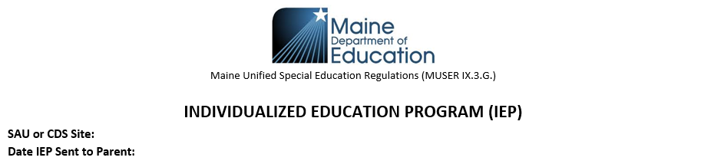
This section is used to:
- Document introductory information related to the IEP.
Directions:
- SAU/CDS Site: Indicate the specific school administrative unit or CDS site. When a child has school choice or is in an out-of-unit placement, the SAU responsible for FAPE should be identified.
- Date IEP Sent to Parent: Parents must receive the annual IEP within 21 school days of the IEP meeting (including the date of the IEP meeting) at which the IEP was developed. The date sent to parent should allow for the parent to receive the document within that timeframe. An amended IEP is required to be sent to parent only upon their request; however, it is best practice to provide the updated documentation whenever agreed upon changes are made.

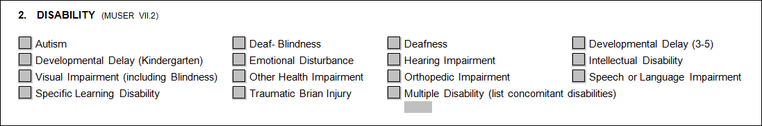
Section 1: CHILD INFORMATION
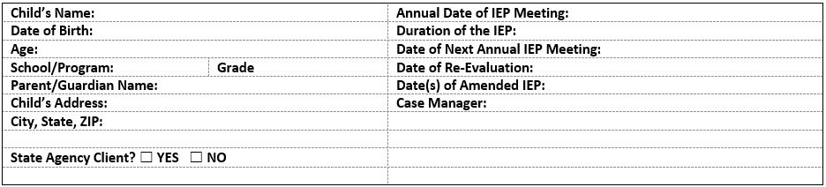
This section is used to:
- Document the pertinent child-related information.

Directions:
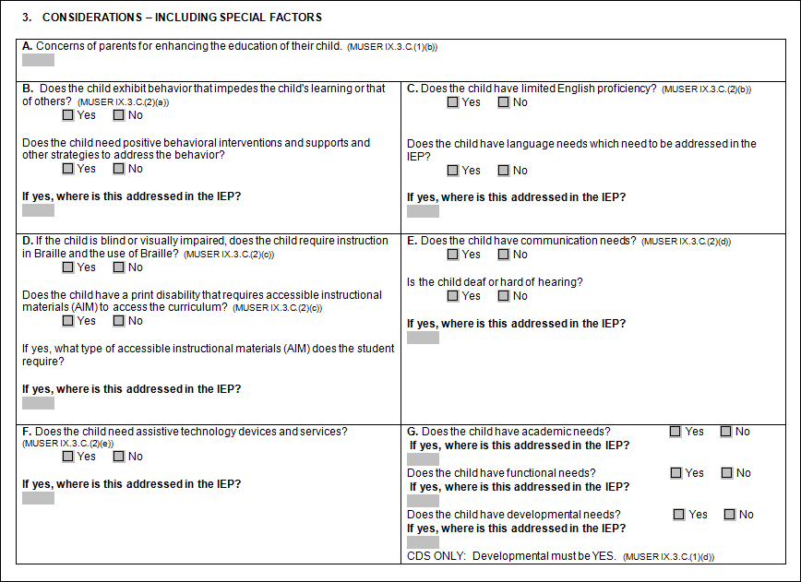
- School/Program: Both school and grade should be documented; for CDS use the word “preschool”.
- Parent Information: This should include the parent/guardian names and addresses.
- Date of Annual Meeting: This is the date the Initial/Annual IEP meeting was held. This should not change unless another annual IEP is developed during the life of the original IEP.
- Duration of the IEP
  - This range should include when the programming within the IEP is going to begin and end.
  - Each school shall implement the initial IEP as soon as possible following the IEP meeting, but no later than 30 calendar days.
  - Subsequent IEPs become effective as determined by the Team, with the determination documented in the Written Notice.
  - Parents should be provided Written Notice 7 days prior to the beginning date, unless the parent agrees at the meeting to implement sooner and it is documented in the WN.
  - The duration should not exceed 364 days.
- Date of Next Annual IEP Review: The next annual IEP should be held within 364 days from the previous year’s annual IEP meeting.

Date of Annual Meeting: 3/17/2019
Duration of the IEP: 3/27/2019-3/26/2020
Date of Next Annual IEP Meeting: 3/16/2020
The date of the annual review MUST not exceed 364 days (but may be less than 364 days) from the date of the last annual IEP meeting, NOT from the effective date of the IEP. If an entirely new IEP is written after the annual meeting, the date that the new IEP was developed becomes the new annual review date. (Example: Transfers)

- Date of Re-evaluation: 3 years from the date of the IEP meeting when initial or previous evaluations were reviewed, and special education eligibility is determined. Re-evaluations cannot be extended beyond 3 years of the determination.
- Date(s) of Amended IEP: When a change has occurred in the IEP prior to the annual review.
  - The date of the amended IEP does not change the original:
    - Date of Meeting
    - Date of Next Annual IEP Meeting.
    - Date IEP Sent to Parent
    - Date of Re-evaluation (unless the amendment was due to a re-evaluation)
- Case Manager: The name of the properly certified or licensed personnel who oversees implementation of the IEP.
- State Agency Client: A child of eligible school age that is:
- In the custody or care of the Department of Health and Human Services (DHHS);
- Placed by a caseworker from DHHS or an authorized agent of Children’s Behavioral Health Services, for reasons other than educational reasons, with a person who is not the child’s parent, legal guardian or relative;
- Attending a public or private school while still a resident of a state-operated institution; or

- In the custody or under the supervision of the Department of Corrections, including, but not limited to, a juvenile on conditional release, an informally adjusted juvenile, a probationer or a juvenile on community reintegration status from a youth correctional facility and who is placed, for reasons other than educational reasons, pursuant to a court order or with the agreement of an authorized agent of the Department of Corrections, outside of the juvenile’s home.
- A state agency client is a child who has been identified as a child with a disability in accordance with this rule. State agency client also means a child who is under 6 years of age who meets one of the criteria listed above.

Section 2: DISABILITY
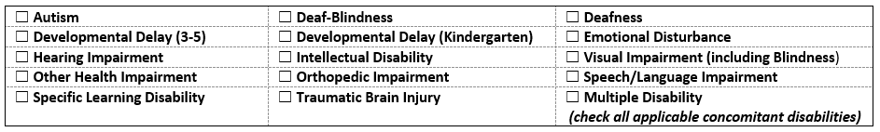
This section is used to:
- Document under which disability the Team has determined that the child is eligible.

Directions:
- Check the box which reflects the disability category.
- In the case of Multiple Disabilities, check the concomitant disabilities.
  - Multiple Disabilities is identified when the child has impairments that occur concomitantly (two or more disabilities that occur at the same time); and
  - The result of the combination of the impairments causes such severe educational needs that the child cannot be accommodated in special education solely for one of the impairments.
  - The term does not include children who have Deaf-Blindness or Developmental Delays.
- Speech or Language Impairment is an eligibility category.
  - Speech/language services can also be a related service to other eligibility categories. Where a child has a need for speech/language services, but Speech or Language Impairment is not the primary disability, do not check the Speech or Language Impairment box; speech/language services would be delivered as a related service. (For example- Other Health Impairment with speech/language services would NOT become Multiple Disabilities unless the two disabilities were concomitant.)

Section 3: CONSIDERATIONS – INCLUDING SPECIAL FACTORS
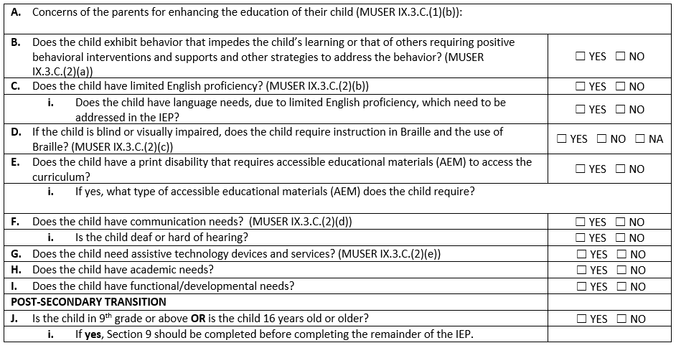
This section is used to:
- Consider the concerns of the parents for enhancing the education of the child.
- Consider any special factors that may interfere with the child’s learning.

Directions:
All questions must be considered and answered appropriately. You MUST check off a box in each section of the chart.

- Document the parents’ concerns. The Team must consider parental concerns when developing the IEP.
- This section should not mirror what is written in Section 6 of the Written Notice. The concerns of the parent for enhancing their child’s education should be documented in this section. Section 6 of the Written Notice documents a parent’s description of their child’s progress which should extend beyond the sole identification of parental concerns.
- If the parents do not attend the IEP meeting, every attempt needs to be made to document the parents’ concerns. Document the fact that they did not attend the meeting in the Written Notice, and not in the IEP. If they did not attend or express concerns, indicate only that the parents did not express any concerns at this time in the IEP.

- Determine if the child exhibits behaviors that impede the child’s learning or the learning of others and the child needs positive behavioral interventions and supports and other strategies to address the behavior.

- Determine if the child’s level of English language proficiency impacts the special education and related services needed by the child AND consider whether the special education and related services should be provided in a language other than English (e.g., goals, accommodations).

This section is used only to address limited English proficiency; speech/language needs are to be addressed in Section 3F.

- Determine if the child is blind or visually impaired, determine if the child requires instruction in Braille or the use of Braille. If the child is NOT blind or visually impaired, please check NA.

- Determine if the child has a print disability that requires Accessible Educational Materials (AEM).
i. If the child requires Accessible Educational Materials, document the type(s) of AEM the child requires.
- For all children, determine if the child has a print disability (an individual who experiences barriers to accessing standard printed instructional materials in non-specialized formats due to blindness, visual disability, physical limitations, organic dysfunction or dyslexia) that requires Accessible Educational Materials (AEM) to access the curriculum. (For example, a child with a specific learning disability may be determined to have a print disability.)
- NOTE: Office of Special Education Programs (OSEP) expanded the definition of educational materials to include both print and digital technology based material, including print and electronic textbooks and related core materials that are required by SAUs for use by all children produced or rendered in accessible media, written and published primarily for use in early learning programs, elementary, or secondary schools to support teaching and learning.” (Footnote 10, Federal Register/Vol. 79, No.90/Friday, May 9, 2014/Notices, page 26728)
- The Individuals with Disabilities Education Act (IDEA 2004) requires the timely delivery of accessible instructional materials to children who are IDEA 2004 eligible. To assist in implementation of this requirement, IDEA 2004 established the National Instructional Materials Access Center (NIMAC) which serves as a repository for electronic files prepared in the National Instructional Materials Accessibility Standard (NIMAS) format. NIMAS is the technical standard to be used by publishers in the preparation of electronic files. A NIMAS source file can convert into specialized formats (Braille, large print, digital audio and electronic text).

- Determine if the child has communication needs.
- Is the child deaf or hard of hearing?
- If the child is receiving speech/language services, it should be indicated as a communication need.
- Consider the communication needs of the child, and in the case of a child who is deaf or hard of hearing, consider the child's: language and communication needs; opportunities for direct communications with peers and professional personnel in the child's language and communication mode; academic level; and full range of needs, including opportunities for direct instruction in the child's language and communication mode.

- Determine if the child requires assistive technology (AT) devices and services as they relate to the child’s functional capacity.
  - An assistive technology device is any item that can be used to increase, maintain, or improve the child’s functional capabilities. An assistive technology service directly assists a child with a disability in the selection, acquisition, or use of an assistive technology device.

  - A specific recommendation for assistive technology devices should be made by conducting an evaluation of the needs of a child. This evaluation should include a functional evaluation in the child’s customary environment completed by a qualified individual. Related Service providers may determine AT needs when evaluating within their scope of practice and documented in their evaluation report.
  - Examples of assistive technology (AT) devices include but are not limited to magnifiers, adapted keyboards, braille devices, tablets/mobile devices, apps, and communication devices. AT that is low tech or high tech should be considered. AT re-assessment is recommended periodically as well as in transition planning.
  - The IEP team can make recommendations regarding accommodations that may be technology related such as large button calculator to address fine motor deficits.

- Determine whether the child has academic needs.
- Academic Performance (K-12)
Academic performance is measured by a child’s ability to perform age-appropriate (comparable to same age/grade peers) skills and behaviors in reading, writing, listening, speaking, and mathematical problem solving in the school environment.

- Determine whether the child has functional/developmental needs?
- Developmental Performance (Ages 3-5)
Developmental performance (ages 3 to 5) refers to how the child is performing developmentally in physical, cognitive, communicative, social, emotional and/or adaptive areas.

- Functional/Developmental Performance (Ages 5-20)
Functional/Developmental performance means how the child demonstrates his/her skills and behaviors in cognition, communication, motor, adaptive, social/emotional and sensory areas. Some of the goals may focus on: executive functioning, habits of work, time management, learning strategies, daily living skills and behavior management. OT, PT and/or SLP needs would be reflected in this section.

This section is used to:
- Identify if the child is of transition age.

Directions:
- Identify if the child is in 9th grade or above, OR if the child is 16 years or older.

If the child is in 9th grade or is 16 years or older, then it is recommended that Section 9 of the IEP should be drafted, reviewed, and updated prior to completing the remainder of the IEP.

Section 4A: ACADEMIC AND FUNCTIONAL/DEVELOPMENTAL EVALUATIONS
This section is used to:
- Describe the results of academic, functional/developmental evaluations, and any other pertinent assessments that support the child’s programming.

Directions:
- Record the name of evaluation, date of evaluation, and all evaluation scores of the initial or most recent academic evaluation of the child used to determine the child’s eligibility and/or programming, including: Full and individually-administered standardized achievement and cognitive tests, which are normed and or/criterion referenced (including, but NOT LIMITED to: WIAT-III, WJR-IV, WISC, CTOPP, CELF, WPPSI-IV, Brigance, ABLLS).
  - Local, curriculum-based measures such as NWEA, STAR, AIMSweb, and running records, are examples of additional assessments that might be included in this section.
  - Use results from evaluations/assessments in the appropriate section to explain and support the goals necessary to meet the child’s educational needs.
- Record the name of evaluation, date of evaluation, and all evaluation scores of the initial or most recent functional/developmental evaluations of the child used to determine the child’s eligibility and/or programming, including: Vineland, functional assessments, BASC, BRIEF, and Achenbach.
- For children who are blind or visually impaired, evaluations that support the Extended Core Curriculum administered by a Teacher of the Visually Impaired would be documented in this section.
- If new data is collected in between triennial evaluations, this data should be documented in Section 4 in support of the implementation of program and/or program changes.

For initial or re-evaluations, all evaluation results used in consideration of the development of an IEP should also be documented in Section 3 of the Written Notice for that year only. For an annual review, evaluation results are not required to be documented in Section 3 of the Written Notice.

Section 4B: ACADEMIC AND FUNCTIONAL/DEVELOPMENTAL STRENGTHS
This section is used to:
- Identify the strengths (or relative strengths) within the child’s academic and functional/developmental performance.

Directions:
- For children 3-5: This section includes relative strengths and statistical strengths from the initial or most recent evaluations but can go beyond information from evaluations. What abilities does this child have? Examples may include but are not limited to: language comprehension, phonological awareness or emergent reading, categorization, sequencing, problem solving, recalling events, mathematical practices, counting, cardinality and mathematic operations.

Based on the results from the evaluation, identify functional strengths. Functional refers to a description of the child’s performance in the classroom (developmentally appropriate) activities. Teams should consider skills in executive functioning, functional communication, social-emotional development, approaches to learning, learning strategies, motor development, safety skills, daily living and adaptive skills and behavior management. What abilities or skills does the child have (self-concept, initiating communication)? Consider the child’s independence, how they interact with others, how they adapt to known and unknown situations, how they problem solve; their ability to independently interact with their environment; and ability to successfully apply learned skills in authentic situations.

- For children 5-20: This section includes relative and statistical strengths from the initial or most recent evaluations but should go beyond information from evaluations including but not limited to observable strengths. What skills does this child have (i.e. a child’s ability to comprehend grade level text with their non-disabled peers or solve)?

Functional/developmental performance refers to a description of the child’s ability to complete routine activities in relation to their functioning in the school environment. Teams should consider skills in executive functioning, habits of work, time management, learning strategies, daily living skills, self-advocacy, and behavior management. This section includes relative and statistical strengths from the initial or most recent evaluations but should also go beyond information from evaluations including but not limited to observable strengths. Consider the child’s ability to successfully apply learned skills in authentic situations.

Section 4C: ACADEMIC NEEDS AND “HOW” STATEMENT (AGES 5-20 ONLY)
This section is used to:
- Identify the child’s academic needs and how they affect the child’s involvement and progress in general education.
Directions:
- Identify (list) specific academic skill deficits that are to such a degree, that they need to be aligned to an annual goal and addressed through a provision of service. Academic skill deficits can be identified based on formal or informal evaluations, academic performance and observation, and formative and summative assessments. Ensure that each identified academic need is being addressed through at least one academic annual goal.
- For each Need, explain what it is about the child’s needs that prevent the child from being involved and making progress in the general education curriculum that affect the child’s participation in appropriate activities.

Example:
Reading comprehension impedes the child’s ability to comprehend grade level text and accurately provide details and events described in the text within the general education curriculum.

Section 4D: FUNCTIONAL/DEVELOPMENTAL NEEDS AND “HOW” STATEMENT (AGES 5-20 ONLY)

This section is used to:
- Identify the child’s functional/developmental needs and how they affect the child’s involvement and progress in the general education.

Directions:
- Identifies specific functional/developmental skill deficits that are to such a degree, that they need to be aligned to an annual goal and addressed through a provision of service. Functional/developmental skill deficits can be identified based on formal or informal evaluations, functional/developmental performance and observation, and formative and summative assessments. Related services (e.g. OT, Speech/Language) would be reflected in this section. Ensure that each identified functional/developmental need, including a need being addressed through a related service, is being addressed through at least one functional/developmental annual goal.
- For each Need, explain how the disability adversely affects the child’s access to the general education curriculum. This is not a restatement of LRE and should identify the how the child’s needs are adversely affecting his/her involvement in the general education curriculum.

Example:
Coping strategies and self-regulatory techniques to assist with the child’s anxiety which is manifesting in the child not attending classes and missing instructional time within the general education curriculum.

Section 4E: DEVELOPMENTAL NEEDS AND “HOW” STATEMENT (AGES 3-5 ONLY)
This section is used to:
- Identify the child’s developmental needs and how they affect the child’s involvement and progress to participate in appropriate activities.

Directions:
- Based on the results from the evaluation(s). Developmental refers to how the child is functioning in accessing a developmentally appropriate curriculum and activities in alignment with the State of Maine Early Learning and Development Standards. http://www.maine.gov/doe/publicpreschool/documents/Maine-ELDS.pdf
- Based on the results from the evaluation, identify developmental skill deficits and behaviors that interfere with the child’s ability to access the educational program.
- For each Need, explain what it is about the child’s needs that prevent the child from being involved and making progress to participate in appropriate activities.
PROGRESS MONITORING OF ANNUAL IEP GOALS
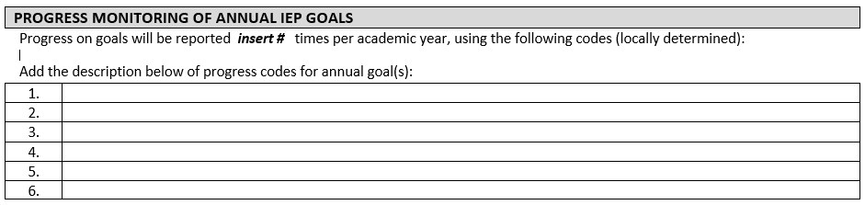
This section is used to:
- Describe how progress toward IEP goals will be reported for all children.
- Progress of annual goals should be reported as least as often as reporting occurs for non-disabled peers.

Directions:
- Indicate how progress toward IEP goals will be reported.

Section 5: MEASURABLE ANNUAL GOAL(S) (MUSER IX.3.A.(1)(b) & (c))
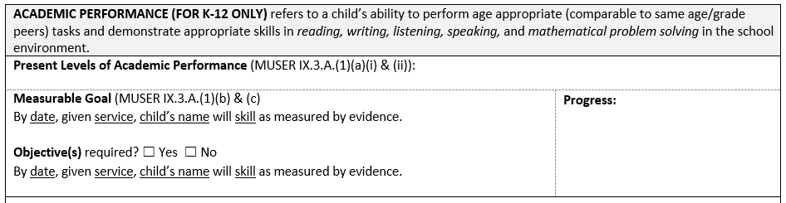
This section is used to:
- Provide baseline data of a child’s identified Needs and set reasonable, attainable, and challenging annual goals to lessen the adverse impact of the child’s disability and close the gap towards grade level performance.

Directions:
- This section is for Ages 5-20 only.
- Programming for children Ages 3-5 may include pre-academic needs, present levels, and annual goals, but it is considered a part of and should be documented in the child’s Developmental Performance.
- Academic performance refers to a child’s ability to perform age appropriate (comparable to same age/grade peers) tasks and demonstrate appropriate skills in reading, writing, listening, speaking, and mathematical problem solving in the school environment.
- Include statement(s) of the child’s current academic performance (baseline data) above each academic annual goal. The present level and annual goal should be aligned to the same skill. The IEP should include a present level and annual goal for all identified academic skill deficits listed in the Needs section. This statement should be written in a way that all members of the IEP Team can understand the current uniqueness of the child’s academic performance. This should not include specific levels of programs and curriculum as not all IEP Team members will have foundational knowledge of the program being used and its unique leveling.

IDEA requires that a statement of the present level of academic performance must be included in each IEP even if the child does not exhibit any academic deficits that require special education services. If the child does not exhibit academic deficits, the present level statement should be included above the first goal only.

Example:
“The child is academically commensurate with his/her peers.”

- Write a measurable goal related to the identified area of need.
  - To develop these goals, the IEP Team should reasonably calculate growth based on the present level of academic performance.
    - Describe conditions under which the child will demonstrate his/her abilities (Given…).
    - Describe the expected measurable improvement from the documented present level of performance with regard to the identified skill or behavior.
    - Describe how the improvement will be quantified.
When writing goals, there should be a direct alignment between an identified need, present level of performance and annual goal that allows the child to be involved and make progress in the general curriculum while receiving a provision of service. Goals should also be aligned with The Maine Learning Results: Parameters for Essential Instruction and Guiding Principles (Maine Department of Education Rules Chapter 132). Additionally, if the child is of transition age, the annual goals should directly support and promote the attainment of their post-secondary goals.

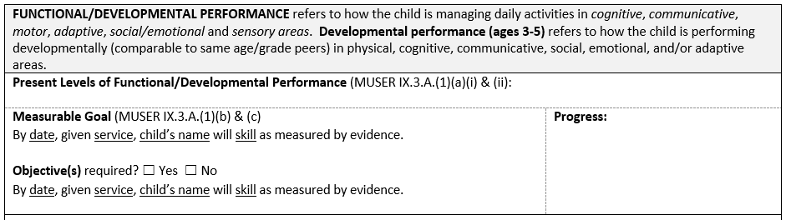
Directions:
- Developmental performance (Ages 3-5) refers to how the child is performing developmentally (comparable to same age/grade peers) in physical, cognitive, communicative, social, emotional, and/or adaptive areas.
- Functional/Developmental performance (Ages 5-20) refers to how a child is managing daily activities in cognitive, communicative, motor, adaptive, social/emotional and sensory areas.
- Include statement(s) of the child’s current functional/developmental performance (baseline data) above each functional/developmental annual goal. The present level and annual goal should be addressing the same skill. The IEP should include a present level and annual goal for all identified functional/developmental skill deficits listed in the Needs section. This statement should be written in a way that all members of the IEP Team can understand the current uniqueness of the child’s functional/developmental performance.

IDEA requires that a statement of the present level of functional performance must be included in each IEP even if the child does not exhibit any functional deficits that require special education services. If the child does not exhibit functional deficits, a present level statement should be included above the first goal only.

Example:
“Child is functionally commensurate with his/her peers.”

- Write a measurable goal related to the identified area of need.
  - To develop these goals, the IEP Team should reasonably calculate growth based on the present level of functional/developmental performance.
    - Describe conditions under which the child will demonstrate his/her abilities (Given…).
    - Describe the expected measurable improvement from the documented present level of performance with regard to the identified skill or behavior.
    - Describe how the improvement will be quantified.

Functional/Developmental present levels and annual goals should address gaps in the child’s functional/developmental performance, not intended and hopeful outcomes (attendance, work completion, passing classes/grades).

Example:
If a child is not attending school, the child’s IEP should not include a goal related to the child attending school 75% of the time. The functional/developmental needs, present levels, and goals should identify and address the gaps that are manifesting in the child not attending school (such as a need for instruction in the utilization of coping skills).

When writing goals, there should be a direct alignment between an identified need, present level of functional/developmental performance and annual goal that allows the child to be involved and make progress in the general education curriculum, or for preschool children, to participate in appropriate activities, while receiving a provision of special education or related service. Additionally, if the child is of transition age, the annual goals could directly support and promote the attainment of his/her post-secondary goals.

Section 6: SUPPLEMENTARY AIDS, SERVICES, MODIFICATIONS AND/OR SUPPORTS
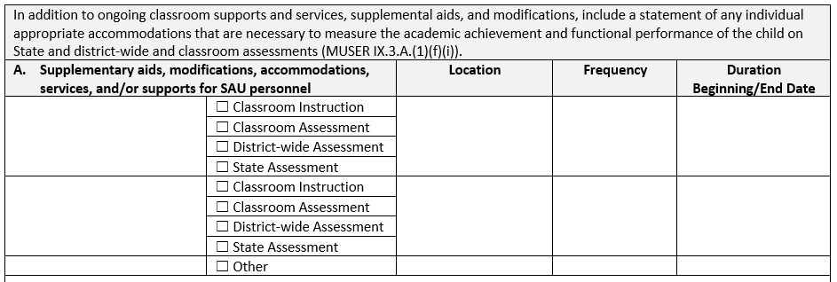
This section is used to:
- Identify accommodations, modifications and supplementary aids and services that are necessary and aligned to the child’s disability. This is to ensure that the child advances appropriately toward attaining his/her annual goals, to be involved in and make progress in the general education curriculum, to participate in extracurricular and other nonacademic activities and to be educated and participate with his/her non-disabled peers.

Accommodations mean changes in the manner in which instruction and assessment is delivered that does not alter the curriculum level expectation being measured or taught.

- Identify any appropriate accommodations that are necessary to measure the academic achievement and functional performance of the child on State and district-wide assessments.

Modifications mean changes in the regular education curriculum and/or assessment that lower the standards of the curriculum.

- “Other” could include accommodations, modifications, and supplementary aids and services that occur across all educational settings which may include: Behavior or Health Plan, 3-Point Harness, Wheelchair Accessible Transportation.
- “Other” could include collaboration and recommendations from related service providers that are not directly related to an annual IEP goal (For example, manipulation of the child’s environment or instructional materials).
- Medical needs that impede a child from accessing FAPE should be addressed in the IEP through referring to a child’s individual health plan. This also includes behavioral health professionals.

Educational Technicians or BHPs providing behavioral health services are always documented in Section 6 as determined by the IEP Team.

- Examples include:
  - Supports to address environmental needs [e.g., preferential seating, planned seating (on the bus, in the classroom, at lunch, in the auditorium, and in other locations), or altered physical room arrangement]
  - Child’s specialized equipment needs (e.g., wheelchair, computer, software, voice synthesizer, augmentative communication device, utensils/cups/plates, restroom equipment)
  - Pacing of instruction needed (e.g., breaks, more time)
  - Presentation of subject matter needed (e.g., taped lectures, sign language, primary language, paired reading and writing)
  - Materials needed (e.g., tests and notes scanned into computer, shared note- taking, large print or Braille, assistive technology, home set of materials)
  - Assignment modification needed (e.g., shorter assignments, taped lessons, instructions broken down into steps, child allowed to record or type assignment)
  - Self-management and/or follow-through needed (e.g., calendars, teach study skills, use of orientation and mobility tools)
  - Testing adaptations needed (e.g., read test to child, modify format, extend time)
  - Social interaction support needed (e.g., provide Circle of Friends, use cooperative learning groups, teach social skills)
  - Training needed for personnel assisting in the use of identified Assistive Technology.

Directions:
    - Statement of supplementary aids, modifications, accommodations, services, and/or supports for SAU personnel.

Ensure that all fields are considered and complete.

- First column: Describe the supplementary aid, modification, accommodation, service or support.
- Second column: Indicate all circumstances where the above would be used. An accommodation may only be used for district or statewide assessment if it is used in the classroom.
- Third column: Indicate where the supplementary aid, modification, accommodation, service or support will be used.
- Fourth column: Indicate when the supplementary aid, modification, accommodation, service or support will be used. (“As needed” could be an appropriate response in this column if the accommodation requires flexibility in its frequency.)
- Fifth column: Indicate the beginning and end date for use of the supplementary aid, modification, accommodation, service or support. Supplementary aids, modification, accommodations, services or supports may begin or end anytime during the duration of the IEP. Amendments to the IEP may affect the beginning date but should not extend beyond the duration of the annual IEP.
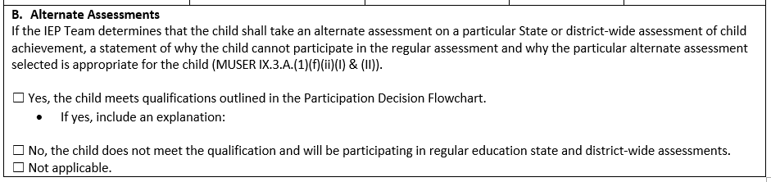
    - Alternate Assessments
      - Document if the child meets or does not meet the qualifications for the alternative assessment using the Participation Decision Flowchart below.
      - If yes, provide explanation of why the child cannot participate in the regular district-wide or State-wide assessment and why the alternate assessment selected is appropriate.
      - If the IEP Team completes the Participation Decision Flowchart, and the child does not meet the qualifications, check No.
      - If the IEP Team did not consider the Alternate Assessment as it was determined not appropriate for the child, or the child’s grade dictates that no state/district-wide assessments will be completed that year, check Not applicable.
      - The Maine’s Alternate Assessment Participation Guidelines can be found at the following website:
        - https://www.maine.gov/doe/alternate/MAINEAlt.Guidlines.pdf
      - The Participation Decision Flowchart can be found at the following website:
        - https://www.maine.gov/doe/alternate/ParticipationDecisionFlowchart.pdf

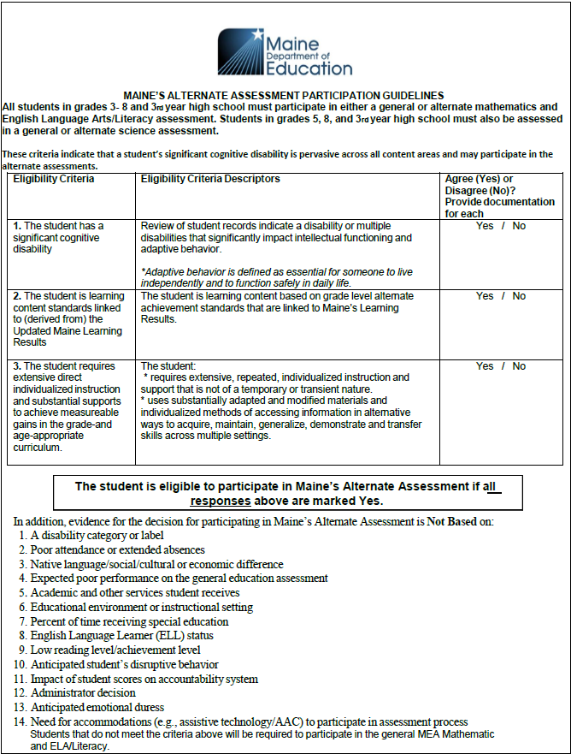
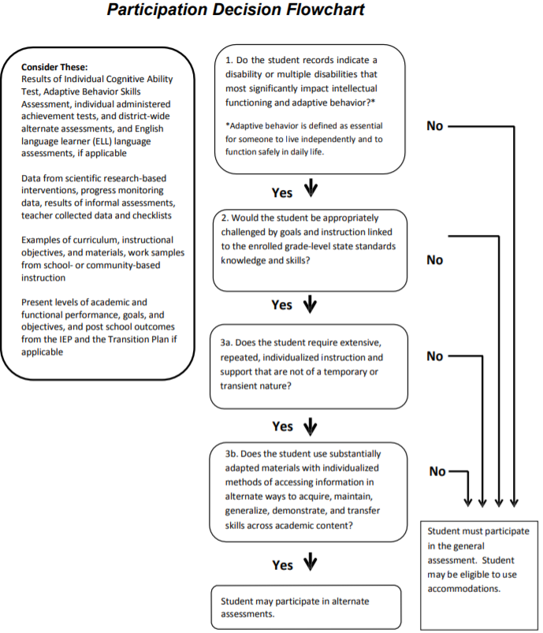

Section 7: SPECIAL EDUCATION AND RELATED SERVICES
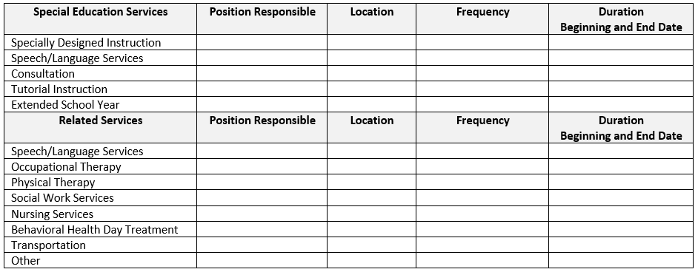
This section is used to:
- Document any special education and related services including ESY services.

Special Education Services
Directions:
- Indicate the specialized instruction services the child requires. For children ages 5-20, each identified instructional area should be listed unless the child is accessing a self-contained program.
- Indicate the position of the properly certified or licensed personnel who will be responsible for the identified specialized instruction area. Only the role of the person should be identified, not specific individuals by name. This allows for continuation of services when there are changes in staff or when the child changes schools.
- Indicate the location where the service will be provided. Be reasonably specific, e.g., specific general education setting, specific special education setting, related service room, etc.
- Indicate frequency of services. Identify how many minutes the provider will work with the child on a daily, weekly or monthly basis. Totals should be tallied for ease of data collection. Frequency should be written so as to facilitate calculation of LRE. The frequency of direct and related services should be documented in a way that does not exceed the school day or school week.
- Indicate the start date. Services indicated should ordinarily begin on the Effective Date of the IEP with the exception of ESY Services.
- Indicate the end date. The date indicates the anticipated duration of the service.
- Extended School Year for related services should be delineated in the appropriate category.
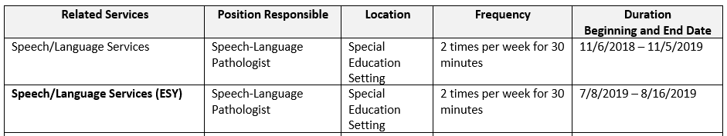

Speech/Language services are a direct special education service when:
- The child is a child with a Speech/Language impairment (solely or as a part of a Multiple Disability)
- The child is a child with Autism and Speech/Language services are the child’s only service.

Related Services
- Related services are to assist the child with a disability to benefit from his/her special education programming such as Speech/Language, OT, PT, Health Services, and Social Work.
Directions:
- Indicate the related services the child requires in order to benefit from his/her educational program.
- Indicate the service provider who will be responsible for the identified related service. Only the role of the person should be identified, not specific individuals by name. This allows for continuation of services when there are changes in staff or when the child changes schools.
- Indicate the location where the service will be provided. Be reasonably specific, e.g., specific general education setting, specific special education setting, related service room, etc.
- Indicate frequency and duration of services. Identify how many minutes/hours the provider will work with the child on a daily, weekly, bi-weekly or monthly basis. Totals should be tallied for ease of data collection. Frequency should be written so as to facilitate calculation of LRE. The frequency of direct and related services should be documented in a way that does not exceed the school day or school week.
- Indicate the start date. Services indicated should ordinarily begin on the Effective Date of the IEP with the exception of ESY Services.
- Indicate the end date. The date indicates the anticipated duration of the service.

Speech/Language services would be delivered as a related service in cases where a child has a need for speech/language services in order to benefit from their special education program. In these cases, the child does not need to qualify as a child with a Speech or Language Impairment. Do not use the Speech/Language Eligibility form to make determinations about speech/language as a related service.

If a child requires support from a behavioral health professional in a day treatment setting, the frequency of that support should not be considered in the calculation of the LRE percentage. The frequency of this service is not in lieu of specially designed instruction, the frequency of this service is in addition to special education and other related services.

Only a credentialed school nurse can provide “Nursing Services”. If an appropriately trained special education staff member or a related service staff member provides the service, it should be documented in Section 7 as “School Health Services”.

A Related Service must have a clear purpose and be educationally relevant and necessary. Teams should consider the following:

- Is the proposed related service educationally relevant?
  - Consider whether this potential service is educationally relevant. Educational relevance exists when a proposed service can be explicitly linked with a component of the child’s educational program. Example that is educationally relevant: If an occupational therapist recommends support for a child’s handwriting skills and handwriting is on the IEP or is part of the general education curriculum the child is pursuing, it is educationally relevant. Example that is not educationally relevant: If a physical therapist recommends that the Team work on a series of exercises designed to improve a child’s balance so she can learn to ride a bicycle and bike riding is not part of the educational program for this child (e.g., not an IEP goal, not a part of the general education curriculum), the proposed service is not educationally relevant because it cannot be explicitly linked to a component of the child’s educational program.

- What is the purpose of the proposed related service?
- In considering whether to accept a recommendation to provide a proposed service, the Team should clearly understand the purpose. A clear purpose promotes effective implementation and evaluation. Sometimes the purpose of providing a related service is to:
- select and monitor the use of equipment,
- make adaptations,
- transfer information/skills to other team members,
- be a resource or support to families, or

- Is the proposed related service educationally necessary?
  - Establishing educational relevance and understanding the purpose of a service are not sufficient to warrant service provision. The service also must be educationally necessary. If a proposed service, with a clear purpose, is determined to be educationally relevant, it is time to consider whether it is educationally necessary by asking the following questions (Giangreco, 1996):
- If the Team answers, “Yes” to the following question, it is an indication that the service under consideration probably is educationally necessary:
  - Will the absence of the service interfere with the child’s access to or participation in his or her educational program this year?
- If the Team answers, “Yes” to any the following questions, the service under consideration probably is not educationally necessary:
  - Could the proposed service be addressed appropriately by the special educator or classroom teacher?
  - Could the proposed service be addressed appropriately through core school faculty or staff (e.g., school nurse, guidance counselor, librarian, teachers, administrator, bus drivers, cafeteria staff, or custodians)?
  - Has the child been benefiting from his or her educational program without the service?
  - Could the child continue to benefit from his or her educational program without the service?
  - Could the service be appropriately provided during non-school hours? (This question is based on the 1984 U.S. Supreme Court Tatro decision)
  - Does the proposed service present any undesirable or unnecessary gaps, overlaps, or contradictions with other proposed services?

Transportation is always a related service. When the IEP team also determines that the transportation service has an instructional component (e.g. modifying the behavior that necessitates the provision of a transportation aide, or learning to utilize a safety harness), there must be an annual goal in the IEP corresponding to that instruction.

Section 8: LEAST RESTRICTIVE ENVIRONMENT
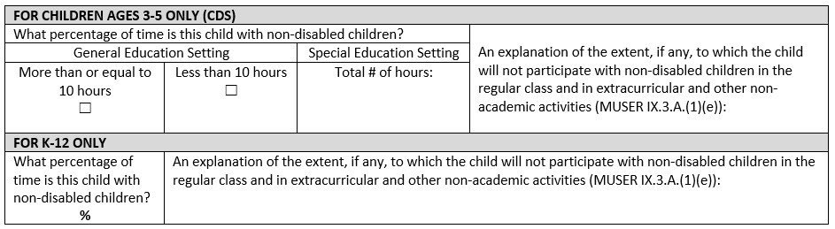

This section is used to:
- Document for children ages 3-5 the number of hours spent in the general education setting and in the special education setting.
- Document the specific percentage of time that the children ages 5-20 spend with non-disabled children.

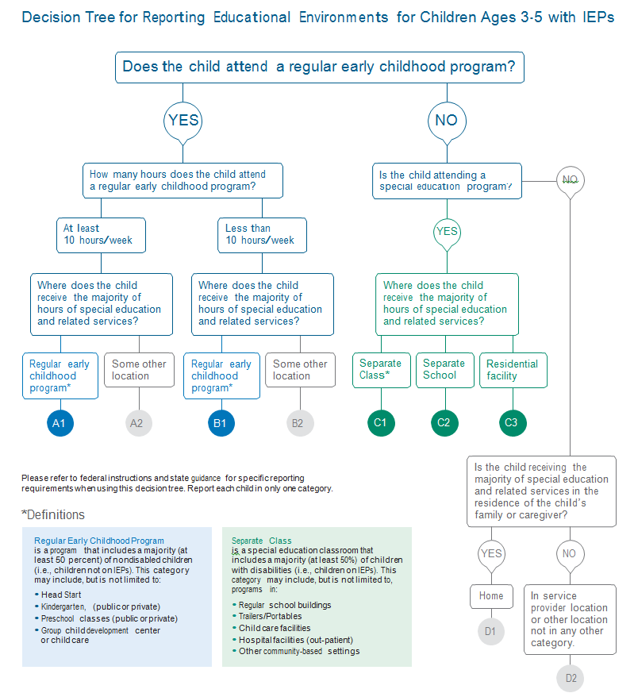
Directions:
- For children ages 3-5
  - Indicate how many hours a child is in a general education or special education setting.
  - In the explanation, you must include the nature and severity of the child’s disability as well as the location where the child will receive the majority of his/her special education and related services in addition to why the child will not participate with non-disabled children.
  - Reference the following decision tree for additional information.

- For children ages 5-20
  - Identify and explain the nature and severity, of the child’s disability, and the extent in which they will not be participating with non-disabled children in the regular education class and in extracurricular and other nonacademic activities.
  - This statement does not need to include frequency of accommodations and services as they are already documented in previous sections.
- Reflect the specific percentage of time with non-disabled children. A range cannot be utilized.
- N/A is not acceptable. If child is with non-disabled peers 100% of the time, state that in this section.

Section 9: POST-SECONDARY TRANSITION PLAN
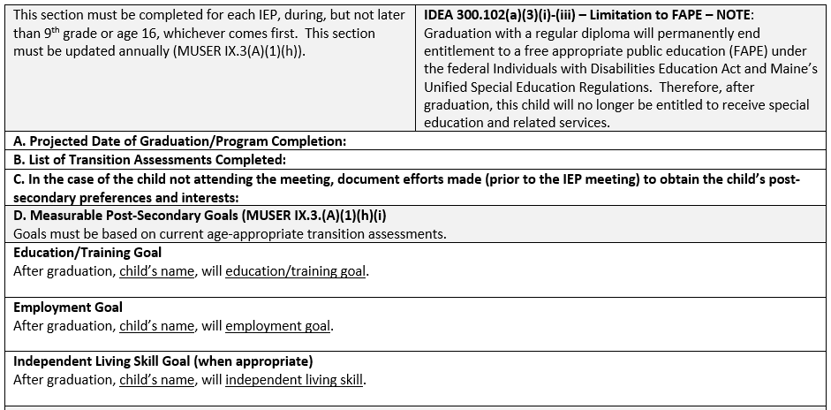
This section is used to:
- Identify the coordinated set of transition activities for children beginning in 9th grade or age 16, whichever comes first. This section may be used earlier if deemed appropriate by the IEP Team.

Directions:
- Projected date of graduation/program completion:
- This date should reflect the month and year that the Team anticipates the child will reach graduation or high school completion. It can be adjusted based on objective criteria (total credits earned, or standards met) at each annual review.

B. Transition Assessments Completed
- Indicate the age-appropriate transition assessments used to develop the post- secondary goals. As a means to show annual movement, it is encouraged, but not required, to include the year in which the assessment was provided.
- At least one transition assessment should be completed annually prior to the meeting where transition planning is being discussed. Cumulative list of transition assessments completed could be documented to show movement towards attainment or progress towards post-secondary goals.
- Completed transition assessment data serves as the common thread in the transition process and forms the basis for defining goals and services to be included in the IEP. Documenting transition assessment data and/or results in the IEP is encouraged, but not required. These results can be documented in Section 4 of the IEP but is not required.

- When a child is in 9th grade, but no later than when the child is 16, whichever comes first, an age-appropriate, transition-focused assessment process must be used to identify post-secondary goals.
- Use formal and informal methods of gathering data related to the child’s interests, preferences, aptitudes and abilities as they relate to and align with the skills needed for the child’s given interest area.
- The assessment process considers multiple data sources to facilitate discussions and decision making in the development of the post-secondary transition plan; it is not the administration of a single assessment instrument. Types of transition assessments include: interview with child and/or parent, observations, behavioral assessment information, aptitude tests, interest and work values inventories, personality or preference tests, career maturity or readiness tests, self-determination assessments, work-related temperament scales, and transition planning inventories.
- Transition assessments are not required for eligibility and may not require parental permission to administer.

C. If the child attended the IEP meeting, it should be noted in this section of the IEP. Otherwise, document the efforts prior to the IEP Team meeting to obtain information about the child’s preferences and interests. Documentation may include the date in which the information was obtained from the child.

D. Write measurable post-secondary goals aligned with the child’s interests, preferences, aptitudes, and abilities. Sensitivity to the child and his/her family’s cultural, racial, and ethnic value systems must be considered in the development of the post-secondary goals. The family structure, personal resources, and familiar cultural norms are potentially all elements of scrutiny and consideration when developing the post-secondary goals and will guide the rest of the IEP.
- It is critical that transition assessment data and the child’s participation are utilized in the development of their measurable post-secondary goals in the areas of education or training, employment, and independent living.
  - Measurable post-secondary goals must indicate what the child “will do” after graduation or exiting school district services through attainment of the maximum age of service provision (age 20), and what education/training is necessary to attain chosen career path.
  - Measurable post-secondary goal statements should be written as complete sentences with an established timeline (after graduation and post-secondary education/training) and observable outcome (place of employment and/or chosen field).
  - Measurable post-secondary goals are the cornerstone of effective transition planning and are written before the annual goals are developed as to guide the planning process. Without a clear direction for post-secondary living, working, and learning, a comprehensive plan reflecting a coordinated set of activities designed within a results-oriented plan cannot occur.
  - Measurable post-secondary goals should continue to evolve (showing movement) from year-to-year based on the child’s interests, transition assessment results, and transition activities and services.

As Teams design post-secondary goals, adherence to the following must be complete:
- The post-secondary goals reflect an outcome, not a process.
- Must be measurable (observable and defined).
- Should reflect a real intent or plan (not simply stating the hopes and desires of a child, but an intentional plan to achieve the goal).
- Must reflect the child’s interests and preferences.
- Must utilize assessment for development.

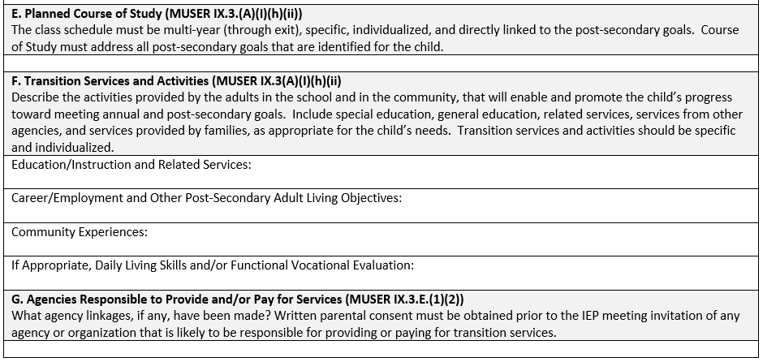
This section is used to:
- Identify the planned course of study.
- Outline the transition services and activities needed to support the child, including education, employment, community and daily living/functional skills.
- Identify adult service agencies that will be needed to assist the child with post-secondary goals.

Directions:
E. A course of study can include course titles and descriptions of how the courses will lead to the acquisition of post-secondary goals. The course of study must:
  - Promote movement toward and skill acquisition for the post-secondary goals
  - Indicate a multi-year high school plan (current status to anticipated exit date)
  - Reflect the child’s preferences and his/her unique interests.
  - Relate to the child’s needs
  - Be more specific than just completing graduation requirements
  - Pass the stranger test (e.g., would someone unfamiliar with the child completely understand the courses necessary to facilitate a meaningful and effective transition-focused class schedule?)
  - Be clearly transferable (e.g., can another school build a schedule based on the information in the course of study?)
  - Provide a clear description of course needs, in the pursuit of the post-secondary goals

F. Transition services and activities may include related services, community experiences, and services related to employment and other independent living objectives that are occurring during the life of the IEP with adult support.

There must be at least one transition service for each post-secondary goal; however, it is possible that a number of the transition services described below might apply to more than one post-secondary goal.

- Education/Instruction and Related services include:
  - Transportation
  - Developmental, corrective, and other supportive services including:
    - specially designed instruction
    - speech-language pathology and audiology services
    - interpreting services
    - psychological services
    - physical and occupational therapy
    - recreation, including therapeutic recreation
    - social work services
    - school nurse services
    - counseling services, including rehabilitation counseling
    - orientation and mobility services
    - medical services
- Instruction in specific areas that the child needs to:
  - Complete needed courses
  - Succeed in the general curriculum
  - Gain needed skills
- Career/Employment and Other Post-Secondary Independent Living Objectives are components of a transition program required to achieve desired post-secondary goals. (This is not a restatement of the goal, but rather a description of the activities that are necessary to accomplish the goal.)
  - These objectives could include career/employment/adult living skills such as:
- Exploring internships
- Job seeking and keeping skills
- Job site training
- Registering to vote
- Filing taxes
- Renting a home
- Accessing medical services
- Filing for insurance or accessing adult services such as Social Security Income (SSI)
- Community Experiences are one component of a transition program that is provided outside the school building or in community settings.
  - Examples could include:
    - Community-based work experiences and/or exploration
    - Banking
    - Shopping
    - Transportation
    - Recreation activities

- If appropriate, Daily Living Skills and/or Functional Vocational Evaluation describes components of a transition program that may be considered, if appropriate, to support the child’s ability to do the routine tasks of adulthood.
  - These may include:
  - Preparing meals
  - Budgeting/Paying bills
  - Maintaining a home
  - Caring for clothes
  - Hygiene
The description of these services need not be duplications of the services outlined on the special education services page but should include those services specifically designed to help the child move toward the attainment of his/her post-secondary goals.

G. The IEP Team must identify any potential adult service agencies that are necessary to facilitate the implementation of post-secondary goals.
- If the SAU determines that outside agency services are necessary:
  - List in this section of the IEP the agencies that have agreed to be responsible to provide or fund services in the coming year.
  - Prior to inviting any agencies, the school must obtain written prior consent from the parent or adult student using the Consent to Invite Outside Agencies form. This form must be retained by the SAU in the child’s educational record and the process repeated before every post-secondary transition meeting.
  - If a family or adult student decline to give written consent to invite an agency, it should be noted in this section and clearly documented in the Written Notice.
- Example: “Child and family have been informed of agency connections and potential benefits of services but decline to pursue services at this time.”
- Once an agency connection has been identified and the school has obtained the appropriate written consent to invite the agency, invitations to the appropriate agencies should be extended via the Advance Written Notice.
- If a representative from the agency is unable to attend, the school must ensure that the parents/child understand the need to connect with the agency. Since actual eligibility for services from most agencies involves unique intake processes, schools must make an effort to assist parents and children in compiling the necessary eligibility information.
- If the SAU determines that outside agency services are NOT necessary
  - If an adult service agency is NOT currently needed due to the child’s age, current needs for such services, or other factors, provide a simple explanation of why agency connections are not necessary.
  - Examples of this documentation include:
    - “Child is not currently eligible for services related to this post-secondary goal at this time.
    - “Child does not require services from outside agencies at this time.”
    - “Child is too young for services from adult agencies at this time.”
    - “NA”

Section 10: AGE OF MAJORITY
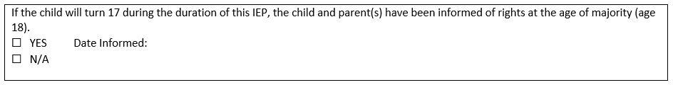
This section is used to:
- Indicate whether the child and parent(s) have been informed of the transfer of rights.

Directions:
- Indicate the date that the child and parent(s) were informed of the transfer of rights at the age of majority (18). This should be completed at or before the IEP meeting for the year the child will turn 17. This date should not change.

Age of Majority should be documented in the IEP and can be documented in the Written Notice.

Parental Consent to Evaluation
This form is used to:
- Document parent consent or lack of consent to evaluate.
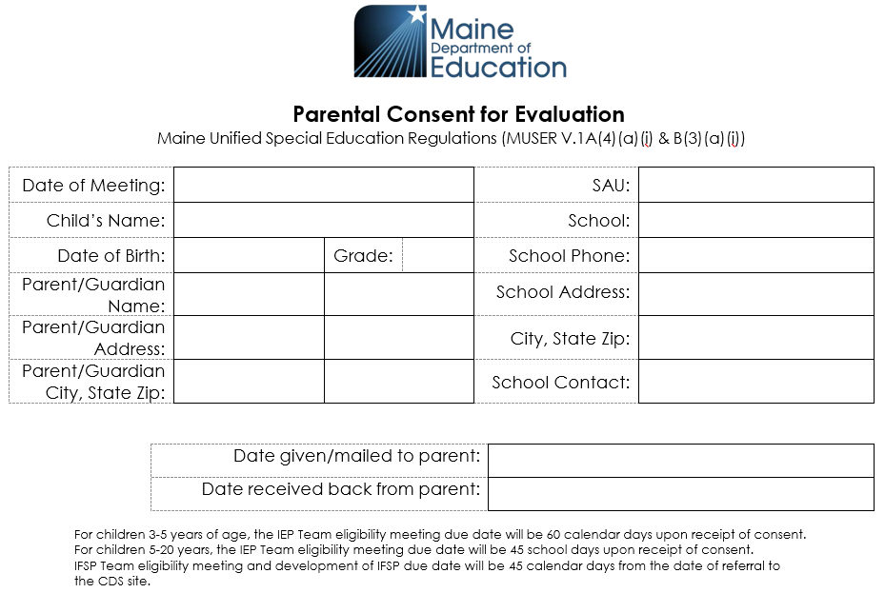
This section is used to:
- Document pertinent child-related information.

Directions:
- Use this form when conducting one or more individual evaluations that result in an evaluation report.
- Record the date that the form was sent to the parent.
- Record the date that the form was received back from the parent.

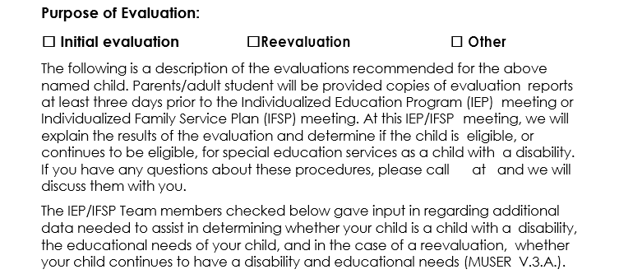
This section is used to:
- Indicate the purpose of the evaluation(s) that is/are being requested.
Directions:
- “Other” would include:
  - Functional Behavioral Assessment
  - Risk/Safety Assessment
  - Orientation/mobility assessment
  - Additional evaluations as determined by the IEP Team beyond the initial or re-evaluations

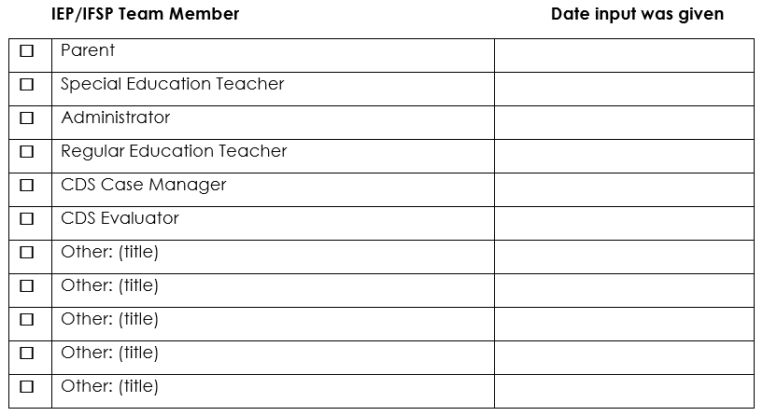
This section is used to:
- Indicate the members of the IEP Team that determined the evaluations to be conducted.

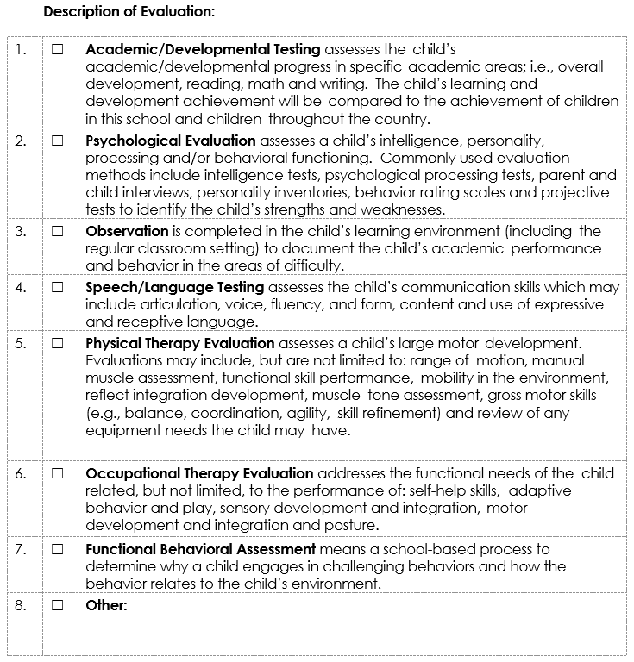
This section is used to:
- Indicate the assessments/evaluations that are being proposed.

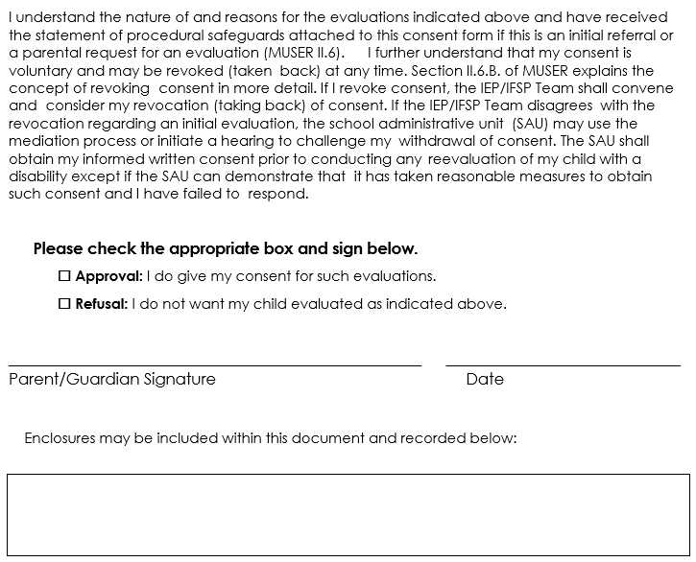
This section is used to:
- Document the parent’s consent or refusal of consent for evaluation.
- Document any enclosures that are included with this form (e.g. procedural safeguards for initial referral).

Parental Consent to Invite Other Agencies to IEP Meetings – Postsecondary Goals & Transition Services

This form is used to:
- Document parent consent or lack of consent to invite outside agencies to an IEP meeting to discuss post-secondary goals and transition services.
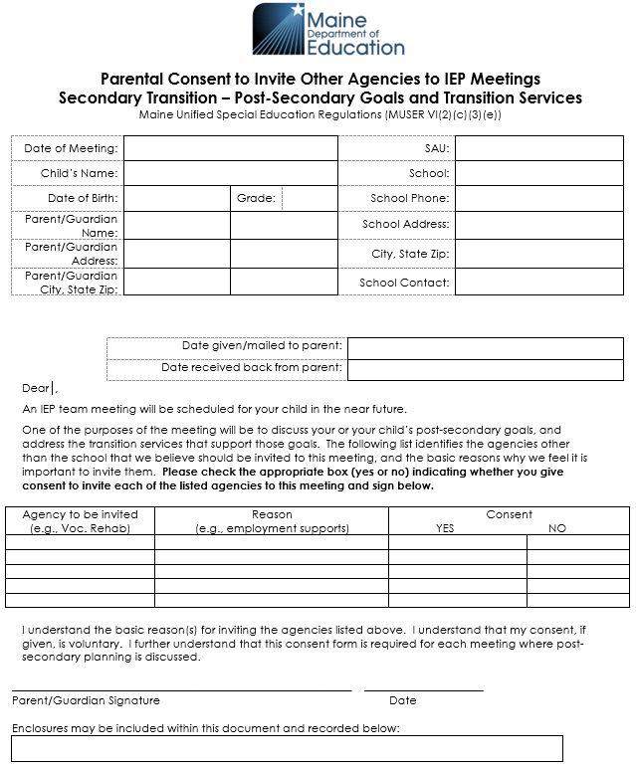
Directions:
- Make sure the dates when the form was given and received are filled in.
- This form does not need to be used when parents have invited the representatives of outside agencies.

Representatives of outside agencies may not be invited to attend unless parents have given their consent.
- Make sure that parents have checked either “Yes” or “No” in addition to providing their signatures.

A release of information does not substitute for parents’ signature on this form.

Referral for Special Education Services

This optional form is used to:
- Provide a written record of a child’s referral for special education services. This (optional) form may be used to support the SAU’s referral process under IDEA’s child find requirement. The use of this form is not intended to delay the referral process of a child with a suspected disability.

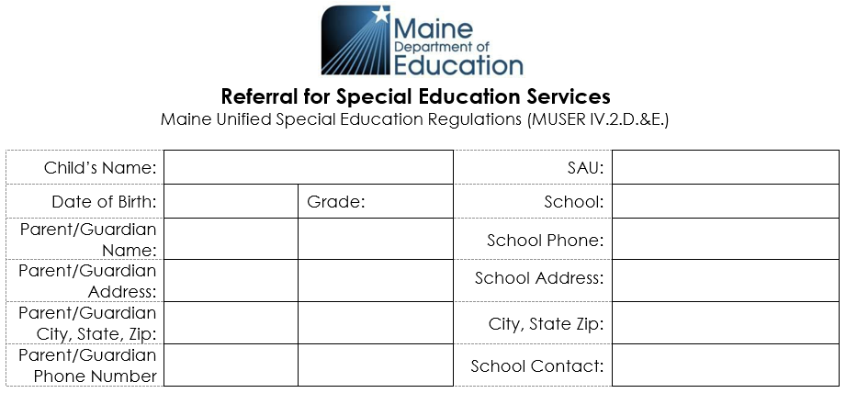
Directions:
- Document the pertinent child-related information (including the parent/guardian’s phone number)

This section is used to:
- Identify the referring person(s).

Directions:
- Document the name of the referring party and circle their title.
- If other, please specify role. (Grandparent, Outside Agency, Non-Teaching Staff, Guardian, etc.)
- Either parent can refer a child for special education services at any time.
This section is used to:
- Document the referral question related to the suspected disability.

Directions:
- Identify the specific concerns regarding the child’s performance including the adverse impact on the educational setting in the form of a question (e.g. Is the child’s inability to comprehend grade level literature due to a learning disability?).
- The question will assist the IEP Team in determining appropriate evaluations, however, this section should not include requests for specific evaluations.
- The question should not include generic concerns (not completing work, can’t sit still, inappropriate behavior, not a good reader, etc.).
- If a parent referral, the question should include the parent’s concerns for the education of their child as they relate to the suspected disability.

This section is used to:
- Document parent input and the date which it was obtained.

Directions:
- Documents conversation(s) (phone, email, letters, etc.) that identify parent concerns.
- Parent concerns must be solicited and documented in this section.
- If a parent referral, parental input should be documented throughout the referral form.

This section is used to:
- Document any other outside input.

Directions:
- Documents input from outside agencies or other providers (if applicable).
- Could include outside evaluations provided by the family.

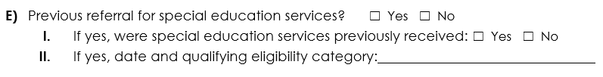
Directions:
- Documents if the child has been referred and/or received special education services in the past.
- If yes, special education documents should be included in the child’s cumulative file and considered as part of the referral.

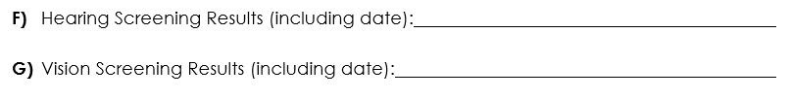
Directions:
- Must be completed to ensure that the evaluation results are valid and reliable.
- Should indicate if the child requires glasses or hearing aids.

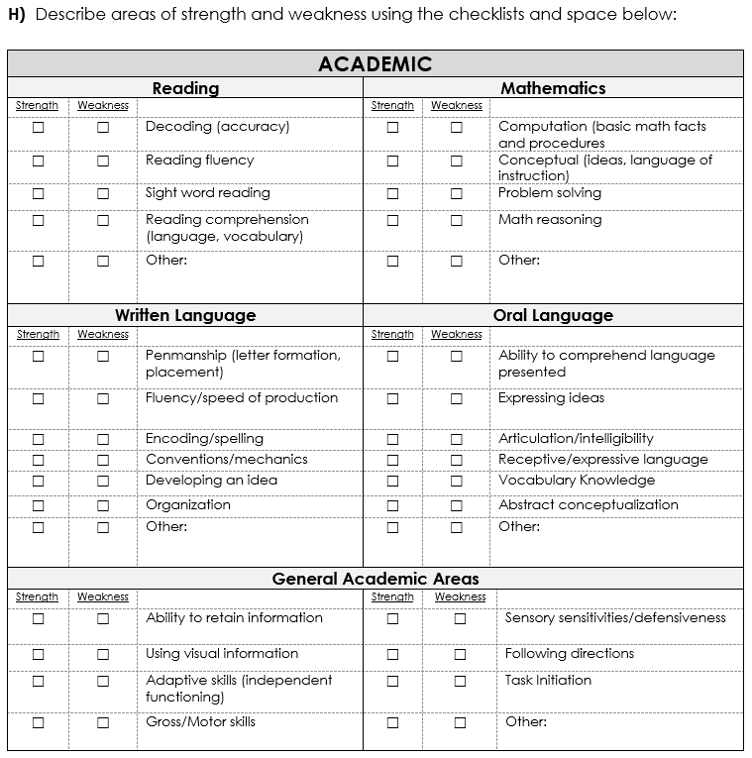
This section is used to:
- Identify the academic strengths and weaknesses of the child.

Directions:
- Every single box is not required to be completed, but the boxes checked should be directly related to the referral question(s).
- Areas checked should be outside of the “average range” (25th-75th percentile), and should be supported by multiple and reliable data sources and attached to this document.
- If “Other” is checked, it should be specified and supporting documents should be included.
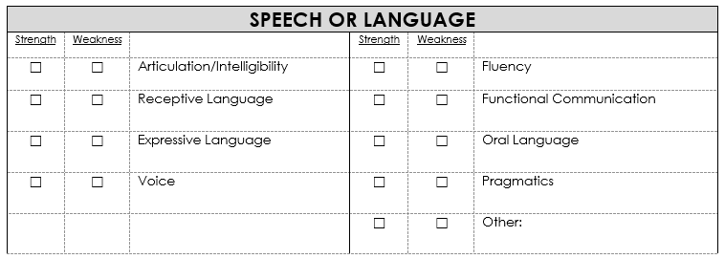
This section is used to:
- Identify the Speech or Language strengths and weaknesses of the child.

Directions:
- Every single box is not required to be completed, but the boxes checked should be directly related to the referral question(s).
- Areas checked should be outside of the “average range” (25th-75th percentile) and should be supported by multiple and reliable data sources and attached to this document.
- If “Other” is checked, it should be specified and supporting documents should be included.

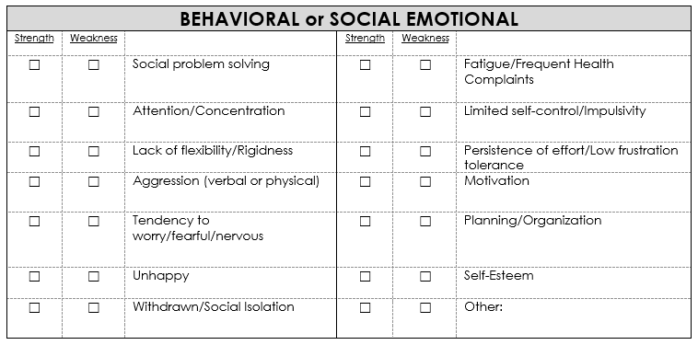
This section is used to:
- Identify the behavioral or social emotional strengths and weaknesses of the child.

Directions:
- Every single box is not required to be completed but should be directly related to the referral question(s).
- If “Other” is checked, it should be specified and supporting documents should be included.
- Behaviors should be documented through observation and data collection to demonstrate frequency and intensity outside the norm when compared to his/her same aged/grade level peers.
- All supporting documents should be attached to this form.

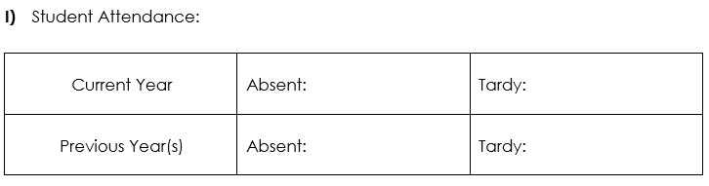
This section is used to:
- Document the attendance of the child.

Directions:
- Attendance trends should be identified and may require data from more than one year.

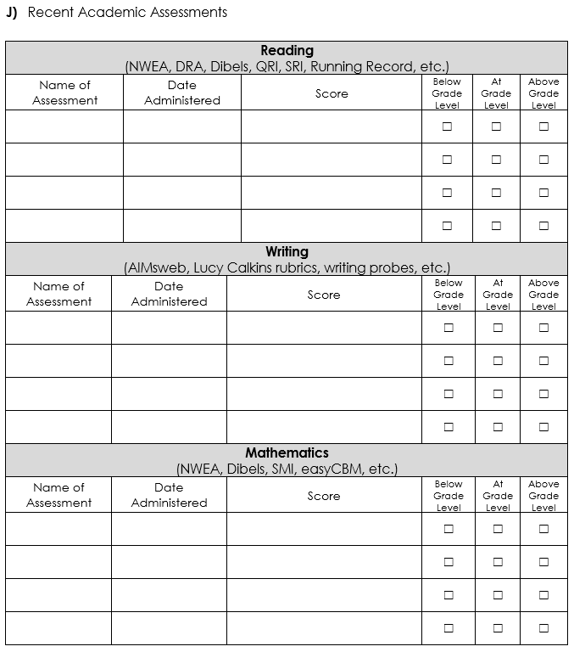
This section is used to:
- Document the child’s current assessment results in reading, writing, and mathematics.
Directions:
- This information should be included to enable appropriate identification of strengths and weaknesses in the child’s educational performance.
- If an assessment is listed, all subsequent sections should be completed.
- Provide information that captures the child’s performance when compared to their typically developing peers.
- Assessment data more than 3 years old should not be included.

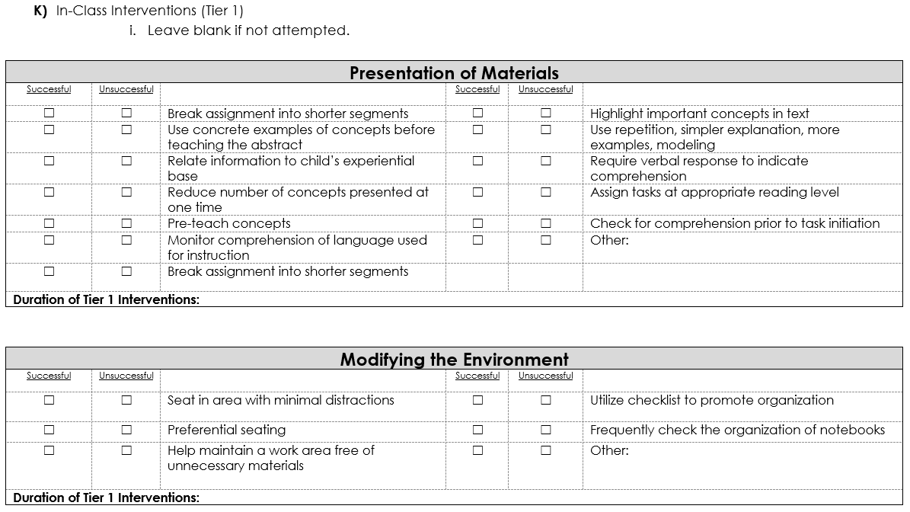
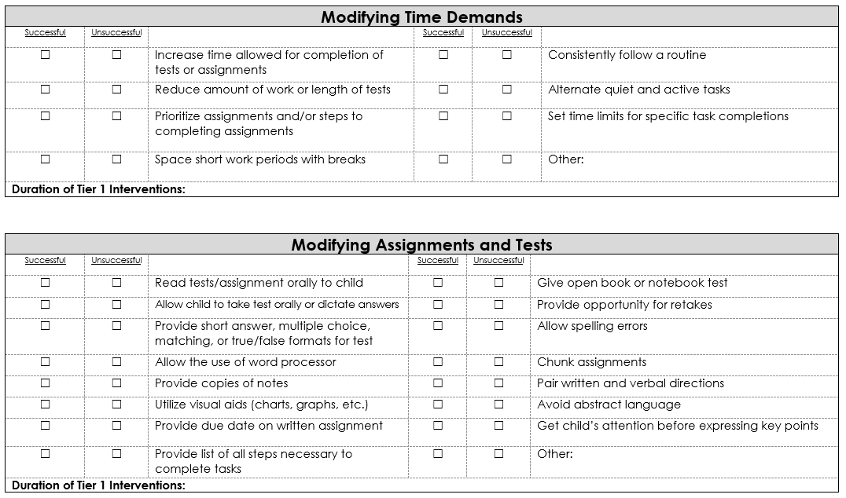
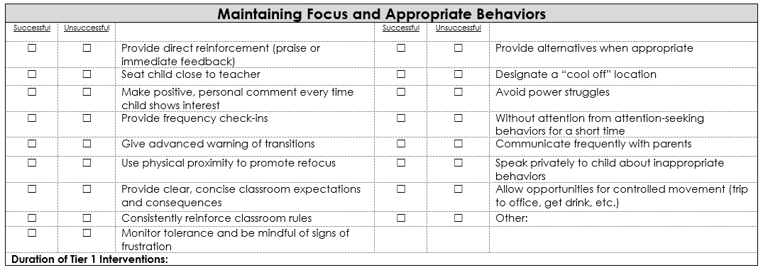
This section is used to:
- Document the in-class interventions (Tier 1) that were attempted.

Directions:
- If an in-class intervention was attempted, check whether the intervention was successful or unsuccessful.
- If an in-class intervention was not attempted, leave the box blank.
- If “Other” is indicated, please specify the intervention.
- The duration of the attempted interventions should be included as well.
- This section cannot be left blank.

If a parent referral, interventions should begin immediately and continue through the referral process.

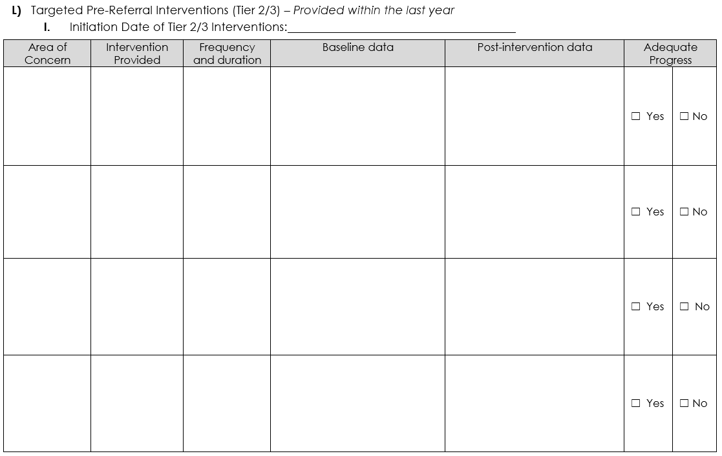
This section is used to:
- Identify the Tier 2/3 interventions that were attempted.

Directions:
- Local pre-referral policy should be consulted prior to completion of this section.
- Tier 2/3 services could include: Title 1, reading and mathematics interventions, behavioral consultation, PBIS, etc.
- Intervention Provided should include the specific skill deficits and the specific program used.
- Frequency and duration should include the length and intensity of the intervention.
- Adequate Progress is measured by multiple data points that show evidence of trends towards the target.
- The intervention being implemented should include tools that allow for adequate progress monitoring.
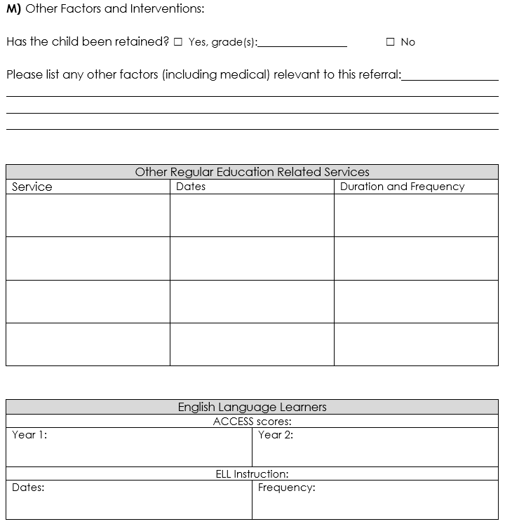
This section is used to:
- Document any other factors that should be considered in the referral.

Directions:
- Other factors could include: homelessness, hospitalizations, highly mobile, family disruptions, etc.
- Other Regular Education Related Services could include: social work, guidance counseling, behavior consultation, substance abuse counseling, JMG, Alternative Education, CTE, credit recovery programming, outside agency involvement, learning labs, etc.
- English Language Learners should document two years of ACCESS scores, dates of administration from initiation of services, and frequency of ELL instruction.
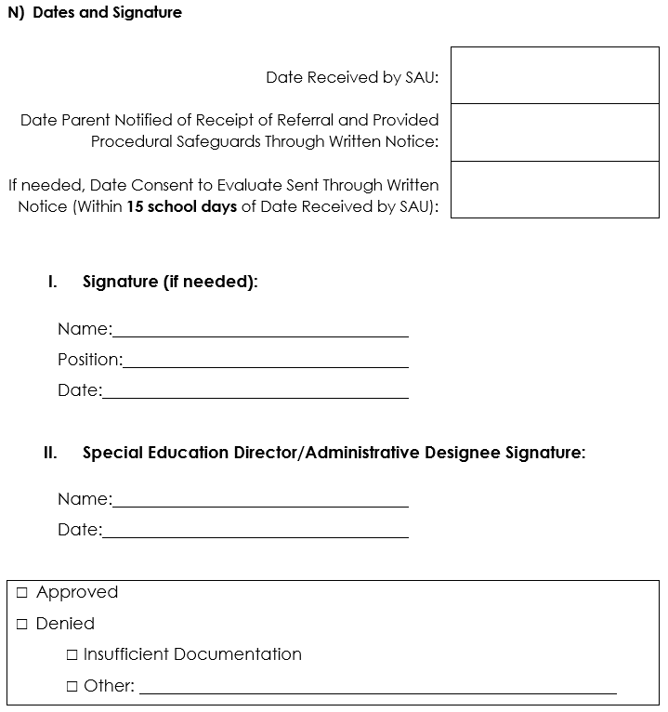
This section is used to:
- Document the date the referral was received and whether it was approved or denied.

Directions:
- The Date Received by SAU is defined by local policy and could initiate regulatory timelines.

Revocation of Parental Consent for Special Education

This form is used to:
- Document a parent’s revocation of special education services.

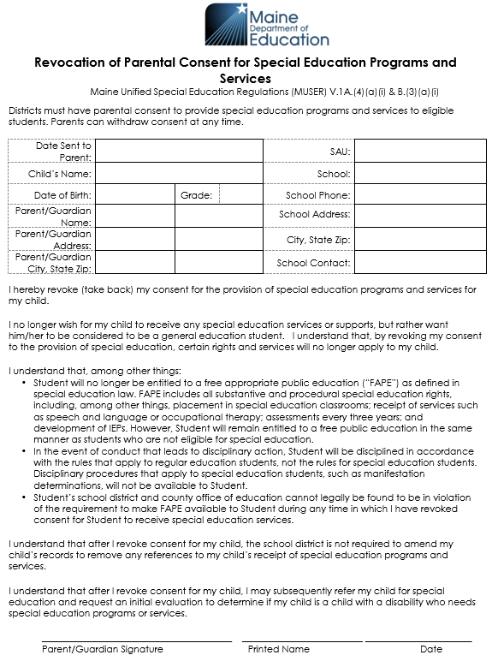
Seven Day Waiver

This optional form is used to:
- Document a parent’s decision to waive their right to Written Notice (WN) 7 days prior to any proposed or refused action being taken by the SAU.

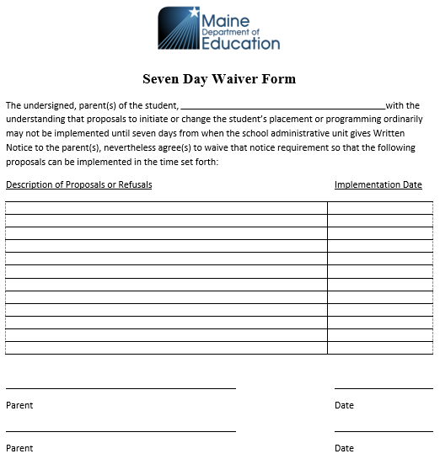

Directions:
- Proposals or refusals documented in Section 1 of the WN should be documented on this form along with the proposed implementation date.
- If a parent waives their right to WN, it must be documented in Section 1 of the WN.
Specific Learning Disability Eligibility Form

This form is used to:
- Determine the child’s eligibility for special education services as a child with a Specific Learning Disability.

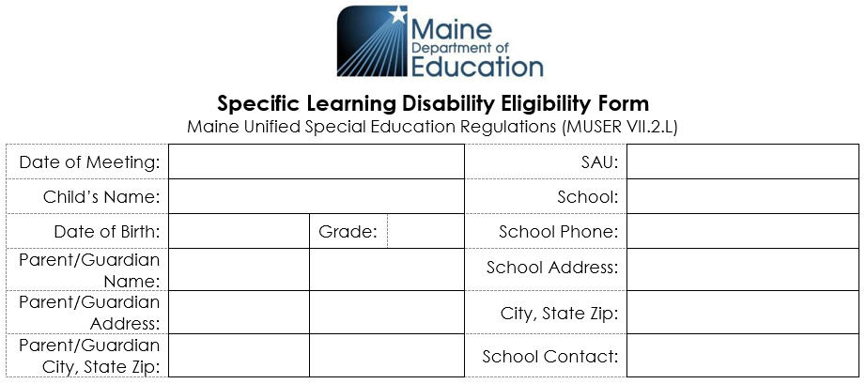
This section is used to:
- Document the pertinent child-related information.

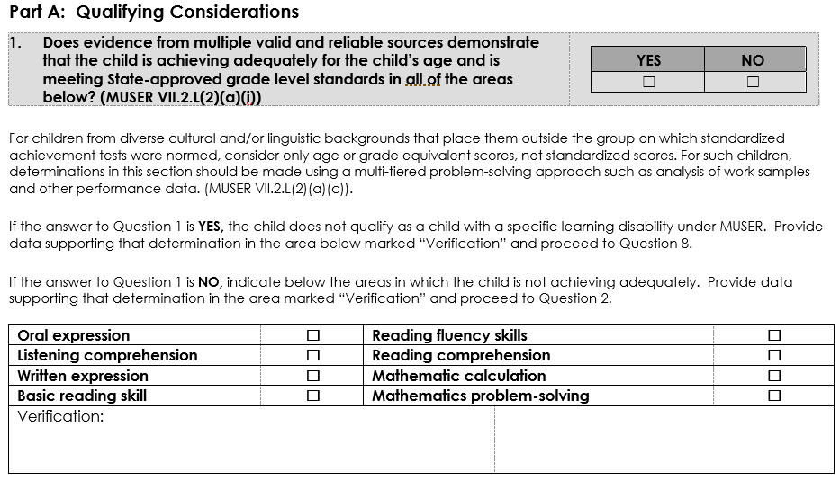
This section is used to:
- Identify lack of adequate achievement in any of several academic areas.

Sources should include: age normed, standardized assessments of academic achievement, state-wide or district-wide assessments, curriculum-based assessments, and classroom assessments based on state standards. Where indicated, sources could include speech/language assessments.
Directions:
- Consider whether the child is able to be successful when provided with general education curriculum.
  - If so, check “YES” and describe the basis for this conclusion in the “Verification” box. Then go to Question 8.
  - If not, check “NO” and check the areas where the child is not achieving adequately/is not meeting State-approved grade level standards, then describe the basis for this conclusion in the “Verification” box. Then go to Question 2.

Verification should identify the assessments that were considered and the child’s scores on those assessments.

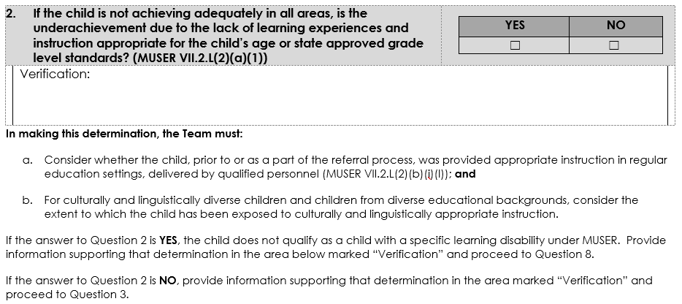
This section is used to:
- Identify whether any failure to achieve adequately is primarily the result of lack of appropriate instruction.

Directions:
- Consider whether the child has received culturally and linguistically appropriate instruction in regular education.
  - Section a.
    - Appropriate instruction should include, at a minimum, instruction targeted to the child’s specific area of academic weakness.
    - Appropriate instruction would include general education interventions. If the child received those interventions, the “Verification” should identify the methodologies, not the results.

    - A child’s attendance record would be considered under this question. (Did the child’s extended absences result in a lack of appropriate instruction, and was that lack of instruction a primary cause of the child’s failure to achieve adequately?)
    - A teacher not being appropriately certified could result in a finding that the child did not receive appropriate instruction, but the Team would then need to consider whether the lack of an appropriately certified teacher was a primary cause of the child’s failure to achieve adequately.
  - Section b.
    - For culturally and linguistically diverse children, appropriate instruction would include instruction consistent with the knowledge and skills embedded in the assessments being used to measure academic achievement.

- If so, check “YES” and describe the basis for this conclusion in the “Verification” box. Then go to Question 8.
- If not, check “NO” and describe the basis for this conclusion in the “Verification” box. Then go to Question 3.

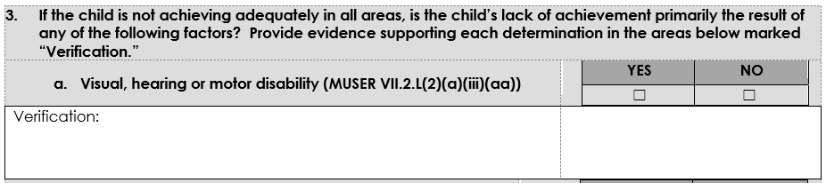
This section is used to
- Indicate whether the lack of adequate achievement is primarily the result of other factors.

Directions:
- Consider whether the child’s failure to achieve adequately is primarily the result of a visual, hearing or motor disability.

This asks not whether the child has an intellectual disability, emotional disturbance, hearing disability, etc., but whether any such disability is a primary cause of the child’s failure to achieve adequately.

- Sources of data include: screening, medical records, observation.
- If so, check “YES” and describe the basis for this conclusion in the “Verification” box.
  - If you have checked “YES”, go on to Question 8

Verification for “YES” answer should contain not only the data reflecting the child’s other disability, but the basis for the Team’s determination that the other disability is a primary cause of the child’s lack of achievement.

- If not, check “NO” and describe the basis for this conclusion in the “Verification” box. Then go on to the next factor.

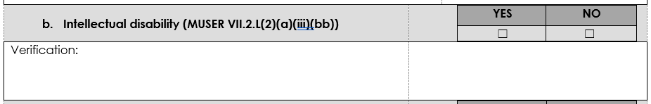
- Consider whether the child’s failure to achieve adequately is primarily the result of an intellectual disability.
- Sources of data include: cognitive scores and/or adaptive behavior scales.
  - If the child does have an intellectual disability, is it a primary cause of the lack of achievement?
- If so, check “YES” and describe the basis for this conclusion in the “Verification” box.
  - If you have checked “YES”, go on to Question 8.
- If not, check “NO” and describe the basis for this conclusion in the “Verification” box. Then go on to the next factor.
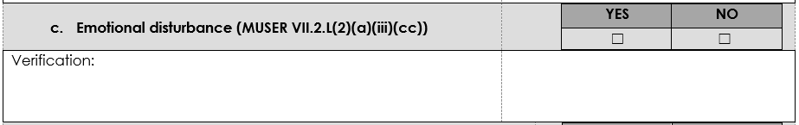
- Consider whether the child’s failure to achieve adequately is primarily the result of an emotional disturbance.
- Sources of data include: rating scales, disciplinary records, teacher/parent reports, medical records, observations.
  - Emotional Disability – areas that are not part of the referral
- If so, check “YES” and describe the basis for this conclusion in the “Verification” box.
  - If you have checked “YES”, go on to Question 8.
- If not, check “NO” and describe the basis for this conclusion in the “Verification” box. Then go on to the next factor.
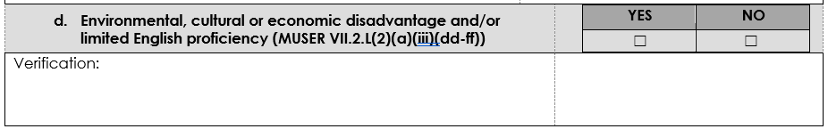
- Consider whether the child’s failure to achieve adequately is primarily the result of an environmental, cultural or economic disadvantage and/or limited English proficiency.
- Sources of data include: WIDA scores, ACCESS scores, parent/guardian report; documentation of chronic life disruptions.
- If so, check “YES” and describe the basis for this conclusion in the “Verification” box.
  - If you have checked “YES”, go on to Question 8.
- If not, check “NO” and describe the basis for this conclusion in the “Verification” box. Then go on to the next question.
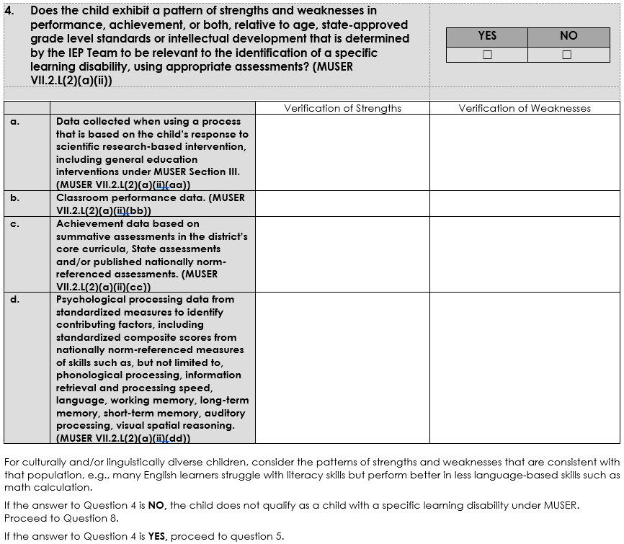
This section is used to:
- Identify whether the child’s strengths and weaknesses demonstrate a pattern of strengths and weaknesses.

“Performance” refers to how the child performs in the classroom; “achievement” refers to how the child performs on academic assessments.

Directions:
- This decision should be based on the profile of the child using all Sections a-d.

A child whose performance and achievement scores are uniformly depressed and are consistent with the child’s intellectual development does not demonstrate a pattern of strengths and weaknesses consistent with a specific learning disability, in contrast to a child whose performance and achievement scores show variable strengths and weaknesses across academic areas.

- Record data in each category (a-d) under either “Verification of Strengths: or “Verification of Weaknesses” as appropriate and consider whether the child shows a pattern of strengths and weaknesses.
  - If so, check “YES” and go on to Question 5.
- If not, check “NO” and go on to Question 8.

A pattern of strengths and weaknesses should not be confused with the “discrepancy model” which was based solely on a significant discrepancy between a child’s cognitive function and academic achievement. The child’s performance and/or achievement relative to intellectual development remains one of the team’s considerations.

- For a child who has repeated one or more grades, the team may consider a curriculum-based measure as opposed to solely using norm-reference measured based on age.
  - Sources of information include:
    - RTI information; CBA; progress monitoring; formative assessment
    - Observation; work samples; grades; CBA-PBE performance indicators
    - Evaluations; results of psych evaluations
- For culturally and/or linguistically diverse children, consider the patterns that are consistent with that population.

The following guidance is from the Maine Association of School Psychology’s “Clinical Guidance on Implementation for the Identification of Students Suspected of Having a Specific Learning Disability” (Appendix VI, Determining Patterns of Strengths and Weaknesses). http://www.masponline.net/

This federal requirement is not elaborated upon in the federal regulations. Some guidance is provided from the Learning Disabilities Roundtable (February 2005 page 13)
“This guideline is not meant to encourage use of formulas or a rigid approach to interpreting strengths and weaknesses. Only empirically validated patterns of discrepancy should be considered by teams…it is important to recognize that the new guideline also acknowledges intra-individual differences as a fundamental concept of SLD…”
The only portions of the Maine regulations that provide guidance for identifying this pattern of strengths and weaknesses are:
- The requirement in VII (2) (L) (2) (a) (ii) that requires “peer reviewed, scientific research documentation, independent of that provided in the test manual, that supports a correlation between the processing problem and the academic deficit”.
- The requirement in VII (2) (L) (2) (a) (iii) that provides a means for measuring the student’s cognitive ability.

Given the limited guidance available in federal and state regulations, the following is offered as a framework for a clinical response to this requirement in Section 4b. of the SLD form.
Academic Achievement: Typically measured through standardized achievement tests that provide age-based norms as referenced in Question 1 of the SLD form.
Educational Performance: Performance in academic areas (for example, written literacy skills, math, communication. (MUSER II (3)) as measured through local assessment instruments, rubrics, grade-level standards, etc. as referenced in Question 1 of the SLD form.
Age: The student’s chronological age.
State-Approved Grade Level Standards: As referenced in Question 1 of the SLD form above, each district should have developed means for measuring student progress relative to state approved grade level standards as part of the ESSA and Maine Learning Results requirement.
Intellectual Development: As determined through standardized intellectual assessments.

Procedure for identifying patterns of strengths and weaknesses in Educational Performance:
- Gather measures of the student’s educational performance in the area(s) of academic weakness identified in Question #1 of the SLD form (basic reading, reading fluency, etc.) such as:
- Classroom Work Samples
- Classroom Participation Samples
- Homework Assignments
- Classroom Quizzes and Tests
- Portfolios
- Curriculum Based Assessments
- Classroom based measures of State Approved Grade Level Standards
- Gather measures of the student’s educational performance in at least one area of academic strength. Use information similar in format to the material used for identifying the weakness above.
- Means for identifying a pattern of strengths and weaknesses in Educational Performance relative to age:
  - If the student were performing significantly closer to other students the same age in the area of strength than the area(s) of weakness, then this would constitute a pattern of strength and weakness.
  - As there are no statistical formulae available for determining significance in this matter, the team will have to use its judgment.
- Means for identifying a pattern of strengths and weaknesses in Educational Performance relative to State approved grade level standards:
  - If the student were achieving significantly closer to State approved grade level standards in the area of strength than the area(s) of weakness, then this would constitute a pattern of strength and weakness.
  - As there are no statistical formulae available for determining significance in this matter, the team will have to use its judgment.
- Means for identifying a pattern of strength and weakness in Educational Performance relative to intellectual development.
- Measure the student’s intellectual development in a manner consistent with requirements of Question #3B of the SLD form.
- Compare the results of the intellectual assessment with the student’s performance in the identified area of weakness.
- Since intellectual assessments are scored according to age norms and educational performance is scored according to grade level norms, it is not possible to make a statistical correlation between the two measures. Rather, the Team will need to compare where the student is performing compared to the norm group for each measure.
Example:
A second-grade student earns ‘Does Not Meet’ on measures of State-approved second grade level measures of basic reading and reading fluency. This student earns ‘Does Meet’ on measures of State-approved second grade level measures of math calculation and math problem solving. This variance in educational performance is consistent with a pattern identified by research for students with a specific learning disability in reading.

Procedure for identifying patterns of strengths and weaknesses in Academic Achievement:
  - Review results of achievement measures in the area(s) of academic weakness identified in Question #1 of the SLD form (basic reading, reading fluency, etc.).
  - Review results of similar achievement measures in one or more areas of academic strength in a manner consistent with guidance for Question #1 of the SLD form
  - Compare the difference between the student’s achievement in the area of greatest strength and the area of greatest weakness as identified above. Be sure to use similar measures (If using age-based achievement norms for measuring the strength, then use age based achievement norms for measuring the weakness).
  - Means for identifying a pattern of strengths and weaknesses in academic achievement relative to age:
    - Compare age based standardized scores in the area of strength and weakness.
    - To meet this criterion, there should be variance between scores.
  - Means for identifying a pattern of strengths and weaknesses in academic achievement relative to State-approved grade level standards:
    - Compare the student’s performance on grade level assessments in the areas of greatest strength and greatest weakness.
    - To meet this criterion, there should be variance between scores.
  - Means for identifying a pattern of strength and weakness in academic achievement relative to intellectual development.
    - There must be scientifically based research correlating the processing disorder(s) identified in Question #4d with the area(s) of academic deficit identified in Question #1 in the SLD form
    - Measure the student’s intellectual development.
    - Compare the results of the intellectual assessment with standardized scores on an age normed achievement test measuring the area of academic weakness identified in Question #1 of the SLD form.
    - To meet this criterion, there should be variance between scores and cognitive processing deficits should match areas of academic weakness while other scores (both cognitive and achievement) should be consistently higher.

Example:

A seven-year-old student earns the following standard scores:
- 75 on measures of reading skill
- 72 on measures of phonological processing
- 98 on measures of math calculation and problem solving
- 100 on measures of fluid or perceptual reasoning

- There is a research-based correlation between the reading deficit and the deficit in phonological processing.
- There is a research-based correlation between the student’s strong math skills and their strong fluid or perceptual reasoning skills.
- There is significant variance between the student’s academic achievement in reading and math and between phonological processing and fluid or perceptual reasoning.

The following chart presents the different comparisons districts may use in identifying patterns of strengths and weaknesses:
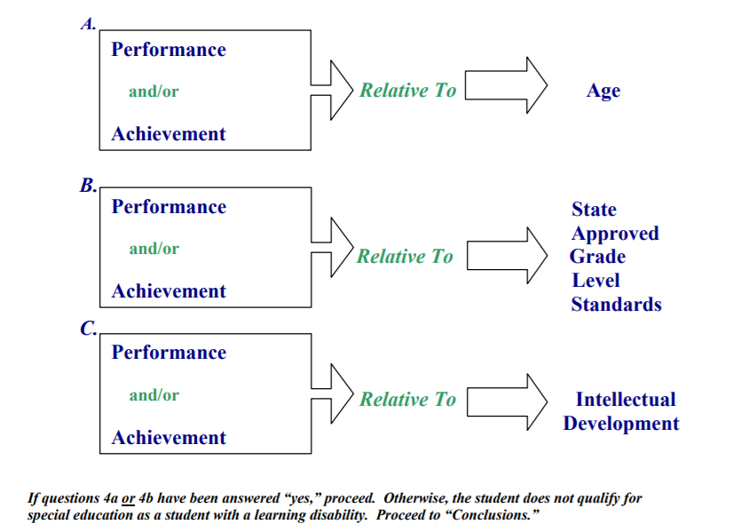

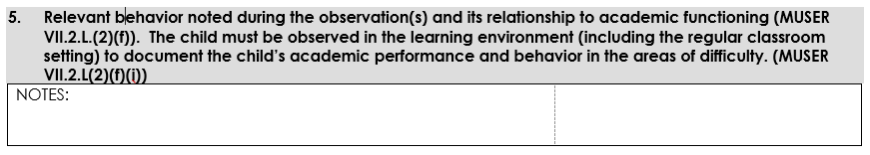
This section is used to:
- Document behavior noted during observation as it relates to academic functioning.

Directions:
- Summarize relevant findings obtained during the observation of the child in the regular education classroom. Examples might include: withdrawal, inattention, disengagement, lack of productivity.
- Go on to Question 6.

This section is used to:
- Document any medical findings as they relate to academic functioning.

Directions:
  - Summarize relevant information regarding any medical conditions that may have an effect on the child’s educational achievement. Relevant medical conditions might include ADHD, seizure disorder, tic disorder, mental health diagnoses (depression, anxiety, etc.), diabetes, or traumatic brain disorder.
  - Go on to Question 7.

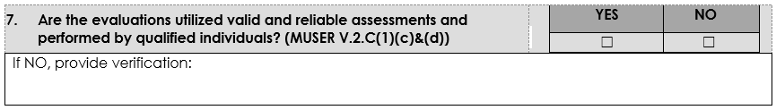
This section is used to:
- Document evaluation validity and reliability.

Directions:
- Indicate whether the evaluations being considered are both valid and reliable and were performed by qualified personnel.
  - If “NO” for any assessment, then provide information about that assessment and why it is not considered valid and/or reliable or was not performed by a qualified person. If, due to cultural, linguistic or physical characteristics of the child assessments were not utilized, provide an explanation for this in the “verification” box.
  - Go on to Question 8.

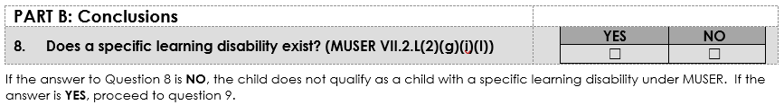
This section is used to:
- Document the Team’s conclusions as to the existence of a specific learning disability.

Directions:
- If “YES”, the following must be true
  - Question 1 must be NO, and verification must be provided.
  - Question 2 must be NO, and verification must be provided.
  - All parts of Question 3 must be NO, and verification must be provided.
  - Question 4 must be YES, and verification must be provided.
  - Question 7 must be YES.
  - Go on to Question 9.
- If “NO”, the following must be true
  - Either Question 1, 2, or any part of 3, must be YES or Question 4 must be NO.

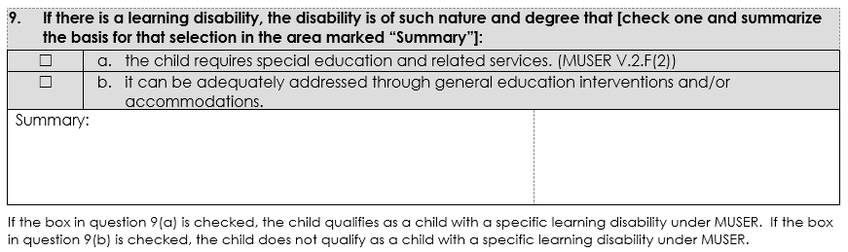
This section is used to:
- Indicate the determination as to whether the child requires special education and related services.
Directions:
- If “a”, the following must be true:
  - Question 8 must be “YES” AND
  - The disability is of such nature AND degree that it cannot be adequately addressed through general education interventions and/or accommodations and only special education and related services will address it.

- If “b”, the following must be true:
  - Question 8 must be “YES” AND
  - The disability is of such a nature AND degree that it can be adequately addressed through general education interventions and/or accommodations; therefore, special education and related services are not needed to address it.
  - If a child has been receiving RTI and/or other general education interventions which have enabled the child to make adequate academic progress, check 9b; if a child has failed to make adequate academic progress despite having received such interventions, check 9a. If the child has not received RTI and/or other general education interventions, the Team must determine whether, in view of the nature and degree of the disability, such interventions would likely enable the child to make adequate academic progress

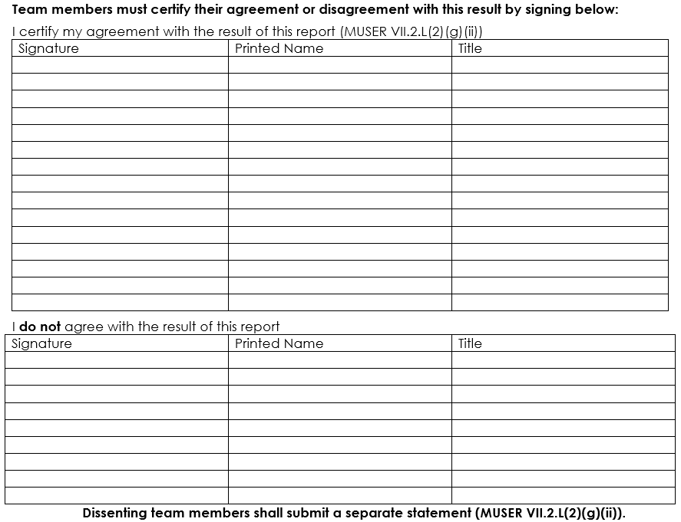
This section is used to:
- Document the team members’ agreement or disagreement with the result of the report.

Directions:
- Team members who agree with the result of the report should sign, print and date in the designated space indicating agreement.
- Team members who DO NOT agree with the result of the report should sign, print and date in the designated space indicating disagreement; as well as submit a separate statement.

Speech or Language Impairment Eligibility Form

This form is used to:
- Determine the child’s eligibility for special education services as a child with a Speech or Language Impairment. This form is not used if Speech or Language is a related service.
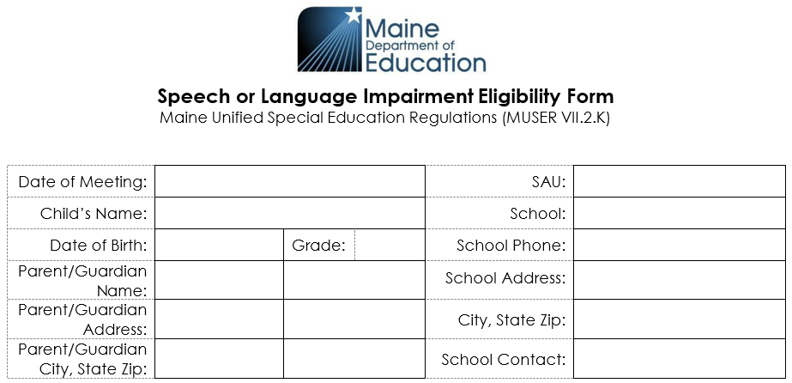
This section is used to:
- Document the pertinent child-related information.
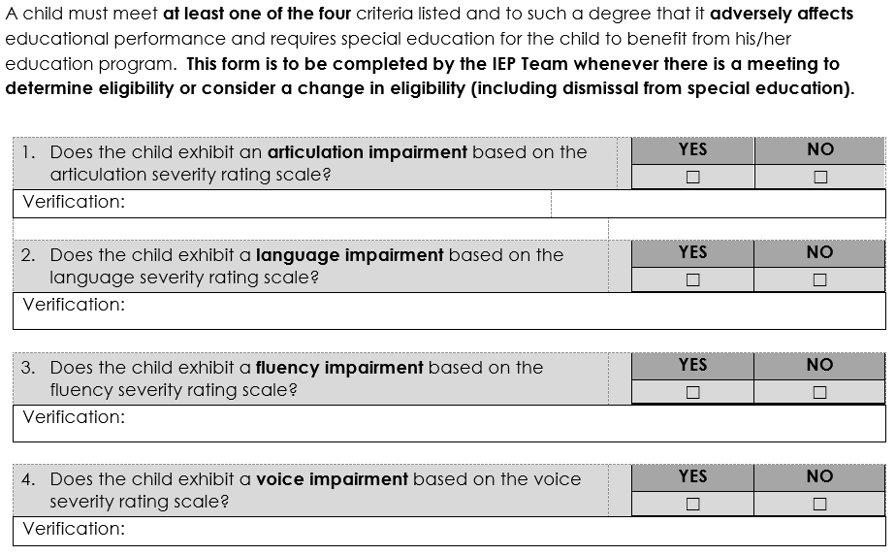
This section is used to:
- Identify a specific impairment based on the severity rating scales.
Directions:
- In order to answer questions 1 through 4, the IEP Team must first complete the four severity rating scales that follow.
- The results of those rating scales will dictate the answers to these questions.
  - If the Team recorded scores of “Moderate” or “Severe” in each of the categories on a rating scale, then the answer to the corresponding question on this page will be “Yes”
  - If the Team recorded a score of “No Apparent Problem” or “Mild” in any of the categories, or checked “No Assessment Needed,” then the answer to the corresponding question will be “No.”
- Complete the “Verification” box for each of the four questions
  - Record scores on formal assessments and a short narrative description of results of informal assessments.
    - Sources of data or information would include: standardized assessments, language samples, checklists, criterion-referenced assessments, rating scales (such as the “Observational Rating Scale” or “Pragmatics Activities Checklist” from the “CELF-5”).
    - Identify the components of the assessments that reveal the presence or degree of impairment.
  - If the answer to a question is “No” due to checking the “No Assessment Needed” box, indicate “Not an area of suspected disability” in the “Verification” box.

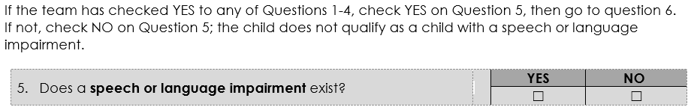
This section is used to:
- Indicate whether a speech or language impairment exists.

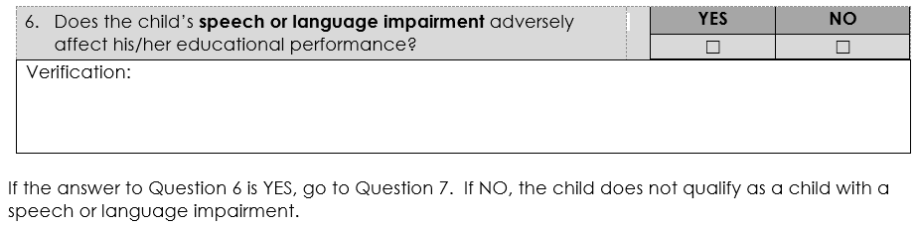
This section is used to:
- Indicate whether a speech or language impairment adversely affects the education of the child.

Directions:
- The Team records in the “Verification” box for question 6 the data forming the basis upon which the Team determined that the child’s speech or language impairment does/does not adversely affect his/her educational performance.
  - Sources of data may include classroom grades, child work products, measures of attainment of literacy standards, scores on standardized tests of academic achievement (including reading comprehension scores), teacher and parent reports, evidence of functional communication skills, evidence of social cognitive strengths and social pragmatics, records of attendance, disciplinary evidence or behavior rating scales, and observations or ratings of social/emotional functioning.

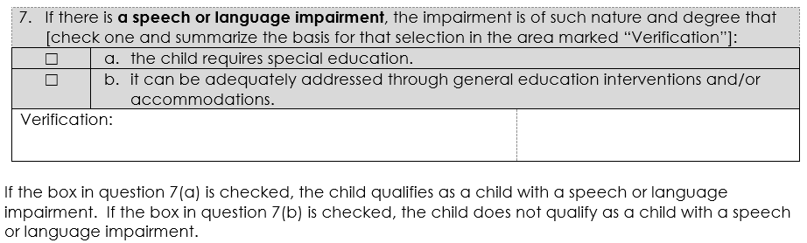
This section is used to:
- Indicate whether the child requires special education to address the speech or language impairment(s).

Directions:
- If “a”, the following must be true:
  - Question 6 must be “YES” AND
  - The disability is of such nature AND degree that it cannot be adequately addressed through general education interventions and/or accommodations and only special education and related services will address it.

- If “b”, the following must be true:
  - Question 6 must be “YES” AND
  - The disability is of such a nature AND degree that it can be adequately addressed through general education interventions and/or accommodations; therefore, special education and related services are not needed to address it.

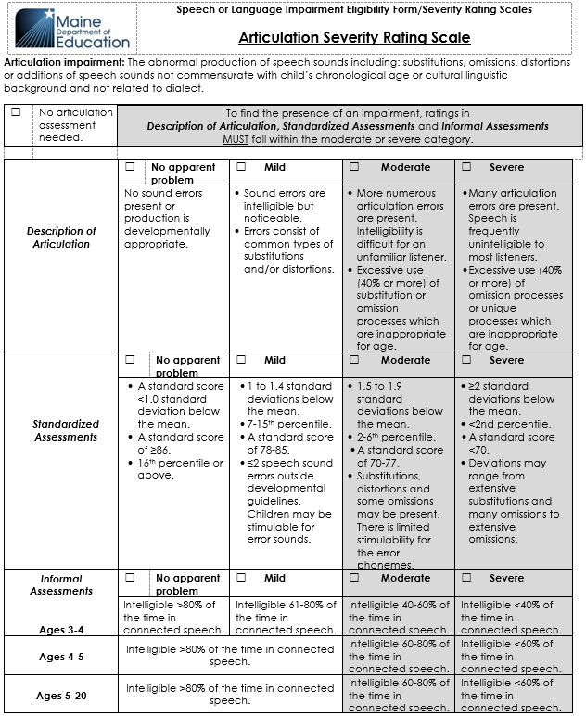
This section is used to:
- Determine the level of articulation impairment.
Directions:
- Check “No articulation assessment needed” when a standardized assessment was not administered because articulation impairment was not part of the referral, and was not raised as an area of suspected disability during referral or as part of a re-evaluation
- Unless “No articulation assessment needed” is checked, one of the four boxes in each of the three categories must be checked.
  - When completing the “Informal Assessments” category for a child aged 5, use the “Ages 3-5” grid if the child is receiving services through CDS, and the “Ages 5-20” grid if the child is receiving services through the SAU.
  - If either the “Moderate” or “Severe” box is checked in each of the three categories, then the child exhibits an articulation impairment and the “Yes” box for question 1 on page 1 should be checked.
  - If “No apparent problem” or “Mild” is checked for any of the three categories, the child does not exhibit an articulation impairment and the “No” box for question 1 on page 1 should be checked.

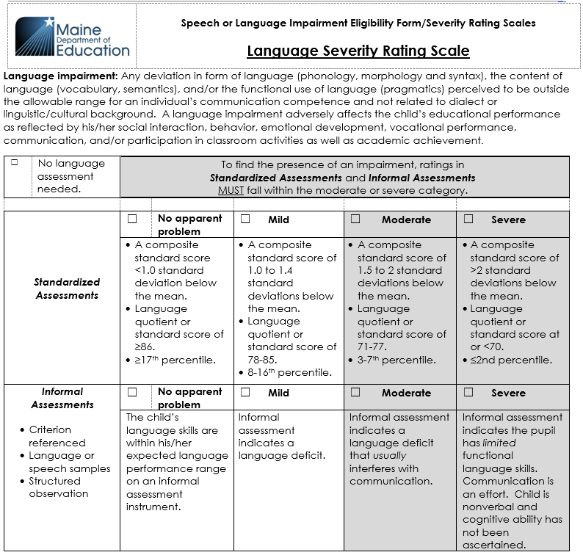
This section is used to:
- Determine the level of language impairment.

Directions:
- Check “No language assessment needed” when a standardized assessment was not administered because language impairment was not part of the referral and was not raised as an area of suspected disability during referral or as part of a re-evaluation.
- Unless “No language assessment needed” is checked, one of the four boxes in each of the two categories must be checked.
  - If either the “Moderate” or “Severe” box is checked in both of the two categories, then the child exhibits a language impairment and the “Yes” box for question 2 on page 1 should be checked.
  - If “No apparent problem” or “Mild” is checked for either of the two categories, the child does not exhibit a language impairment and the “No” box for question 2 on page 1 should be checked.

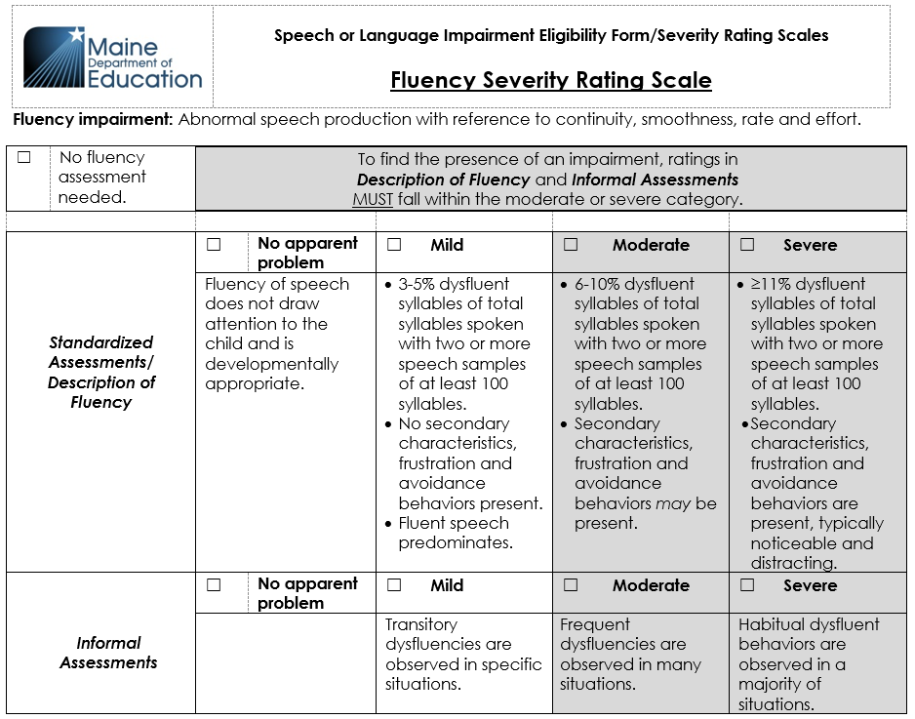
This section is used to:
- Determine the level of fluency impairment.

Directions:
- Check “No fluency assessment needed” when a standardized assessment was not administered because fluency impairment was not part of the referral and was not raised as an area of suspected disability during referral or as part of a re-evaluation.
  - For children in CDS, a standardized assessment is not required; alternative assessment procedures such as clinical observations can be utilized to score the description of fluency.
- Unless “No fluency assessment needed” is checked, one of the four boxes in each of the two categories must be checked.
  - If either the “Moderate” or “Severe” box is checked in each of the two categories, then the child exhibits a fluency impairment and the “Yes” box for question 3 on page 1 should be checked.
  - If “No apparent problem” or “Mild” is checked for either of the two categories, the child does not exhibit a fluency impairment and the “No” box for question 3 on page 1 should be checked.

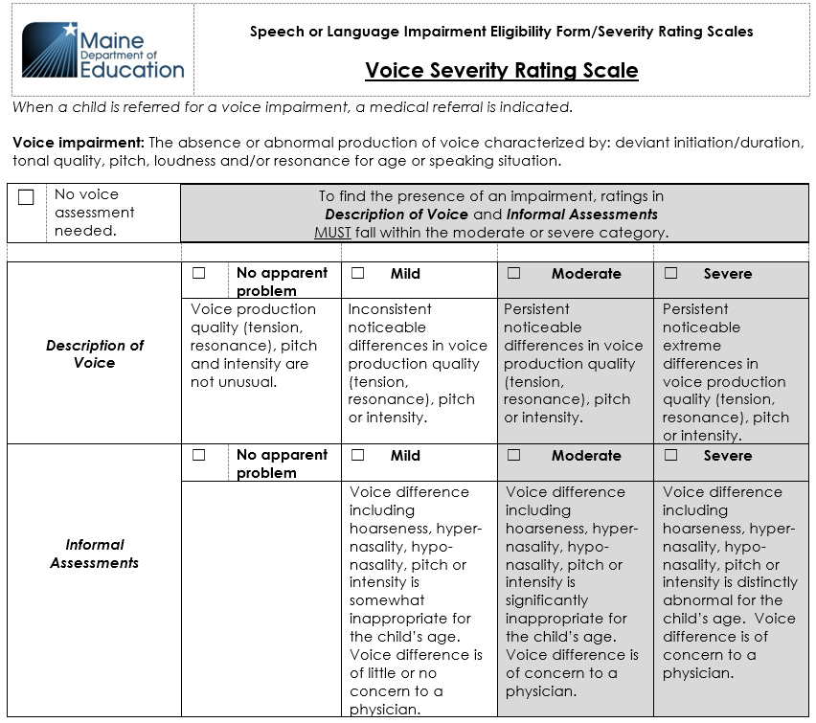
This section is used to:
- Determine the level of voice impairment.

Directions:

Voice impairment is a medical condition, and the diagnosis from a physician is required.

- Check “No voice assessment needed” when a physician’s assessment was not obtained because voice impairment was not part of the referral and was not raised as an area of suspected disability during referral or as part of a re-evaluation.
- Unless “No voice assessment needed” is checked, one of the four boxes in each of the two categories must be checked.
  - If either the “Moderate” or “Severe” box is checked in each of the two categories, then the child exhibits a voice impairment and the “Yes” box for question 4 on page 1 should be checked.
  - If “No apparent problem” or “Mild” is checked for either of the two categories, the child does not exhibit a voice impairment and the “No” box for question 4 on page 1 should be checked.

Summary of Performance

This form is used to:
- Provide information and recommendations designed to assist the child after graduating or aging out.
Directions:

The Summary of Performance (SOP) must be completed during the final year of a child’s high school education using the most current information available regarding the child’s performance.

The SOP should be written in a way that is useful to the child. It may be accompanied by documents useful in assisting the child with the transition from high school to a higher education, training, or employment setting.
- Statements should be positive and supportive of the child’s post-secondary goals. This summary is an opportunity to describe ways in which the child positively impacted the high school environment.

The summary should be written with the child’s input/child inclusive practice. Review of this document with the child is suggested.

This document is required under the reauthorization of IDEA (2004).
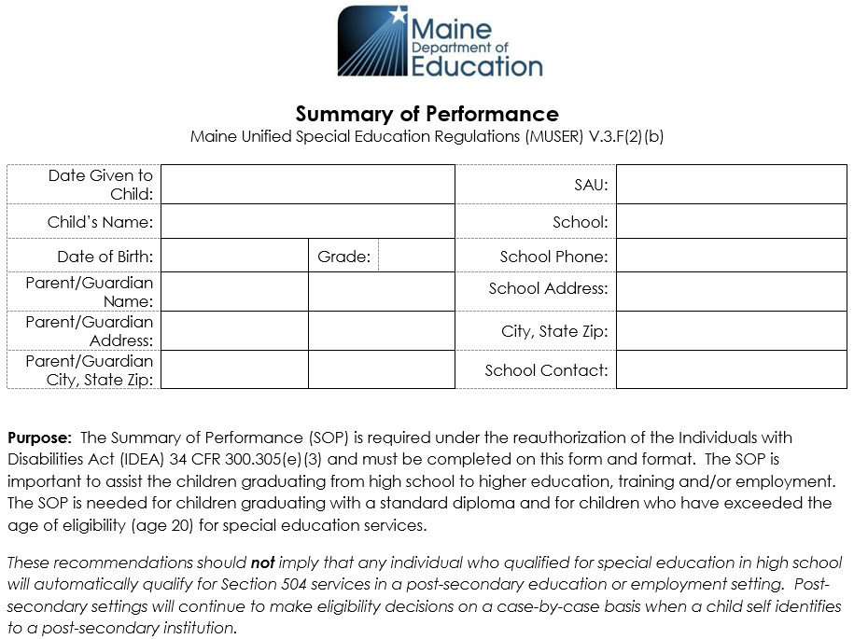
This section is used to:
- Document pertinent child-related information.

Directions:
- The Date Given to Child: The child should be given this document prior to his/her exit from high school, by graduation date or exit date. Document the date it is given to the child.
  - Suggested practice: Notify the child at the age of majority that the SAU will continue to send paperwork to the parent/guardian unless the child directs the SAU to stop.

Section 1: SUMMARY OF ACADEMIC ACHIEVEMENT

This section is used to:
- Summarize the child’s current level of academic performance.

Directions:

Specifically discuss the child’s current level of academic performance, summarizing the strengths and needs of the child. This could include:

Reading (comprehension, fluency), math (calculations, algebraic problem solving ), language (written, speaking, listening, spelling), and learning skills (work habits, note taking, keyboarding, organization, time management, assignment completion, study skills, test taking skills).

Scores and grades that would be informative, as well as how the child has progressed towards meeting grade level standards.

How the child’s disability affected his/her school work and school activities and supports that were tried and found successful.

The child should be able to understand the language used in the summary and should know his/her strengths and weaknesses.

Section 2: SUMMARY OF FUNCTIONAL PERFORMANCE

This section is used to:
- Summarize the child’s current functional performance.

Directions:
- Functional performance information is intended to help postsecondary institutions consider accommodations for access. Reference the accommodations and modifications that were beneficial to the child.
- Remember that recommendations should not imply that an individual who qualified for special education in high school would automatically qualify for services in postsecondary education or employment settings. These decisions will be made on a case-by-case basis as to student services at the college level or employment support services, if appropriate.

- Use the present level of functional performance section of the IEP. The summary could include:
  - General ability to problem solve (reasoning and processing).
  - Attention and executive functioning, memory, processing speed, impulse control, activity level.
  - Social work, counseling, speech, PT and OT input.
  - Behavior: interaction with others, responsiveness to services.
  - Extra-curricular activities, confidence in activities.
  - Persistence in the learning environment.
  - Independent living skills, such as self-care level, leisure skills, personal safety, transportation and money skills.
  - Environmental access/mobility (assistive technology, mobility, transportation).
  - Self-determination/self-advocacy (ability to respectfully identify needs and articulate goals).
  - Career/employment (interests, experiences, exploration, aptitudes).

Section 3: RECOMMENDATIONS TO ASSIST THE CHILD IN MEETING POST-SECONDARY GOALS
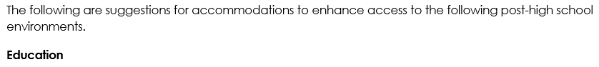
This section is used to:
- Outline recommendations to assist the child in post-secondary education.

Directions:
- Recommendations for child action could be:
- Consider completing CNA training at a nursing home
- Complete situational assessment funded by Voc Rehab
- Meet with Student Services to discuss disability and to advocate for accommodations
- Meet with new instructors prior to courses starting to ease anxiety
- Accommodations: Some children with disabilities may have needed accommodations to participate in the general curriculum; many of these are transferrable to the postsecondary setting. Examples include:
- Curriculum:
    - provide audiotapes of textbooks
    - use highlighters to mark important sections
    - provide a model of end-product with directions
    - provide overview of long-term assignments
    - have child practice presentation before presenting to class or group
- Environment:
    - provide a computer for written work
    - provide separate work space
    - allow use of a calculator

- Time/Transition:
    - provide additional time to complete tasks
    - provide detailed directions
    - provide visual aids when possible
    - allow voluntary exit from class when child is in a high stress or unsafe place
    - give child progress reports through process of task or assignments

This section is used to:
- Outline recommendations to assist the child in employment settings.

Directions:
- Recommendations for child action could be:
  - Stay in touch with Vocational Rehabilitation (Department of Labor) counselor to obtain help with new or additional employment
  - Meet with supervisors when unsure of expectations or to communicate needs or accommodations
  - Meet with Human Resources to walk though benefits of employment package (if appropriate)
- Accommodations - Some children with disabilities may have needed accommodations to participate in the general curriculum; many of these are transferrable to the postsecondary setting. Examples include:
  - check-in with time management and organization needs
  - use non-verbal cues to remind child of expectations
  - provide step-by-step instructions
  - allow practice of task before independently performing
  - allow job shadowing and peer mentoring to support new expectations

This section is used to:
- Outline recommendations to assist the child in training situations.

Unlike an education setting, training can take on different forms such as vocational or on-the-job training.

Directions:
- Recommendations for child action could be:
  - Consider completing customer service course
  - Consider taking adult education courses to support vocational training courses

  - Accommodations - Some children with disabilities may have needed accommodations to participate in the general curriculum; many of these are transferrable to the postsecondary setting. Examples include:
  - provide step-by-step instructions
  - provide additional time to complete tasks
  - provide visual aids when possible

This section is used to:
- Outline recommendations to assist the child with independent living skills (if needed).

Directions:
- Recommendations for child action could be:
  - Continue to improve budget skills
  - Seek support for banking and budget management
  - Pay bills with parental assistance
  - Work on driving skills
  - Monitor regular car maintenance such as oil changes, tire pressure, and tune-up schedule
  - Practice laundry skills and cooking at home
  - Preplan meals and make shopping lists before entering grocery store
  - Review home safety plan
  - Access community agencies and resources as needed for services
  - Review emergency contacts and phone numbers for support
  - Seek support for medical appointments

Written Notice
The form is used to:
- Meet the requirement to notify parents at least 7 days prior to the date upon which the SAU takes any proposed action or refuses to act with regard to:
  - referral
  - evaluation
  - identification
  - programming
  - placement
  - informed consent for initial placement of services
  - provision of early intervention services or a free appropriate public education to a child.
- Provide documentation of specific changes to be made to the IEP/IFSP and the timing for those changes.
A Written Notice must be generated and sent to a parent after every IEP/IFSP Team meeting, agreement with parent to amend the IEP/IFSP without a meeting, or any other time that the SAU makes a decision affecting FAPE or Early Intervention Services. This includes an SAU decision to not convene an IEP meeting.

- Document parents’ informed consent to the initial provision of special education services.

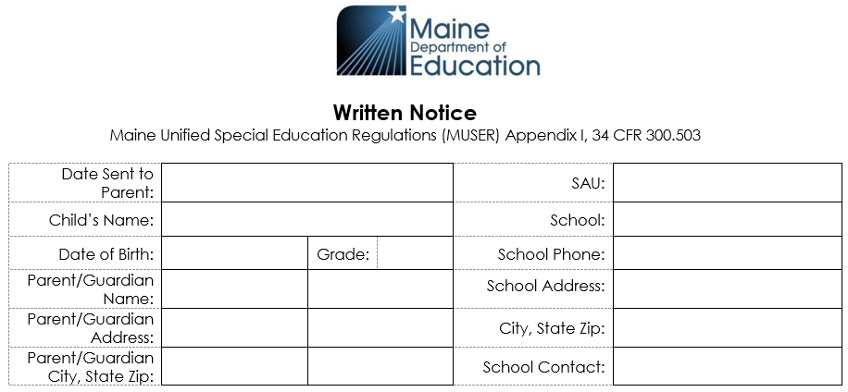

This section is used to:
- Document the pertinent child-related information.

The regulatory timeline is that the SAU must give the parents Written Notice at least 7 days prior to the date upon which the SAU takes any proposed action or refuses to act, unless parents agree to a shorter implementation timeframe which should be documented in Section 1. The timeframe may be shortened only if the parent attends the IEP meeting either in person or by the use of technology such as video or phone conferencing.

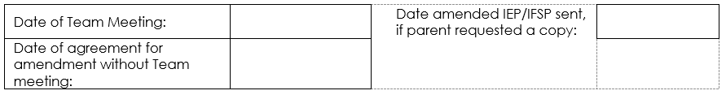
This section is used to:
- Indicate the relevant dates.

Directions:
- You must enter date of IEP Team meeting OR the date of agreement for amendment without Team meeting.
- If parent requested a copy of the amended IEP/IFSP enter date sent to parent.

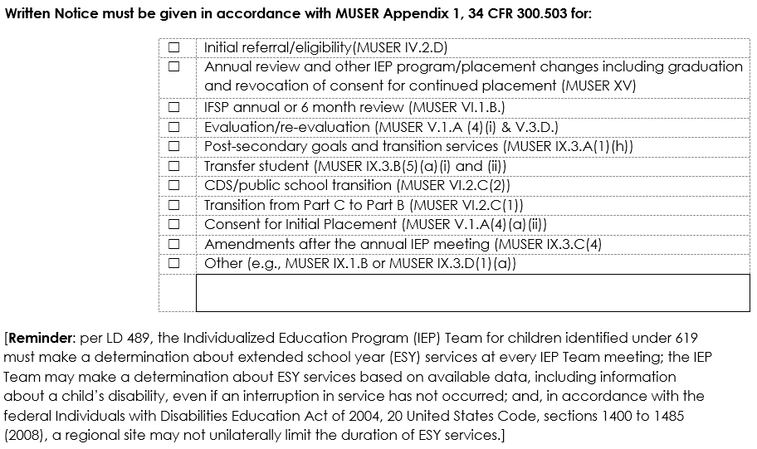
This section is used to:
- Indicate the purpose of the IEP meeting.

Directions:
- Purpose(s) of Meeting: Check all boxes that are pertinent to the actions that are proposed.
- Initial referral/eligibility (MUSER IV.2.D.) is checked when an initial referral is made, including discussion of the need for initial evaluation(s) (also check evaluation/re-evaluation box), or at a meeting to determine eligibility.
- Annual review and other IEP program/placement changes including transition (MUSER XV) and revocation of consent for continued placement (MUSER XV) is checked:
  - for every annual IEP meeting (MUSER IX.3.D(1)(a))
  - when there are any changes to program/placement
  - when parental consent for services is revoked.
- IFSP annual or 6-month review (MUSER VI.1.B.) is checked:
  - only for children birth to 2
  - for every annual IFSP meeting
  - for every 6-month IFSP review
- Evaluation/re-evaluation (MUSER V.1.A(4)(i) & V.3.D.) is checked when an evaluation or re-evaluation is proposed or refused by the SAU and to review any completed evaluations.
- Post-secondary goals and transition services (MUSER IX.3.A(1)(h)) is checked ONLY when transition services are being discussed; BUT must be discussed at least once annually.
- Transfer student (MUSER IX.3.B(5)(a)(i) and (ii)) is checked when a child transfers from one SAU to another or when entering an SAU from another state.
- CDS/public school transition (MUSER VI.2.C(2)) is checked when a child transitions from CDS to Kindergarten.
- Transition from Part C to Part B (MUSER VI.2.C(1)) is checked when a child is exiting Part C (birth to 2 years) and entering Part B (3 to 5 years), no later than 90 days prior to 3rd birthday.
- Consent for Initial Placement (MUSER V.1.A(4)(a)(ii)) is checked when the child is first determined eligible for special education services.
- Amendments after the annual IEP meeting (MUSER IX.3.C(4)) is checked for any amendment to the IEP.
- Other (e.g., MUSER IX.1.B or MUSER IX.3.D(1)(a)) is checked for other purposes such as:
  - Manifestation determination meetings
  - 30-day program review
  - Parent request
  - Amendments after the annual IFSP meeting
  - Revocation of consent for continued placement of the IFSP

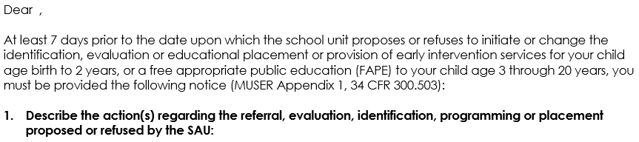
This section is used to:
- Describe the action(s) regarding the referral, evaluation, identification, programming or placement proposed or refused by the SAU.

Directions:
- Record determinations of the IEP meeting or agreement including, but not limited to:
- Evaluations
- Eligibility
- Transition Plan
- Goals Reviewed or Developed
- Accommodations/Modifications/Supplementary Aids/Services added or removed
- Services (frequency/intensity)
- Related Services (frequency/intensity)
- ESY
- Educational Setting
- Be specific; parents should be able to go to Section 1 and easily find each determination that was made, including refusals.
- Determinations are not by a majority vote but by consensus; when consensus cannot be reached, the SAU will make the final determination.
- If the parents have an initial request but, following the discussion, they now agree and form consensus, it is NOT a refusal. If parents continue to request something that the SAU has refused to do, this is a refusal.
- There can be an agreement to implement something sooner (in less than 7 days). This agreement can be documented in the Optional 7-day Waiver form but must be stated in Section 1.

This section is used to:
- Explain why the SAU is proposing or refusing this action

Directions:
- For each determination in Section 1, there must be a specific and detailed corresponding explanation in Section 2. The reader should be able to clearly understand each proposal or refusal.

This section is used to:
- Describe each evaluation procedure, assessment, record or report the SAU used as a basis for the proposed or refused action.

Directions:
- Evaluations – The description of the evaluation procedure considered by the IEP/IFSP Team for the determination of initial eligibility or continuing eligibility including:
  - The name(s) of the evaluations conducted
  - The date(s) on which the evaluation(s) was/were conducted
  - The subtests that were considered in the Team decision-making
  - The scores of the evaluation(s).
- Assessments (State, Local, Curriculum)
- Observation
- Parent Report (could also be included in Section 6)
- Teacher Report
- Informed Clinical Opinion (Birth to 2)
- Progress Report
- Related Service Provider Report

Evaluation results do not need to be included in this section if eligibility is not being determined at the IEP meeting.

The section is used to:
- Describe any other options that the Team, which includes the parent, considered and the reasons why those options were rejected.

Directions:
- In reviewing the determinations in Section 1, document other alternative options that were available/presented to the team and not chosen.
Examples
- LRE Options that were not chosen (General vs Special Ed)
- Continue present program vs. change the program
- Discussions around more than one eligibility criterion
- ESY (yes/no) - amount of ESY
- Natural Environment vs Clinical Setting/Office
The section is used to:
- Describe any other factors that are relevant to the SAU's proposed or refused action(s) described above.

Directions
- Other factors that impact educational programming include, but are not limited to:
- Medication/Other Health Conditions
- Change in Residence
- ELL Learners
- Family-Related Factors
- Attendance
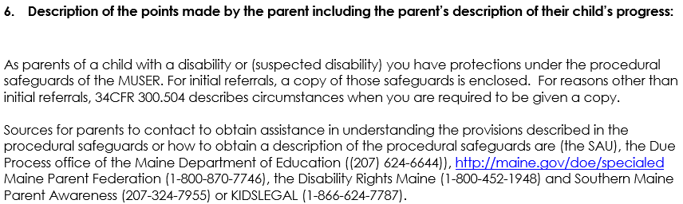
This section is used to:
- Describe the points made by the parent including the parent's description of their child's progress.
- Provide the name, title, and phone number of the person(s) or agencies to contact to obtain a copy of the Procedural Safeguards or assistance in understanding them.

Directions:
- Input from parent prior to the meeting can be included. If the parent did not attend the meeting, and input from the parent was not obtained, then the SAU may document that the parent did not attend the meeting in this section.
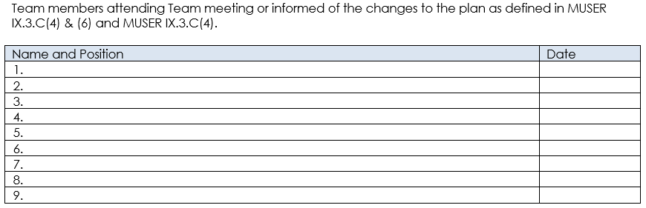
This section is used to:
- Identify IEP/IFSP Team members.

Directions:
- If the Written Notice is being issued following an IEP Team meeting, identify the Team members in attendance at the IEP meeting
- If the Written Notice is being issued without a meeting having taken place, identify the required Team members who were informed of the determinations.

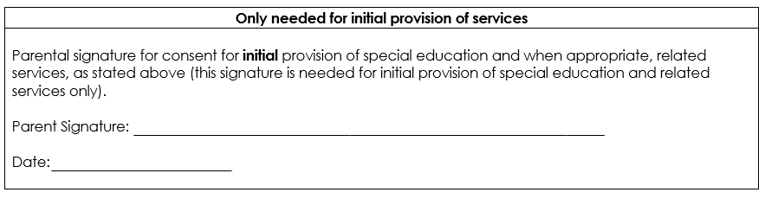
This section is used to:
- Indicate parent consent for initial provision of services.

Directions:
- Parental signature and date are required only for initial provision of services.
- Services cannot begin until this signature is obtained.
- Signature must be obtained only after the Written Notice has been completed – a signature on a blank Written Notice or separate page is not informed consent.

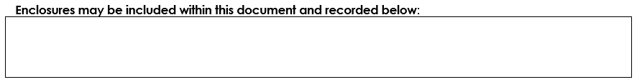

This section is used to:
- Indicate what enclosures are included.

Directions:
- Identify any documents enclosed with the Written Notice.
  - Examples include:
    - Procedural Safeguards
    - IEP
    - Adverse Effect Form
    - Learning Disability Evaluation Report
    - Speech/Language Eligibility Form
    - Parental Consent for Evaluation

