Ages: Birth through 5 months 6 through 11 months

Breakfast

Breast Milk or Formula 4-6 fluid ounces 6-8 fluid ounces; and

Fruit or Vegetable or combination 0-2 Tbsp.; and

Grain or 0-1/2 Oz. Eq. infant cereal,

Meat/Meat Alternate or combination 0-4 Tbsp. meat, fish, poultry, whole egg, cooked dry beans or peas; or 0-2 ounces cheese; or 0-4 ounces (volume) cottage cheese; or 0-4 ounces yogurt or a combination

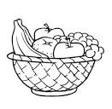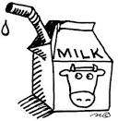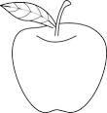

Food Chart

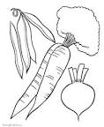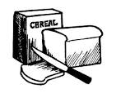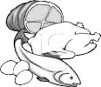

Child and Adult Care Food Program

Snack

Breast Milk or Formula 4-6 fluid ounces 2-4 fluid ounces; and

Fruit or Vegetable or combination 0-2 Tbsp.; and

Grain 0-1/2 Oz. Eq. bread or 0-1/2 Oz. Eq. infant cereal or 0-1/4 Oz. Eq. ready-to- eat cereal or 0-1/4 Oz. Eq. crackers

Lunch/Supper

Breast Milk or Formula 4-6 fluid ounces 6-8 fluid ounces; and

Fruit or Vegetable or combination 0-2 Tbsp.; and

Grain or 0-1/2 Oz. Eq. infant cereal,

Meat/Meat Alternate or combination 0-4 Tbsp. meat, fish, poultry, whole egg, cooked dry beans or peas; or 0-2 ounces cheese; or 0-4 ounces (volume) cottage cheese; or 0-4 ounces yogurt or a combination

This institution is an equal opportunity provider.

Child and Adult Care Food Program