 |  | Interdisciplinary/Project-Based Learning |  |  | April 2022 Issue #3
 |  | Expanding Our Practices to Improve Our Communities
The Interdisciplinary Instruction Team  https://www.maine.gov/doe/learning/II |  |  | 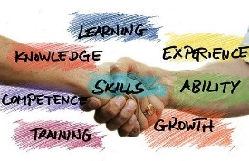 | Our students are  Engaged  Supported  Challenged  Prepared
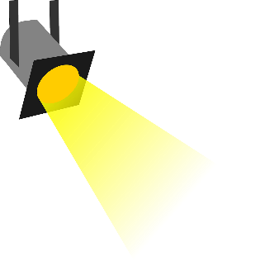  By: Michele Mailhot  Interdisciplinary Instruction Specialist  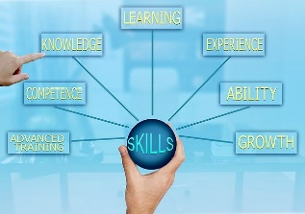 |  | Conceptual Knowledge  and  Procedural Knowledge  A common statement often uttered is “it’s not that they don’t know it, they just don’t know how to apply it.” What does that statement tell us? Does it tell us they only have conceptual knowledge? Procedural knowledge? A little bit of both?  What knowledge do our students need to apply what they know in new and unique situations? Research suggests that there is a relationship between conceptual and procedural knowledge, and different levels of understanding that support this transfer and application of skills. “…Baroody, Feil, and Johnson (2007) proposed a reconceptualization to represent the different types and qualities of conceptual and procedural knowledge which recognized the connections …. Routine expertise is where there is a superficial conceptual and/or procedural knowledge, which can be applied to familiar situations, but not unfamiliar ones, or to new tasks. Adaptive expertise is where both conceptual and procedural knowledge is deep, and where that knowledge can be applied creatively, flexibly and appropriately to all situations, familiar or new.”¹  The debate around one type of knowledge being more important than the other still endures but realizing this connection between the two is important while making instructional decisions. Some will argue you must first have procedural knowledge and the conceptual knowledge will follow. Others argue just the opposite. So, what are we to do? As we plan our instruction consider the knowledge and skills of the lesson and how students can engage both conceptually and procedurally to deepen their understanding. Allowing for inquiry and investigation to connect the two types of knowledge during the lesson will support retention of the concept and begin to develop the reasoning needed to understand when and how to apply these newfound skills in unique situations.  Perhaps if we consider working towards building the connections and relationships between the two types of knowledge, we will find that sweet spot for the adaptive knowledge Baroody, Feil, and Johnson propose.  ¹Conceptual knowledge OR Procedural knowledge OR Conceptual knowledge AND Procedural knowledge: Why the conjunction is important for teachers

Education Innovation |  |  | April 2022 Issue #3
What’s UP: Timely Information  The Interdisciplinary Instruction Team continues to provide support for making the transition to II and project-based learning. Go to the home page and watch a video that explains II and project-based learning, then follow the links on the bottom of the page to learn more about what II/PJB learning is and why it is important.  Click on the How Do We Do Interdisciplinary Instruction link to find supports.  For kindergarten through grade 2 teachers, Foundations of Learning provide essential elements that will prepare students to learn deep content knowledge and skills and they continue learn content and make interdisciplinary connections.  Plan for Learning looks across systems of education and suggests considerations for transforming curriculum, professional learning, assessment, and instruction.  Taking Action is still in development and will provide resources for classroom practice. From initial inquiry through analysis and evaluation, on to problem solving and development of a product, these supports will help you tweak your instructional planning.  If you have questions about interdisciplinary and project-based instruction, join us during office hours, Monday through Thursday.  Monday 9:00, Tuesday 3:00, Wednesday 4:00, and Thursday 3:00. |  |  | Resources: professional texts, websites, podcasts, etc.  Conceptual knowledge OR Procedural knowledge OR Conceptual knowledge AND Procedural knowledge: Why the conjunction is important for teachers  Read the article used to support this week’s Spotlight article  4 Types of Knowledge  Dr. Joel Tapia shares the 4 types of knowledge and how they connect and interact.  Surface, Deep and Transfer Level Learning.  Doug Fisher and Nancy Frey have teamed with John Hattie to provide a collection of resources to better understand practices that have significant impact on student learning.

The Last Word
Next issue – Wondering how to approach administrators and colleagues with ideas for collaboration when it comes to Interdisciplinary and Project-Based learning? Next week’s spotlight article will feature some strategies that can support you when you decide to take the leap to collaborating more purposefully with others.

