NWEA Rostering Technical Assistance Session
April 8, 2021
I did all my roster manually. Is that a problem? Is there a place where I can see all the students and all the teachers?
Rostering manually is not a problem.

To see all students and all teachers:
Log into NWEA MARC (https://teach.mapnwea.org/)
Click "View Reports"
Operational Reports

"Student by District" report will show you all the students currently rostered into the active term
"User Roles" report will show you all your active staff members and their roles

How does NEO organize student cohorts?
There is no correlation between NEO and local student information systems with regards to schedule. Users should create assessment rosters (called test sessions in NWEA) and upload those via the Import Profiles/ Rostering section of MARC. Users should select Standard - Add/Update Recommended (Add to or Update existing data) and following the steps.
Should we be uploading a special programs file?
Many SAUs use a special programs file to evaluate subsets of data (e.g. students receiving special education services, or English Learners). This can be done locally, and it is also done in MARC under Import Profiles/ Rostering. The information in the programs file does not get exported to MAARS/MDOE.
My state district and school IDs are single digits 2 and 3 respectively. NWEA requires a 3- digit code for district and school. I added 002 and 003 as my district and school code. Will that align for state data purposes?
Yes, this will work.
Do we need to have state school IDs or just the district?
Yes, the state school IDs need to be included, but are not uploaded form any external file. Instead this is done within MARC under Modify Preferences – Modify District – Edit Name and State Code (screenshot below)
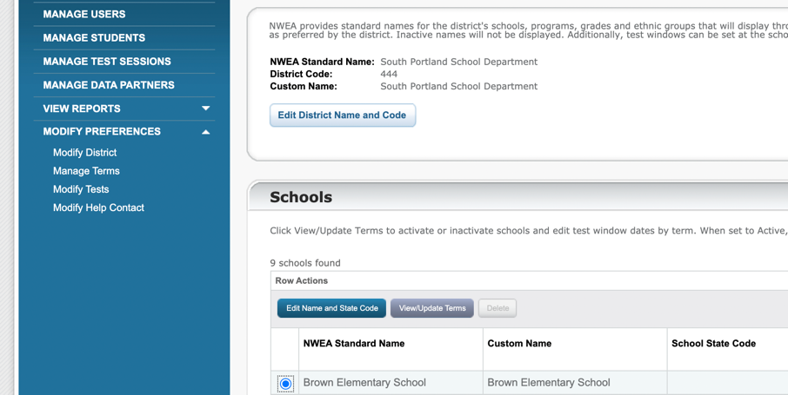

How far in advance can you set up test sessions?
Test sessions can be set up as soon as the students are uploaded and the testing window has opened. It’s important to note that students who enroll after the rosters are made will need to be added to the test session. Many schools ask proctors to look over the list two days in advance to be sure the rosters are up to date.
For existing users, how do you add the state school number?
In MARC under Modify Preferences – Modify District – Edit Name and State Code
Does the Instructor role allow them to proctor the exam?
No, after the student roster file from NEO is uploaded you will need to do another roster file import that includes roles. This can be found on the second sheet of this Roster File Template.

