NEO Daily Attendance Summary Report Instructions
In order to access the Attendance Reports, you will need an active NEO login with Student Data access for your school district.
If you do not yet have a NEO account or Student Data access, you must contact your Superintendent/Director to submit an access request form on your behalf.
Note: If your SAU does not operate any schools, you will not have any reports to view.

- Login to NEO

- Choose ‘Student Data’ module from up top:
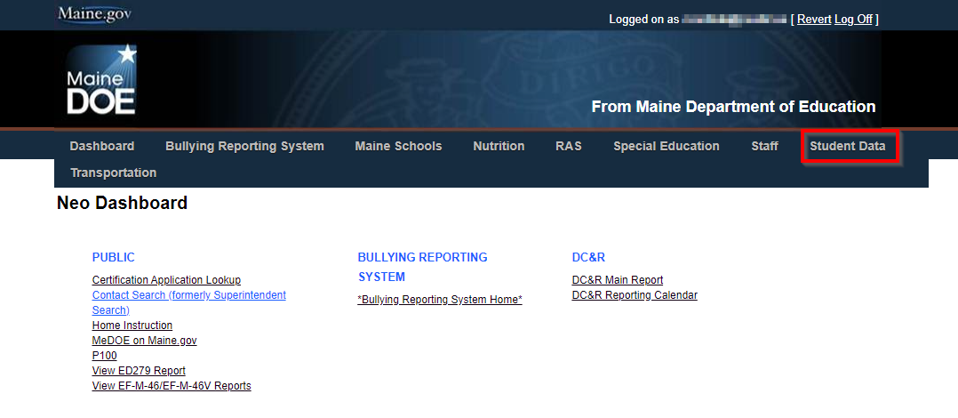
- Choose ‘Student Reports’: 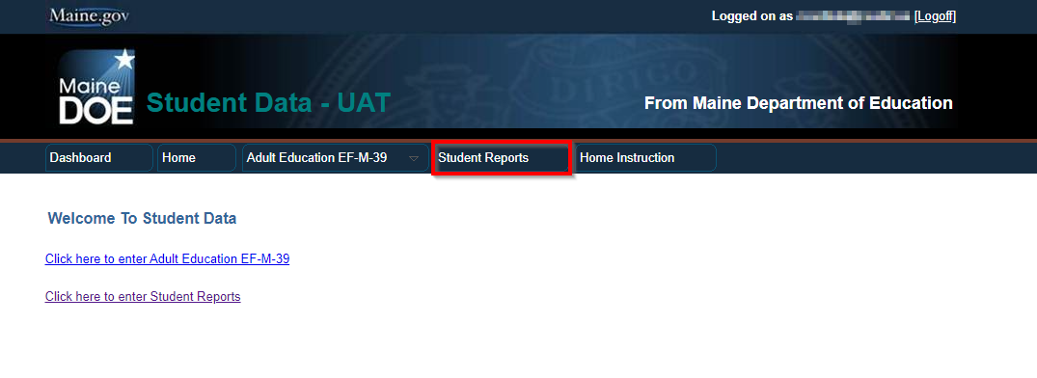

- Scroll down in the report listing to locate the Daily Attendance Summary Report, and click ‘View Report’ on the right side:
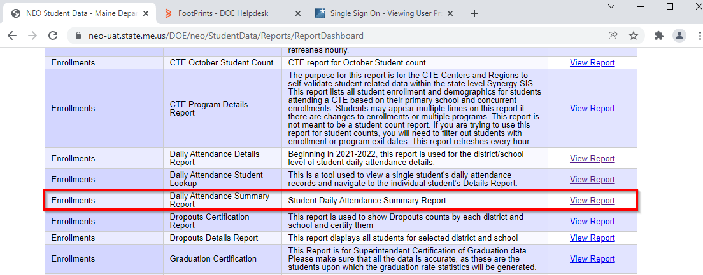

- The report opens in a new tab, and displays the current year data for the SAU:
(See below)
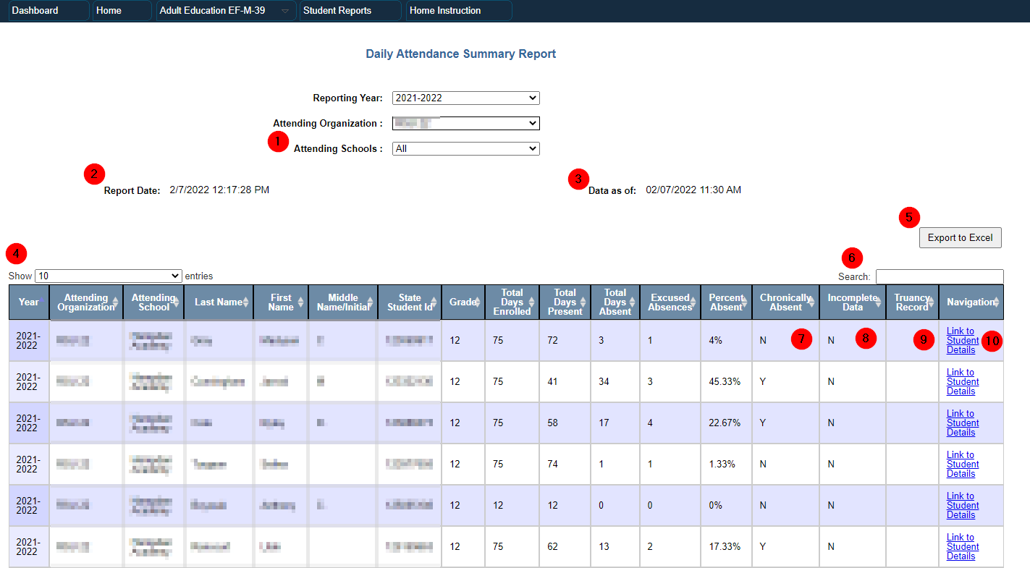

1 – Attending Schools filter allows you to view only a single school’s data.
2 – Displays the timestamp the report was opened.
3 – Displays the timestamp for when data was last updated from Synergy.
4 – Filter allows for 10-100 records to be displayed per page.
5 – Button to download the report as an Excel spreadsheet.
6 – Search box allows for searching the entire report.
7 – Chronically Absent shows students that meet the 10 days & 10%+ absence criteria.
8 – Incomplete Data shows if a student is missing attendance data in Synergy.
9 – Truancy Record indicates if the student has a Truancy incident in Synergy.
10 – Link which loads an individual student report displaying daily-level data.

FAQs:
- This data is loaded directly from Synergy each hour. Check Synergy if data in report is incorrect as a first check. Then check #3 to see if the report has updated since changes were made.
- The arrows at the top of each column allow the report to filter the column A-Z/High-Low.
- The report cannot be Validated or Certified if any student is flagged Incomplete = Y.
- Chronically Absent = E means the student is Exempt from the totals. PK students and students with less than 10 total days enrolled are Exempt.

If you have any questions, comments, or concerns regarding this document please do not hesitate to contact the Maine Education Data Management Systems Helpdesk directly.

Contact Us
(207)-624-6896
Medms.helpdesk@maine.gov
Hours: Mon-Fri – 8:00 am to 4:00 pm

