Based on feedback from the field re: MLR and NCCAS and observations of music curriculums and applications from across the state:
ORGANIZE BY STANDARD:
- A. Music Critique (listen, respond, and reflect)
- B. Music Connections (historical, situational, & personal experiences)
- C. Music Performance (performance & re-creation skills)
- D. Music Literacy (musical terminology and notational literacy)
- E. Music Composition (improvisation and composition)
- F. Collaborative Group Music Making (ensemble specific skills) - WHERE APPROPRIATE
THEN essential skills and indicators - by MODALITY:
- 1. Elementary
- 2. MS general music
- 3. MS Collaborative ensemble
- 4A. HS General Music - Performance Based [e.g., guitar class, piano class]
- 4B. HS General Music - Nonperformance [e.g., music appreciation]
- 5. HS collaborative ensemble.

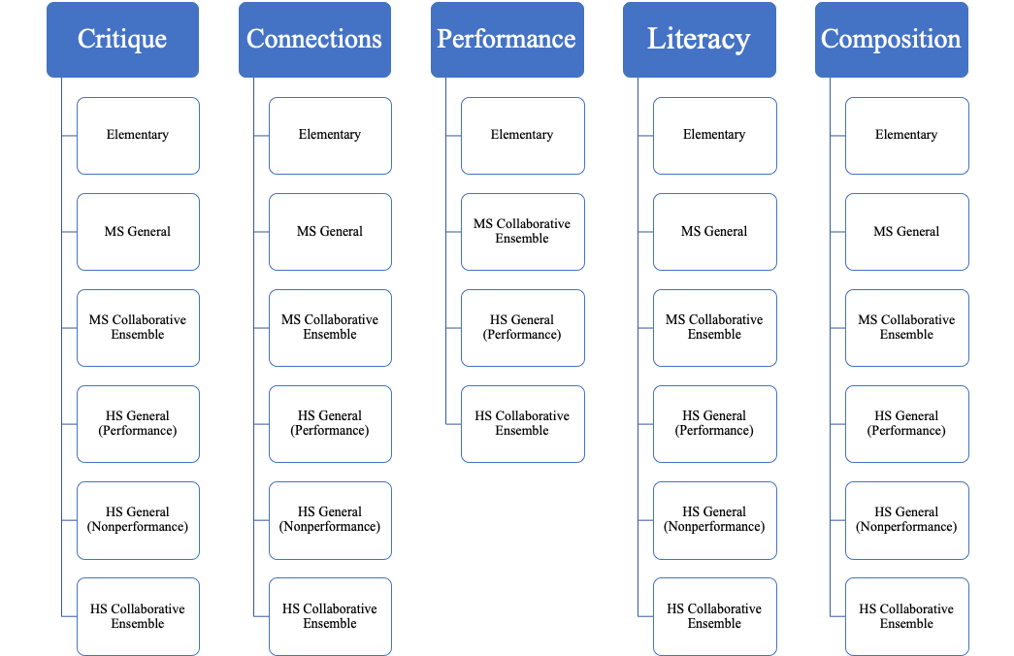
Note to the writing team: We envision that each Vertical Collection above could be its own section of the document that you produce. Alternatively, if you wanted to organize by teaching level, the graphic below could be the model you choose to utilize in your organization:
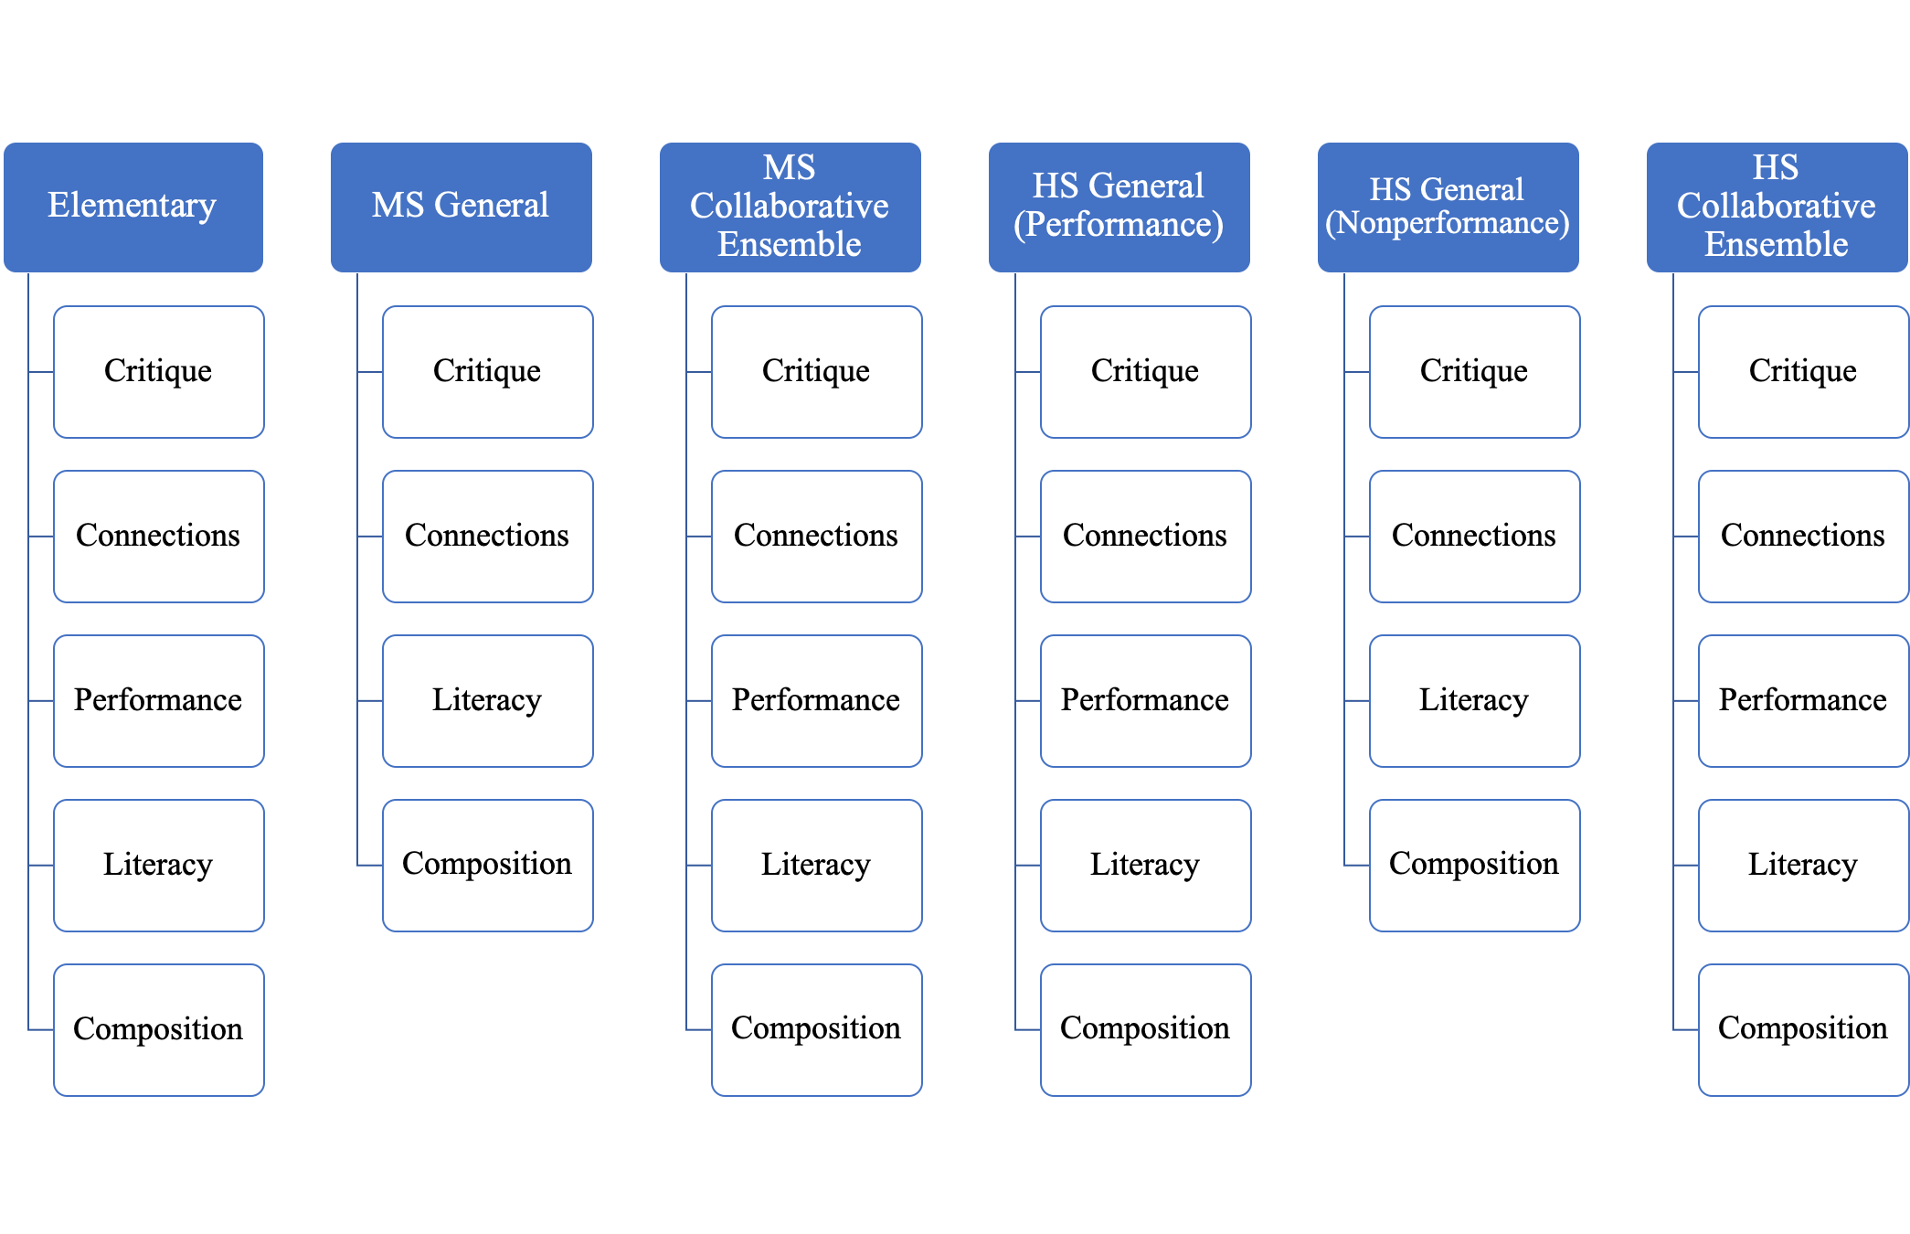

The standards for each may be similar, but the indicators, emphasis and grain size of each indicator may be the variable. This is how elements from A, B, C, D, E, F if desired, can be organized and listed.
--------------------

General VPA Introduction:
  - Utilize the introduction to:
    - convey the importance of the arts as a collective educational experience while maintaining the integrity of each discipline. (Keep the separation of the arts within one introduction)
    - Clearly incorporate the guiding principles and their role within arts education (or identify where/how they are embedded within the standards)
    - Avoid language that seeks to “justify” arts education
    - Consider using the introduction to state what the standards are and are not. (Overtly or in a more nuanced fashion)
  - Materials to consider:
    - Other introductions from other contents within the MLR’s, other state model introductions, and the NCAS model for the structure of an introduction
    - look at every iteration of all MLR ('97), National Standards ('94), and Maine Dance Curriculum Guide to address weaknesses, strengths and and culturally relevant items

Music Specific Introduction:
  - Utilize the introduction to:
    - Explain the structure of the standards as you’ve written them (and why they are different from NCAS).
    - Situate music as an important element of a students well-rounded education.
    - Emphasize that music is a standalone subject, and not intended as a “support” for other discipline areas.
  - Materials to consider:
    - NCCAS Introduction
    - NYSSMA Manual Introduction

--------------------

General Consideration for VPA Document:
- Create a companion guide that includes a glossary, suggested activities, and additional resources
  - Consider including a reference document that includes examples of performance indicators that are third-party identifiable that can be shared with administrators, parents, students, etc.
  - Consider National Core Arts Standards as a reference for the glossary, though develop definitions pertinent to terminology within the Maine Learning Results

General Considerations for the Music Standards:

- Throughout the Music Standards:
  - Strive for clarity and utilize inclusive language when determining wording, terminology, and processes. Pursue ways to increase equity and access rather than factoring in current delivery of instruction
  - Develop Enduring Understandings & Essential Questions that are relevant to the essential skills as determined by the Maine writing committee - utilize backwards design to identify educational outcomes, then enduring understandings, essential questions, and performance indicators/expectations for each stage of music instruction. As you consider backwards design, please think about the various levels of BD (lesson, unit, course, and overall objectives). Do not just adopt the NCAS Enduring understandings and essential questions.
    - Consider the Indiana Music Standards for EU, EQ, and a modified format of the NCAS
    - Essential Questions/Enduring Understandings are to be pertinent and developmentally appropriate based on and organized within each level by modality i.e. Elementary, Middle School General, Middle School Ensemble, etc.
  - Clearly define and articulate developmentally appropriate skills and robust performance indicators/expectations at each grade level and ensure a consistent progression through K-12. Utilize verbs that reflect different levels of understanding.
    - performance indicators/expectations should be specific and/objectively assessable skills, abilities or knowledge which identify what students need to know, understand, and/or be able to demonstrate;
    - Consider: Bloom’s Taxonomy and Norman Webb’s Depth of Knowledge for verbs
  - Utilize language and connect to the National Core Arts Standards where appropriate and applicable.
  - Consider using language that allows for multiple methods of instructional pedagogies (i.e. Kodaly, Orff, etc.) The standards should provide the WHAT that allows teachers to develop the HOW. This also includes ensemble representation beyond the BOC modalities.
  - Consider incorporating MLR E5 into multiple standards where it directly relates to skill building for example, specific skills related to functioning within a Music Ensemble

Additional Considerations for the Music Standards:
- A. Music Critique (listen, respond, and reflect)
  - Consider ways to listen/respond to music within the Music Critique Strand, including:
    - audiation as a concept to be explored throughout the standards either as a stand alone anchor standard.
    - incorporating movement explicitly as a way to respond to music, especially at the elementary level.
  - Consider using terminology that makes the process of reflection meaningful to students within the Music Critique Strand
- B. Music Connections (historical, situational, & personal experiences)
  - Consider making interdisciplinary connections within Music Connections
- C. Music Performance (performance & re-creation skills)
  - Consider using language that reflects performance opportunities and/or demonstration for performance tasks expanding beyond the traditional concert.
- D. Music Literacy (music terminology and notational literacy)
- E. Music Composition (improvisation and composition)
  - Be clear that composition can happen a prior to or in the moment
  - This is very closely related to D. Music Literacy, so there can be a fair amount of crossover between the two.
  - Consider alternative language to “select” - plan, arrange, etc.
  - Consider “Creativity” and “critical thinking” through the lens of student skill and knowledge development
- F. Music Ensemble (ensemble specific skills)
    - Include music ensemble standards where appropriate

