# Maine Seal of Biliteracy in (Language)

# is awarded to

(Student Name)



**(School Name )** 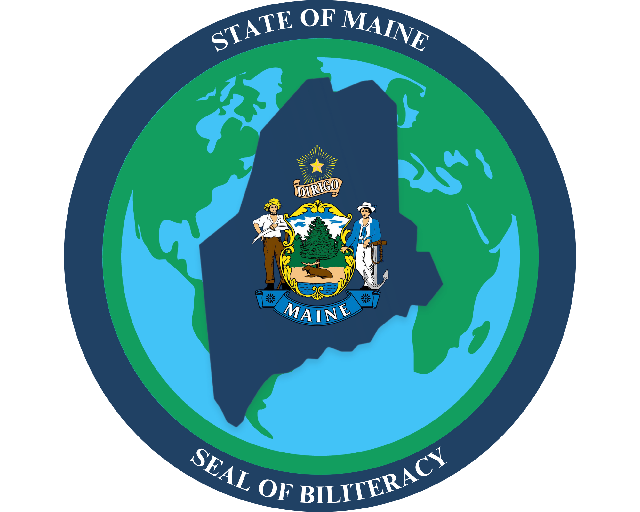

**2026**

___________________________ ___________________________

(Name of Seal of Biliteracy Coordinator) (Name of Principal)

Seal of Biliteracy Coordinator Principal