Teacher Performance Evaluation and Professional Growth (T-PEPG) Model
Facilitator Guide for Training Module 5: Reflecting and Adjusting

Teacher Performance Evaluation
and Professional Growth (T-PEPG) Model
Facilitator Guide for Training Module 5: Reflecting and Adjusting
December 2014

Contents
Page
T-PEPG Modules: Purpose and Goals 1
Audience 1
Timing and Structure 1
List of Training Modules 2
Preparing for Module 5 5
Module Overview 5
Intended Outcomes 5
Agenda–Part 1 6
Agenda–Part 2 6
Equipment and Materials 8
Model System Resources 9
Facilitator Guide–Part 1 10
I. Welcome (5 minutes) 10
II. Connecting (20 minutes) 12
II. Learning (1 hour, 35 minutes) 14
IV. Implementing (45 minutes) 19
V. Reflecting and Wrap-Up (30 minutes) 22
Part 2: Optional Extension Materials 23
I. Connecting (30 minutes) 23
II. Learning (1 hour) 23
III. Implementing (30 minutes) 30
III. Feedback (45 minutes) 31

T-PEPG Modules: Purpose and Goals
This series of five T-PEPG modules is designed to provide teachers with information and guidance on the Maine Department of Education (Maine DOE) Teacher Performance Evaluation and Professional Growth (T-PEPG) model, which is being implemented in their schools.
T-PEPG Leads and the administration (if necessary) will train the Professional Cohort facilitators, who will then train teacher participants using the module materials. The module materials are intended to:
- Make the four-step T-PEPG process meaningful, doable, concrete, and actionable for teachers.
- Support teachers in developing a common understanding of the evaluation model, the MSFE Rubric, and the opportunities for professional growth and development grounded in the five National Board Core Propositions.
- Provide participants with tips, strategies, and opportunities to share best practices aligned with the T-PEPG model.
The T-PEPG modules provide facilitators with consistent, standardized materials and content, detailed facilitator guides, and participant handouts that align with the T-PEPG model. Facilitators may use some or all of these materials and may modify them as appropriate to meet teachers’ needs and accommodate the amount of available time.

Audience
The T-PEPG modules will be presented to teachers by Professional Cohort facilitators in their respective schools. Districts and schools can determine whether to bring educators together for a schoolwide or districtwide training session or provide training to smaller grade-level or content-area teams.
The modules are designed so that Professional Cohort facilitators can facilitate abbreviated, chunked, or complete versions of each module to teachers as necessary (see the section on timing and structure for more details).

Timing and Structure
Each training module varies in length (from two to three hours) and includes interactive learning activities, which were designed within a framework of adult learning theory and best practice. Suggested assignments described at the conclusion of each module are intended to help participants extend and apply their learning and are designed to be integrated into the work teachers are already doing. Each module allocates time for participants to share what they have learned as a result of completing the assignment and to collaborate on the appropriate next steps.
The modules are organized into four parts to help facilitators and participants pace the content appropriately. The four segments of each module are as follows:
- Connecting—Builds community, prepares the team for learning, and links to prior knowledge, other modules, current work, and the MSFE Rubric; designed for all school-based educators
- Learning—Describes key concepts and highlights various implementation scenarios; supports teams in applying knowledge and sharing ideas; designed for all school-based educators
- Implementing—Supports teams in problem solving and planning next steps for schools and districts; geared toward school leadership teams
- Reflecting—Engages participants in providing feedback, reflecting on learning, and closing the session

List of Training Modules
Module 1: Model Overview. The first module provides participants with a big-picture overview of the key features of the T-PEPG model, including its purpose and goals, timelines, and annual process; the National Board for Professional Teaching Standards (NBPTS) Core Propositions; multiple measures of effectiveness; summative scoring; and professional growth plans. Participants unpack the basic structure and terminology of the MSFE Rubric and examine the rubric’s standard indicators in preparation for self-assessment, reflection, and goal setting, which are covered in Module 3.
Module 2: Student Learning Objectives. The second module engages participants in the student learning objective (SLO) development process. Knowing how to set realistic and rigorous targets is critical for supporting student learning throughout the year. SLOs are specific and driven by needs, and they include an instructional plan that enables students to meet their learning targets. SLOs also inform teachers’ professional goal setting, which is covered in Module 3.
Module 3: Reflection and Goal Setting. The third module supports participants in reflection in order to set professional goals. Participants engage in SMART goal development, which is a process that can help teachers achieve or maintain effective practice and ensure students meet the rigorous learning targets established through the SLO process. Professional growth is one of the multiple measures of the T-PEPG model, and SMART goals provide participants the opportunity to strategically identify specific areas of growth and focus for the school year.
Module 4: Evidence, Observation, and Feedback. The fourth module describes expectations for observations (both inside and outside classrooms); the collection and organization of observation evidence; and the sharing of timely, constructive feedback. All participants engage in peer observation, and the module provides information about how to make the process meaningful, collaborative, and constructive.
Module 5: Reflecting and Adjusting. The fifth module supports participants in the use of the MSFE Rubric, evidence, and student data to monitor progress toward their professional goals. Participants explore when and how to revisit their professional goals, check in on student progress, and collaboratively determine appropriate midcourse adjustments to their practice. The module includes an extension section that facilitators can use (as needed) to prepare teachers to gather evidence for the summative evaluation conference, and as a tool to guide reflection and future goal setting. The section also includes an overview of the summative scoring process and professional growth planning process.

Preparing for Module 5

Module Overview
The fifth module supports participants in the use of the MSFE Rubric, evidence, and student data to monitor progress toward their professional goals. Participants explore when and how to revisit their professional goals, check in on student progress, and collaboratively determine appropriate midcourse adjustments to their practice. The module includes an extension section that facilitators can use (as needed) to prepare teachers to gather evidence for the summative evaluation conference, and as a tool to guide reflection and future goal setting. The section also includes an overview of the summative scoring process and professional growth planning process.

Intended Outcomes
At the end of this session, participants will be able to:
- Use the MSFE Rubric to self-assess progress thus far and prepare for evidence submission, including analyzing and presenting student progress on growth targets
- Reflect on progress toward achieving goals using a range of evidence
- Develop an appropriate and actionable plan for making midcourse adjustments to practice to stay on track for achieving goals, and look ahead to next year.
Optional Extension Outcomes
- Understand how to combine evidence and ratings to arrive at a summative effectiveness rating, including SLO scoring

Agenda–Part 1
- Welcome (5 minutes)
- Connecting (26 minutes)
- Connecting: Where Are We in the Four-Step Process? (1 minute)
- Connecting Activity: Gallery Walk (20 minutes)
- Connecting Wrap-Up/Debrief (5 minutes)
- Learning (1 hour, 15 minutes)
- Learning Content 1: Tools and Strategies for Reflecting (5 minutes)
- Learning Activity 1: Teacher Interview (15 minutes)
- Learning Wrap-Up/Debrief 1 (5 minutes)
- Learning Content 2: Using Data and Feedback to Reflect (15 minutes)
- Learning Activity 2: Putting the Steps Into Practice (35 minutes)
- Learning Wrap-Up/Debrief (10 minutes)
- Implementing (45 minutes)
- Implementing Activity 1: Starting With Your Students (45 minutes)
- Implementing Wrap-Up/Debrief (5 minutes)
- Reflecting and Wrap-Up (30 minutes)
- Activity: Summarizing Your Reflection (20 minutes)
- Wrap-Up and Next Steps (10 minutes)

Agenda–Part 2
Optional Extension Material
- Connecting (30 minutes)
- Connecting Activity: 3, 2, 1 (30 minutes)
- Learning (55 minutes)
- Learning Activity: Teacher-Submitted Evidence (15 minutes)
- Learning Wrap-Up/Debrief 1 (5 minutes)
- Learning Content: Summative Scoring Process (20 minutes)
- Learning Wrap-Up/Debrief (15 minutes)
- Implementing (30 minutes)
- Implementing Activity 1: Preparing for the Summative Evaluation Conference (20 minutes)
- Implementing Wrap-Up/Debrief (10 minutes)
- Reflecting and Wrap-Up (45 minutes)
- Reflecting Activity: Looking Ahead to Next Year (30 minutes)
- Sharing Out (15 minutes)

Equipment and Materials
- Materials: Make a copy of the Participant Handout packet for each participant.
- Participants should have a copy of Form 8 (blank).
- Participants should have access to the Handbook, their own Points of Contact documentation forms, their SLOs (including student growth targets), and student progress data.
- Participants were asked at the end of Module 4 to bring some student progress data; however, you may want to remind participants to bring some student progress data that they can use to determine how their students are progressing toward meeting their student learning objective.
Put the following materials on each table:
- Sticky notes
- Markers
Bring the following materials for use by you:
- Chart paper, easel, sticky notes, computer paper (two pieces), tape, and markers
- Three pieces of sticky chart paper with the following questions written on them for the Connecting Activity (You may need two or three copies of each question, depending on the group size):
  - What have you learned about your practice as a result of getting feedback?
  - What evidence have you collected so far on elements of the MSFE Rubric?
  - How, if at all, have you participated in peer observation so far this year, either as an observer or as the teacher observed?
- Four pieces of chart paper, one with each of the following questions on it for Learning Activity 1
- How do you reflect on your teaching practice daily or weekly?
- How do you reflect on your teaching practice after each unit or over
the summer?
- How do you build time into your schedule for reflection?
- How does your team (PLC, grade level, or subject area) reflect on
its practice?
- Paper, tape, and sticky notes to create a confidence scale for Learning Wrap-Up 2
1
2
3
4
5
6
7
8
9
10
Not Confident
Very Confident

Additional Instructions for Optional Extension Materials
The optional extension materials for Part 2 are designed as an end-of-year portion that should be adapted based on the context for the audience. This portion could be delivered as a preview, or could be presented at a later date when teachers are preparing for their summative ratings. Prior to delivering this module, facilitators should review the slides and ensure that the particulars described are aligned with their district’s modifications to the model system that served as a starting point for all districts. In particular, facilitators should check the following:
- Slide 29: “Calculating the Summative Effectiveness Rating.” This slide shows, through a diagram, how the summative rating is calculated.
- Slide 37: “Summative Effectiveness Ratings and Professional Growth Plans” This slide shows each of the summative rating descriptors that teachers might receive (Ineffective through Distinguished) and provides a chart format where teachers can see, “What does this rating mean for me?”
- Slides 22 and 43: “Looking Ahead.” These slides are placeholders where facilitators can fill in information that teachers need to know, such as upcoming dates and deadlines, as well as gathering participants feedback for continuous improvement processes.

Model System Resources
Maine DOE model resources can be found on the Maine DOE website at http://www.maine.gov/doe/effectiveness/index.html. Specific resources that are useful to review before facilitating this training include:
- Maine DOE Teacher Performance Evaluation and Professional Growth Model (T-PEPG Model) Handbook and Implementation Guide for School Administrative Units
- MSFE TEPG Rubric Companion Guide 2014–15 (which includes the MSFE Rubric in Appendix A of the Maine DOE T-PEPG Handbook)

Facilitator Guide–Part 1

I. Welcome (5 minutes)
Slide 1 is the title slide.  Welcome participants to the training and introduce yourself as the facilitator. | Slide 1
Explain:  “This is Module 5 of a series of five modules on the Maine DOE teacher evaluation model.  In this fifth module, we will practice using the MSFE Rubric, evidence, and student data to monitor progress toward professional goals. We will explore when and how to revisit professional goals, check in on student progress, and collaboratively determine appropriate midcourse adjustments to practice. The module includes an extension section that facilitators can use (as needed) to prepare teachers to gather evidence for the summative evaluation conference, and as a tool to guide reflection and future goal setting. The section also includes an overview of the summative scoring process and professional growth planning process.” | 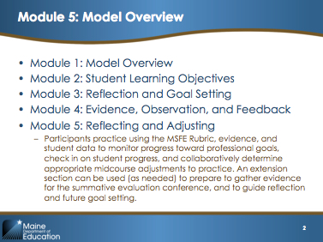  Slide 2
Provide an overview of the agenda to participants or give them a minute to read the agenda themselves. | 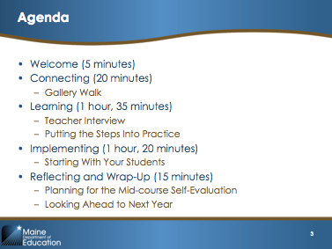  Slide 3
Explain:  “This module will help you develop foundational knowledge for completing the T-PEPG process. By the end of today, you will be able to:  - Use the MSFE Rubric to self-assess progress thus far and prepare for evidence submission, including analyzing and presenting student progress on growth targets  - Reflect on progress toward achieving goals using a range of evidence  - Develop an appropriate and actionable plan for making midcourse adjustments to practice to stay on track for achieving goals, and look ahead to next year.”  Optional Extension Outcomes  - “Understand how to combine evidence and ratings to arrive at a summative effectiveness rating, including SLO scoring” | 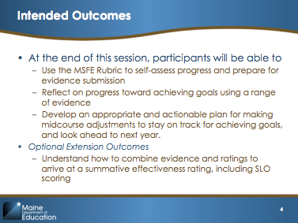  Slide 4
Explain  “This module focuses on Core Proposition 4, including its two standard indicators.  Core Proposition 4 states teachers think systematically about their practices and learn from experience.  Standard indicator 4.1 relates to adjustment to instructional plans. The teacher analyzes sources of evidence as he or she continually reflects on professional practice, using information about the needs of students to make decisions about adjustments in practice and goals for professional growth.  Standard indicator 4.2 relates to continuous professional growth. The teacher uses current research-based resources, ongoing feedback from others, and professional learning opportunities to accomplish professional growth.” | 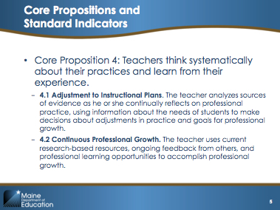Slide 5

II. Connecting (20 minutes)

Slide 6 is the title slide for this section.

Connecting Content (1 minute)
Explain:  “Here you will see the familiar graphic of the four-step evaluation process. This module, which focuses on reflection and the adjustment of practice, falls into Step 3: Reflection and Rating.” | 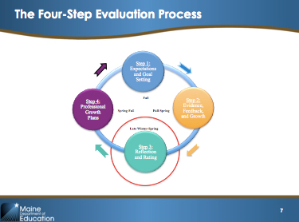Slide 7

Connecting Activity (20 minutes)

Purpose and intended outcomes:
The purpose of this activity is for participants to reflect on what has occurred in their evaluation cycle so far this year.

Facilitation directions:
The facilitator can create three, six, or nine pieces of chart paper with three questions repeated on them. The number of pieces of chart paper depends on the size of the group. There should be enough posters for there to be three to five participants at each sheet of chart paper.

Explain:  “The purpose of this module is for teachers to reflect on their practice and think about how to adjust practice.  To get started, you are going to think about what evidence has been collected so far as a part of your teacher evaluation. We will use a carousel brainstorm to structure this reflection.  At each sheet of chart paper, you will be reflecting on one of the following questions:  1. What have you learned about your practice as a result of getting feedback?  2. What evidence have you collected so far on elements of the MSFE Rubric? (Note: You may have collected this evidence in your Points of Contact documentation forms or in Appendix 0, Part 4.)  3. How, if at all, have you participated in peer observation so far this year, either as an observer or as the teacher observed?  Each group is going to respond to one question at each poster, spending five minutes or so discussing the question and recording your responses on the chart paper. Listen for my signal for your group to move clockwise to the next chart paper.  Let’s have you count off by threes.”  Allow participants to count off and tell each group which chart paper to start with. | 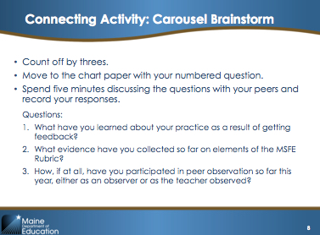Slide 8
Possible Facilitation Challenges and Solutions:
Challenge | Solution(s)
Participants may not have completed many of the steps of the evaluation cycle. | Even if teachers have not officially recorded evidence for themselves or others or received feedback, they can still reflect on what they have seen and heard so far this year. Encourage them to discuss the informal or anecdotal experiences they have had if formal experiences have not occurred yet.
Participants may not be familiar with or remember Appendix O, Part 4, which is referenced in the second question. | Inform participants they can find Appendix O, Part 4, on pages 64 and 65 in the Handbook.

Guiding Questions:
- What have you learned about your practice as a result of getting feedback?
- What evidence have you collected so far on elements of the MSFE Rubric?
- How, if at all, have you participated in peer observation so far this year, either as an observer or as the teacher observed?
- If you have not formally experienced these aspects of the evaluation cycle yet, then what have you noticed informally about your practice and the practice of your peers this year?

Connecting Wrap-Up/Debrief (5 minutes)
When participants get to their final sheet of chart paper, ask them to share out a short minute-long summary of what was written in response to that question. Call on groups around the room until every group has had a chance to respond. Ask participants to take their seats.  Transition to slide 9—explain:  “It was good to have this discussion about what parts of the evaluation cycle you have experienced so far, because the purpose of this module is to discuss strategies for reflection and adjusting practice.” | No Slide

II. Learning (1 hour, 35 minutes)

Slide 9 is the title slide for this section.

Learning Content 1: Tools and Strategies for Reflecting (5 minutes)
Explain:  “As an educator, you are probably reflecting on your practice regularly.  Take two minutes and jot down on the back of one of your handouts ways in which you regularly reflect.”  Give participants 2–3 minutes.  Reflection is an important part of the continuous improvement process and for ensuring your professional growth. Reflection is so critical to good teaching practice that it is an important part of the process to become a National Board Certified Teacher.  As part of your summative effectiveness rating, you will receive a Professional Growth rating based on Core Propositions 4, Standard Indicators 4.1 and 4.2. You have been gathering evidence for these indicators through your professional growth plan, and possibly through other Points of Contact.  Pausing for some reflection in the middle of the evaluation cycle is good practice. It can help to inform midcourse corrections in practice, identify necessary professional development, and inform goal setting during the next evaluation cycle. Each of these activities help provide evidence for your Professional Growth Rating on Core Proposition 4.  “So now that you have considered how you reflect and reviewed the purpose of reflection, we are going to do an activity in which get to interact with your colleagues and learn about how they reflect.” | 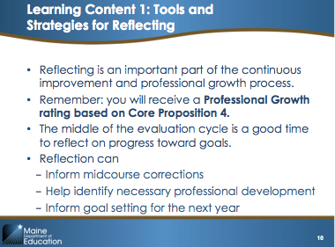Slide 10

Learning Activity 1: Teacher Interview (15 minutes)

Purpose and Intended Outcomes
The purpose of this activity is for participants to learn from each other about ways they reflect on practice.
Explain:  “If you turn to Handout 1: Teacher Interviews in your packet, you will see that there are four interview questions listed and space for you to record the responses of two teachers.  We are going to count off by fours. You will be assigned one interview question and will have seven minutes to interview two people about this question. There is space on the handout for you to record your responses.”  As participants to count off by fours. Tell them to begin to interview their colleagues.  Gauge participant completion—the activity may take from 7 to 10 minutes. Give the group up to 10 minutes to complete the task if it looks like they are not finished by the seven-minute mark.  Make sure the pre-made pieces of chart paper for this activity are hanging up during this time. | 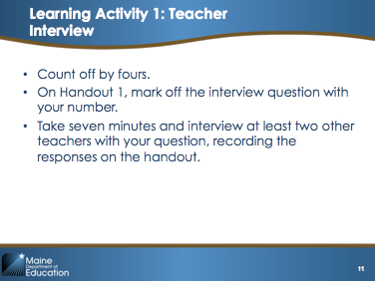Slide 11  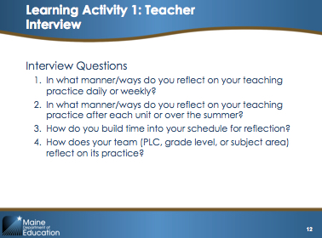Slide 12

Guiding Questions:
- In what manner/ways do you reflect on your teaching practice daily or weekly?
- In what manner/ways do you reflect on your teaching practice after each unit or over the summer?
- How do you build time into your schedule for reflection?
- How does your team (PLC, grade level, or subject area) reflect on its practice?

Learning Wrap-Up/Debrief 1 (5 minutes)
Explain:  Ask participants to gather at the sheet of chart paper according to the questions they asked and write a short summary of what they learned about how teachers are reflecting. Inform the teachers they will need to give a one-minute share-out of what they have learned and what, if any, strategies they would like to incorporate into their own practice. Allow participants at least five minutes to record their thoughts.  Call on each group to share out a summary of the strategies their colleagues use. | No Slide

Learning Content 2: Using Data and Feedback to Reflect (15 minutes)
Explain:  “This slide shows a list of steps that teachers can use to more formally reflect on their practice and their progress toward goals at the midpoint of the evaluation cycle. The steps are offered here as guidance to support your successful completion of both the midcourse self-evaluation and the summative evaluation process.  The steps of this formal reflection are on the slide and are included on the Midcourse Reflection handout in your packet (see Handout 4). Again, this handout is not a required part of your evaluation; rather, these are simply supports to help you structure your reflection today in preparation for the reflective portion of the evaluation process.”  Read through the steps on the slide.  “First, we are going to focus on Steps 1 and 2, which focus on your professional practice goals. Then, later in the meeting, we will focus on Steps 3–5, which focus on progress toward your student learning objectives and preparing for your midcourse review.” | 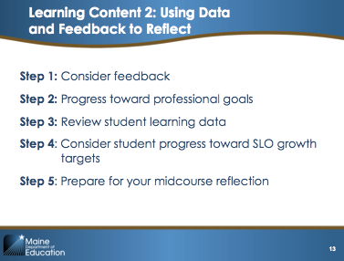Slide 13
Be aware Mrs. Smith is the elementary school example and Mr. Smith is the secondary school example. Use the correct title for the teacher that matches the level of the teachers at this training.
Explain:  “If you turn to Teacher Smith’s Midcourse Reflection (Handouts 2 and 3), you will find an example of what this reflection might look like in Steps 1 and 2.  This reflection was filled out by Teacher Smith, the teacher whose practice we observed in Module 4.  To complete this reflection, Teacher Smith reviewed the feedback from his or her observation, particularly the post-observation conference notes. He or she also reviewed the professional practice goal that was set at the beginning of the observation cycle.  After reviewing this information, you can see in the chart that Teacher Smith identified some concrete skills, knowledge, and action steps that could help improve his or her practice.  Looking at this form, it seems like the step from identifying what is wrong to identifying a possible solution is an easy one, but without thoughtful reflection, it is easy to jump to a conclusion or a solution that does not address the problem. This is definitely an area where you will want to spend some quality time reflecting.  Take five minutes to read over this form and share with an elbow partner significant things that you noticed.  For example, are the reflections evidence-based? Where do you see the most benefit to Mr/s. Smith based on his/her reflection? Is there more information or more reflection that is needed? If so, where?  Monitor the group; when most people have discussed the reflection with a colleague, call the group back together to continue on to the next Learning Activity.  Be sure to note for the group (if they do not raise it on their own) that one problem with Mr/s. Smith’s reflection is that the teacher mentions the specific names of students. In general, teachers should not make student names visible to anyone but those who have a compelling educational reason to view the information on behalf of the students. Reviewing one another’s goals is not a compelling reason. | 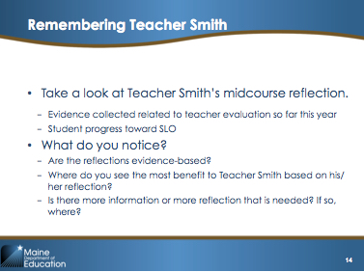Slide 14

Learning Activity 2: Putting the Steps Into Practice (35 minutes)

Purpose and Intended Outcomes
The purpose of this activity is to introduce teachers to a set of steps to use to formally reflect on their practice and progress toward goals.
Explain:  “For this activity, we’re going to begin putting these reflection steps into practice.  Using Handout 4, begin by focusing on Steps 1 and 2.  You can work with a partner if you would like.  You should use the MSFE Rubric and feedback you have received on your evaluation thus far.  Identify action steps for adjusting practice to ensure you are on track to meet your professional practice goal.”  Tell participants they will have 35 minutes to complete these steps.  During this time, use paper and sticky notes to create a confidence chart on the wall, from 1 (not confident) to 10 (very confident). | 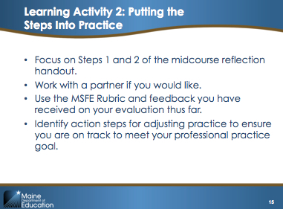Slide 15

Possible Facilitation Challenges and Solutions:
Challenge | Solution(s)
Participants may not have enough information to complete these questions. | Encourage teachers who may not have experienced enough of the evaluation process to reflect to use Appendix M to record evidence of their practice on different standard indicators. Appendix M can be located on pages 57–58 in the Handbook. Alternatively, participants could also use this time to plan out how they will collect the evidence they need in order to complete the reflection.

Guiding Questions:
- Step 1: Consider the feedback you have received so far during the evaluation cycle on the MSFE Rubric.
- Step 2: Consider your progress toward meeting your professional practice goal.
- Identify the knowledge, skills, and action steps needed to ensure you meet your professional practice goal.
- Identify the changes in instruction that need to take place to ensure you are on track to meet your goal.

Learning Wrap-Up/Debrief 2 (10 minutes)
Read the instructions on the slide and tell participants to use sticky notes to indicate their response to the question, “How confident are you that you will achieve your professional practice goal?”  Once everyone has voted, summarize the results for the group.  What level of confidence did most teachers vote for? Do most people have a high, middle, or low level of confidence in meeting their professional practice goal? | Slide 16

IV. Implementing (45 minutes)

Slide 17 is the divider slide for this section.

Implementing Activity: Starting With Your Students (45 minutes)

Purpose and Intended Outcomes
The purpose of this activity is to allow teachers time to complete the last three steps of the reflection handout, which focus on reflecting on student learning progress.

Note to facilitator: If your district is using a different approach to scoring SLOs, you will need to modify the information on Slide 19.  Explain:  “For this last section of the day, you will have time to reflect on your progress toward your student learning objective.  Use Handout 4 and respond to Steps 3 and 4.  You should have been asked to bring some data on student progress to this module. Feel free to work in grade level or subject area teams to review source(s) of data on student progress toward meeting SLO targets before you identify action steps for adjusting practice to help student get on track to meet their targets.”  Click the slide to add a chart.  “Even though you are considering students’ progress toward their goals, you should remember how student learning objectives are scored.  The expectation is not that every single student will necessarily meet his or her SLO target. That is of course our aspiration for each of our students—that they succeed and show individual growth. However, to earn the highest score on your SLO, it is not necessary that all of the students meet those targets.  - A teacher can earn the highest score (4) if 85–100 percent of his or her students meet their targets.  - A teacher earns a score of 3 if 71–84 percent of the students meet their targets.  - A teacher earns a score of 2 if 41–70 percent of the students meet their individual targets.  - A teacher earns a score of 1 if fewer than 40 percent of the students meet their growth targets.  Take about 30 minutes to work with your teammates to answer questions 3 and 4 on the Midcourse Reflection handout.” | 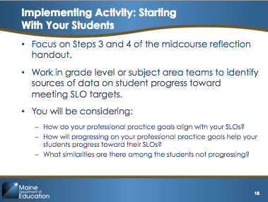Slide 18  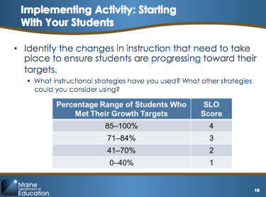Slide 19
Possible Facilitation Challenges and Solutions
Challenge | Solution(s)
Participants may not have teammates at the meeting. | Participants don’t need to work with their PLC or team members. They can work with other school team members or alone to complete this reflection.
Participants may not have brought student data to the module. | If the training is occurring at that teacher’s school, then allow the teacher to go to his or her classroom to gather some student data. If not, then tell teachers to just use their knowledge of their students to begin the reflection on student SLO attainment; they can complete it later when they have the data they need. Participants could also use this time to plan for how they will get the data they in order to reflect.

Guiding Questions:
- Step 3: Review student learning data.
- Step 4: Consider how close students are to meeting their targets on your student learning objective.
- Identify the changes in instruction that need to take place to ensure students are progressing toward their targets.

V. Reflecting and Wrap-Up (30 minutes)

Slide 20 is the divider slide for this section.
Read the instructions on slide 21. Tell participants they will have 20 minutes to complete Step 5.  Explain:  “Step 5 on Handout 4 asks you to summarize this reflection to prepare for your midcourse reflection (Appendix O, Part 3) and summative self-evaluation (Appendix M).”  When there are five minutes left, click the slide, which will add the discussion prompt to the slide.  Ask participants to discuss their responses with a partner at their table. | 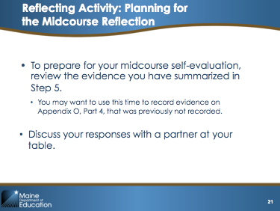Slide 21
Explain:  “The next time we gather, we will be [facilitator to modify based on plans for use of extension material.]” | Slide 22
Come to closure (1 minute)  Note: Enter your e-mail address on this final slide so participants know where to send questions. | 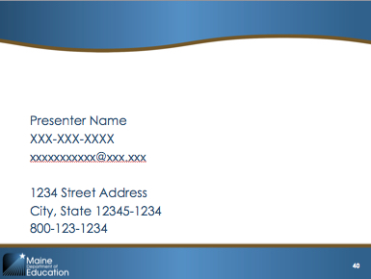  Slide 23

Part 2: Optional Extension Materials

The slides and facilitator’s notes that follow are intended for an end-of-year learning segment after teachers have completed the first year of the T-PEPG and have already received their summative ratings; Or facilitators could use this material to help participants begin their end-of-year self-evaluations in preparation to receive their summative ratings. Therefore, you may wish to approach these slides as a preview of the end of year process.

I. Connecting (30 minutes)

Slide 25 is the divider slide for this section.

Connecting Activity (10 minutes)
Explain:  “Consider your experience with SLOs and the MSFE Rubric. Based on your experience with SLOs and the MSFE Rubric, share with a partner:  - 3 highlights from your school year  - 2 hopes for next year  - 1 change you want to make and why  Invite partners to write their responses on chart paper and share with the group. Keep the charts visible to revisit at the end of the session.” | 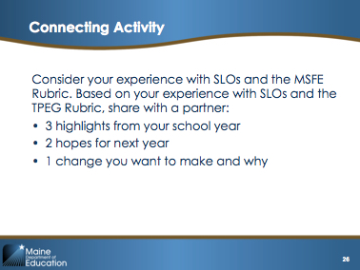Slide 26

II. Learning (1 hour)

Slide 27 is the divider slide for this section.

Learning Activity: Teacher-Submitted Evidence (15 minutes)
The purpose of this activity is to give teachers a chance to reflect specifically on the process (and outcome, if possible) of collecting evidence. The evidence collection process was introduced during Module 4, so this is a chance for teachers to revisit the process and think ahead to next year.

Explain:  “Now we are going to give you a chance to take a look back at Appendix M and Appendix O, Part 4, which you have either been working on or have already submitted.  Note to facilitator: You can decide whether to cover this content based on where most participants are in the evaluation process.  “You should be familiar with Appendix M (see Handout 5) from Module 3; you completed this as part of the self-evaluation process. When you reach the end of your summative evaluation cycle, you will need to complete your self-evaluation again by filling out Appendix M one more time.  Working in pairs, either reflect on how these appendixes were received by your evaluator or review with a partner the evidence you plan to submit to your evaluator. Discuss the following questions with your partner:  - For those who have already submitted your evidence: Did your submissions work in your favor? Did your evaluator understand the purpose for each piece of evidence and the connection to your goals? Did you submit enough? Too much? What will you do differently next year?  - For those who have not yet submitted your evidence: Are the submissions you have collected sufficient? Is their connection to your goals clear?  - For everyone: What did you learn from collecting evidence this year? What (if anything) would you do differently? Do you have suggestions to improve on this process?  Everyone should also have time to think ahead to next year. Spend a few minutes talking about this in pairs, and then we will also discuss that part as a whole group.” | Slide 28

Learning Wrap-Up/Debrief (5 minutes)
Once you notice that most pairs have had a chance to discuss the guiding questions on the slide, transition to a whole-group share out.  Explain:  “We want to be sure to capture everyone’s thoughts on the process of collecting evidence. We would love to hear if any of you have suggestions for how we might improve upon this process for next school year. We can’t promise that all the changes you suggest will be made, but it would be great to hear your thoughts so we can pass them along.”  Give teachers a chance to share out; record their suggestions on chart paper. | No slide

Learning Content: Summative Scoring Process (20 minutes)
Explain:  “At the end of your summative evaluation cycle, your evaluator will use evidence from each of the various practice measures as well as your SLOs to determine your summative effectiveness rating.  To help ensure you understand this process, and therefore your own rating when you receive it, let’s walk through a summative scoring process for Mr. Kelso together.  After we review the scoring process, we will look in greater detail at the outcome of your summative effectiveness rating—the type of professional growth plan you will be on next year.” | 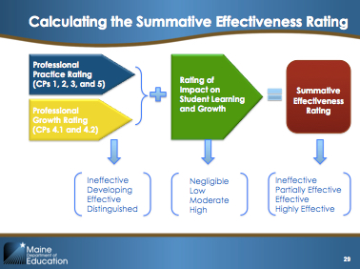Slide 29
Note to Facilitator: This slide is animated.
Explain:
“As we discussed in Module 1, the Maine DOE T-PEPG model uses a series of matrixes to combine the ratings from each type of measure and determine a final summative effectiveness rating.
Before we dive into the matrixes, let’s review the ‘big picture process’ first.
The evaluator will first combine the professional practice rating and professional growth rating to create a single rating on a four-point scale (ineffective, developing, effective, and distinguished).
Next, the evaluator will use another matrix to combine that rating with the teacher’s rating of impact on student learning and growth (SLOs).
This final combined rating will be your summative effectiveness rating, which will determine the professional growth plan you will be on next year.
Now let’s take a more detailed look at how the evaluator will arrive at each of the ratings.”
Explain:  “Turn to Appendix P in the Handbook; you should see the Summative Rating Worksheet.  Take 3–5 minutes to read through Appendix P in the Handbook.”  Give participants a few minutes to read, and then ask if they have any questions about the process. Clarify any misunderstandings and then move on to the next question.  Take out Handout 6, which provides you the relevant scoring information for our fictional teacher, Mr. Kelso. This is a mocked-up version of a Summative Rating Worksheet that we will use to explore the process.  “Take a look at Mr. Kelso’s ratings on each Core Proposition. Based on these scores, what will his professional practice rating be?”  Give participants 1–2 minutes to decide; call on the first person who offers an answer and if correct, ask them to explain their answer. Note: the answer is “Effective.” Ask participants to record this in the appropriate row in Mr. Kelso’s table (third row from the bottom). | 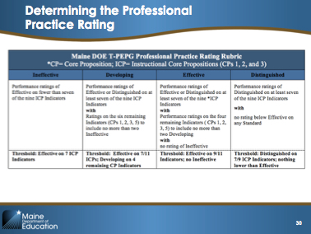Slide 30
Explain:  “Next, let’s look at Mr. Kelso’s information to determine his professional growth rating.”  Give participants 1-2 minutes to decide or ask questions, call on the first person who offers an answer and if correct, ask him or her to explain their answer. Note: the answer is “Distinguished.” Ask participants to record this in the appropriate row in Mr. Kelso’s table (second row from the bottom) | 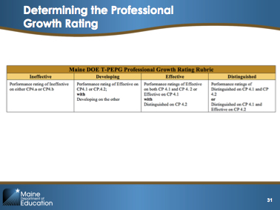Slide 31
Explain:  “Next, let’s look at the rubric for combining the practice rating and the professional growth rating  What is Mr. Kelso’s combined rating?”  Give participants a minute to decide or ask questions, call on the first person who offers an answer and if correct, ask them to explain their answer. Note: the answer is “Effective.” Ask participants to record this in the appropriate row in Mr. Kelso’s table (last row). | 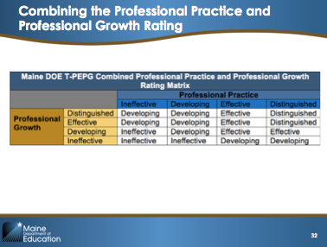Slide 32
Note to Facilitator: You may want to modify the explanation and slide for this section if your district has adopted a different approach to scoring SLOs.  Explain:  “Next, let’s look at Mr. Kelso’s SLO scores.  Let’s revisit the last several steps in the SLO scoring process:  Before administering the post-assessment, you must discuss any students who will be exempt from scoring, based on the criteria in Table 1in the SLO Handbook.”  Pause for questions. Remind teachers that answers to specific SLO questions can be found in the SLO Handbook, which is available at http://www.maine.gov/doe/effectiveness/maine-doe-tpepg-slo-handbook.pdf  “At the end of the predetermined interval of instruction, teachers administer and score assessments. After scoring, we go back to the original growth targets we set and determine which students met their growth targets. This gives us a total number of students who met their targets, which we then translate into a percentage. We discuss our outcomes with our evaluators.  Take a look at the example for Mr. Kelso in your work sheet. Complete the score by weighting each rating and calculating the total. What is Mr. Kelso’s overall impact rating based on the percentage?”  Give participants a minute to decide or ask questions, call on the first person who offers an answer and if correct, ask them to explain their answer. Or you can reveal slide XX and walk through the correct answer as a whole group. | 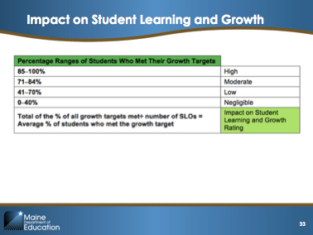  Slide 33  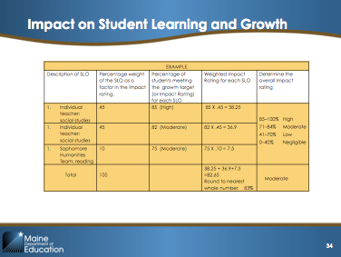Slide 34
Explain:  “In the final step, we will use Mr. Kelso’s combined professional practice and growth score and his student learning and growth rating to determine his final summative effectiveness rating using the Summative Effectiveness Rating Matrix. Based on this matrix, what will Mr. Kelso’s final summative effectiveness rating be?”  Give participants a minute to decide or ask questions, call on the first person who offers an answer and if correct, ask them to explain their answer. Note: the answer is “Effective.” | 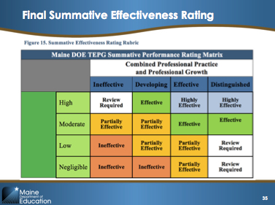Slide 35
Participants may ask what “Review Required” means in Figure 15. If so, explain as follows.  Explain:  “In most cases the component ratings generate a clear summative rating; however, when a significant disparity exists between the professional practice/growth rating and the impact on student learning and growth rating an evaluator does not assign a summative rating until a review is conducted and the disparity resolved. The review must include but is not limited to an investigation and consideration of all evidence related to:  - The accuracy of the scoring process;  - The accuracy of the evaluator's judgments;  - The appropriateness of the assessments used to measure student growth;  - The students included in the calculation of the student growth measure; and  - The appropriateness of the student growth target.  If the reason for the disparity is not readily apparent and easily resolved, the teacher continues on the current growth plan and a second evaluator is brought in to confer and calibrate with the original evaluator.” | 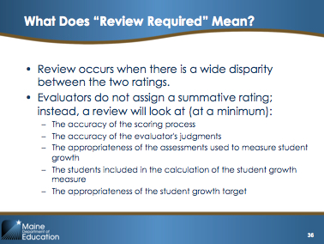Slide 36

Learning Wrap-Up/Debrief (15 minutes)

Explain:  “Your summative effectiveness rating will determine which professional growth plan you will be on for the next year.”  Review the table on the slide with participants. | 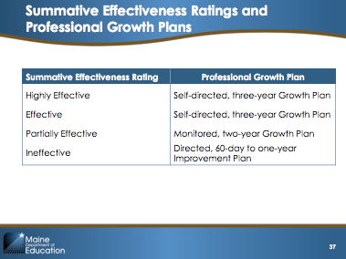Slide 37
Explain:  “Let’s take a moment and remind ourselves what each of these growth plans entail.”  Review the table on the slide with participants. | 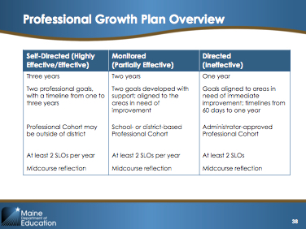Slide 38

III. Implementing (30 minutes)

Slide 39 is the divider slide for this section.

Implementing Activity: Preparing for the Summative Evaluation Conference
The purpose of this activity is for teachers to have time to work independently on their self-evaluations and Appendix O, Part 4, with facilitators on hand to support them as they work. This will not be enough time for teachers to complete the self-evaluation component, but it will provide teachers the chance to begin and at least gain an understanding of what they will need to do once the time comes. This activity builds directly off of the Reflection activity that closes out Part 1 above.
Explain:  “You have some time now to begin working independently (please feel free to ask questions of us or each other as you work). You should review what you wrote on Appendix M in the fall and what you have collected thus far in Appendix O, Part 4. Look at the evidence you have been provided so far by your evaluator, the evidence you have gathered, and your rubric. You can begin writing or outlining your thoughts on what you will write now that the school year is coming to a close.”  Allow teachers to work independently for about 20 minutes. | 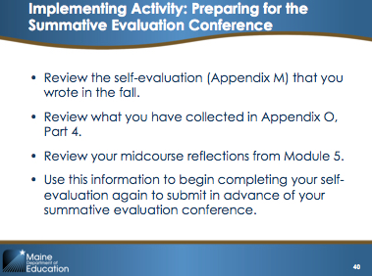Slide 40

Implementing Debrief/Wrap-Up (10 minutes)

Note to facilitator: Select from the discussion question below based on your participants’ needs and modify the slide accordingly. Use the questions to facilitate a short round-robin discussion with participants.  Explain:  - “Do you know what you want to say in your end-of-year reflection? Do you need any help?  - Do you think that you met your professional learning goal this year? How do you know?  - Are your evaluator’s notes helpful? Can you give an example of something you found helpful (or not helpful)?  - Do you know how to use the rubric to guide you during the end-of-year evaluation?  - Was your goal too easy or too hard? Do you have ideas of what your goal might be next year?” | 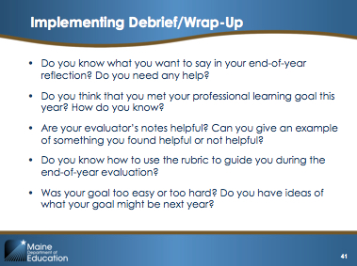Slide 41

III. Feedback (45 minutes)

Slide 42 is the divider slide for this section.

Reflecting Activity: Looking Ahead to Next Year

This activity provides participants with a structured opportunity to reflect on and provide feedback to the district about the T-PEPG model. Facilitators can collect participants’ feedback to share with the steering committee in order to make improvements to the process for the following year.

Give each table a piece of chart paper. Ask participants to divide the paper into three areas or columns, labeling each area as one of the following:  Professional practice, professional growth, and SLOs.  Explain:  “For each of the areas, discuss: What do you plan to change next year about your approach to completing the evaluation process? What should the district change about any of these processes in our district’s T-PEPG system for next year? Why? What went well? What additional supports do teachers and evaluators need? Record your ideas on the chart paper. We will be sharing your ideas with the district steering committee to improve the process next year.”  Give participants 25–30 minutes to discuss this question.  After 25–30 minutes, reconvene and ask each group to share out their recommendations. Collect the chart paper at the end of the exercise to share with the district. | 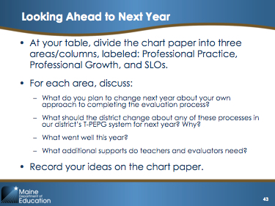Slide 43

Note: for Module 5, the module includes three additional hours of material that is optional and can be used based on the individual district needs.

