Teacher Performance Evaluation and Professional Growth (T-PEPG) Model
Facilitator Guide for Training Module 1:
Model Overview

Teacher Performance Evaluation and Professional Growth (T-PEPG) Model
Facilitator Guide for Training Module 1: Model Overview

November 2014

Contents
Page
T-PEPG Modules Purpose and Goals 1
Audience 1
Timing and Structure 1
List of Training Modules 2
Preparing for Module 1 4
Module Overview 4
Intended Outcomes 4
Agenda 5
Equipment and Materials 6
Maine DOE Model Resources 6
Facilitator Guide 7
I. Welcome (5 minutes) 7
II. Connecting: Hopes and Worries (10 minutes) 8
III. Learning (50 minutes) 9
IV. Implementing (55 minutes) 22
V. Wrap-Up (5 minutes) 28

T-PEPG Modules Purpose and Goals
This series of five T-PEPG modules is designed to provide information and guidance to teachers on the Maine Department of Education (Maine DOE) Teacher Performance Evaluation and Professional Growth (T-PEPG) model in their schools. T-PEPG Leads and the administration (if necessary) will train the Professional Cohort facilitators, who will train teacher participants using the module materials. The aim of the module materials is to:
- Make the four-step T-PEPG process meaningful, doable, concrete, and actionable for teachers.
- Support teachers in developing a common understanding of the evaluation model, the MSFE Rubric, and the opportunities for professional growth and development grounded in the five National Board Core Propositions.
- Provide participants with tips, strategies, and opportunities to share best practices aligned to the T-PEPG model.
The T-PEPG modules provide facilitators with consistent, standardized materials and content, detailed facilitator guides, and participant handouts that connect to the T-PEPG model. Facilitators may use some or all of these materials and modify them as appropriate to fit the available time and teachers’ needs.

Audience
The T-PEPG modules will be presented to teachers by Professional Cohort facilitators in their respective schools. Districts and schools can determine whether to bring together educators for a school- or district-wide training session, or provide training in smaller grade-level or content-area teams.
The modules are designed so that Professional Cohort facilitators can facilitate abbreviated, chunked, or complete versions of each module to teachers as necessary (see the Timing and Structure section for more details).

Timing and Structure
Each training module is between two and three hours in length and includes interactive learning activities, which were designed within a framework of adult learning theory and best practice. Suggested assignments described at the conclusion of each module are intended to help participants extend and apply their learning and are designed to be integrated into the work teachers are already doing. Each module will include time for participants to share what they have learned as a result of completing the assignment and to collaborate on the appropriate next steps.
The modules are organized into a four-part structure to help facilitators and participants pace the content appropriately. The four segments of each module are as follows:
- Connecting—Builds community, prepares the team for learning, and links to prior knowledge, other modules, current work, and the MSFE Rubric; designed for all school-based educators
- Learning—Describes key concepts and highlights various implementation scenarios; supports teams in applying knowledge and sharing ideas; designed for all school-based educators
- Implementing—Supports teams in problem-solving and planning next steps for schools and districts; geared toward school leadership teams
- Reflecting—Engages participants in providing feedback, reflecting on learning, and closing the session

List of Training Modules
Module 1: Model Overview. The first module provides participants with a big-picture overview of the key features of the T-PEPG model, including its purpose and goals, timelines, and annual process; the National Board of Professional Teaching Standards (NBPTS) Core Propositions; multiple measures of effectiveness; summative scoring; and professional growth plans. Participants unpack the basic structure and terminology of the MSFE Rubric and examine the rubric’s standard indicators in preparation for self-assessment, reflection, and goal setting, which is covered in Module 3.
Module 2: Student Learning Objectives. The second module engages participants in the student learning objective (SLO) development process. Knowing how to set realistic and rigorous targets is critical for supporting student learning throughout the year. SLOs are specific and driven by needs, and they include an instructional plan that enables students to meet their learning targets. SLOs also inform teachers’ professional goal setting, which is covered in Module 3.
Module 3: Reflection and Goal Setting. The third module supports participants in reflection in order to set professional goals. Participants engage in SMART goal development, a process that can help teachers achieve or maintain effective practice and ensure students meet the rigorous learning targets established through the SLO process. Professional growth is one of the multiple measures of the T-PEPG model, and SMART goals provide participants the opportunity to strategically identify specific areas of growth and focus for the school year.
Module 4: Evidence, Observation, and Feedback. The fourth module describes expectations for observations (both inside and outside classrooms), the collection and organization of observation evidence, and the sharing of timely, constructive feedback. All participants engage in peer observation, and the module provides information about how to make the process meaningful, collaborative, and constructive.
Module 5: Reflecting and Adjusting. The fifth module supports participants in the use of the MSFE Rubric, evidence, and student data to monitor progress toward their professional goals. Participants explore when and how to revisit their professional goals, check in on student progress, and collaboratively determine appropriate midcourse adjustments to their practice. The module includes an extension section that facilitators can use as needed to prepare teachers to gather evidence in preparation for the summative evaluation conference and as a tool to guide reflection and future goal setting. The section also includes an overview of the summative scoring process and professional growth planning process.

Preparing for Module 1

Module Overview
The first module provides participants with a big-picture overview of the key features of the T-PEPG model, including its purpose and goals, timelines, and annual process; the NBPTS Core Propositions; multiple measures of effectiveness; summative scoring; and professional growth plans. Participants unpack the basic structure and terminology of the MSFE Rubric and examine the rubric’s standard indicators in preparation for self-assessment, reflection, and goal setting, which is covered in Module 3.

Intended Outcomes
At the end of this session, participants will
- Understand the T-PEPG model foundation, elements, and four-step process
- Understand the NBPTS professional practice standards, indicators, and rubrics (MSFE Rubric), especially their structure and use in evaluation
- Be able to use the Companion Guide to deepen familiarity with and understanding of the instructional and professional practices in the MSFE Rubric

Agenda
- Welcome (5 minutes)
- Connecting (10 minutes)
- Connecting Activity: Hopes and Worries (7 minutes)
- Connecting Wrap-Up/Debrief (3 minutes)
- Learning (50 minutes)
- Learning Content 1: T-PEPG Foundations, Elements, and Process (20 minutes)
- Learning Activity 1a: Where Is the Rubric in the Four-Step Evaluation Process? (10 minutes)
- Learning Activity 1b: Getting to Know the Points of Contact Framework (15 minutes)
- Learning Wrap-Up/Debrief (5 minutes)
- Implementing (55 minutes)
- Implementing Content: The MSFE Rubric and Companion Guide (10 minutes)
- Implementing Activity 1a: Levels of Performance (20 minutes)
- Implementing Activity 1b: Taking a Deep Dive Into the Companion Guide (20 minutes)
- Implementing Wrap-Up/Debrief (5 minutes)
- Reflecting and Wrap-Up (5 minutes)
- Reflection: Revisiting Hopes and Worries
- What’s Next: Module 2

Equipment and Materials
- Equipment: Laptop computer, projector
- Materials:
- Review the entire facilitator guide. Note that there are certain sections and slides that you should modify to make sure the content reflects your district’s specific T-PEPG process, timeline, and Professional Cohort model. There are suggestions throughout notes in the facilitator’s guide for where to make these modifications.
- Make a copy of the Participant Handout packet for each participant.
- Make a copy of the MSFE Rubric and Companion Guide for each participant.
- Put the following materials on each table:
  - Sticky notes
  - Markers
- Bring the following materials for use by you:
  - Chart paper, easel, and markers

Maine DOE Model Resources
Maine DOE model resources can be found on the Maine DOE website at http://www.maine.gov/doe/effectiveness/index.html. Specific resources that are useful to review before facilitating this training include:
- Maine DOE Teacher Performance Evaluation and Professional Growth Model (T-PEPG Model) Handbook and Implementation Guide for School Administrative Units
- MSFE TEPG Rubric Companion Guide 2014–15 (which includes the MSFE Rubric in Appendix A)
- Maine DOE Professional Cohort Guide

Facilitator Guide

I. Welcome (5 minutes)
Slide 1 is the title slide.  Welcome participants to the training and introduce yourself as a facilitator. | Slide 1
Explain:  “This is Module 1 of a series of five modules on the Maine DOE teacher evaluation model.  “In this first module, we will be exploring the key features of the T-PEPG model, including its purpose and goals, timelines, and annual process; the NBPTS Core Propositions; multiple measures of effectiveness; summative scoring; and professional growth plans. Participants will unpack the basic structure and terminology of the MSFE Rubric and examine the rubric’s standard indicators in preparation for self-assessment, reflection, and goal setting.  The purpose of this module is to provide a high-level overview of the T-PEPG model and provide focused time for you to develop familiarity with the MSFE Rubric. As you can see, in the modules that follow, we will be going into greater depth on each aspect of the model.” | 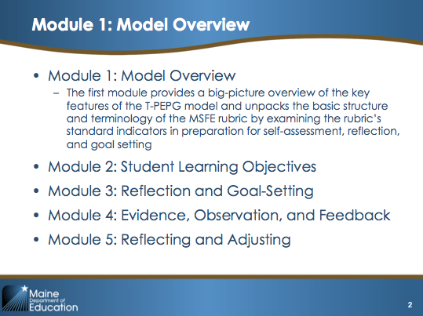  Slide 2
Provide an overview of the agenda to the teachers, or give them a minute to read the agenda themselves. | 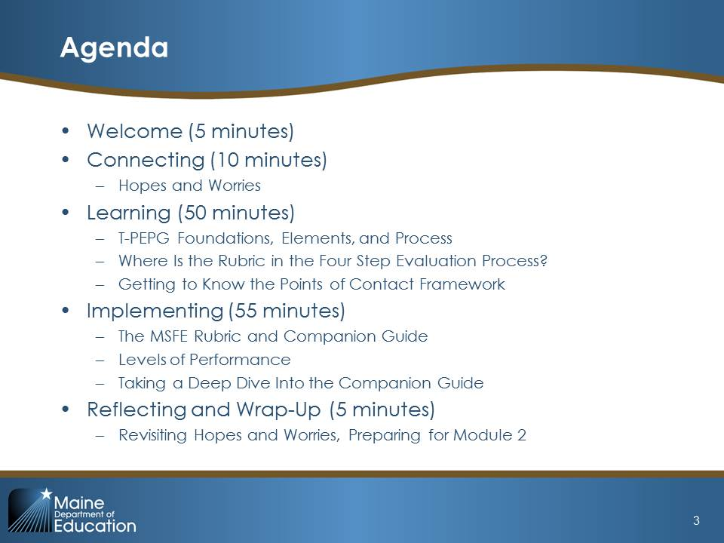  Slide 3
Explain:  “This module will help you develop foundational knowledge for completing the T-PEPG process. By the end of today, you will:  - Understand the T-PEPG model foundation, elements, and four-step process  - Understand the NBPTS professional practice standards, indicators, and rubrics (MSFE Rubric), especially their structure and use in evaluation  - Use the Companion Guide to deepen your familiarity with and understanding of the instructional and professional practices in the MSFE Rubric.” | 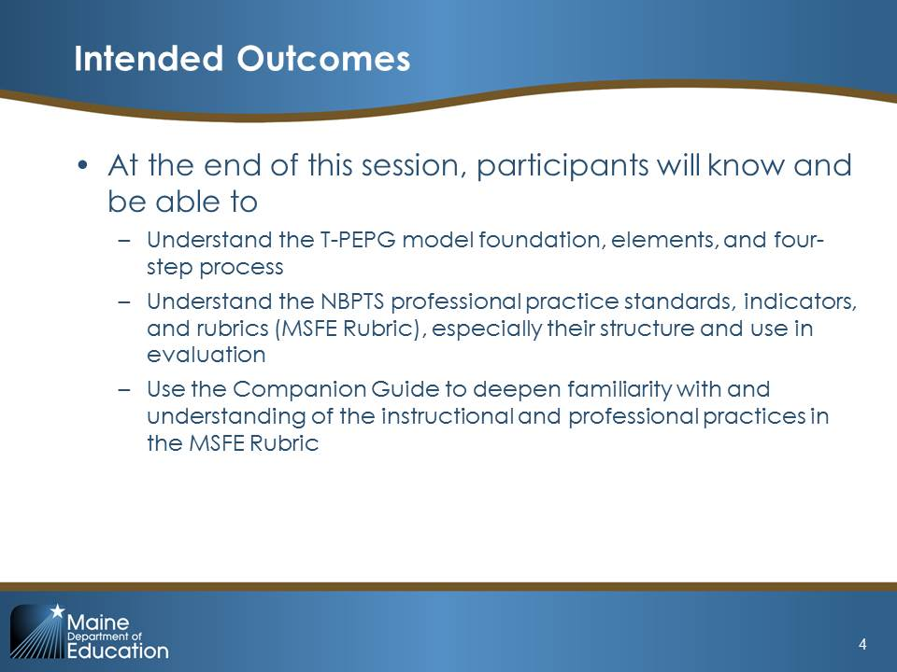  Slide 4

II. Connecting: Hopes and Worries (10 minutes)

Slide 5 is the title slide for the Connecting section.
Explain:  “Before we get started, I’m sure you all have heard different things about the new evaluation model and probably have many questions, thoughts, and concerns about it. Let’s take a minute to put those things on the table before we dive into the overview. On your table you have sticky notes and pens. On one sticky note, write down your biggest hope for the new model (i.e., what you hope you or your students might gain from it), and on another sticky note write down your most significant concern or worry about the new model. Take 2 minutes and jot them down now.”  Give participants 2–3 minutes and then move to sharing out.  “Okay, could a few people volunteer to share out their biggest hope?”  Take 3–4 volunteers.  “How about a few volunteers to share your most significant concerns?”  As each volunteer shares his or her hope or concern, prompt the full group by asking, “Did anyone else write down something similar? Or something different?” After about 7 minutes, close by saying:  “Great. Thank you for sharing those thoughts. I’d like you to hang on to your sticky notes and we’ll revisit them at the end of the session.”  At the end of Module 1, you will ask participants to look back at their sticky notes and consider whether, after going through the session, they would now change their answer, and if yes, how? This will provide you, as the facilitator, with useful feedback on aspects of the model to which you may need to devote additional time and attention in order to best address your teachers’ needs and concerns. This can also be useful feedback to pass along to district planning teams to help improve communication and model design. | 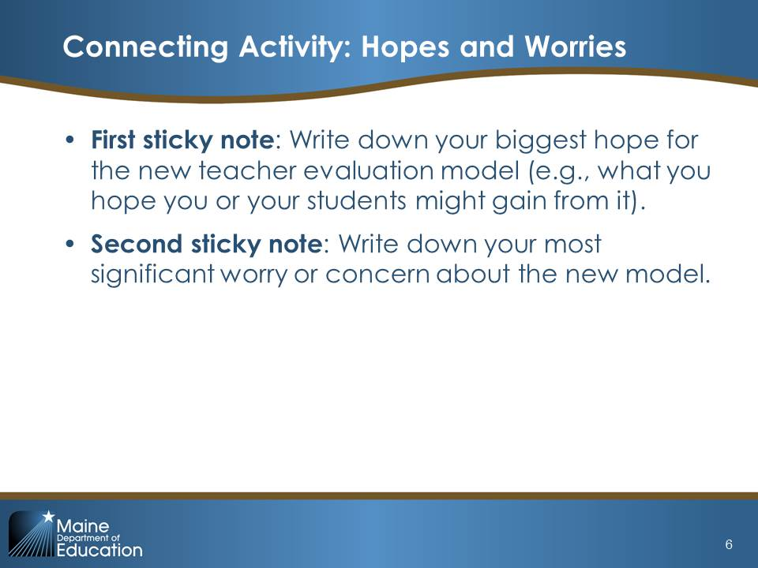  Slide 6

Possible Facilitation Challenges and Solutions
Challenge | Solution(s)
Participants may have many questions about the details of the model. | Acknowledge the questions and remind participants that the purpose of the professional cohort meetings and the modules is to provide time and space to learn about each other and work together in implementing the T-PEPG model. Today’s session will not answer every question and is not intended to do so—today is an overview and introduction to the model; however, by raising the questions now, it helps the facilitators to tailor future cohort meetings agendas and content to make sure those questions do get answered.
Participants may share concerns beyond the scope of T-PEPG or may share their concerns in a manner that is not conducive to a productive dialogue and learning process. | Acknowledge the concerns but remind participants that the purpose of the activity is to help assess (at the end of the day) what aspects of the T-PEPG module may need clarification and what additional content or resources are needed to better support them in completing the T-PEPG process. In addition, it elicit surface helpful feedback that can support the district in improving the T-PEPG model over time.

III. Learning (50 minutes)
The title slide of the Learning section of the module is on slide 7.

Learning Content 1: T-PEPG Foundations, Elements, and Process (10 minutes)

Explain:  “The T-PEPG model is rooted in the Maine Department of Education’s commitment to providing all students with effective teachers. As this quotation from the department’s strategic plan, Education Evolving, illustrates, effective teachers are the critical element in improving student learning and growth.”  Read quotation: “Systematic changes to standards, curricula, instructional practice, and assessment will achieve little if efforts are not made to ensure every learner has access to highly effective teachers and school leaders.” –Maine DOE, Education Evolving, 2012  “In addition to the T-PEPG model for teachers, Maine districts are also adopting new performance evaluation models for school leaders.” [Facilitators may want to include information here briefly about the district’s leadership evaluation model]. | 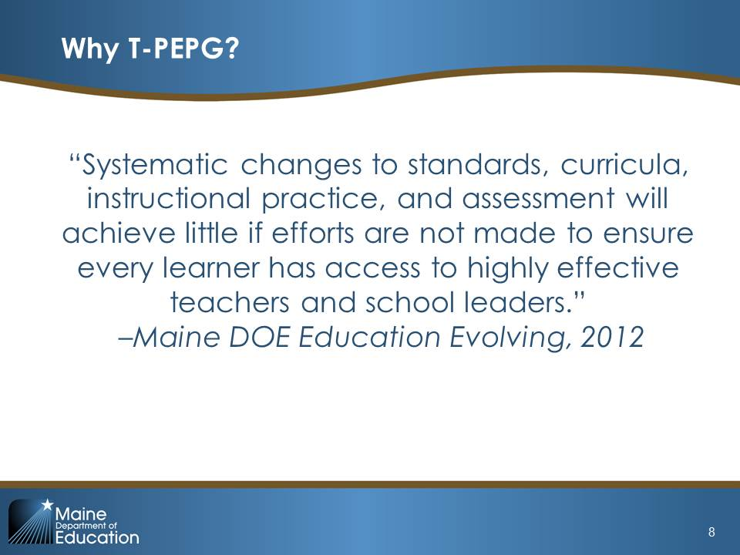  Slide 8
Explain:  “To that end, the T-PEPG model is motivated by several overarching goals:  - Serving as the basis for professional development that can improve instructional effectiveness;  - Clarifying expectations and serving as a guide for teachers as they reflect upon and improve their effectiveness;  - Facilitating collaboration by providing a common language to discuss performance;  - Focusing the goals and objectives of schools and districts as they support, monitor, and evaluate their teachers;  - Serving as a tool in developing structures of peer support for teachers; and  - Serving as a meaningful measurement of performance of individual teachers.  Ask: “Do these goals and purposes align with things you are already doing? If yes, how might T-PEPG serve to support or enhance those efforts?”  Give participants 2–4 minutes to offer responses and then transition to the next slide. | 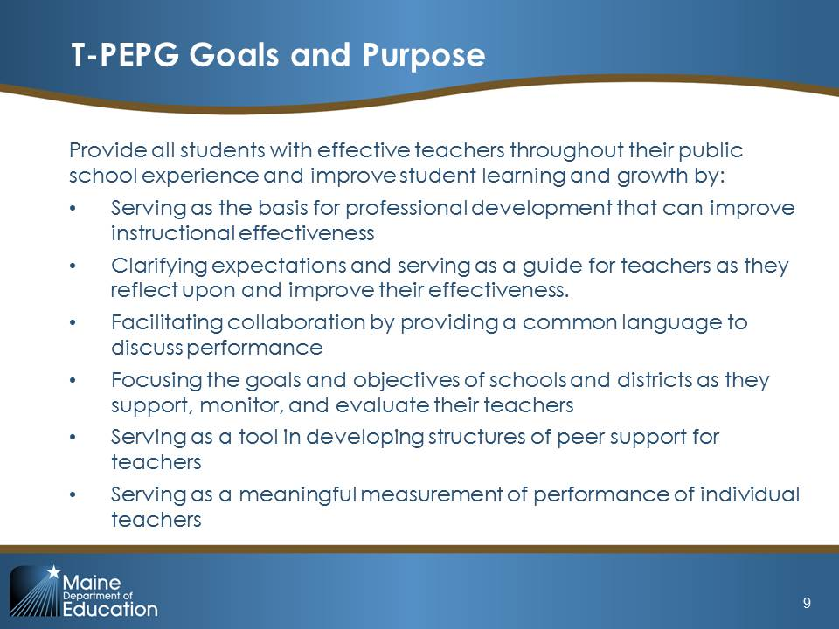  Slide 9
Note: the content below and slide require modification by the Professional Cohort facilitator to add district-specific information if the Professional Cohort structure is not implemented as described.  Explain:  “To help support you in implementing the T-PEPG model, our district has a Professional Cohort model. This model provides a locus of support and training for teachers in achieving professional goals and increasing effectiveness. Over the first year, the content covered in the cohort(s) will align with each step you need to complete in the four-step evaluation process, which we are going to explore today. In addition, your cohort group will both provide training for and serve as a forum for critical review and approval of professional goals and student learning objectives. This Professional Cohort is led by [insert the names and titles of the cohort’s teacher leaders]. These leaders were selected by the administration based on prior knowledge of their qualities and skills in the content areas to be covered.” | 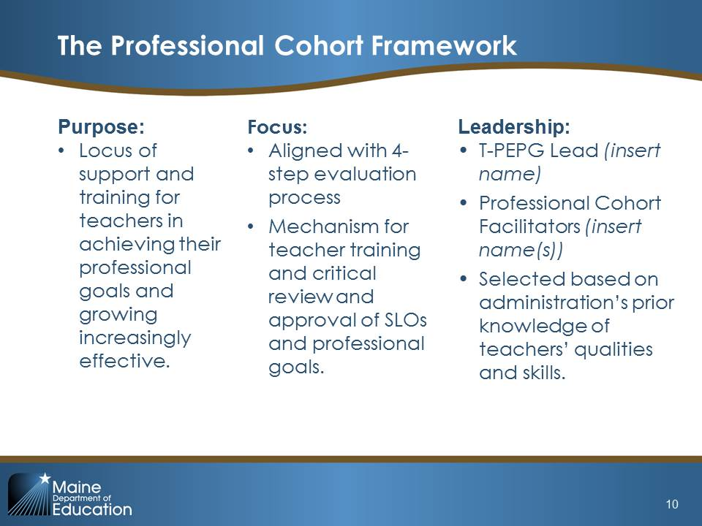  Slide 10
Note: The content below and slide require modification by the Professional Cohort facilitator to add district-specific information.  Explain:  “This year, our Professional Cohort will meet [insert number] times.”  Modify this list and add dates and locations that are specific to your district’s cohort model. Review the slide with participants. You may also want to include information on what roles and responsibilities different people will have as part of the cohort. | 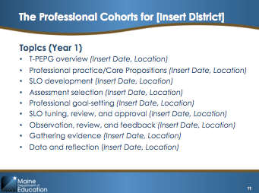  Slide 11
Explain:  “The foundation for the T-PEPG model is the five National Board Professional Teaching Standards (NBPTS) Core Propositions:  - Teachers are committed to students and their learning  - Teachers know the subjects they teach and how to teach those subjects to students  - Teachers are responsible for managing and monitoring student learning  - Teachers think systematically about their practice and learn from experience  - Teachers are members of learning communities  The materials we are using today, including the modules, were developed by the American Institutes for Research for Teacher Incentive Fund (TIF) districts in Maine, and the rubric you will examine in detail today was developed in collaboration with Maine educators.” | 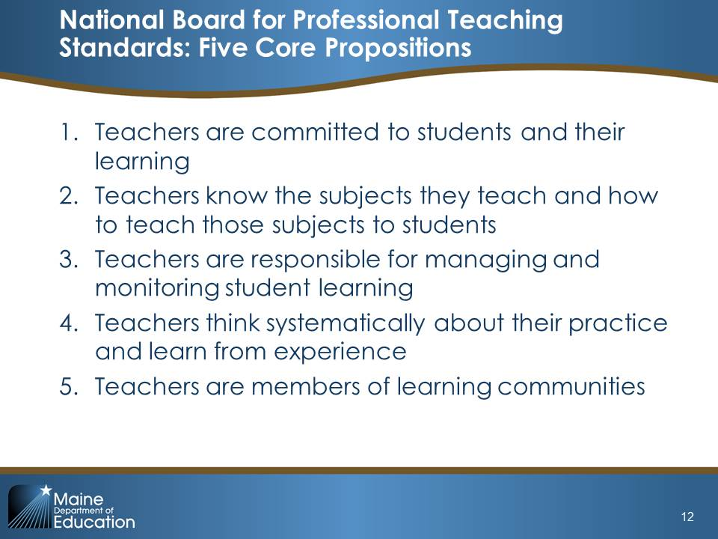  Slide 12
Note: The circles on this slide are animated. As you click through, each box for each Core Proposition will appear/disappear. You may want to tell participants to take out the Companion Guide and turn to page 3 to follow along with the slide.  Explain:  “The MSFE Rubric was developed in collaboration with the National Board for Professional Teaching Standards as part of the TIF 3 Maine Schools for Excellence program. It is a Maine-specific description of effective teaching practices built on the National Board’s five Core Propositions regarding what teachers should know and be able to do. The Core Propositions are broken down into 13 standard indicators. The MSFE Rubric guides self-assessment, the goal-setting process, the collection of evidence throughout the annual evaluation cycle, feedback from peer observers, and standard indicator–level ratings of teacher performance.  Let’s walk through the 13 standard indicators just so you have a sense of what is included under each Core Proposition.”  Click to make the first box appear. Read through the standard indicators, and then click to move to the next one. Proceed through all five Core Propositions. | 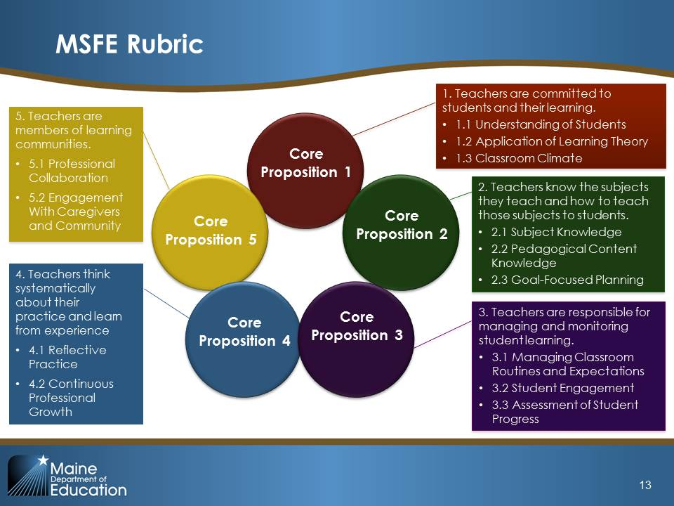  Slide 13
“The MSFE Rubric aligns closely to the InTASC Model Core Teaching Standards, which have been identified as ‘the standard for teacher effectiveness in Maine schools’ (Chapter 180, Section 5). This alignment means that teacher preparation and new teacher induction programs will be able to readily translate their work to the National Board language of accomplished teaching used in the MSFE Rubric.  The rubric describes teacher practice under each standard indicator across four levels of practice: ineffective, developing, effective, and distinguished.  We will be exploring the rubric in greater detail a little later in the session.” | 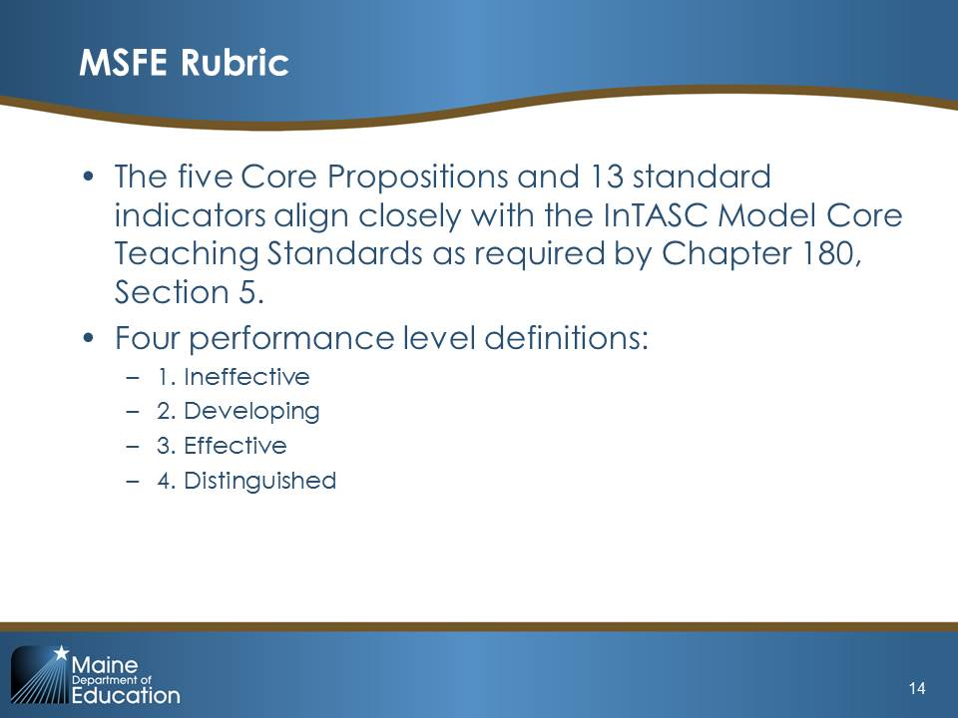  Slide 14
Explain:  “The T-PEPG model evaluates teacher performance on the five Core Propositions using four distinct groups of measures of effectiveness:  - Professional practice measures: These measures focus on effective instruction, management of classroom environment, and student learning, which align with Core Propositions 1, 2, 3, and 5.  - Professional growth measures: Measures based on progress toward and attainment of professional goals that will support teachers in helping students to achieve learning targets, which align with Core Proposition 4.  - Student learning and growth: Measures of the teacher’s influence on students’ academic growth, which will include setting student learning objectives (SLOs).  - Student perception (Year 3): Measures teacher influence on student engagement/perception and is based on a student perception survey. This measure will not be included in teachers’ summative scores until Year 3.  As you can see, the MSFE Rubric and the Core Propositions are aligned with the first two measures in the T-PEPG model.” | 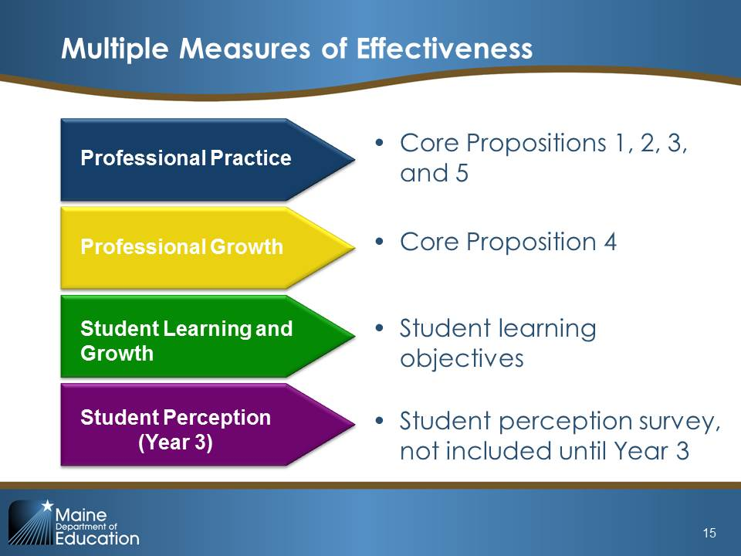  Slide 15
Explain:  “Each year, you will complete a four-step T-PEPG evaluation process that is focused on an ongoing series of conversations and activities that emphasize formative feedback and professional growth. Individual teachers, in collaboration with Professional Cohorts consisting of grade-level or subject-area teams and/or administrators, take a leading role in each step of the process.  To support thoughtful implementation, this annual, four-step process will be phased in over a three-year period between 2015 and 2017. We will discuss the implementation timeline at the end of this section. For now, let’s talk through each step briefly so you will be prepared to take the lead in your own evaluation.  In Step 1, Expectations and Goal Setting, you set goals for your students’ growth through an SLO process. You will use these student growth goals and your own self-assessment and reflections to inform your professional growth goals. You will present both the SLO and professional growth goals for review and approval, although the approval process will look different depending on the teachers’ professional growth plan.”  Note: This slide is animated; click once to move the red circle from step 1 to step 2 on the slide.  “In Step 2, Evidence, Feedback, and Growth, you will be gathering evidence of practice, receiving feedback, and adjusting your practice in response to feedback as you work toward your goals. | 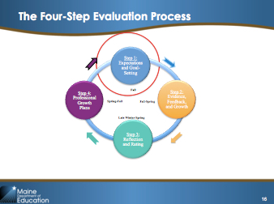  Slide 16
Note: This slide is animated.  Explain:  “In Step 2, you will be focusing on the Points of Contact Framework. This framework identifies a variety of teacher-selected and evaluator-selected interactions that provide multiple contexts for review and feedback by peers and evaluators, while also supporting collection of evidence for performance evaluation. We are going to take a closer look at each of these points of contact in a moment, but for now, just take note of the variety of interactions the framework offers:  - Three types of classroom observation as well as video lesson review  - Review or analysis of curriculum, student learning data, or student engagement  - Observation in professional contexts (facilitating a meeting, PD, teacher leadership)  Each point of contact needs to meet three quality assurances:  - It needs to be person to person, including a two-way conversation that involves evidence collection and feedback.  - It needs to be documented. There is a Points of Contact documentation form (see Appendix F in the T-PEPG Handbook), which we will explore in Module 3.  - It needs to be evidence-based. The evidence and feedback collected needs to be used to inform a teacher’s growth plan and should be aligned to the Core Propositions.  We will further explore the requirements and supports for the Points of Contact Framework in a few minutes.” | 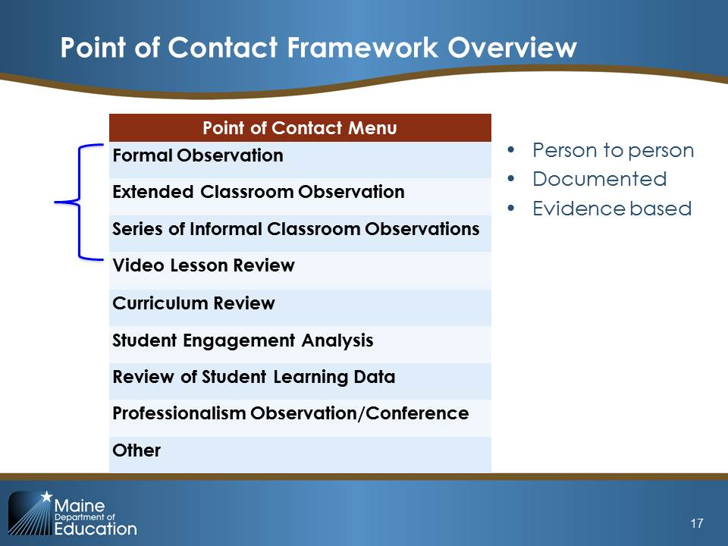  Slide 17
Note: This slide is animated.  Explain:  “Let’s finish the annual four-step T-PEPG evaluation process.  - In Step 3, Reflection and Rating, you will gather together all the evidence, including student learning data, and feedback collected in Step 2 and self-evaluate your progress towards your professional goals. In your summative evaluation year, you will submit the evidence to your evaluator to be included in your final rating. The reflection and rating process is collaborative, and you will meet with your evaluator for a 45- to 60-minute summative evaluation conference to share your self-evaluation, to review preliminary ratings, and to discuss feedback, recommendations, and next steps. | 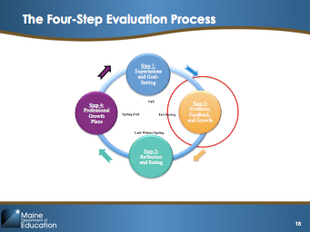  Slide 18
Note: This slide is animated.  Explain:  “After this conference, the evaluator will use a series of matrixes to combine the ratings on each measure to create a single summative effectiveness rating. The scoring process will involve first using a matrix to combine the professional practice rating and professional growth rating. You will receive a rating on a four-point scale (ineffective, developing, effective, and developing). Next, the SLOs will be combined and scored on an appropriate scale to determine your impact on student growth. You will again receive a rating on a four-point scale (negligible, low, medium, and high). The principal will next use a final matrix to combine these two ratings to assign you one of four summative effectiveness ratings:  - Highly Effective  - Effective  - Partially Effective  - Ineffective  We will explore how summative ratings are calculated when we complete Module 5. For now, let’s finish discussing the four-step evaluation process.” | 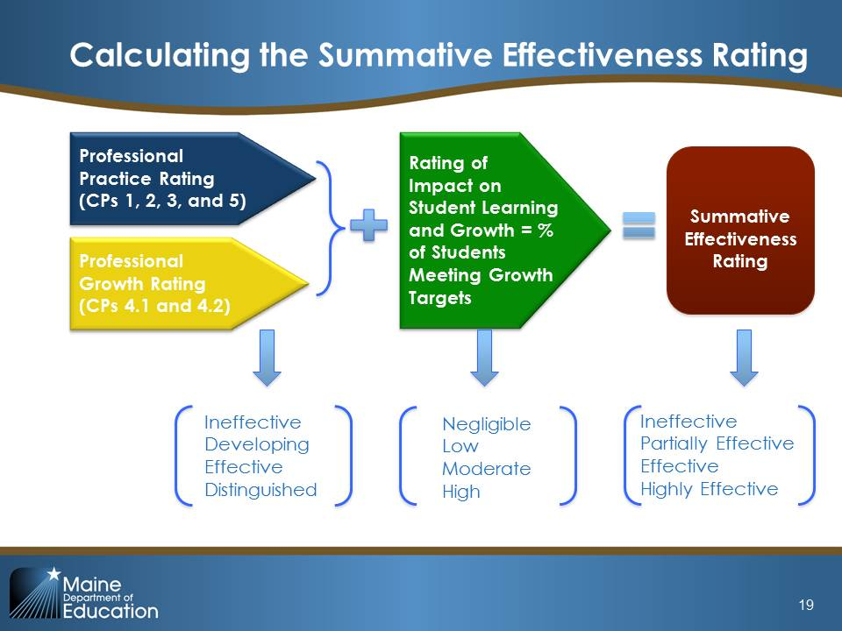  Slide 19
Note: This slide is animated.  Explain:  Finally, in Step 4, Professional Growth Plans, based on your evaluation results, you will be assigned to a professional growth plan and will begin planning for the next evaluation cycle.  “Each year, based on the evaluation results from the previous year, you will be assigned to one of three professional growth plans, which vary in length and requirements but are each focused on opportunities for professional development to attain professional goals and improve practice. In addition, all teachers, regardless of plan, will participate in a peer community that provides opportunities for collaboration, focused dialog, observation, and feedback. The three differentiated growth plans are:  - Self-Directed Professional Growth Plan  - Monitored Professional Growth Plan  - Directed Improvement Plan  Using the table on the slide, highlight the key features of each plan for participants. Note that each plan will be explored in greater detail in Modules 3 and 4. | 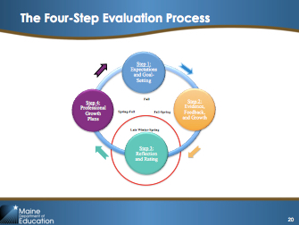  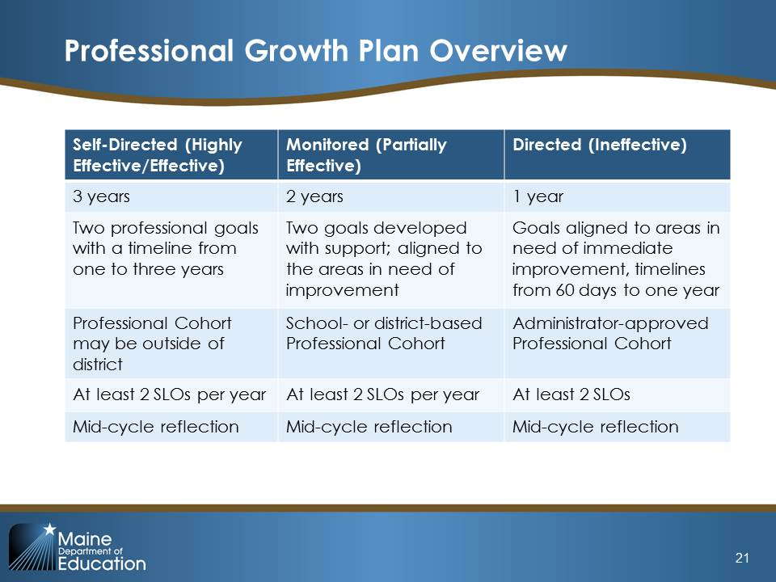  Slides 20 and 21
Explain:  “The Maine T-PEPG Model will be implemented using a two year implementation timeline. The first four-step evaluation process we just discussed will begin in 2015 and conclude in 2017 according to the following timeline:”  Walk through the timeline on the slide, noting that summative ratings do not occur until 2017, starting in February. | 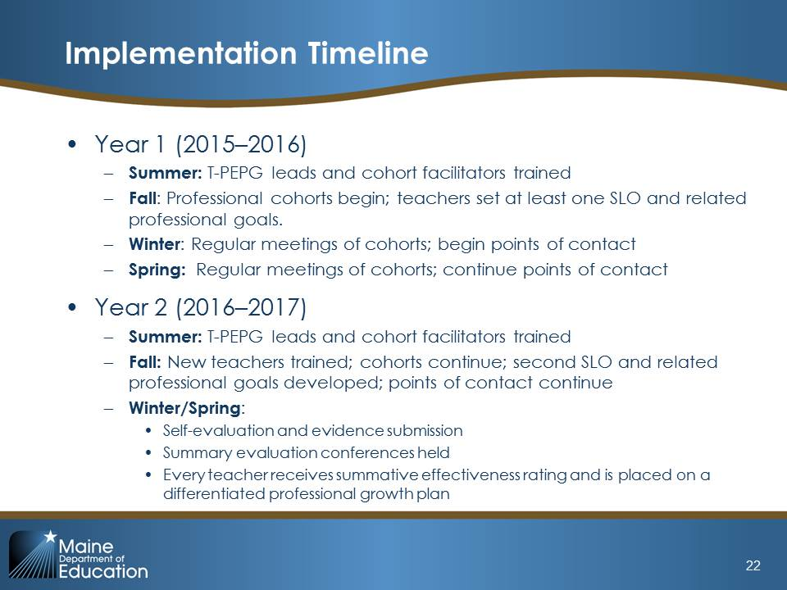  Slide 22

Possible Facilitation Challenges and Solutions
Challenge | Solution(s)
Participants may want more information on summative scoring. | Acknowledge the question, then note that today’s session will not be going into summative scoring in depth and that it’s important to understand the individual measures in the system first before discussing the summative scoring process in detail. For participants who want to know more, encourage them to read pages 22–28 in the Handbook and to bring questions to the next session.

Learning Activity 1a: Where Is the Rubric in the Four-Step Evaluation Process? (10 minutes)
This activity will help participants become more familiar and comfortable with the four-step process as well as start to understand the integral role the MSFE Rubric plays across all four steps.

Activity Detail
Explain:  “Let’s take a few minutes and think about how these elements fit together. We’re going to do an activity that asks you to consider how the MSFE Rubric will be used throughout the four-step evaluation process.  Turn to Handout 1in your handout packet. Work with an elbow partner and determine which of the evaluation activities (A–K) involving the MSFE Rubric is associated with each step of the four-step cycle.  Take about 5 minutes to sort the activities into the four steps.” | 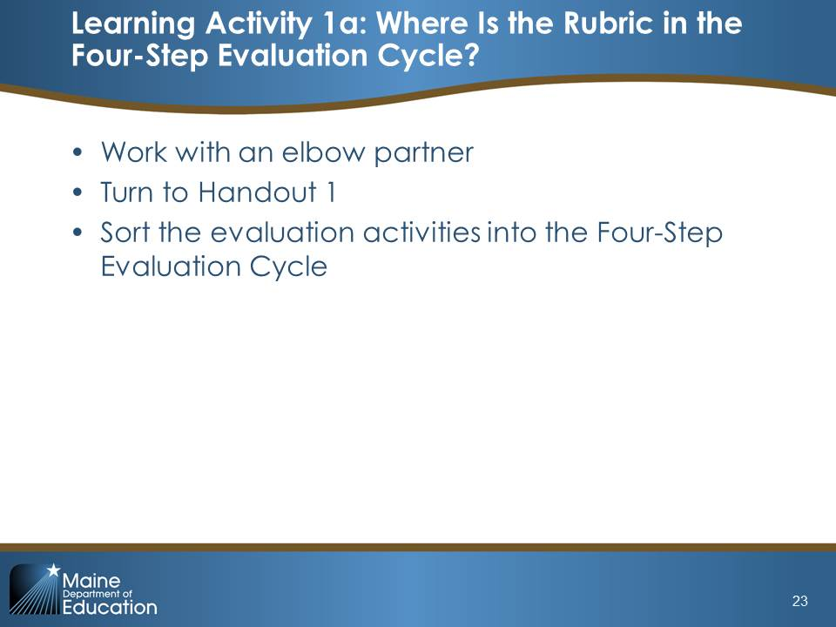  Slide 23
Wrap-Up/Debrief (3 minutes)  Flip to slide 24. Click through as each of the actions is identified as being a part of one of the steps. Ask participants to check their answers as you state the section of the cycle with which each rubric activity is associated.  Explain:  “Many of these activities will inform ongoing professional growth and improvement planning.” | 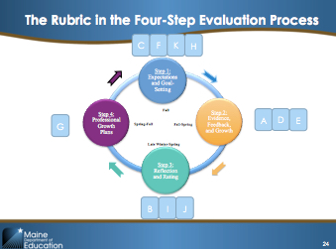  Slide 24

Possible Facilitation Challenges and Solutions
Challenge | Solution(s)
Teachers may not be aware of some of the steps in the evaluation process, especially those that are unique to the Maine DOE process. | If possible, have a copy of Handbook available so that teachers’ questions about the specifics of their evaluation can be answered.

Guiding Questions
- How is the MSFE Rubric used in each step of the four-step teacher evaluation cycle?

Learning Activity 1b: Getting to Know the Points of Contact Framework (15 minutes)

Purpose
This activity will help participants become more familiar and comfortable with the Points of Contact Framework and will introduce them to several guiding considerations in making their teacher-selected choices.

Activity Detail
Explain:  “Now we are going to spend a few minutes working together to do some initial thinking about what points of contact you might consider selecting for this year.  At your table, take out Handout 2, complete step 1, and read through Figures 7 and 8. This should take you about five minutes.  Modification: For Handout 2, depending on the time available, you may choose to modify this activity by removing the suggested topics from the table in step 2 and instead allowing to teachers to brainstorm about the topics themselves.  Give participants about four minutes and then check to see who is finished. If more time is needed, give them an additional minute and then proceed:  Okay, now, working with 3–4 people at your table, talk through the questions on Handout 2. Be prepared to share out when you are done. Let’s take about 7 minutes to do this.  Circulate to each group and check for questions. Give participants a one-minute notice to wrap up and then proceed:  Let’s take the next few minutes to share what we learned. First, can a volunteer group share what they came up with for their guiding questions?  After the group shares out, ask: Great. Did anyone have something different? Take 1–2 more answers if offered.  If you have time, ask: Okay, which points of contact were you most interested in or excited about, and why?  Take 1–2 answers and then move on. | 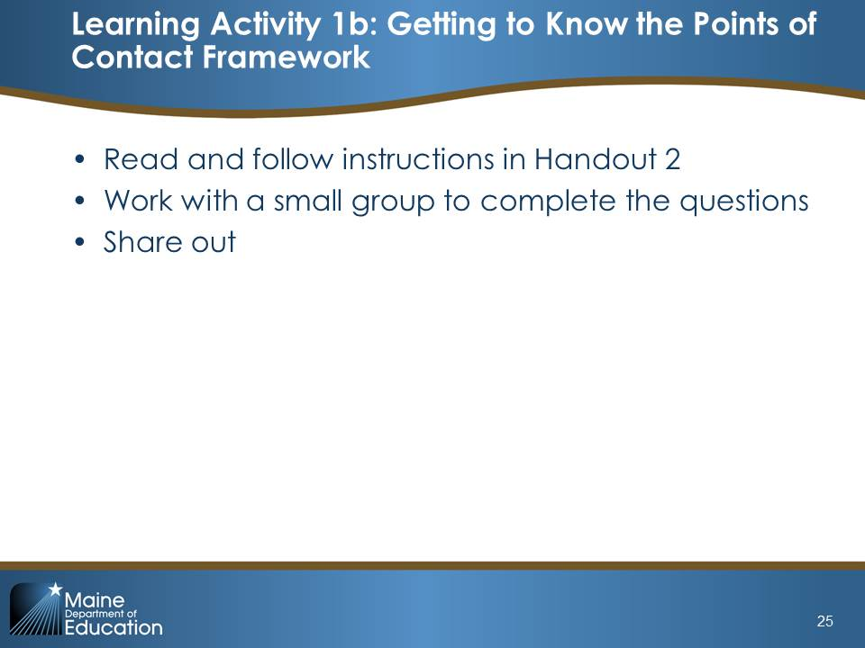  Slide 25

Possible Facilitation Challenges and Solutions
Challenge | Solution(s)
Teachers may have questions about how to read Figure 7. Minimum Points of Contact Relative to Professional Growth Plan. | Be prepared to explain Figure 7 by developing a couple of examples to walk through if needed. For example, you could say:  “Let’s look at the two-year monitored plan. You will see that under the ‘Teacher Selected’ rows, you will need to choose two points of contact in both year 1 and in year 2. Each year, one point of contact will be with a peer and one with an evaluator.”  You could continue the example as needed through the “required” and “evaluator-selected” rows.
Teachers may miss an important consideration in their discussions. | As groups are sharing out their considerations, check off each one from the list below. If any are not mentioned, share them with participants.  - Professional growth goals: Which points of contact provide me with the feedback I need to ensure I will meet my professional goals?  - Student needs: Which points of contact will provide me with the feedback I need to help ensure my students meet their learning targets?  - Evidence: Which points of contact will help me provide strong evidence of my practice on each of the Core Propositions and indicators in the MSFE Rubric?

Guiding Questions
- What are “points of contact” and what should I consider when making my selections for points of contact?
Learning Wrap-Up /Debrief (5 minutes)
Explain:  “Now that you have a ‘big picture’ idea of the T-PEPG model as a whole, we are going to transition into a series of activities that focus on deepening your understanding of the MSFE Rubric and supporting resources like the Companion Guide. As a reminder, we will be learning more about how to complete each step in the T-PEPG process in the modules that follow. Before we move on to exploring the rubric, let’s take a 10-minute break and stretch our legs. Please return at [insert time].” | Slide 26

IV. Implementing (55 minutes)
The title slide of the Learning section of the module is on slide 27.
Implementing Content: MSFE Rubric and Companion Guide (5 minutes)
Explain:  Note: If you have not yet passed out the MSFE Rubric Companion Guide to participants, please do so before starting this section.  “Welcome back. For the next hour, we’re going to start getting familiar with the structure and content in the MSFE Rubric. You can find the rubric in Appendix A of the Rubric Companion Guide. Please take out the Companion Guide now and turn to page 3.  As a reminder, Maine educators supported the development and revision of this rubric, which measures the indicators of the five NBPTS Core Propositions. Recall that each Core Proposition is broken down into standard indicators. For Core Propositions 1 through 3, there are three standard indicators for each. For Core Propositions 4 and 5, there are two standard indicators for each.  The MSFE Rubric is located in Appendix A, on page 96. Let’s turn there now to get familiar with the rubric.” | 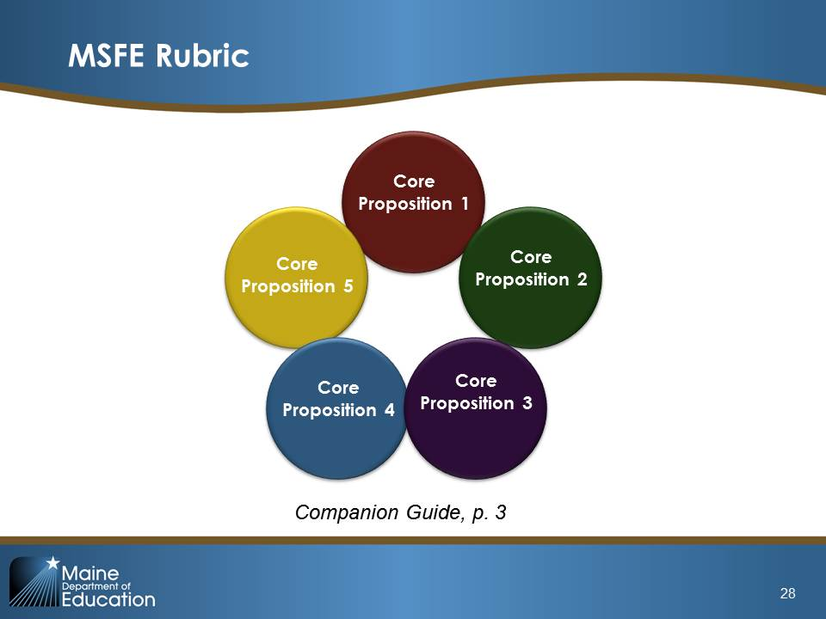  Slide 28
Note: this slide is animated.  Explain:  “The MSFE Rubric is structured as follows:  - Core Proposition  - Standard indicator number and statement  - Four levels of performance  - Performance level descriptions  - Explanatory notes  Pay particular attention in the performance level descriptors to whether the text is in italic font or bold font, as this is a signal about the type of evidence for the indicator. Italic text refers to elements that can be seen in instruction, and thus gathered through classroom observation. Bold text refers to elements that may be more closely tied to planning or preparation, and there you might be collecting evidence through other point-of-contact documentation beyond classroom observations.” | 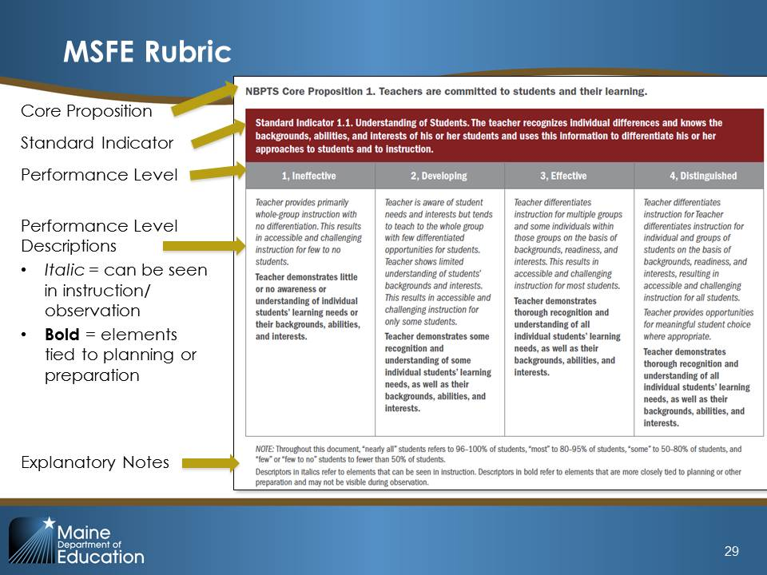  Slide 29
Explain:  “The Companion Guide is a resource that supplements the MSFE Rubric by helping teachers and administrators:  - Learn more about the NBPTS Core Propositions and standards  - Gain a deeper understanding of how teachers demonstrate proficiency in practice  - Encourage and support teachers’ self-reflection on current practices  - Engage in professional conversations about teacher practice that focus on improvement  - Identify steps that teachers can take to improve and enhance their practice, and guide districts in identifying job-embedded opportunities to support teacher efforts.  Turn to page 8. For each standard indicator, the Companion Guide is structured around the following sections:  - Descriptive Narrative, which provides an explanation of the knowledge and skills described by the standard indicator.  - Key Elements, which breaks down the essential practices and knowledge in the indicator into an easy-to-digest list.  - Questions for Reflection and Planning, which offers teachers questions to consider when thinking about their own practice relative to the standard indicator. | 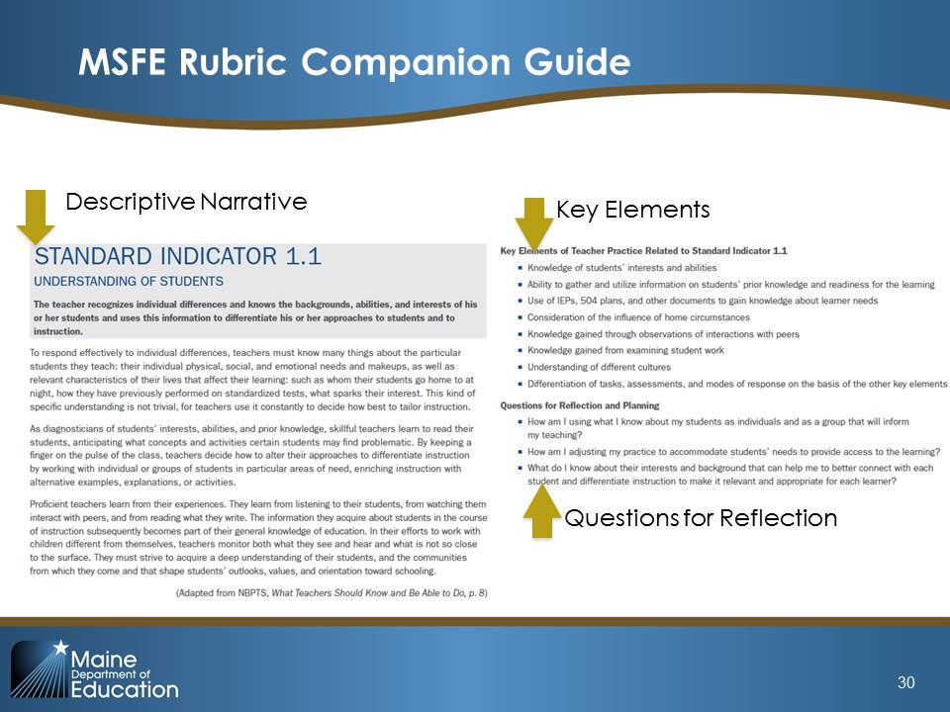  Slide 30
Note: This slide is animated.  Explain:  “Next, for each level of performance under the standard indicator, the Companion Guide repeats the performance level descriptor language, and then describes a set of critical attributes, or ‘look-fors,’ and a set of possible examples to give both teachers and evaluators a clearer picture of what this level of practice looks like under each standard indicator.” | 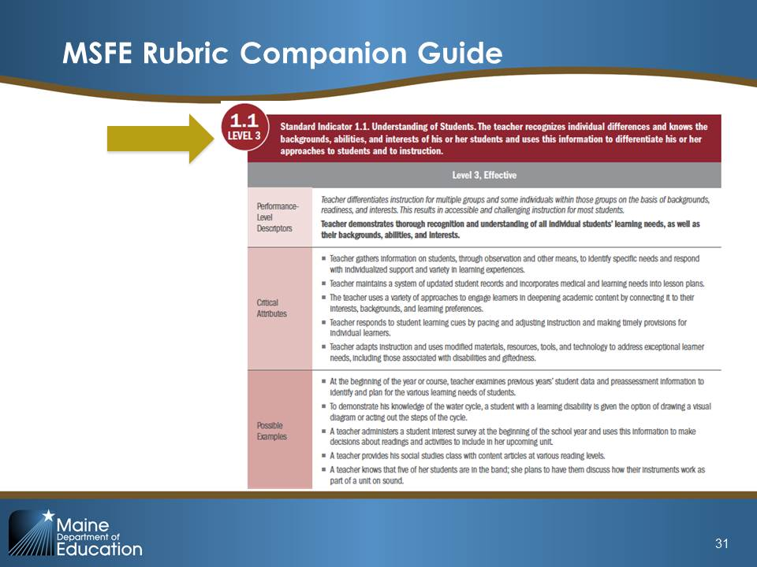  Slide 31
Explain:  “Finally, the Companion Guide includes a section on the professional learning implications for each level of performance. This section is useful to teachers, both for reflection and as peer observers, as well as for evaluators in helping teachers plan for professional learning based on their rating on each standard indicator.” | 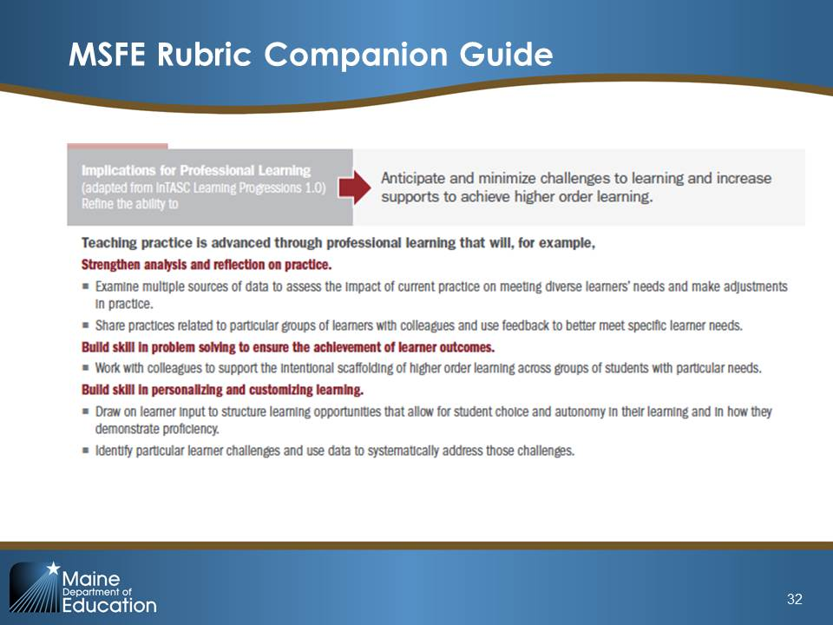  Slide 32

Implementing Activity 1a: Levels of Performance (20 minutes)

Purpose
This activity will help participants start to develop a mental snapshot of the rubric’s overall structure as well as start to develop a shared sense of the performance level distinctions across the rubric.

Activity Detail
Explain:  “For this activity, you are going to be working with your table group, and you will need Handout 3.”  Assign one performance level to each table: ineffective, developing, effective, and distinguished.  “In the MSFE Rubric in Appendix A, read through the performance-level column you were assigned, across all the standard indicators. For example, if you were assigned ‘Developing,’ you would read only that column in each standard indicator. As you read, take note of words that help to define that level. For example, in ineffective, the word ‘little’ is used in many of the standard indicators. Record these words on Handout 3 for the assigned performance level. As you read, also highlight or circle any words you don’t immediately recognize or for which you think you will need a definition to understand.”  After 15 minutes, ask participants to call out the words associated with each performance level. Jot their comments on chart paper.  Ask:  “What are one or two words that you can use to summarize each level of performance?”  Help participants define the levels in a few words and distinguish between them.  “Before we move on, just take note briefly of the words or phrases you highlighted or circled that you were unsure you recognized or think you need a definition for. On your own time, use Appendix C. Glossary of Terms, on page 111 in the Companion Guide, to look up those words. If a term doesn’t appear there, bring it to the next cohort meeting for discussion.” | 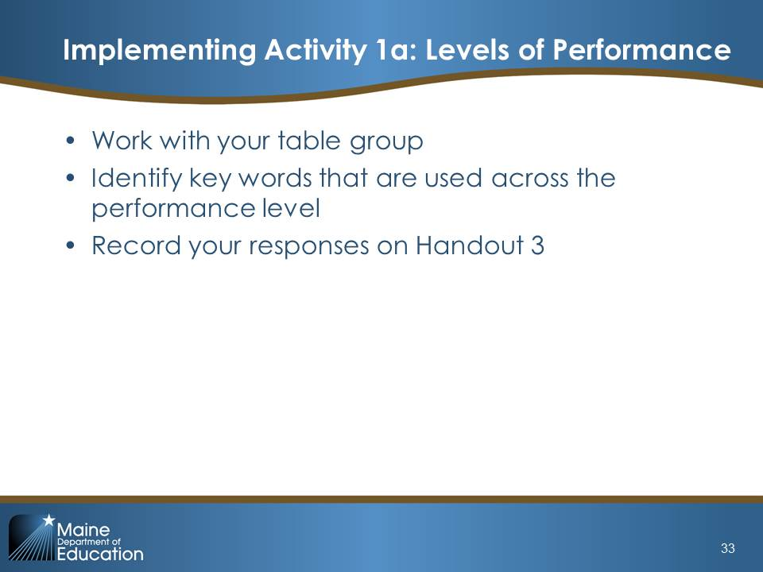  Slide 33

Possible Facilitation Challenges and Solutions
Challenge | Solution(s)
Participants may have a problem shrinking the characterization down to one word. | Tell participants to initially underline key words that characterize the assigned performance level. Then they can look across the standard indicators and narrow the words down from there.

Guiding Questions
- What words do you notice that characterize the level of performance your table has been assigned?
- If you had to narrow down this category to one word, what word would that be?

Implementing Activity 1b: Taking a Deep Dive Into the Companion Guide (20 minutes)

Purpose
Participants will become familiar and comfortable with navigating the Companion Guide, understand how it supports the four-step evaluation process, and develop more in-depth knowledge about at least one Core Proposition. The activity also provides an exploration process that teachers can repeat on their own or collaboratively to continue exploring the other Core Propositions.

Activity Detail
For this activity, as much as possible, split teachers up into groups by grade or subject area. Within each grade or subject area group, if possible, ask teachers to form themselves into five groups, with a minimum of three teachers in each group. Assign a single Core Proposition to each of the five groups. Note: if the composition/number of the participants lends itself to only three groups per grade-level/subject area, assign Core Propositions 1 through 3 only.  Explain:  “For this activity, you are going to be working in groups by grade/subject area. Once you are in your grade or subject area, please divide yourselves into groups of 3–5 people and take out Handout 4.”  After participants have sorted themselves into groups, assign the Core Propositions to each group; instruct them to divide the standard indicators among the individuals in the group.  The directions summarized on the slide are:  - Step 1. Turn to the “effective” level page for your standard indicator, read through the performance level descriptor for the effective level and the critical attributes. Jot down in your own words what this standard indicator is about. (5 minutes)  - Step 2. Read through the “possible examples” at the effective level. Choose one that resonates with your experience in your own classroom. Jot down an example from your own instruction or practice that fits the effective level to share with your group. (3 minutes)  - Step 3. Read the professional learning portion and consider the following questions: (2 minutes)  - How could you use this information to help you complete the four-step evaluation process?  - How could you use this information to provide feedback and coach your peers? | 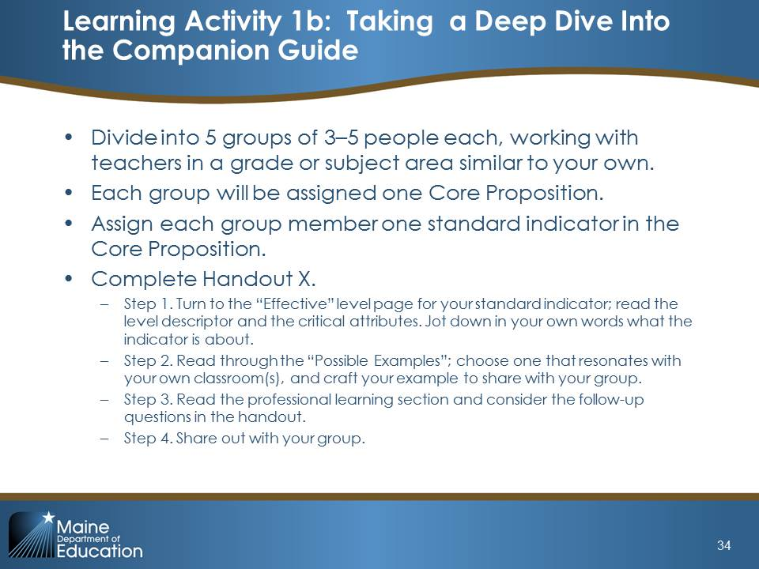  Slide 34
After about 10 minutes, prompt the participants to move on to sharing out with each other in their group.  After 20 minutes, thank the participants and transition them to the debrief. | Continue Slide 34

Possible Facilitation Challenges and Solutions
Challenge | Solution(s)
Some participants may be unsure how to answer the questions in step 3. | Circulate while the groups work. Make sure each group is making the connection between the professional learning section and the four-step process. Specifically, teachers may see this section as useful for self-evaluation, goal setting, setting up a strong growth plan, or selecting points of contact to help them meet their goals.

Guiding Questions
- How would you know that a teacher reached a certain level performance according to the rubric? What evidence would you need?

Implementing Wrap-Up/Debrief (5 minutes)
Explain:  “Hopefully that short exercise helped you start to develop a little better, more detailed understanding of at least one Core Proposition. In your subject area/grade level groups, take two minutes and discuss this question: “How could the Companion Guide and this exercise be extended into existing collaborative opportunities at my school to ensure each teacher has a clear understanding of each Core Proposition and standard indicator?”  Give participants 2–3 minutes to discuss and then ask for volunteers to share out their ideas with the whole group. | 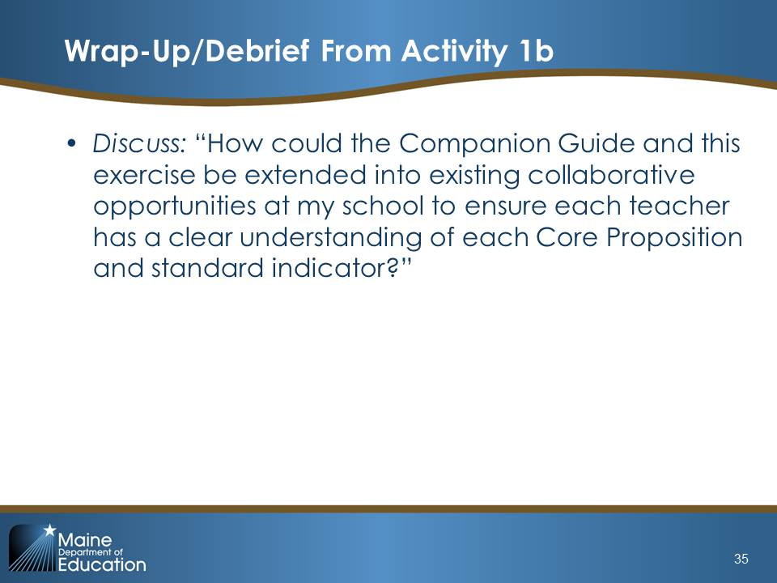  Slide 35

V. Wrap-Up (5 minutes)

The divider slide for this section is slide 36.

Suggested Next Steps
Explain:  “Let’s revisit our first Hopes and Worries activity. Pull out your sticky notes from earlier. Has anyone’s hope or worry changed? Why or why not?  Take answers from 2–4 people, noting remaining concerns that may need to be addressed in a future session or feedback that may need to be passed back to the district. | 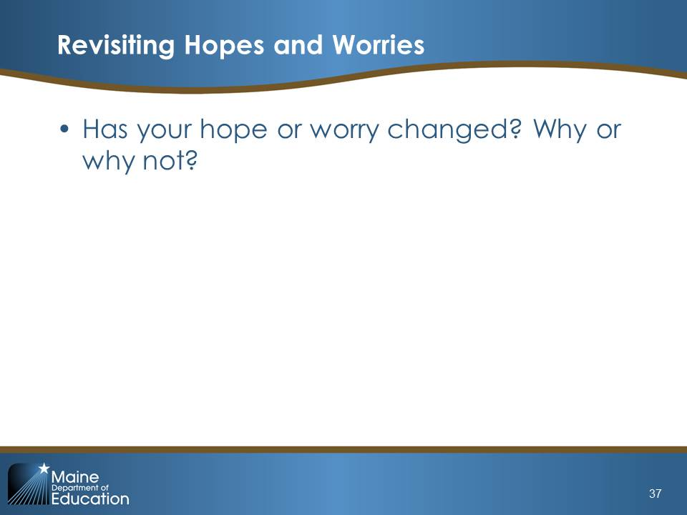  Slide 37
Explain:  “Bring some student data to Module 2, Student Learning Objectives, relevant to the class or course that will be the focus of your SLO. These data may include  - Student assessment scores from the prior year (both for classes you taught last year and test scores of your current students)  - Data from course pre-assessments  - Information on students with IEPs, 504 plans, and gifted and talented designations  - Course grades to date  - Content standards” | 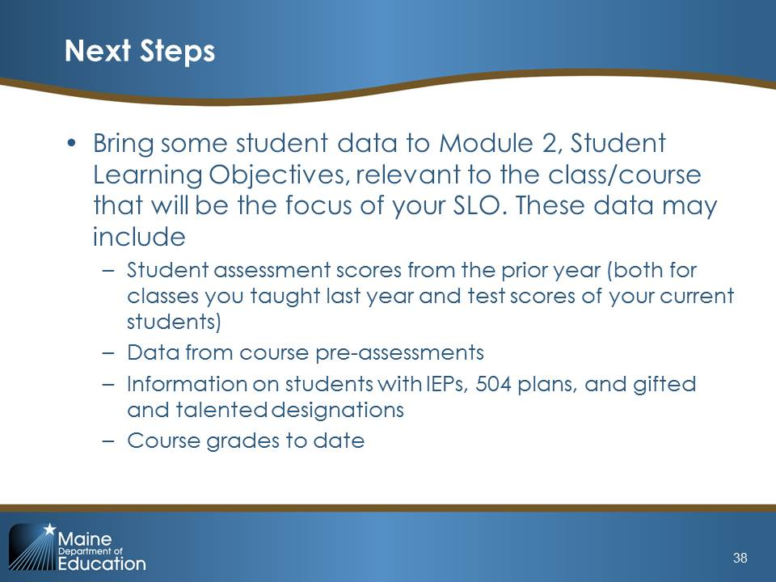  Slide 38
Explain:  “Module 2 will provide details about the SLO process. Participants will engage in activities designed to increase their understanding of the SLO process and will provide time for participants to begin drafting their SLOs for the 2015–16 school year.” | 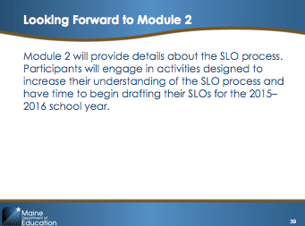  Slide 39
Come to Closure:  NOTE: Enter your e-mail address on the final slide, so that participants know where to send questions. | 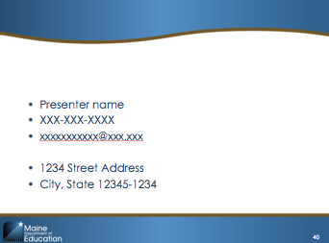  Slide 40

