Lodging Options for
2019 Annual Commissioner’s Conference for Superintendents
June 23-25, 2019

Atlantic Oceanside Hotel & Event Center  119 Eden Street, Bar Harbor, ME  Tel: (207) 288-5801  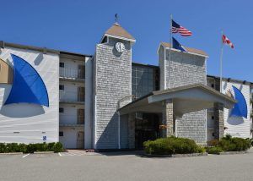  Main Bldg., King Bed/Balcony  - Atlantic View (double queen or king rooms) @ $242.00  - Main Hotel (double queen or king rooms) @ $225.00  - Willows Mansion (13 Rooms @ $242.00) | The Inn on Mount Desert  68 Mount Desert Street  Bar Harbor, ME  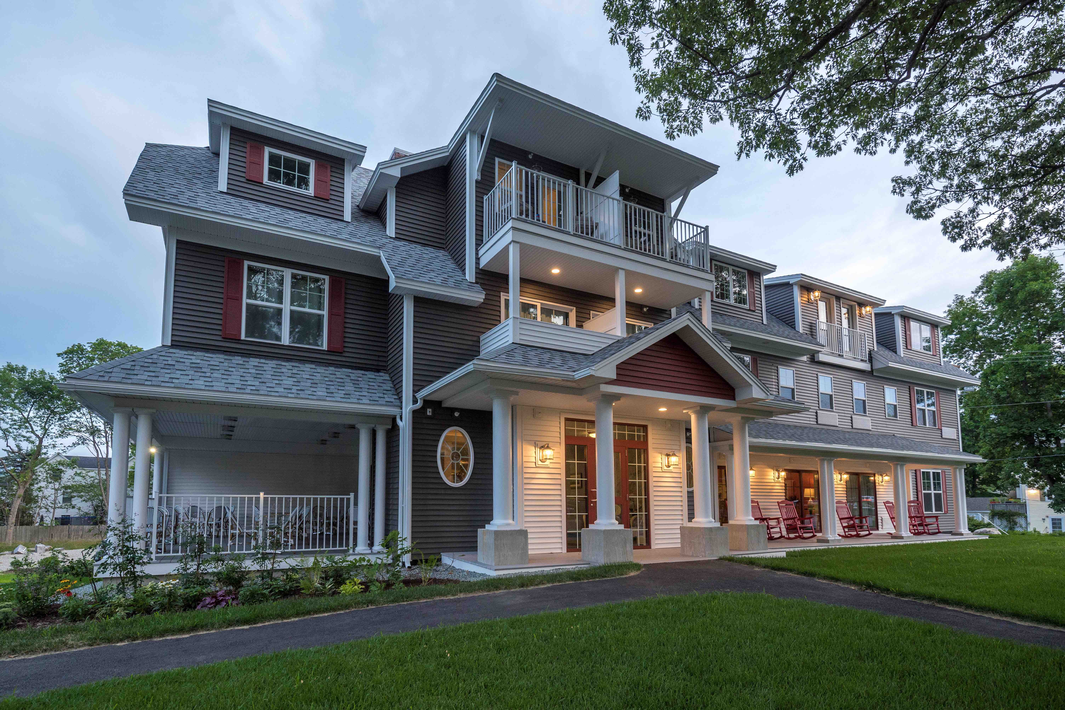  Tel: (207) 288-8300  Price: $249.00  Room Type: King Rooms  Cut-off Date: June 1st, 2019  Reference: Supt. Conf.
Bar Harbor Motel  100 Eden Street  Bar Harbor, ME  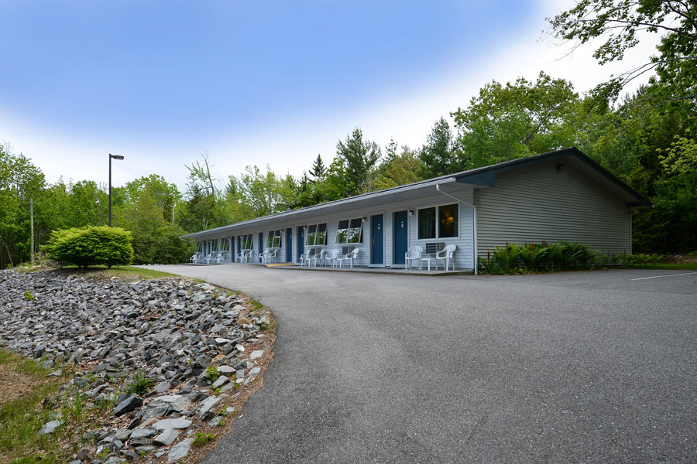  Tel: 1- (800) 388-3453  Price - $169.00  Room Type: Double Queens  Mention: Superintendent Conference  Cut-off Date: Call by May 23rd | Quality Inn  40 Kebo Street  Bar Harbor, ME  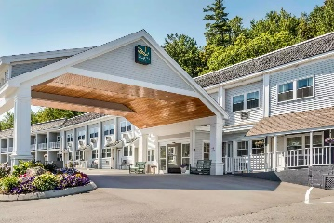  Tel: (207) 288-5403  Price: $150.00  Room Type: Mix of King/queens  Cut-off Date: May 30, 2019
Cleftstone Manor  92 Eden Street  Bar Harbor, ME  Tel: (1 (888) 288-4951  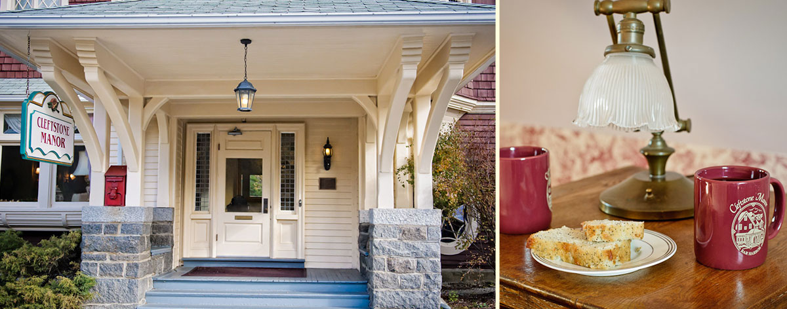  King Rooms w/Bath @ $199.00  Queen w/ Bath (3rd Floor) - $139.00 | Villager Motel  207 Main Street  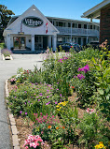  Bar Harbor, ME  Tel: (888) 383-3211  Price: $195.00  Room Type: Dbl. Queen  Cut-off Date: May 30, 2019  Mention: Superintendent Conference
Mira Monte Inn  69 Mount Desert Street, Bar Harbor  Tel: (207) 288-4263  To Book: go to their web: https://miramonte.com/  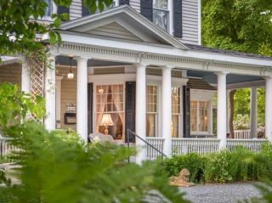 | Edenbrook Motel  96 Eden Street (Rte. 3)  Bar Harbor, ME  Tel: (207) 288-4975  Web: https://www.edenbrookmotel.com/  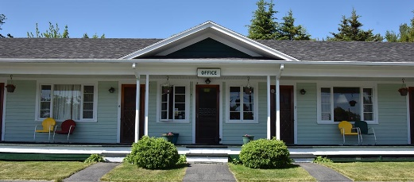  King Size Beds - $99.00  Cut-off Date: May 31st, 2019  Reference: Dept. of Education

