Characteristics of Effective IEP Meetings
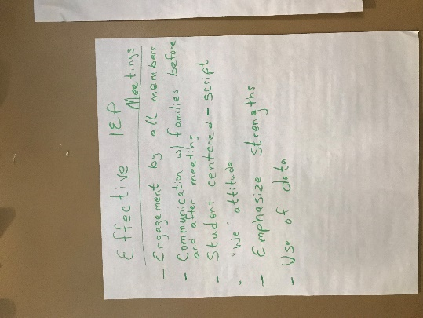
Lewiston
- Engagement by all members
- Communication with families before and after meeting
- Student centered (script)
- “We” attitude
- Emphasize strengths
- Use of data

Technical Assistance/Training Topics
Lewiston
Lewiston
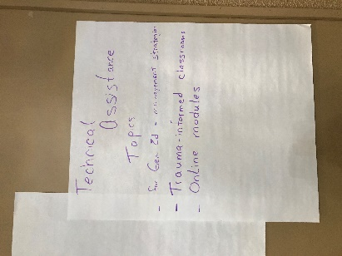
- For Gen ed – management strategies
- Trauma-informed classrooms
- Online modules

Special Ed Dessert – High Qualify Special Education Program

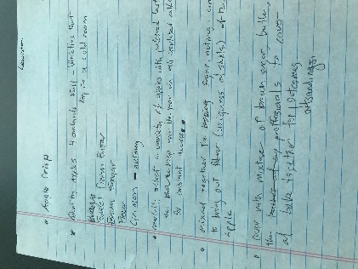
Lewiston
Apple Crisp

Ingredients:
Quality apples 4 orchards full – varieties that keep in a cold room
Sweet cream butter
Brown sugar
Flour
Cinnamon – nutmeg

Directions:
- Carefully select a variety of apples with preferred taste that keep over the year in well-insulated room for constant access
- Mix together the sugar, nutmeg, cinnamon to bring out flavor (uniqueness of skills) of the apple
- Cover with mixture of brown sugar, butter, flour (the professionals) to cover all
- Bake together for outstanding outcomes.

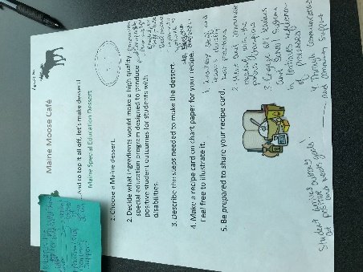
Lewiston

Whoopie Pie

Ingredients:

Communication
Parents as champions
Knowledgeable staff and leaders
Best practices
Systematic approach

Directions:
- Knowledgeable staff and leaders develop best practices
- Meet and communicate regularly with the parents’ champions
- Engage all leaders and school system in continuous reflection of processes
- Through communication and community support
- Student arrives at positive outcomes and meets goals!

