COVID 19 Related Special Considerations for Large Groups 2021

The following directions have been provided to guide you as you enter information from your district for special considerations of large groups. This was developed to streamline the information needed and minimize the burden to Superintendents and Principals.
Before you start
- Information you will need before logging onto Special Considerations Request Survey.

  - Student ID Numbers (SSID)
  - Assessments names
  - Have all parents/guardians been notified?
  - Have all students been notified?
  - Did a team convene to discuss each student request?

- Obtaining parent/guardian consent for a school to request Special Consideration exemption is required during both the bulk COVID19 process and the individual special considerations request process, which can be accessed after logging into the NEO/Maine Educational Assessment module. In the case of bulk requests, the consent form is not pre-populated in the module. The Parent consent form, can be downloaded from the blue dropdown tab labeled “Communication Toolbox,” on the Assessment Administration and Training pages of the assessment webpages.

- 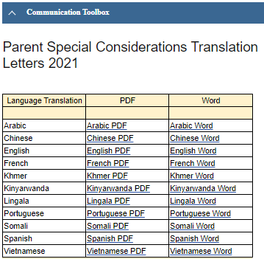

Please reach to the applicable assessment coordinator for a copy of the Bulk Special Considerations template. Contact information is located at the bottom of this guidance.
- Download the Bulk Special Considerations template onto your local device.

- Superintendents or principals are required to fill out this information.

Complete the Template
- At the top of the template, please fill in your district name and the school name pertaining to the information. If you are part of an Alternative Organizational Structure (AOS), which is a group of districts consolidated for shared services, please include the specific district, not the AOS #. E.g. AOS 43 is comprised of RSU 31 and RSU 41. Therefore, the district should be listed as either RSU 31 or RSU 41. It is important for the Maine DOE to have a concrete understanding as to which school district the student is enrolled.

- The Large groups for this survey are considered five (5) or more students, however you may choose alternatively to submit individual requests via the NEO/Maine Educational Assessment Special Consideration Portal. This bulk special consideration process is optional, tailored for convenience.

- School districts are required to complete and submit one template per school. Please do not combine students attending different schools within a single template. There are 500 rows in alternating color. (If there are more than 500 students to be entered, the list is infinite, but not colored after 500).

Submit the Template
- Once completed, upload the template into the 2021 Special Considerations Request Survey housed in Qualtrics. Reminder: please ensure you include the district name and school.

- The bulk upload process is intended to address COVID-19 related absences. If you have students unable to participate in the assessment(s) due to significant medical emergencies, please use the NEO Special Considerations Portal/Maine Educational Assessments module entering each request individually.
If you need help, please reach out to one of our Assessment Team Members listed below. We are here to support you and understand the demanding challenges schools and administrators are facing.
Jodi Bossio-Smith Nancy Godfrey
Alternate & WIDA Assessment Coordinator Assessment Coordinator
(207) 530-1462 (207) 530-1273

Cheryl Brackett, Dr. Regina Lewis
Management Analyst NAEP Coordinator
(207) 441-3019 (207) 530-1355

