Graduation Certification
Report Instructions

Description/Purpose:
The purpose of this reporting is to allow districts/schools to validate the graduate counts.
What is this data used for?
Adjusted Cohort Graduation Rates (ACGR) are reported annually by the Maine DOE to the USDOE for all public high schools and all publicly funded students attending private schools. In addition, the ACGR is used for ESSA school accountability determinations. The State calculates 4-year, 5-year and 6-year Adjusted Cohort Graduation Rates.
Due Dates:
• Open Date: 8/4/2021
• Due Date: 8/30/2021
Completion Instructions:
This requires access to the Student Data Module. If you need access, please have your superintendent submit a NEO access request form on your behalf.
NEO Access Request Form

- Log into NEO
- On the NEO dashboard; find the ribbon header labeled “Student Data”.
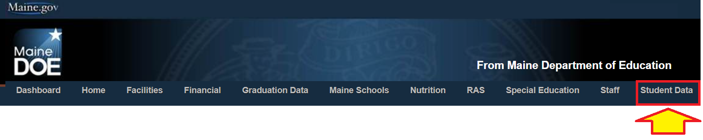
- After selecting the Student Data module select “Student Reports” which will provide you with a list of reports.
- On the Reporting Area dropdown listing select “Enrollments”.
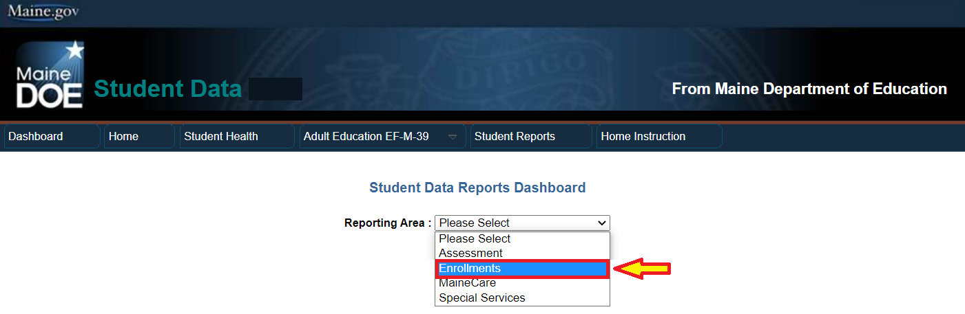
- From the list of reports find “Graduation Certification Report” and select “View Details”.
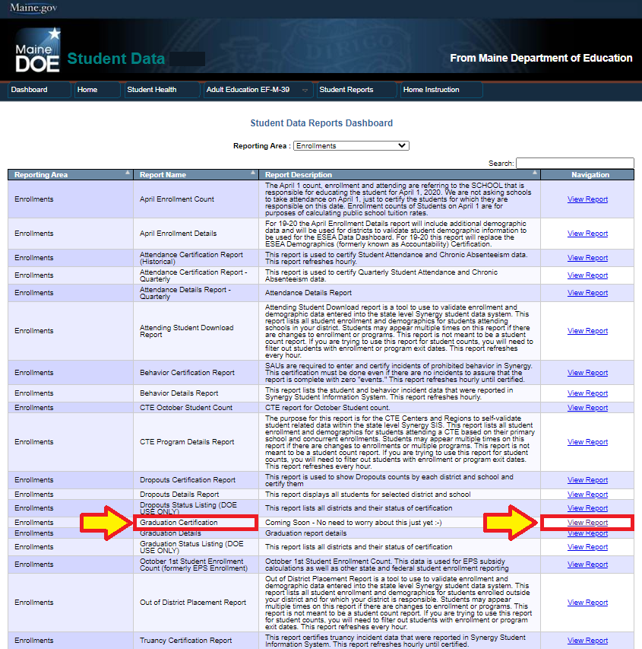

- Once you’re inside the Graduation report, you will be presented with your district’s count of 4, 5, 6-year graduates as well as the number of 2020 completers. Each of these counts have an associated ‘Student Details’ report alongside of them. Inside this link is where you will verify which of your students make up your numbers for the completers, 4, 5- and 6-year counts.
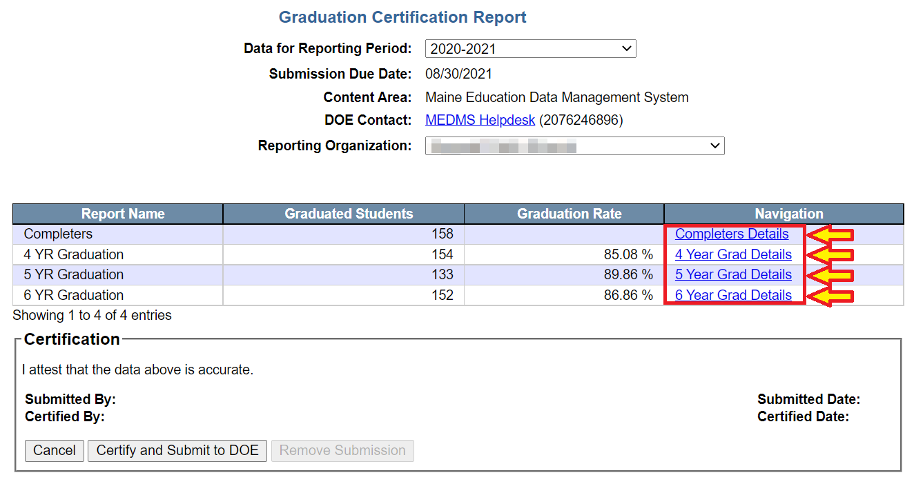
*Please note that only superintendents will have access to the “Certify and Submit to DOE” button.
- If the counts and all the information within the detail reports are correct, your superintendent can click the ‘Certify and Submit’ button.
- If you would like to request a change to the report, either a student needing to be added or removed, please contact the helpdesk with the student Id number ready.

MEDMS.Helpdesk@Maine.gov
or
(207) 624-6896

- It is no longer necessary to validate the start and exit codes of students during this report. The report will also no longer be required to be ‘Accepted’ by the MDOE. Please make sure that all the data is accurate, as these are the students upon which the graduation rate statistics will be generated.

