Unit 1: Building Strong Communities
Week 8: What is a community?
Dear Families,
It is the final week of our first unit of study! We are bringing all our ideas together to think again about what a community is and what makes it strong.
Here are some activities to do with your child this week. When you do an activity, check the box. You don’t have to do every activity and you can do any of them more than once. Remember to make time for reading, too!
Please help your child return this Family Links to school at the end of the week. We hope you enjoy learning with your child!

This week we are reading…
 | 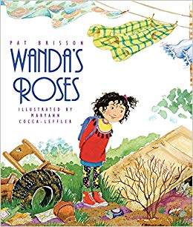 | Wanda’s Roses  by Pat Brisson
Go to the library or look on your bookshelf at home to find more books about children helping to build strong communities—or about anything that interests you!

Your child is practicing reading “Friends Together” (attached). Read it together!

Reading Log
Your child can read to you, and you can read to your child.

It’s always a good idea to read a book many times. We can find something new in a book each time we read the words or look at the illustrations.
Title and Author | What do you think?

Go outside  Go for a walk and collect some evidence that the seasons have been changing. What is on the ground? What are people doing around the community? What are people wearing? Draw a picture about what you found. |  |  | Talk about…  … a favorite part of our study about Building Strong Communities. Think about books you have read together and projects you have been working on.  What do you think a community is?
Tell a story  Start a story about someone with a great idea. Have the other person tell the next part. Keep taking turns until you agree that your story is finished. |  | Read together!  at least 10 minutes every day  Record your reading on the back of this page. |  | Play with math ideas  Play How Many Dots?\  Cut out the plates (attached). Show one plate for 3 seconds and ask your child how many dots were shown. Ask her or him to explain how they know.
Explore science and engineering  The season has been changing from summer to fall while we have been studying communities.  If you have been keeping a weather calendar, study it closely. What do you notice? If you have not started a weather calendar yet, you can start one now! |  |  | Play with words; grow a reader  Our Weekly Words are cultivate, identify, perspective, contribution, observe, and evidence.  Cultivate means to grow. What is something you cultivate in your family or community?

Child’s name ___________________________ Adult’s name ___________________________

Teachers need to print…
*This week’s Family Link (front and back)
*How Many Dots

