Unit 1: Building Strong Communities
Week 7: How can we create positive change in our communities?
Dear Families,
Our Book Access Project is growing! We know that making sure all children and families have access to books is an important way to build a strong community.
Here are some activities to do with your child this week. When you do an activity, check the box. You don’t have to do every activity and you can do any of them more than once. Remember to make time for reading, too!
Please help your child return this Family Links to school at the end of the week. We hope you enjoy learning with your child!

This week we are reading… and continuing to read…
 | Maybe Something Beautiful  by Isabel Campoy and Theresa Howell |  | Doing Your Part: Serving Your Community  by Kelly Rodgers
Go to the library or look on your bookshelf at home to find more books about things people do to help build strong communities—or about anything that interests you!
Your child is practicing reading “This Little Light of Mine” (attached). Read and sing it together, and make up new verses!

Reading Log
Your child can read to you, and you can read to your child.

It’s always a good idea to read a book many times. We can find something new in a book each time we read the words or look at the illustrations.
Title and Author | What do you think?

Go outside  Talk with a couple of people you know in your neighborhood about what they think is important for everyone to have access to. Tell them about the Book Access Project. What ideas do they have? |  |  | Talk about…  … the Book Access Project. What’s happening with the project now? What is the class idea for expanding access to books? What other projects are you working on?
Tell a story  What if someone had so many books he didn’t know what to do with them? What if they were crowding up his apartment? Tell a story about what he might do with all those books. |  | Read together!  at least 10 minutes every day  Record your reading on the back of this page. |  | Play with math ideas  Play Matching Cards to make combinations of 10. Cut apart and use the attached cards.  7 + 3 =10
Explore science and engineering  Find a video of a storm to watch together. As you watch, describe everything you notice. What is happening in the sky? What do you imagine the air feels like? How are people responding to the storm? |  |  | Play with words; grow a reader  Our Weekly Words are donate, empathy, recycle, and volunteer.  These words are all about things we can do to build strong communities. What experiences do you have related to these words?

Child’s name ___________________________ Adult’s name ___________________________

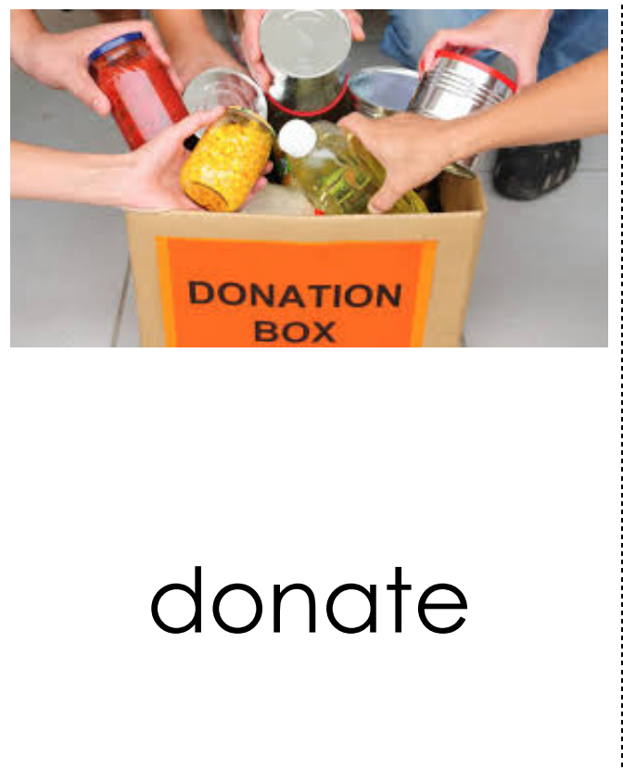  to give food, money, or time to help a person or group | 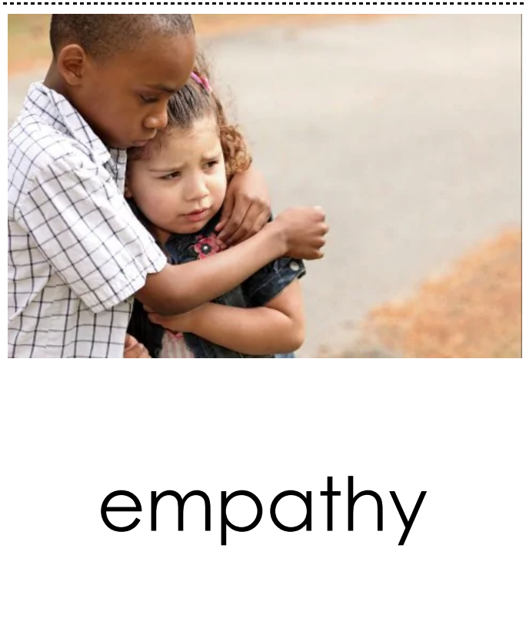  the feeling that you understand another person’s emotions
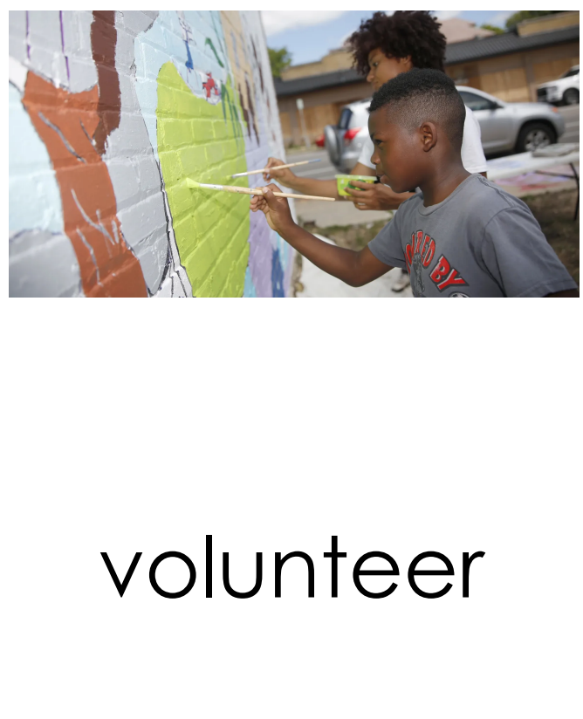  someone who does something without being forced | 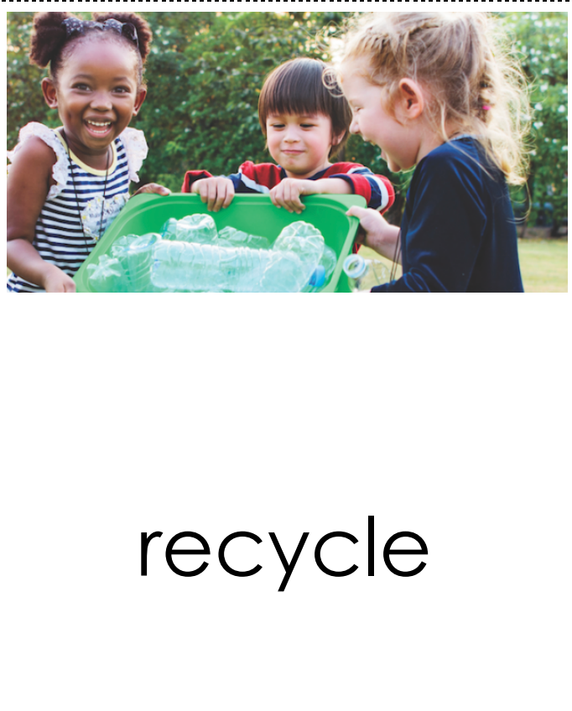  to make something new from something that has been used before

Teachers need to print…
*This week’s letter (front and back)
*Vocabulary Sheet
*This Little Light of Mine
*Math: Matching Cards

