Unit 1: Building Strong Communities
Week 4: How do people become leaders?
Dear Families,
As we learn about what makes a strong community, we are starting to think about leaders. What do they do? How do people become leaders? What kinds of leaders are there in our communities?
Here are some activities to do with your child this week. When you do an activity, check the box. You don’t have to do every activity and you can do any of them more than once. Remember to make time for reading, too!
Please help your child return this Family Links to school at the end of the week. We hope you enjoy learning with your child!
This week we are continuing to read…
 | 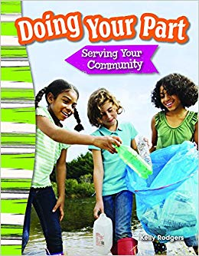 | Doing Your Part: Serving Your Community  by Kelly Rodgers
Go to the library or look on your bookshelf at home to find more books about leaders in communities—or about anything that interests you!

Your child is practicing reading “If You’re a Leader and You Know It” (attached). Read it together!

Reading Log
Your child can read to you, and you can read to your child.

It’s always a good idea to read a book many times. We can find something new in a book each time we read the words or look at the illustrations.
Title and Author | What do you think?

Unit 1: Building Strong Communities
Week 4: How do people become leaders?
Go outside  See what type of community buildings there are around your neighborhood. Can you find a fire station, a library, a park? What other community places can you find? |  |  | Talk about…  … something you would like to do. What change would you like to see in your community? How could you help? For example, maybe you want to start an organization that helps other people in a certain way.
Tell a story  Are you a leader? Tell a true story about how you became a leader.  Or tell an imagined story about a leader you would like to be someday! |  | Read together!  at least 10 minutes every day  Record your reading on the back of this page. |  | Play with math ideas  Play Shapes Hunt.  Look around the place where you live for different shapes.  Talk about the attributes, or characteristics, of these shapes: What do they look like? How many sides, angles, and points do they have?
Explore science and engineering  What have you noticed about the temperature of the air in the last few days? Record each day’s temperatures on your weather calendar or on a list. Are they the same in the morning and in the afternoon? Why do you think this is so? |  |  | Play with words; grow a reader  Our Weekly Words are rights, citizen, leader, election, vote, and government.  What rights feel most important to you?  Talk about what each of these words means to you.

Child’s name ___________________________ Adult’s name ___________________________

Week 4 Vocabulary Guide

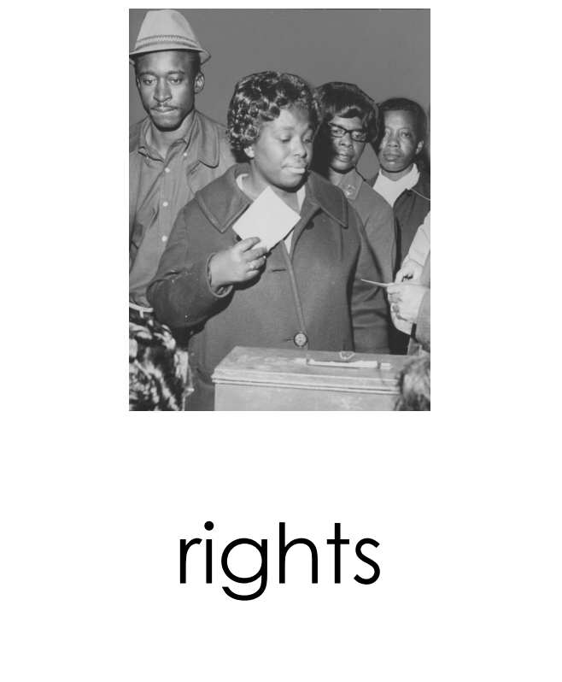  things that a society believes every person should have | 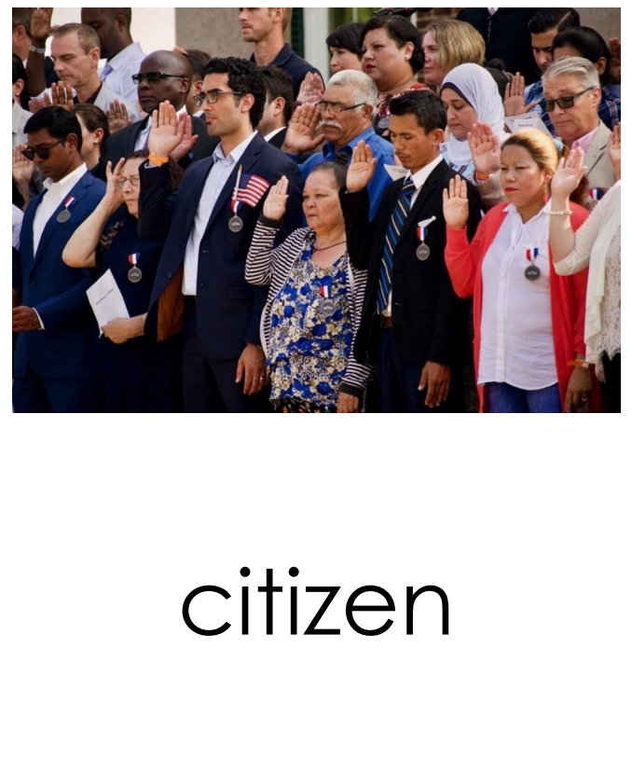  someone who was born in a place, or someone who agrees to follow laws and contribute to the community of a place
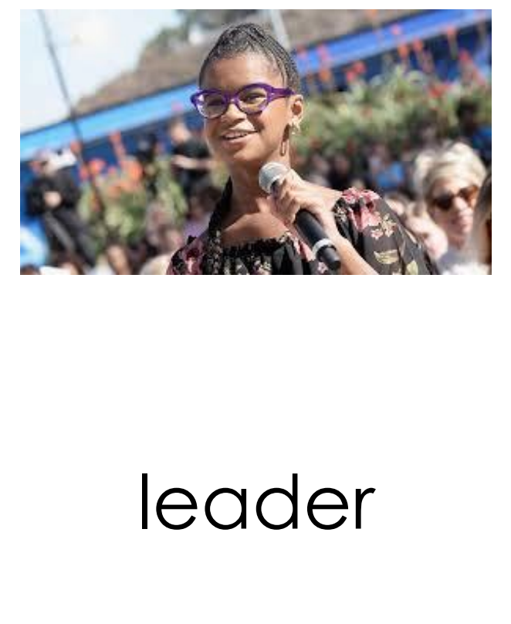  someone who guides other people by telling or showing them what to do | 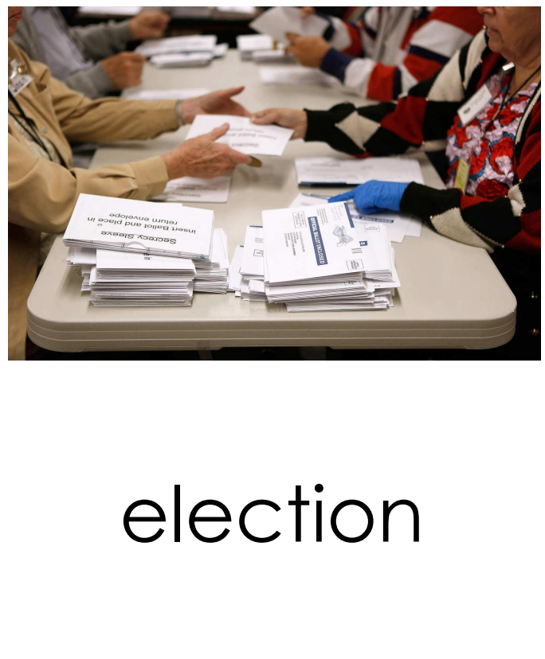  the act of choosing someone for public office with a vote

Teachers need to print…
*This week’s letter (front and back)
*Vocabulary Guide
*If You’re a Leader and You Know It”
*Possibly another weather calendar

