Increase Educational Outcomes Locally Designed Approach
Positive Relationships Equitable Partnerships

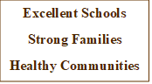

Collaborative Approach Consistent Communication

Individualized Inclusive Practices
Integrated Non-Judgmental
Authentic Flexibility
Strength Based Impactful
Listen & Repeat Availability
On-going over time Shared Responsibility
Beyond Involvement Welcoming Environments
Understanding Family Circumstances Recognize Personal Beliefs/Values

