Maine Schools and School Approval - NEO Module

Before a School System can be updated in Maine Schools, the superintendent must be verified in the NEO Staff Module. If you need to assign your
Superintendent, a NEO user with Staff
Admin access can do so by following these steps (otherwise you may skip past this section):
- Log in to Neo
- Go to the Staff Module (*Staff Home*)
- Click ‘Certification’ & ‘Certification Report’ across the top:
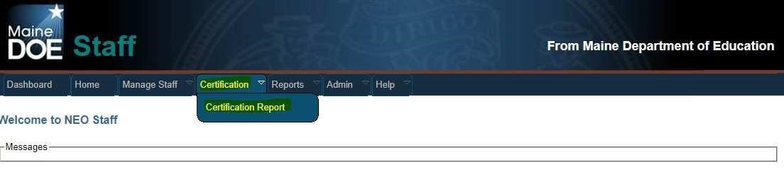
- Scroll to the bottom of the report to see the ‘District Roles’:
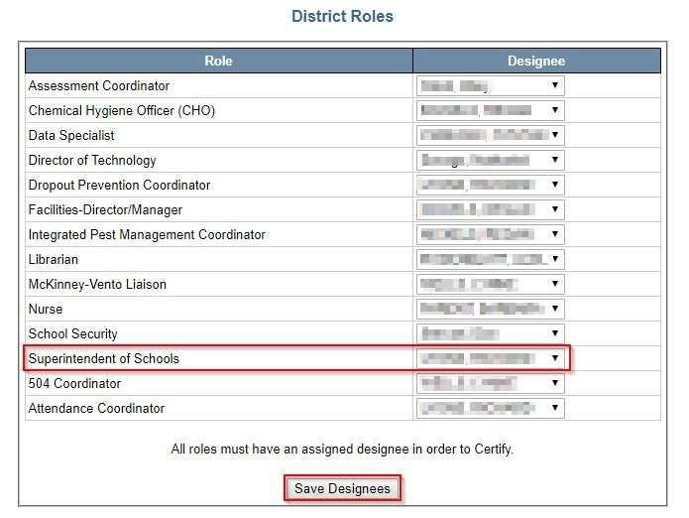
- Under Designee – click on the dropdown arrow and select the correct person that will be the Superintendent of Schools The person must already have a staff assignment for your district in NEO or they will not show on the list.
- Once the person is selected, click ‘Save Designees’ to save the information to the database. If you have issues with the NEO Staff module, please send an email describing the problem to MEDMS.Helpdesk@maine.gov

Now you may enter the Maine Schools Module.

    - Choose Dashboard up top to return to the main menu selections.
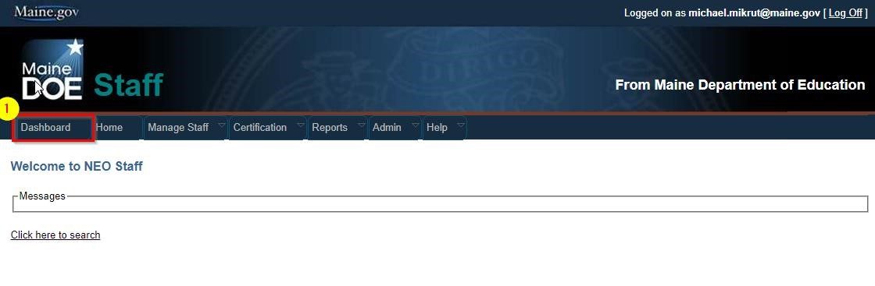
    - Choose Maine Schools.
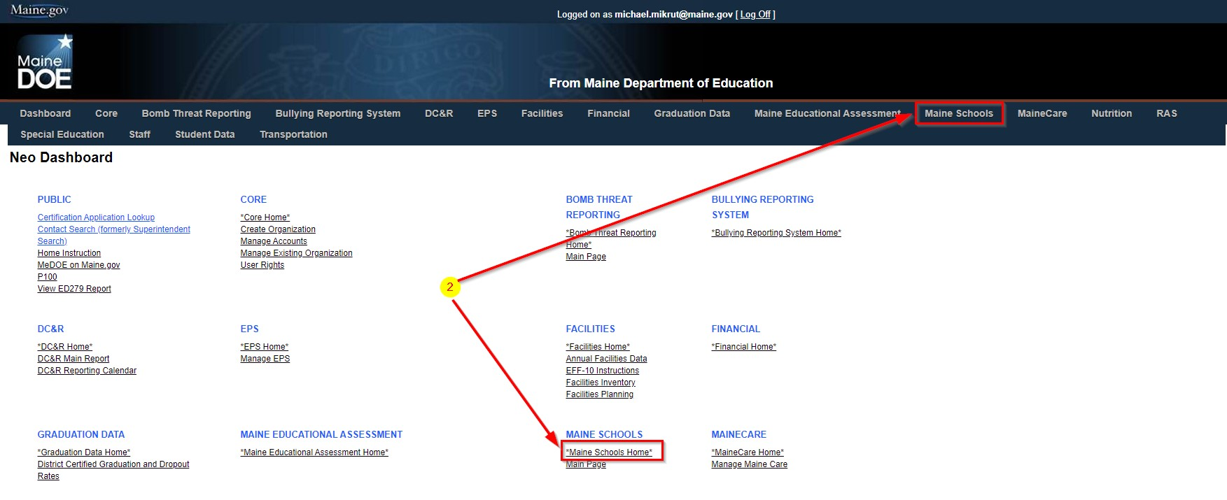
    - Choose “Search SAUs…”
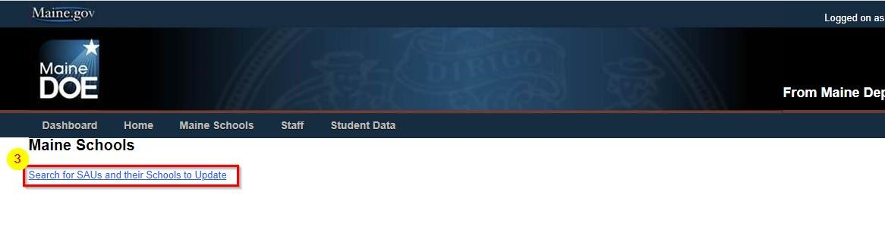

    - Select fiscal year (example: School year 2021-2022 is Fiscal Year 2022) and the SAU you wish to complete. If you do not have an SAU listed, please have your Superintendent submit an access request form so the Helpdesk may add it.
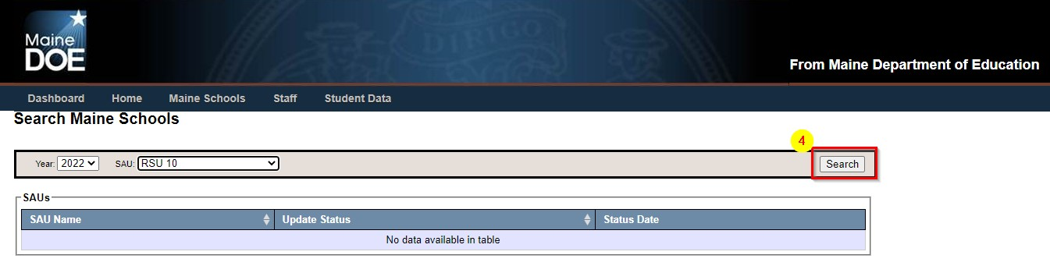
    - The grid will display the SAU you searched on with it’s current status and last modified date. Clicking the SAU will load the form.
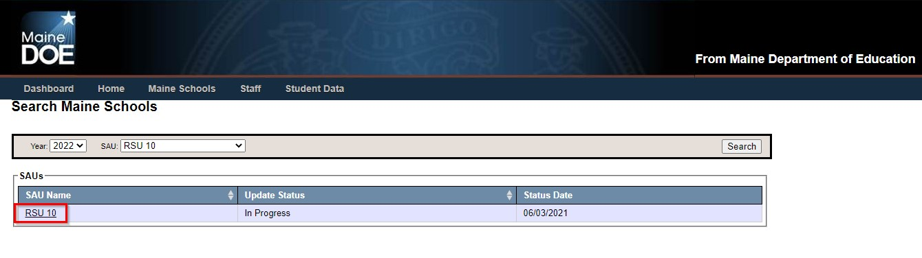

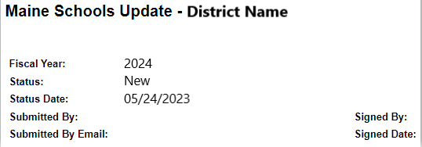
When completing an update, look for the new fiscal year at the top to be the new year. The status date will reflect the last time an update was done to this file. The submitted and signed field will not populate until the update has been submitted for approval.
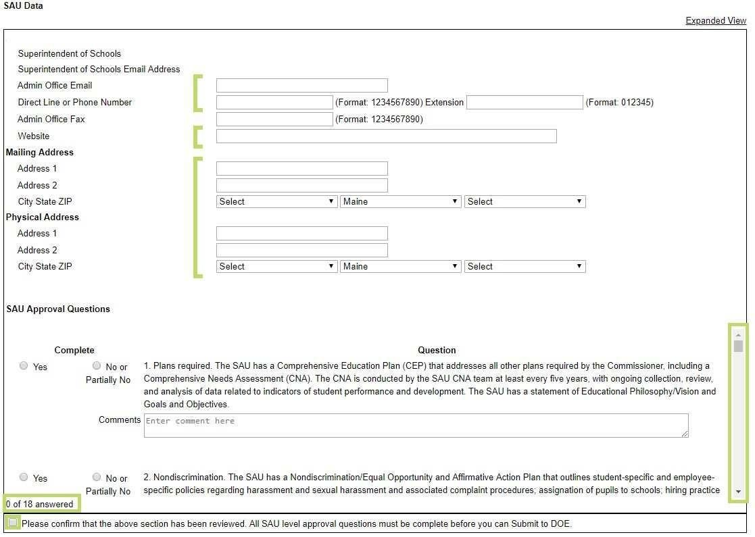
  - Enter or update information for the District. All fields with the exception of Admin Office Fax are required.
  - P.O. Boxes will not be accepted in the “Physical Address” box.
  - The Physical Address should be that of the central office or town office and should not be the superintendent’s address.
  - The only circumstance in which it is appropriate to use the superintendent’s residency is when there is no appropriate address for an office that is located in the district.
  - Mailing address is needed only if different from Physical address.
  - Mailing address may be the superintendent’s mailing address for those superintendents who work remotely.
  - Check the box to confirm that all SAU information has been reviewed before moving on to individual schools information.
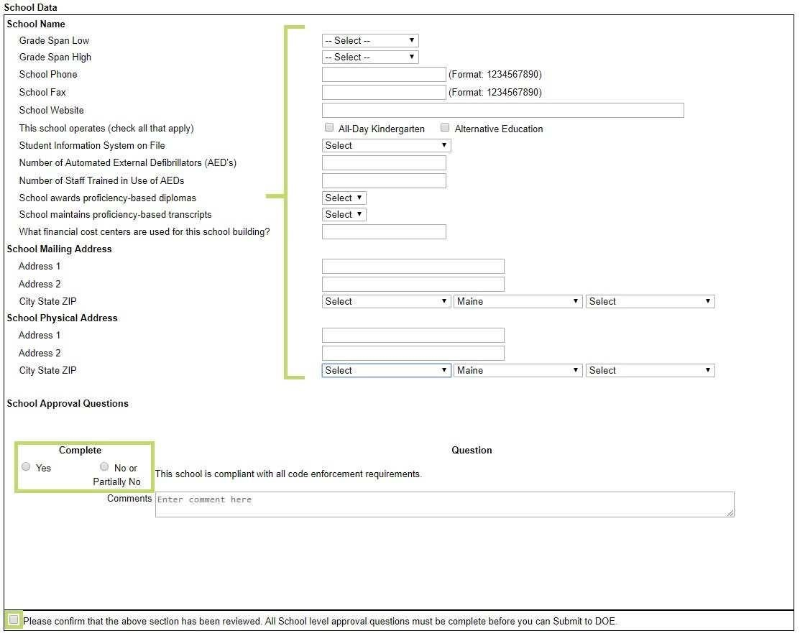
Low & High Grade spans - lowest and highest grade levels the school serves
School Phone, fax, and website – please check for accuracy
If this school offers All-day K or Alternative Education, please indicate
Student information system – enter the system you use to upload data to the state. **This is important we need your correct SIS vendor information for training and communication with the vendor**
Please verify the number of AEDs and those trained in the use of AEDs
Verify if this school awards proficiency based diplomas and/or maintains proficiency based transcripts
The Cost Center information that has been added to Maine Schools references the 3 digit code that the business office uses in the financial system to assign building level costs. Each building will have at least one Cost Center, but may have 2 codes if the building has a combination of PreK-8 grade students and 9-12 grade students. PreK-8 grade will have a range of 010 through 290, and 9-12 grades will have a code in the range of 300 through 380. CTE Centers will have a Cost Center of 390.
If school districts operate an alternative education program where they need to enter the building those will use a cost center in the range of 500 through 590.
The cost center report can be downloaded here:
http://www.maine.gov/education/data/handbook/codereport.htm

School Physical address may not be a PO Box, Mailing and physical address may be the same.

Next, carefully mark all SAU level approval questions with a response, and if the response is “No, or partially No,” a comment must be entered. Additionally, mark to answer the school level approval question for each school listed.

As you move down the module/form, ensure that the SAU- and school-level section question is checked for each section: “Please confirm that the above section has been reviewed…”

At the bottom, date, sign and submit the form.

*An important item to remember is that NEO information may be saved when partially finished to complete at a later time. While completing the approval process, the page should be saved often, as there is a relatively short time-out period.

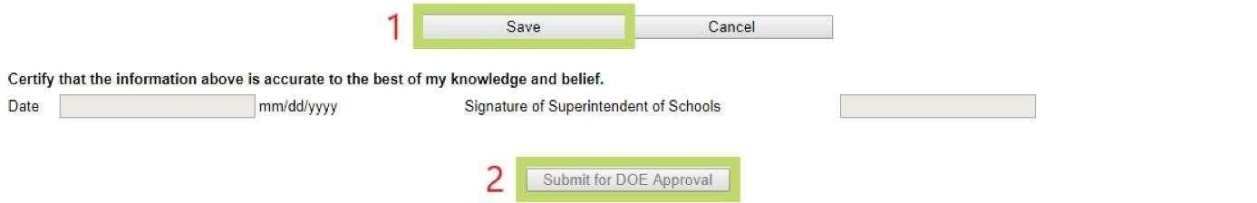

- Save the information first. Date and sign the report to be submitted for DOE approval.
- Then finally click ‘Submit for DOE Approval’.

Once the DOE has received the report, we will check the report in as received and will get back to you as soon as possible with any requests for clarification or more information.
If you have any questions, please call the Data Systems Helpdesk at (207) 624-6896

