PARENT/GUARDIAN--ECONOMIC STATUS SAMPLE FORM

Dear Parents/Guardians:
This form will provide information needed by the Maine Department of Education to determine PUT SCHOOL NAME HERE ‘s eligibility status for State Economically Disadvantaged funds available under the Essential Programs & Services Funding Act. Data in this form is not for school lunch purposes, only to determine economic disadvantaged status*. If you have any questions, please call ______________________ at ________________. The due date to return this form to your school administrator is September___, 2021. Thank you for your cooperation.
Sincerely,
School Administrator
________________________________________________________________________________________________________
Please use the table below as guidance to determine your student’s economic status. If household income is less than the Annual or Monthly earnings for your household size in the chart below, then your student meets the economic disadvantaged status criteria. Household size includes adults and children.
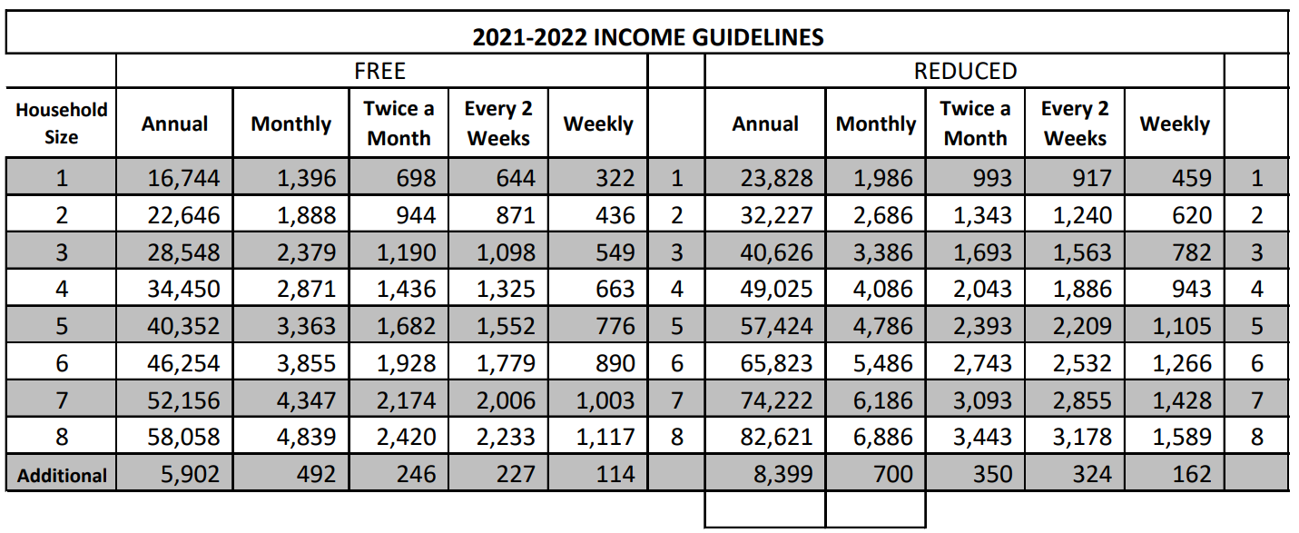
Student’s Last Name | Student’s First Name | Name of School | Student’s Current Grade | Student Meets Free Category Guidelines | Student Meets Reduced Category Guidelines
Please duplicate this form for additional children. Return this form to your child’s school by September ___, 2021
Signature of Parent: _________________________________________________ Date: ________

