File Transfer Protocol (FTP) To Upload
ESESA Monitoring Documents
The FTP process allows the upload of the monitoring documents to a secure location. To facilitate the process, your document files should be saved in a folder that is created in your system. The FTP site folder is a shared folder among all SAUs being monitored for ESEA. Therefore, it is necessary to name the document files in the following format: name of school administrative unit followed by the item number that corresponds with the requested item number in the Monitoring tool e.g: RSU99_A-1.doc, RSU99_A-2.pdf, RSU99_B-1.docx. The response document file to the questions could be named RSU99_Response.doc and contain all the responses. Do not use the Apple Pages application. When gathering documents for the review, rename documents as you locate them and save them in your folder. Ensure that the appropriate program association code [.pdf, .doc, docx] is maintained in the new document file name.
Setup/Preparation for FTP
- Go to the MOVEit website by entering https://ftps.maine.gov in a browser window.
- On the MOVEit Homepage, Sign On Username: Doe_Titles and Password: tt27le [“l” is lower case L]. CAUTION: TWO failed logins within 30 minutes will result in system lockout. Contact Jackie Godbout at 624-6712 if you are having trouble logging in or if you receive a lockout message.
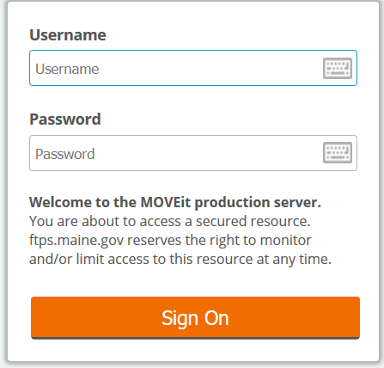

- Once logged in, click Install the Upload Wizard. 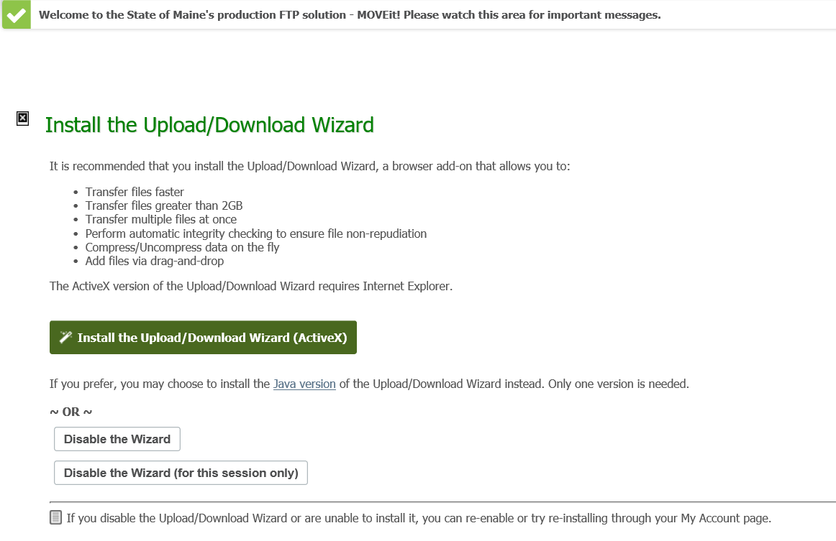

- Click Launch the Upload Wizard

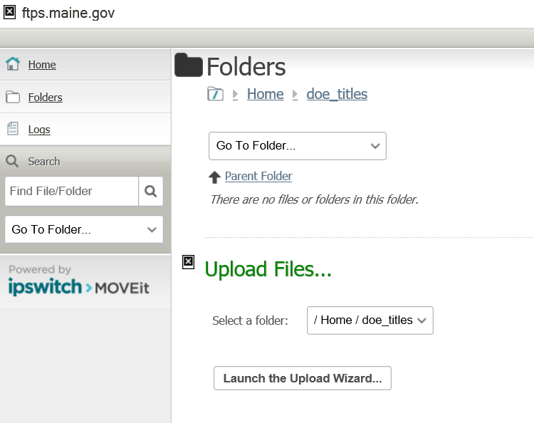

- Click NEXT.
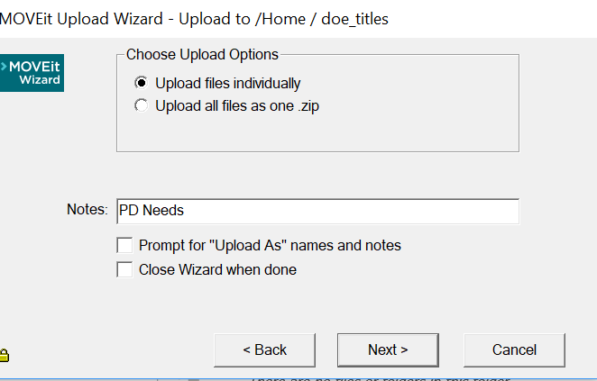

- Click Add File. Locate the folder that contains the documents to be uploaded. Select the files to be uploaded.
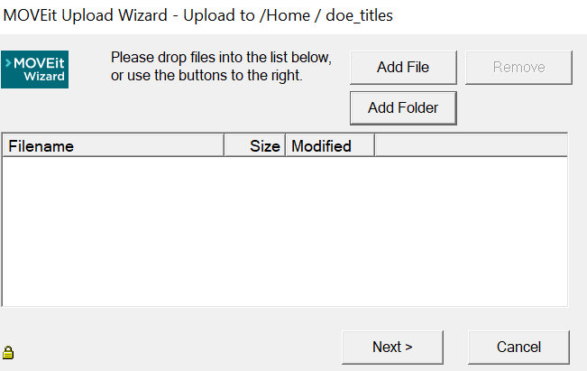

- Files will appear in the Drop files to Add section. Click next when the upload is complete.
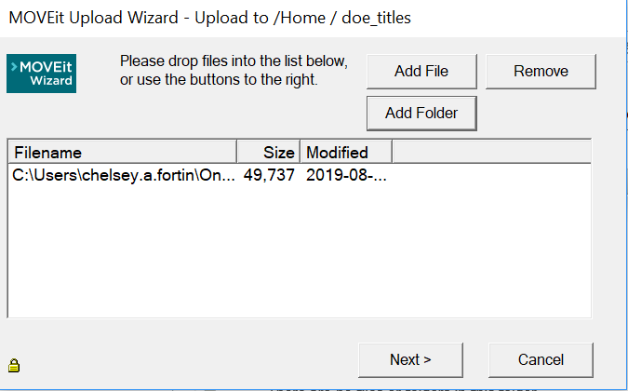

- When the upload is complete, click ok. 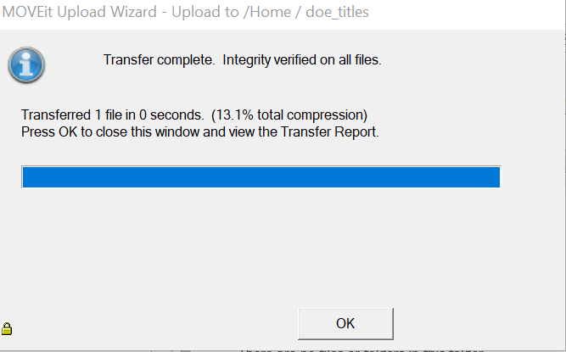

- You will be retun to the Home page. Click Sign Out in the upper right corner.

- If you have questions or problems, contact Jackie Godbout at 624-6712.

