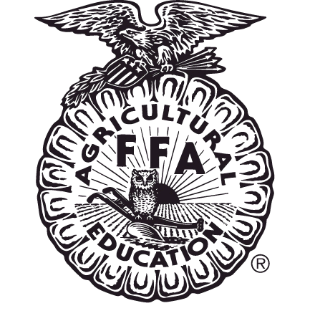
In order to compete in the state FFA Safe Tractor Driving Competition, each participant must have a minimum of 10 hours of total driving experience in operating tractors, skid steers or skidders. This experience must be verified by a parent, an employer or instructor (supervisor signature). Each student must submit his/her completed log to FFA Chapter Advisor. A completed driving log for each contestant is due at the registration deadline for the state FFA Convention.
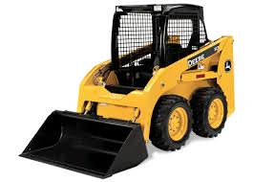
Equipment Driving Log

Student Name _________________________________________________________________________

School _________________________________________Student Telephone #_____________________

DATE | TIME  HOURS &  MINUTES | JOB  OR PROJECT | EQUIPMENT TYPE | SUPERVISOR’S  SIGNATURE
Example:  October 10, 2021 | 1 hour and 10 minutes | Clean loafing barn &  Scrape alleys | John Deere  313 skid steer
Example:  April 1, 2022 | 45 minutes | Spread manure | John Deere 5020 farm tractor

