Preparing Invoice and Supporting Documents for ESSER I / ESSER II grant
- GEM Systems will be utilized for the reimbursement process. Please go to - www.4pcamaine.org
- Select the link for “Federal Grant Reimbursement System”
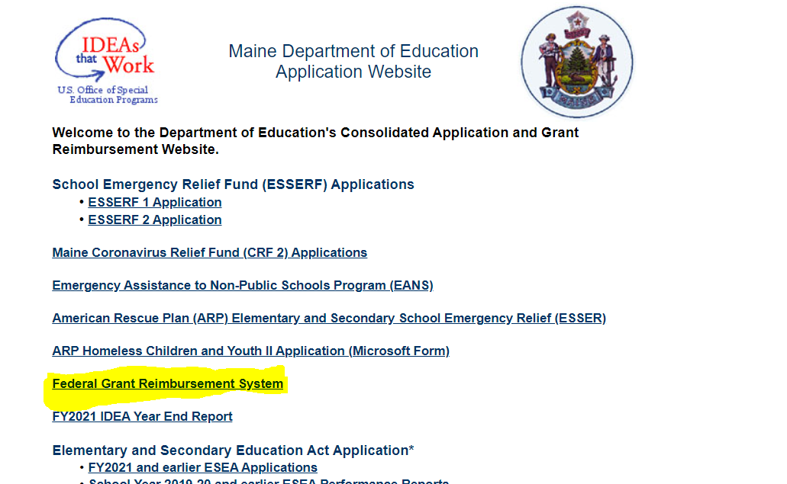
- From federal grant reimbursement menu, select the invoice for ESSER I / ESSER II
- Fill out the Billing period. The billing period on the invoices can be monthly or up to three months but cannot overlap fiscal years.

- Select Reimbursement as the type of funds requested.

- Fill out the funds invoiced per budget category.

- Provide all the required documentation for the invoice. These need to be attached by uploading the .pdf files in GEM system.
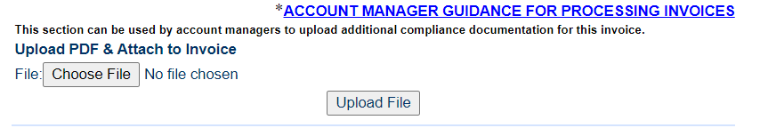

Required Documentation -
Each invoice submission should include:
- Trial Balance –
  - A detailed trial balance
  - Trial balance period must match period being invoiced
- It would be very helpful if, in addition to the Trial Balance, you provide a list of invoices by Category and type i.e. Student Supports-7300, Staff Support-3000, etc.

Following are important information to prepare your submittal-
- ESSER I and ESSER II are reimbursement grant which means you can only request for reimbursement once the expenses are incurred.
- Sales tax is not an allowable expense for federal grants and should not be submitted for reimbursement.
- For each category of expenses submitted, ensure there is a budget amount in that category. Expenses cannot be submitted in categories that do not have an associated budget.

