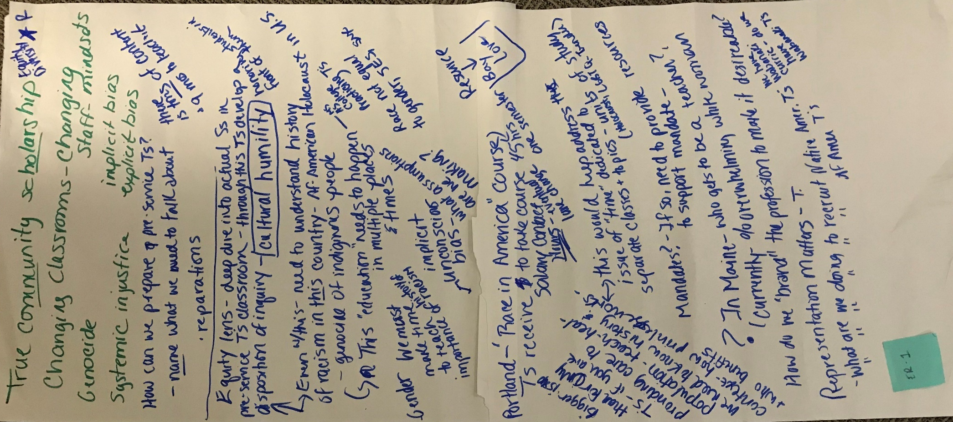
- True Community scholarship, equity diversity
- Changing Classrooms – changing staff mindsets
- Genocide
- Implicit bias
- Explicit bias
- Systemic injustice
- How can we prepare pre=-service teachers?
  - Name what we need to talk about
    - Reparations
  - There is tons of content and 9 months to teach it
- Equity lens – deep dive into actual Ss in
- Pre-service T’s classroom – through this Ts develop a disposition of inquiry – Cultural Humility
  - Honoring students in front of them
- Even with this – need to understand history of racism in this country – African-American Holocaust in U.S.
  - Genocide of indigenous people
  - This “education” needs to happen in multiples places and times – Middle School, Highschool, College, Practicing Teachers
- Gender
- We must make time to teach importance of history of racism
- Implicit unconscious bias – what assumptions are we making?
- Race not equal to gender, SES, sex
- Portland – ‘Race in America’ course
  - Teachers receive salary contact hours – eventual lane change – to take course 45 hours one semester
  - Resource: Bay Love’
- Bigger issue than for only Teachers – if you are providing care to population – teach, heal – we need to know history of context – how privilege works and who benefits
  - This would help address the issue of “time” dedicated to separate classes and topics - units of study (Holocaust, LGBTQ, gender)
- Mandates? If so, need to provide resources to support mandate –
- In Maine – who gets to be a teacher?
- Currently % overwhelmingly white women
- How to de ‘brand’ the profession to make it desirable?
- Representation matters – Teachers
- What are we doing to recruit Native American Teachers, African American Teachers
  - We have Wabanaki curriculum, do we have Wabanaki Teacher?

- Implicit Bias:
  - How to address in educators
  - How to help feel comfortable admitting bias?
- Conflicting views in classroom
  - “losing half the class”
- “You got to start somewhere.”
  - Mandate or not?
- High quality Professional Development, incentivized vs Stick method
- Book Studies “White Fragility.”

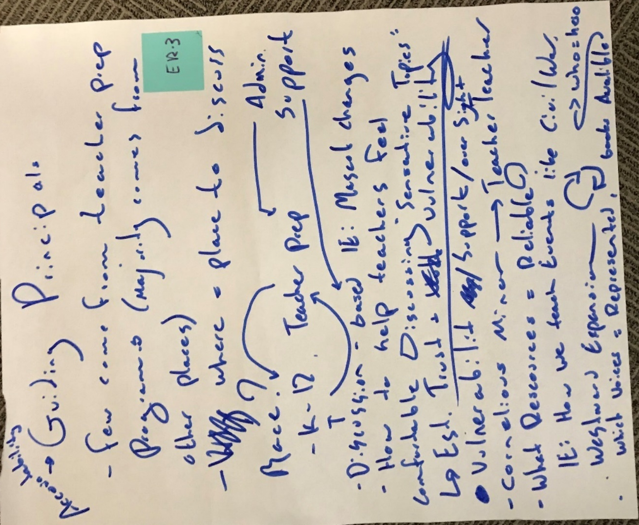
- Accountability Guiding Principals
- Few come from teacher preparation programs (majority comes from other places)
- Where are places to discuss race?
  - K-12 vs Teacher Prep (Chicken and egg problem, which to do first?)
  - Teacher Prep Admin Support
  - Discussion-based IE: Mascot Changes Admin Support
- How to help teachers feel comfortable Discussion “Sensitive Topics”
  - Establishing trust and vulnerability
  - Vulnerability/support/oversight
- Cornelius Minor College Teacher
- What Resources are reliable?
  - IE: How we teach events like the Civil War, Westward Expansion?
  - Which voices are represented, books available, who is the hero?
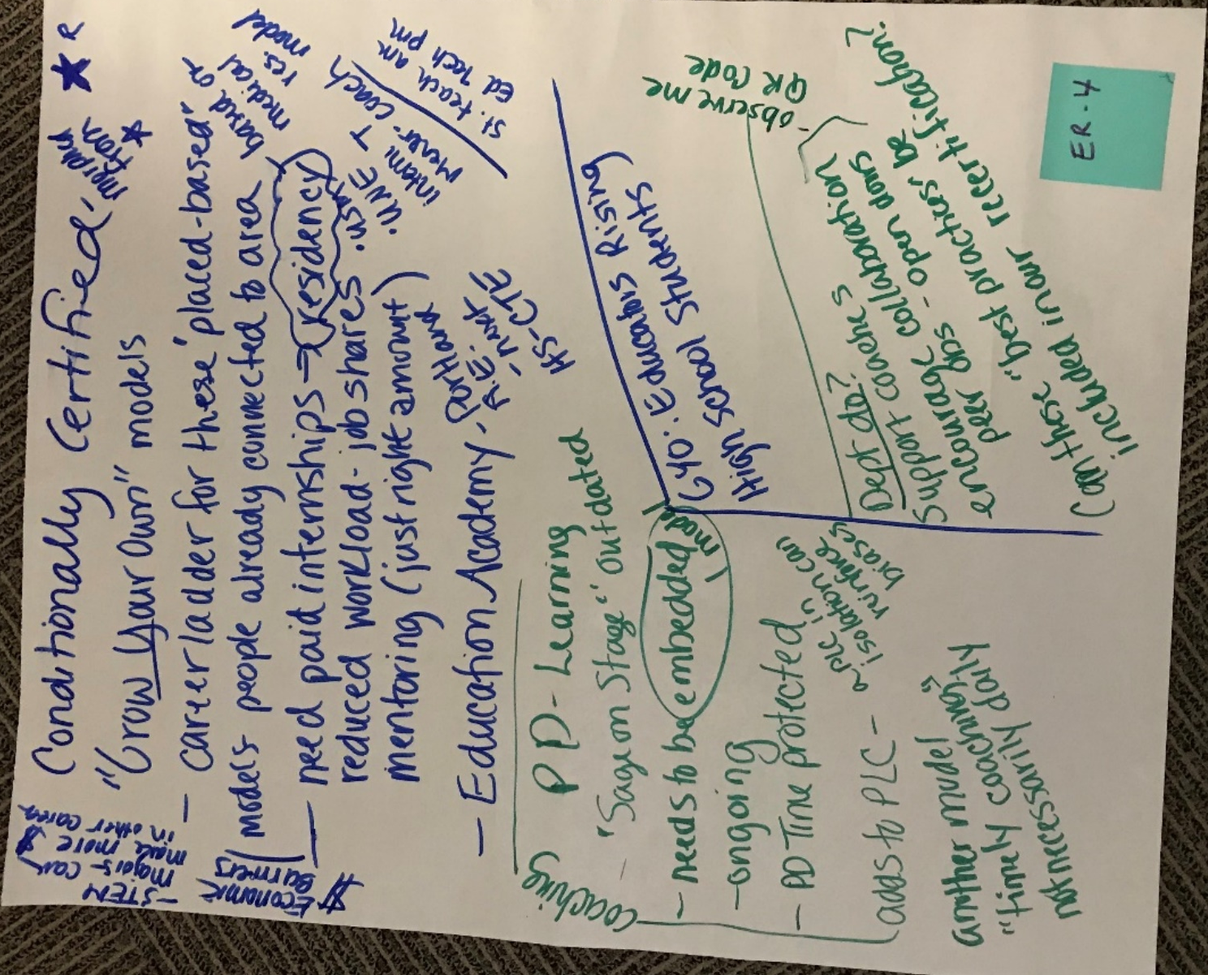

- Conditionally Certified morphed from “Grow your own” models
- STEM majors can make more in other fields
- Economic barriers
- Career ladder for these ‘place-based’ models people already connected to area
  - Based on medical residency model
  - Need paid internships residency
    - USM, UNE, intern Teacher, mentor/coach, student teach am/ed tech pm
    - Reduced workload – job shares mentoring (just right amount)
- Education Academy
  - Portland A.E.
  - Next
  - HS-CTE
- Professional Development Learning
  - “Sage on Stage” = outdated
- Coaching needs to be embedded model
  - Ongoing
  - PD time protected
  - Adds to PLC, a PLC can reinforce biases
- Another model “timely coaching” not necessary daily
- GYO: Educators Rising
- High School Students
- Dept do?
  - Support coaches
  - Encourage collaboration
    - Peer observation, open doors, observe me QR code
  - Can these “best practices” be included in our recertification?

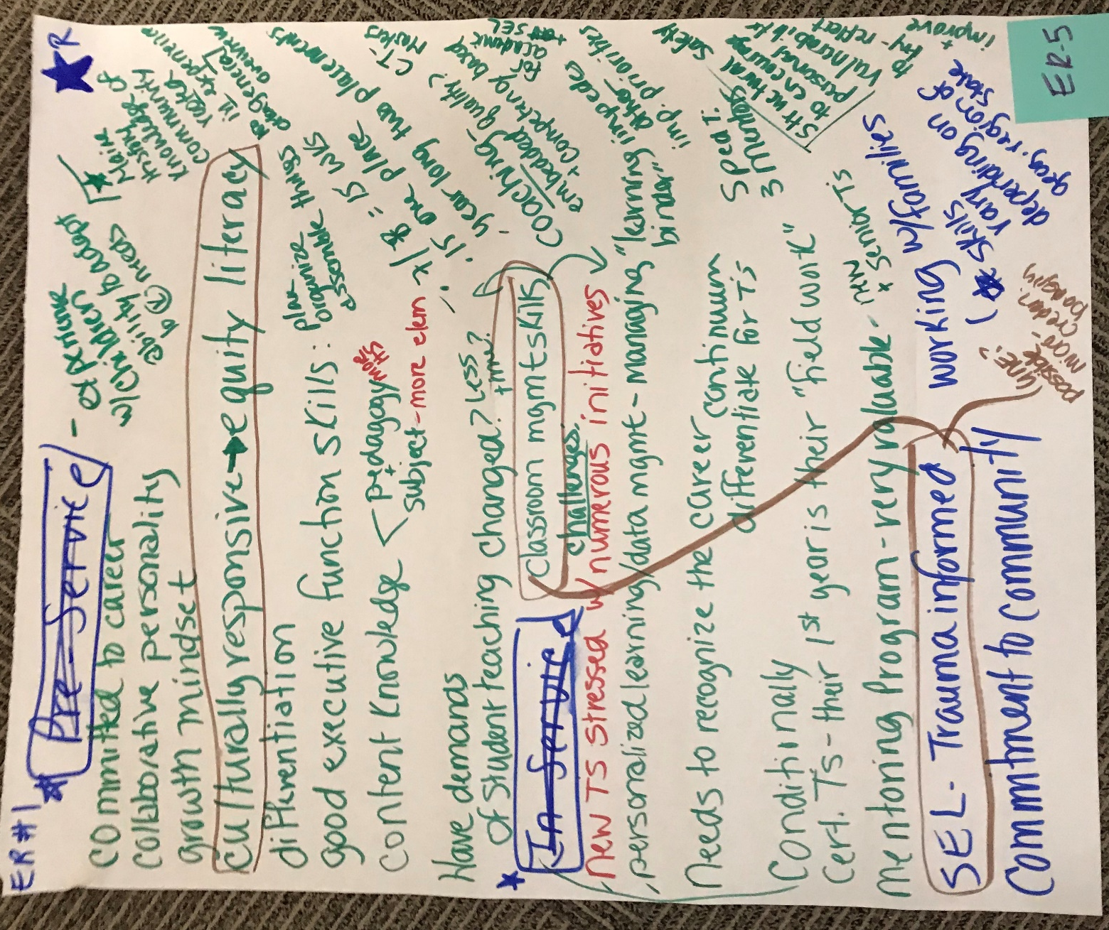

- Committed to career
- Collaborative personality
- Growth mindset
- Experience with children ability to adopt to kids needs
- Culturally responsive equity literacy
- Maine History of community rooted in experience no other general overview
- Differentiation
- Good executive function skills: plan, organize, assemble things
- Content knowledge
  - Pedagogy more High School
  - Subject more elementary
- Have demands of student teaching changed?
  - Less time?
  - 7/8 = 15 weeks
  - 15 one place
  - Yearlong two placements
  - CT masters
- Coaching embedded quality and competency based for academic and SEL
- Classroom Management skills
  - New teachers stressed with numerous initiatives
  - Personalized learning/data management, managing “learning binder”
    - Impedes other priorities
  - Needs to recognize the career continuum differentiate for Teachers
  - Conditionally Cert Teachers, their 1st year is their “field work”
  - Sped Teacher 3 mentors
  - Mentoring Program very valuable, new and senior teachers
- SEL Trauma informed
  - UNE possible micro credit badging
- Commitment to community
- Working with families
  - Skills vary depending on geography region of state
- Structural safety to encourage personal vulnerability to try, reflect, and improve

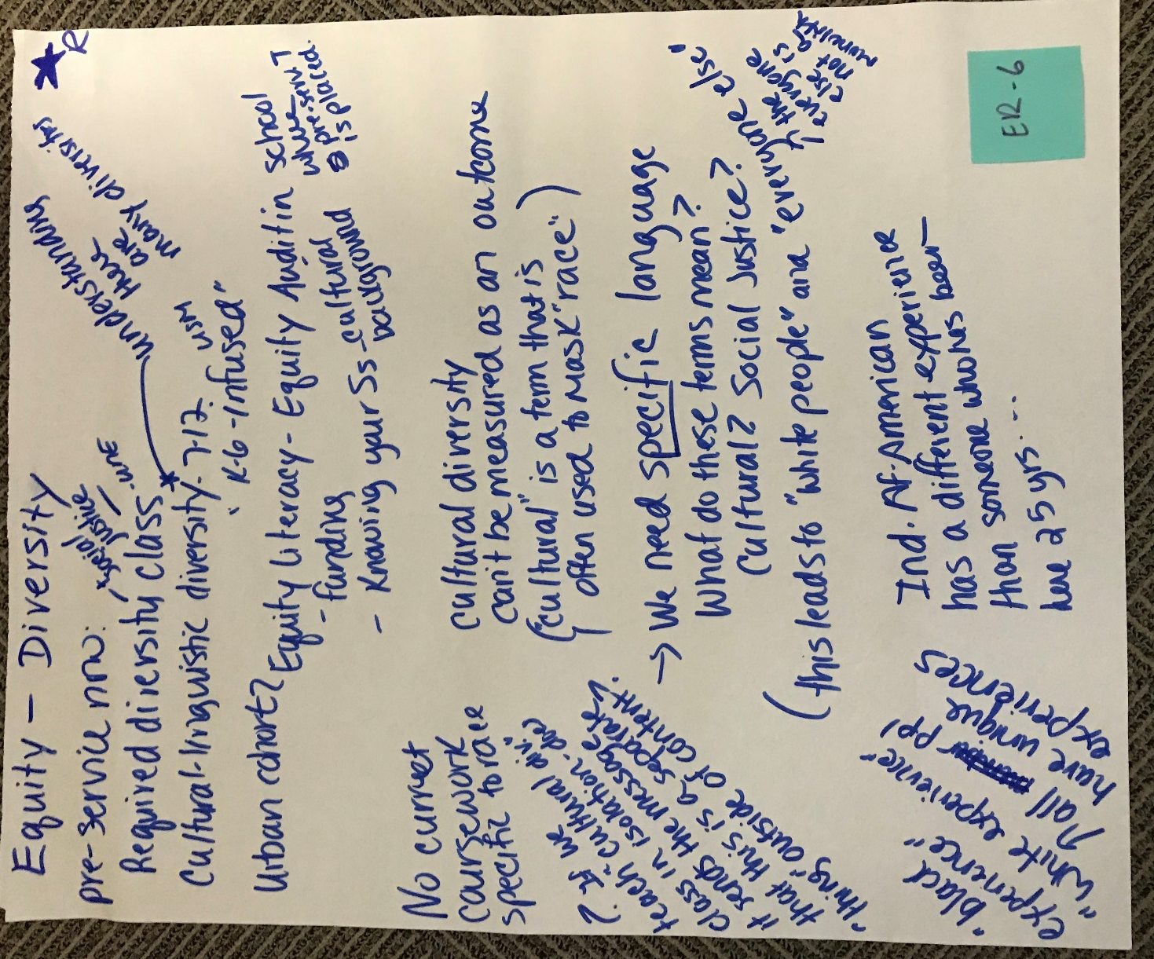

Equity and diversity
- Pre-service now:
  - Required diversity class (UNE)
  - Cultural-linguistic diversity 7-12
    - “K-6 infused” USM
  - Urban cohorts
    - Equity literacy, equity audit in school where pre-service teacher is placed
      - Funding
      - Knowing your Student’s cultural background
- No current coursework specific to race
  - If we teacher “cultural diversity” class in isolation, does it send the message that this is a separate “thing” outside of content?
  - “Black experience “White experience” all people have unique experiences
- Cultural diversity can’t be measured as an outcome (“cultural” is a term that is often used to mask race)
- We need specific language
  - What do these terms mean?
    - Cultural? Social Justice?
  - This leads to “white people” and “everyone else”
    - The everyone else is not monolith
- Ind. African-American has different experience than someone who has been here 25 years….

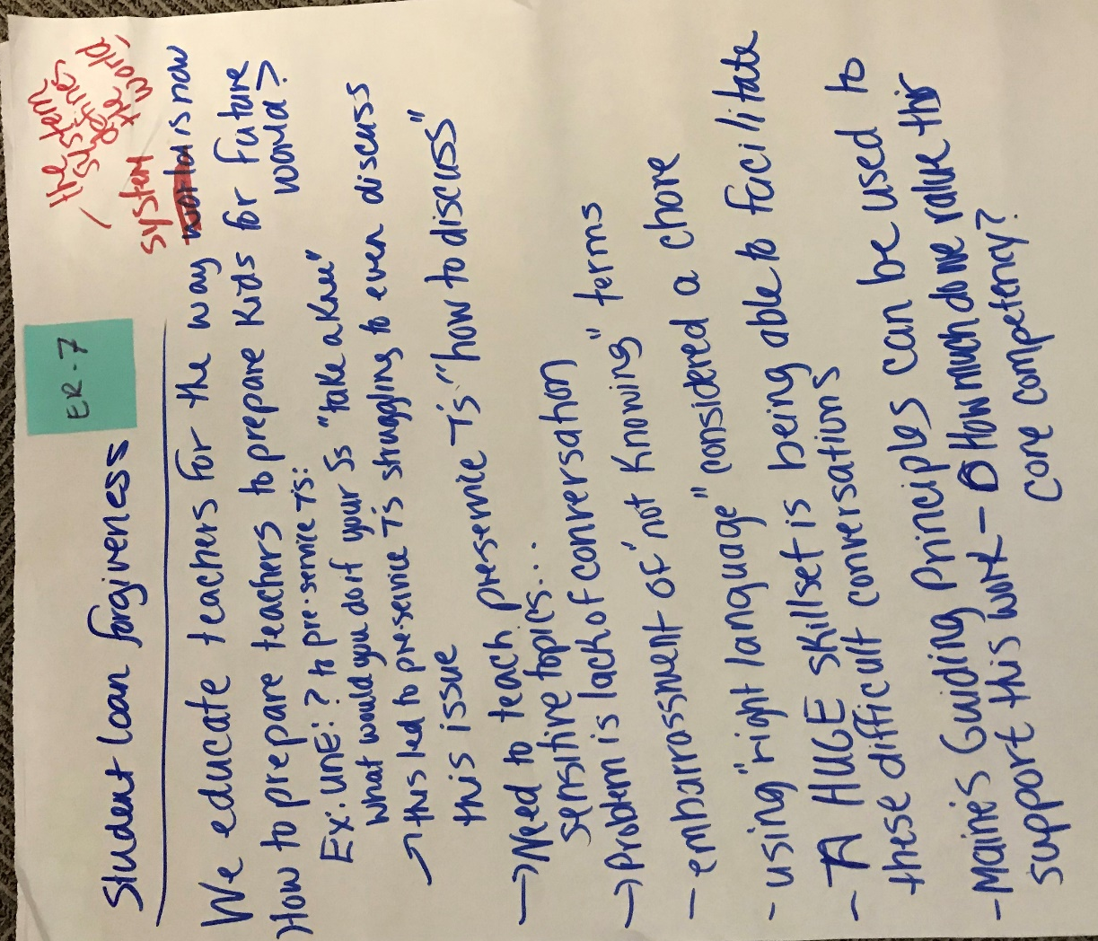
Student loan forgiveness

  - We educate teachers for the way the system (the system defines the world) is now
  - How to prepare teachers to prepare kids for future world?
  - EX: UNE? To pre-service teachers:
    - What would your do if your students “take a knee?”
    - This led to pre-service teachers struggling to even discuss this issue
  - Need to teacher pre-service teachers “how to discuss” sensitive topics
  - Problem is lack of conversation
  - Embarrassment of “not knowing” terms
  - Using “right language” considered a chore
  - A HUGE skillset is being able to facilitate these difficult conversations
  - Maine’s guiding principles can be used to support this work
    - How much do we value their core competency?

