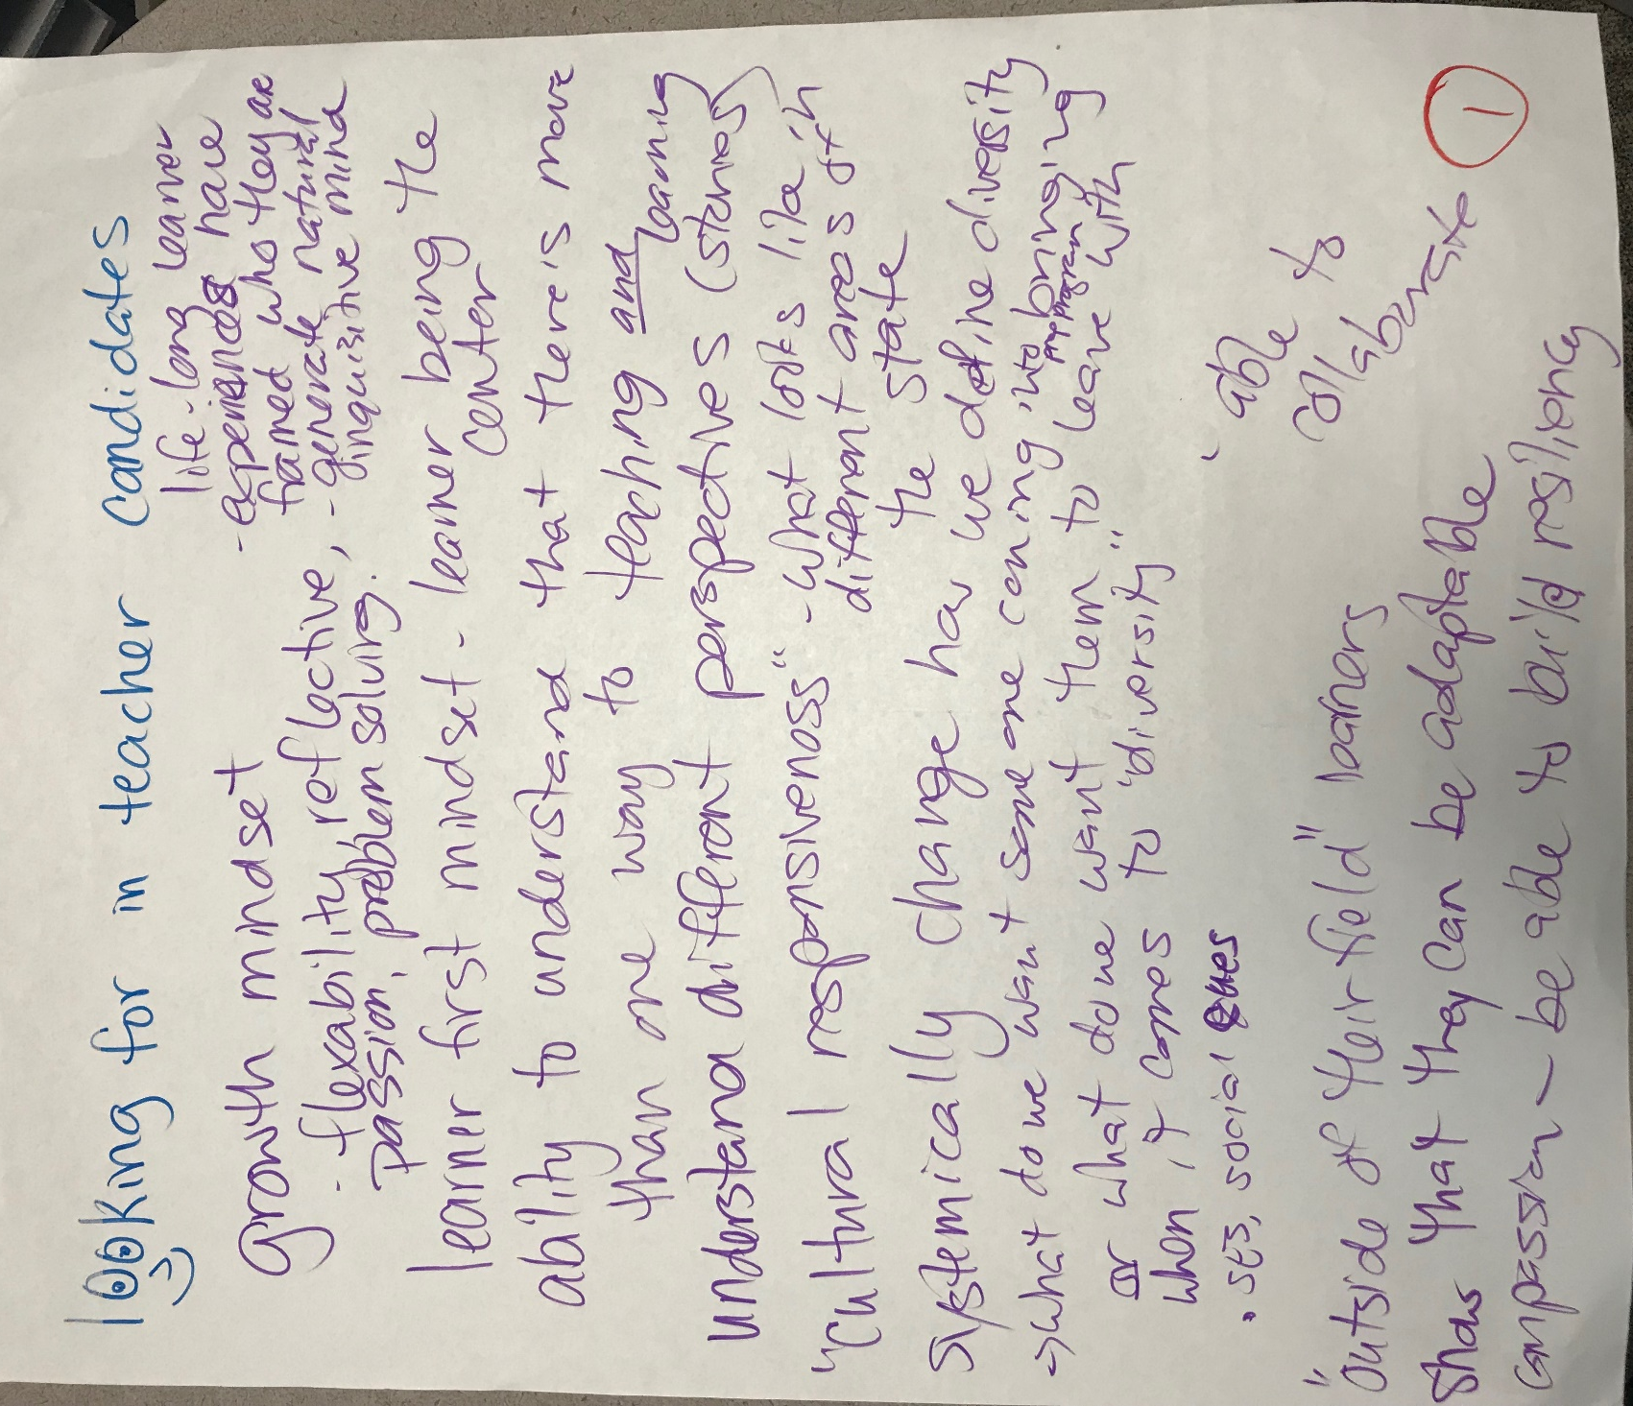
1
looking for in teacher candidates
growth mind set
-flexibility, reflective, passion, problem solving.
learner first mindset – learner being the center
ability to understand that there’s more than one way to teaching and learning
understand different perspectives (stories)
“cultural responsiveness” – what looks like in different areas of the state
systemically change how we define diversity
→ what do we want someone coming into prep program bringing or what do we want them to leave with when it comes to “diversity”
-SES, social cues
“outside of their field” learners
shows that they can be adaptable
compassion - be able to build resiliency
life-long learner
-experiences have framed who they are
-generate natural inquisitive mind
-able to collaborate

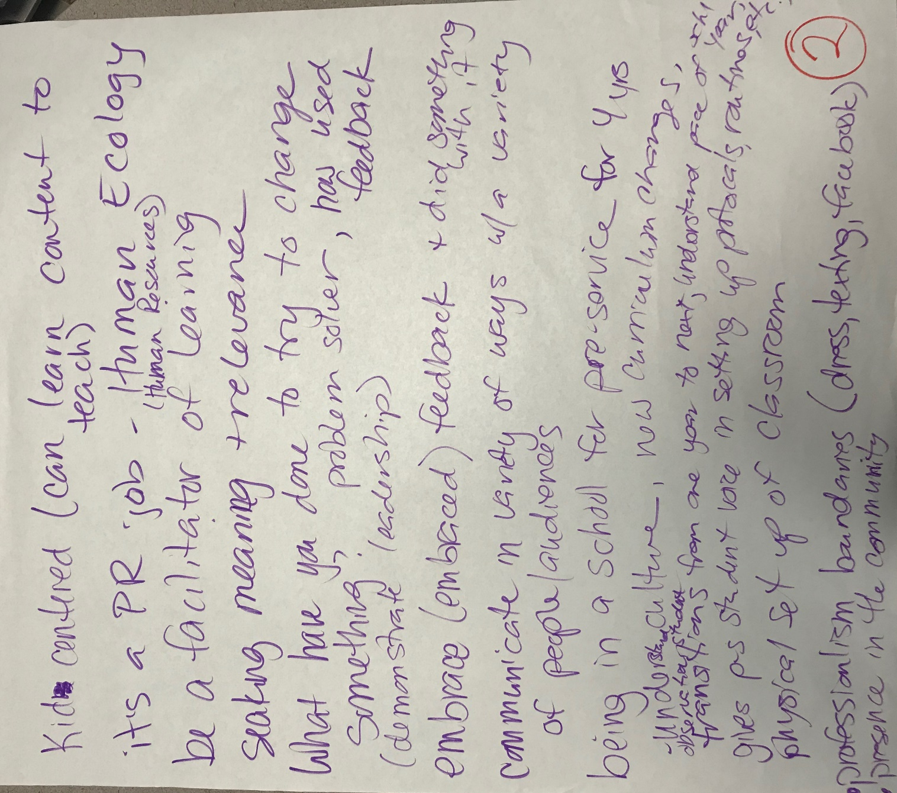

2
kid centered (can learn content to teach)
it’s a pr job – Human Ecology (Human Resources)
be a facilitator of learning
seeking meaning + relevance
what have you done to try to change something? Problem solver, has used feedback (demonstrate leadership)
embrace (embraced) feedback + did something with it
communicate in a variety of ways with a variety of people/audiences
being in a school for pre-service for 4 years
understand culture, new curriculum changes, observes student
transitions from one year to next, understand pace of school year
gives p-s student voice in setting up protocols, routines, physical set up of classroom, etc.
professionalism boundaries (dress, texting, facebook)
presence in the community

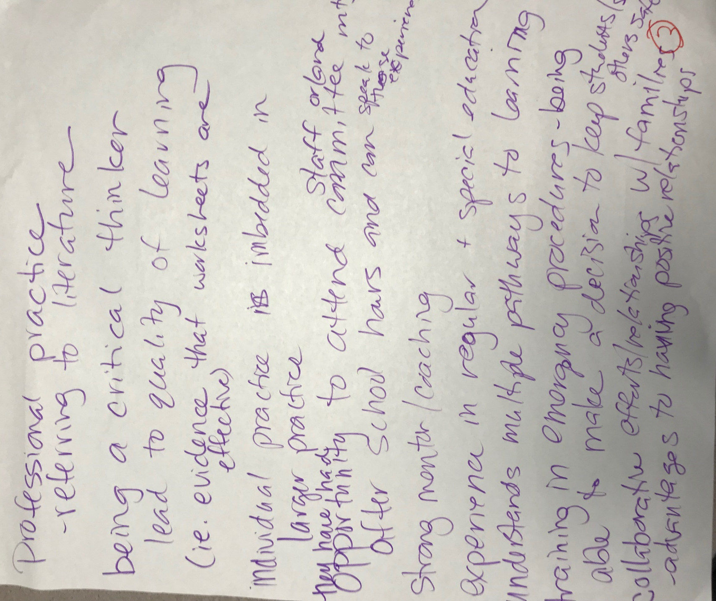

3
professional practice
-referring to literature
being a critical thinker
lead to quality of learning (ie. evidence that worksheets are effective)
individual practice is imbedded in larger practice
they have had opportunity to attend staff or/and committee meetings after school hours and can speak to those experiences
strong mentor/coaching
experience in regular + special education
understand multiple pathways to learning
training in emergency procedures – being able to make a decision to keep student/self/others safe
collaborative efforts/relationships with families
-advantages to having positive relationships

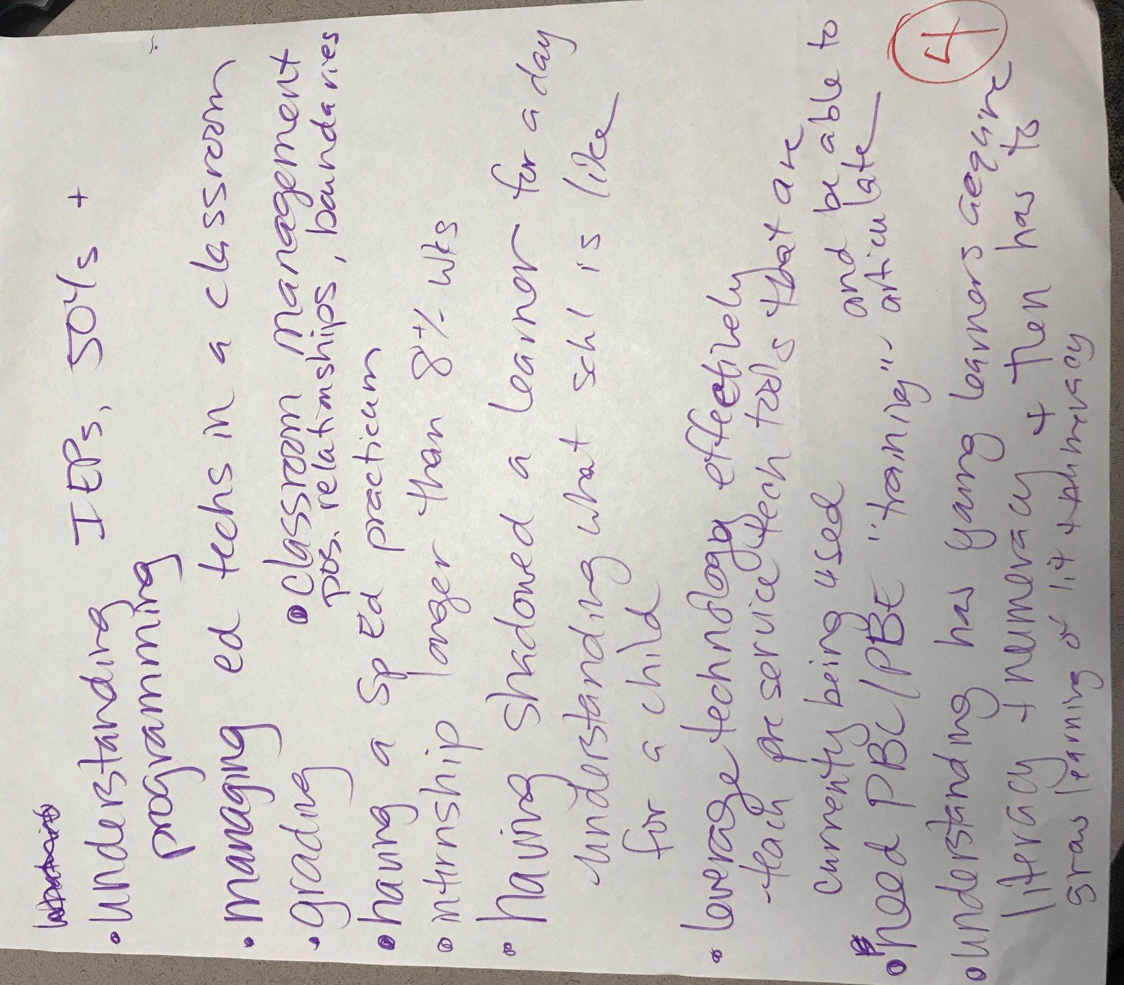

4
understanding IEPs, 504s + programming
managing ed techs in a classroom
grading
classroom management, positive relationships, boundaries
having a special ed practicum
internship longer than 8+/- weeks
having shadowed a learner for a day
understanding what school is like for a child
leverage technology effectively
-teach pre-service tech tools that are currently being used
need PBC/PBE “training” – and be able to articulate
understanding how young learners require literacy + numeracy + then has to grow learning of lit + numeracy

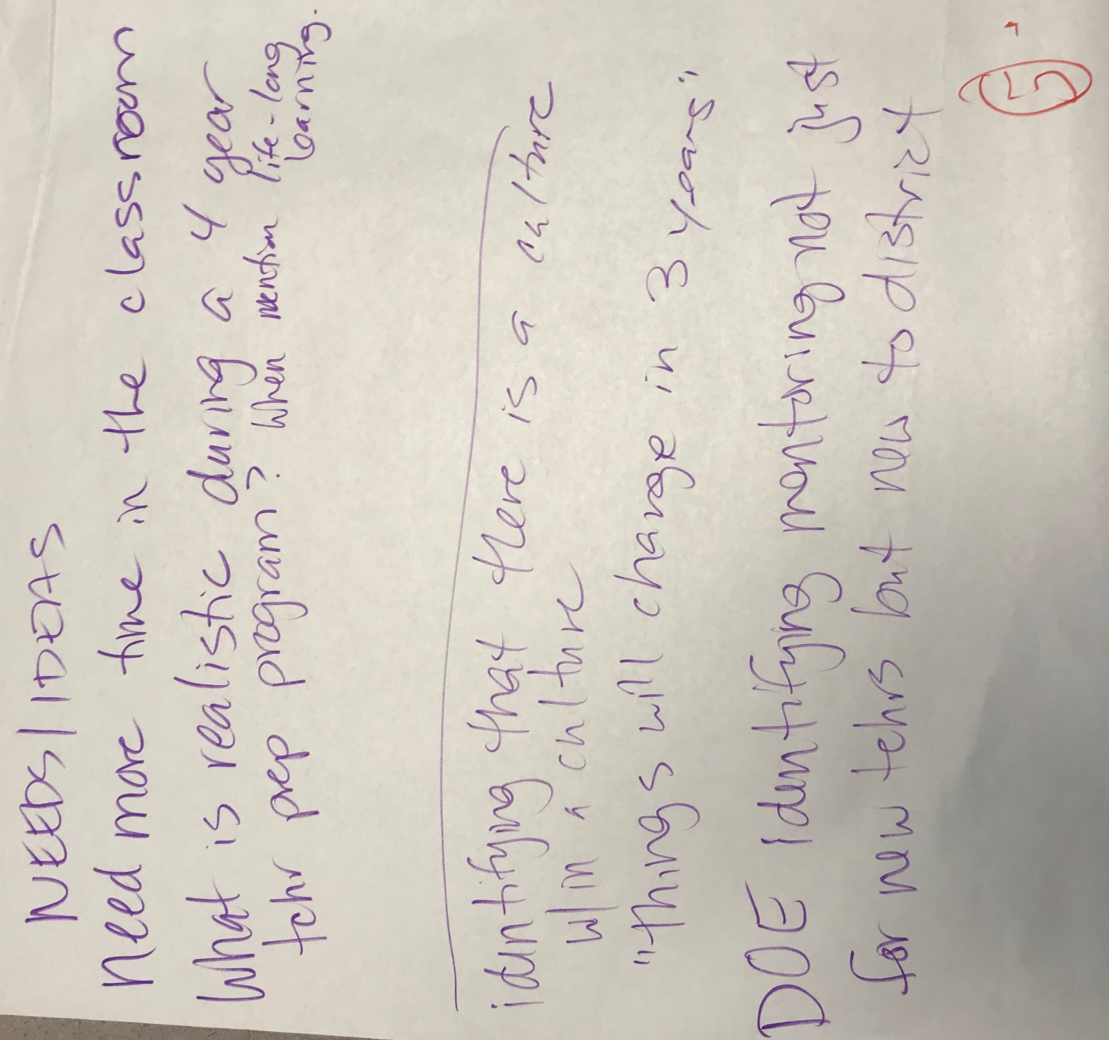

5
NEEDS/IDEAS
Need more time in the classroom
What is realistic during a 4 year teacher prep program? When mention life-long learning

Identifying that there is a culture with in a culture
“things will change in in 3 years”
DOE identifying mentoring not just for new teachers but new to district

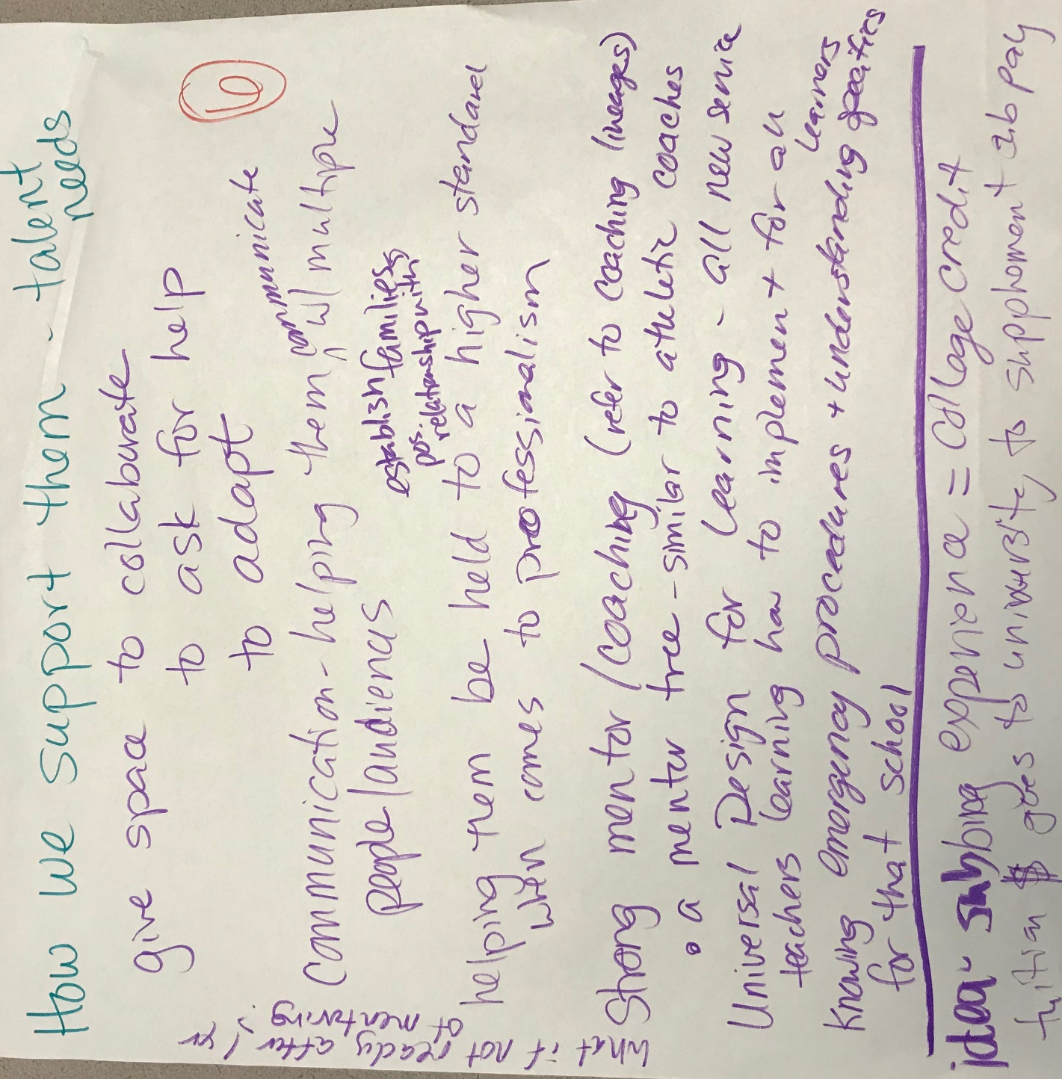

6
How we support them – talent needs
What if not ready after 1 year of mentoring?
give space to collaborate
give space to ask for help
give space to adapt
communication – helping them communicate with multiple people/audiences
establish positive relationships with families
helping them be held to a high standard when it comes to professionalism
strong mentor/coaching (refer to coaching lineages)
-a mentor tree – similar to athlete coaches
Universal Design for learning – all new service teachers learning to implement + for all learners
knowing emergency procedures + understanding specifics for that school

idea – subbing experience = college credit
tuition $ goes to university to supplement sub pay

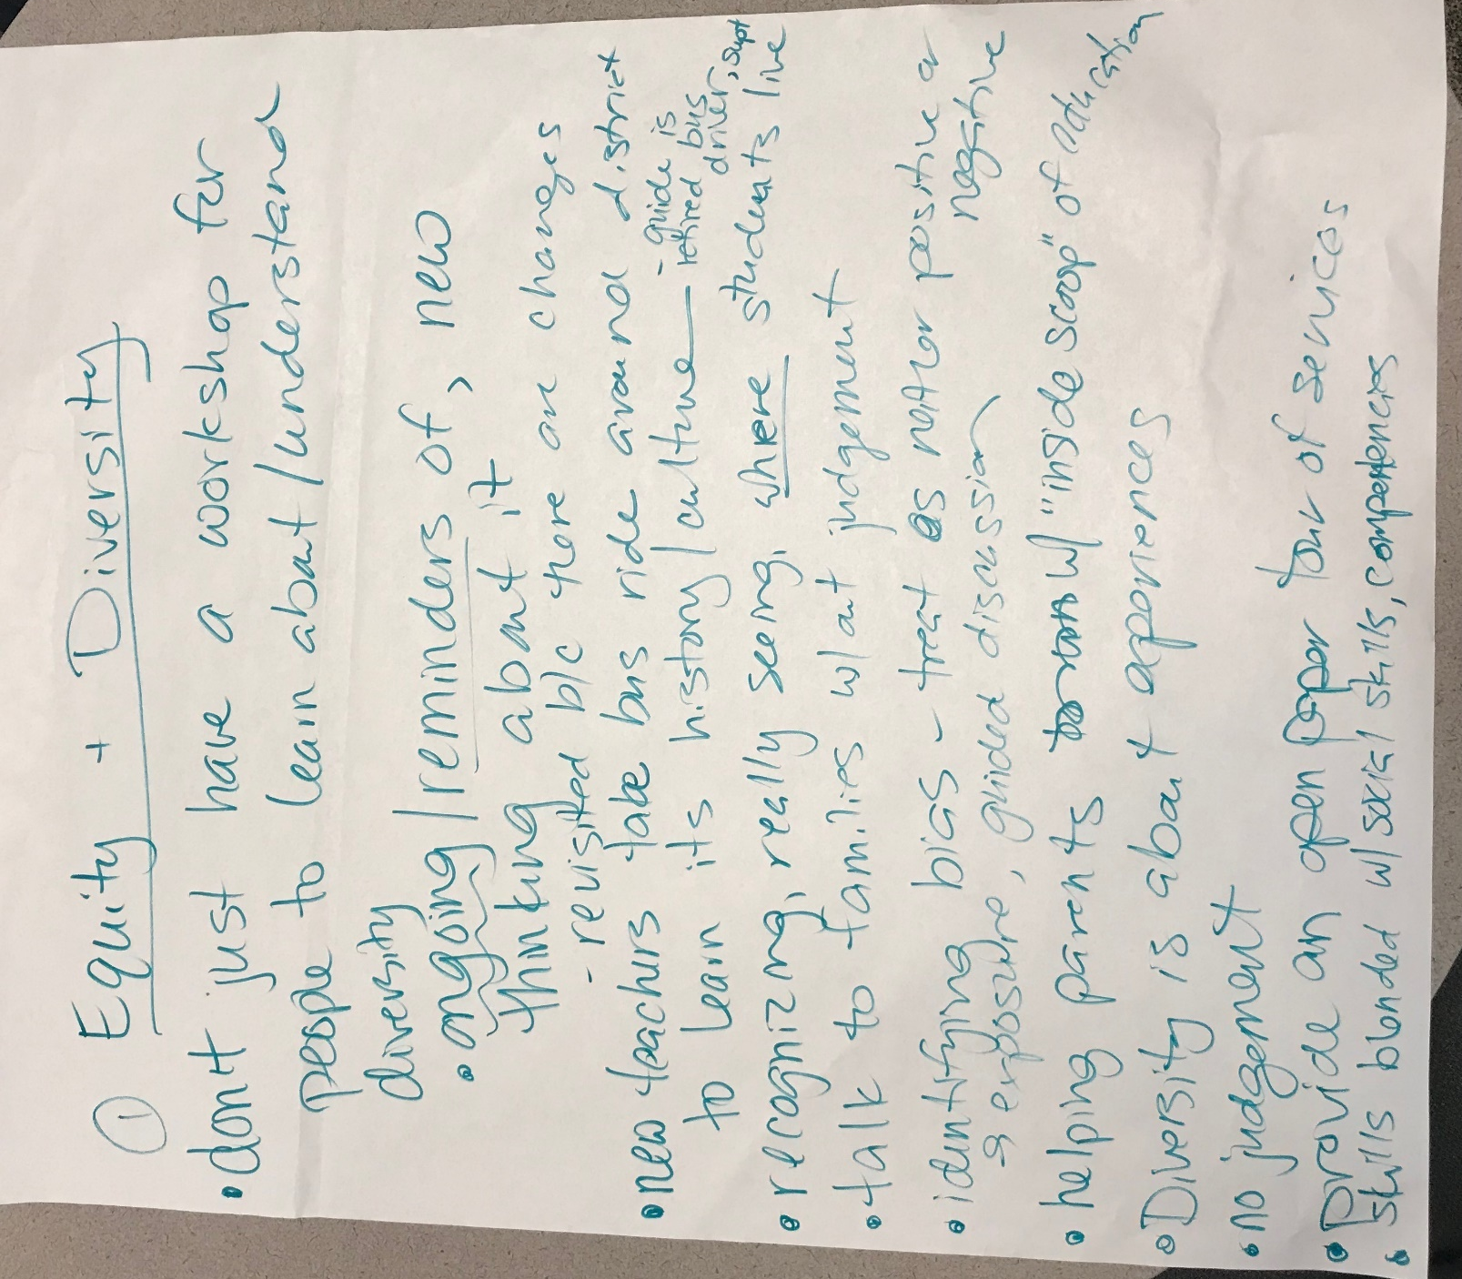
Page 1 Equity + Diversity
don’t just have a workshop for people learn about/understand diversity
-ongoing/reminders of, new thinking about it
- revisited because there are changes
new teachers take bus ride around district to learn its history/culture – guide is retired bus driver, supt
recognizing, really seeing where students live
talk to families without judgement
identifying bias – treat as neither positive or negative
- exposure, guided discussion
helping parents with “inside scoop” of education
diversity is about experiences
no judgement
provide and open paper tour of services
skills blended with social skill, competencies
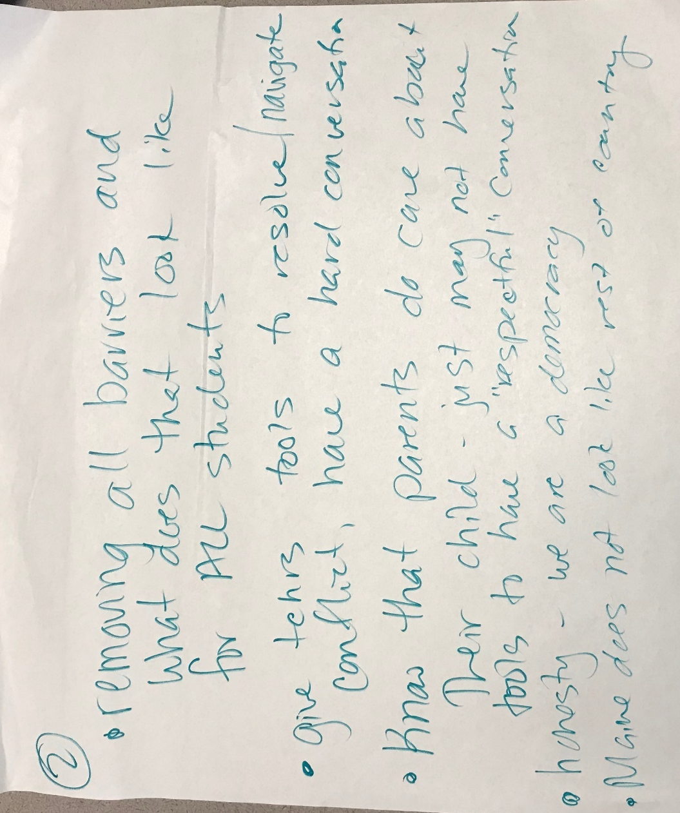
Page 2
removing all barriers and what does that look like for all students
give teachers tool to resolve/navigate conflict, have a hard conversation
Know that parents do care about their child – just may not have tools to have a “respectful” conversation
honesty – we are a democracy
Maine does not look like rest of country

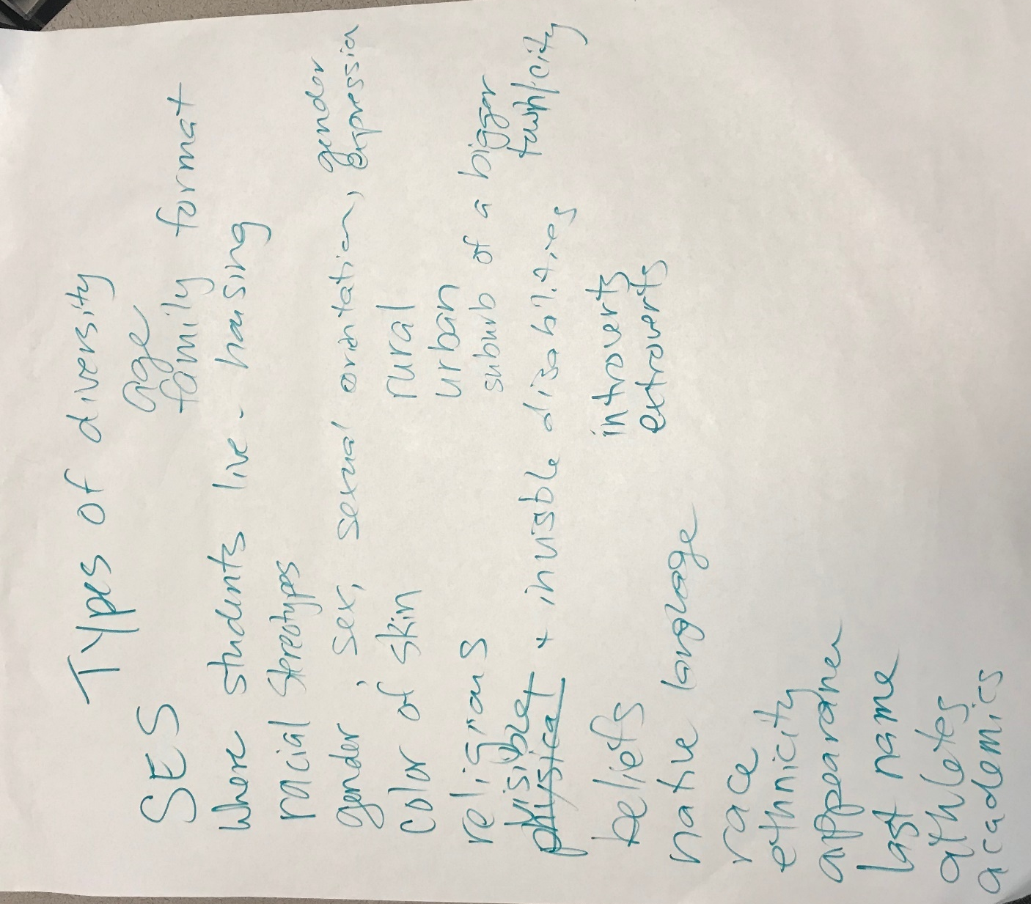

Types of diversity
SES
Where students live – housing
Racial stereotypes
gender, sex, sexual orientation, gender expression
color of skin
religious
visible + invisible disabilities
beliefs
native language
race
ethnicity
appearance
last name
athletes
academics
age
family format
rural
urban
suburb of a bigger town/city
introverts
extroverts

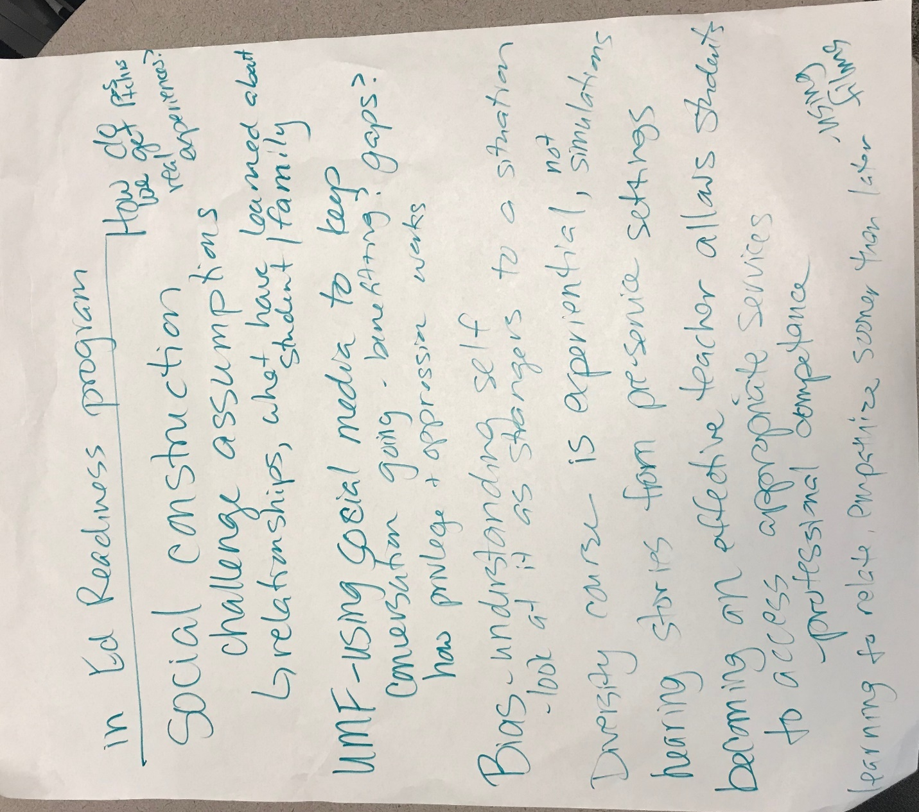

In Ed Readiness program
How do we get positive teachers real experiences?
Social construction
- challenge assumptions, relationships, what have learned about student/family
UMF-using social media to keep conversation going – benefiting? gaps? how privilege + oppression works
Bias – understanding self
-look at is as strangers to a situation
Diversity course is experiential, not simulation
Hearing stories from pre-service settings
Becoming an effective teach allows student to access appropriate services
Professional competence
Learning to relate, empathize sooner than later
-using films

