1
Talent Development –
Willingness to learn new things
Learning
Flexible thinker
Open to new things
National Education Association – 4 Cs
- Critical thinking
- Communication
- Collaboration
- Creativity & innovation

How do we determine these things?

Mirror what you want in questions using
Teach a short lesson
How to plan a unit – what was hard/easy

Look for core beliefs and attitudes
Where did you discover love of teaching
What would you do if
Crystal = 4 years at DOE. Standard 9 where problems were. Beginning staff members.
People skills, collaboration
Knowledge/skills -= disposition=formative tool
Guide others out of profession
Experiences – look for
Some experience working with children
Got to like kids
Get students out early in their programs
Some need an exit plan
Some people can be helped – build on a strength model
Teachers need to learn what to do when they face obstacles
Change culture to support the young teachers
50& leave within five years
Opportunities for growth
Encourage growth and know where to get support – even with mistakes
Always in 2 roles – teacher (professional) and student to be effective educator
And shift for existing teachers
→
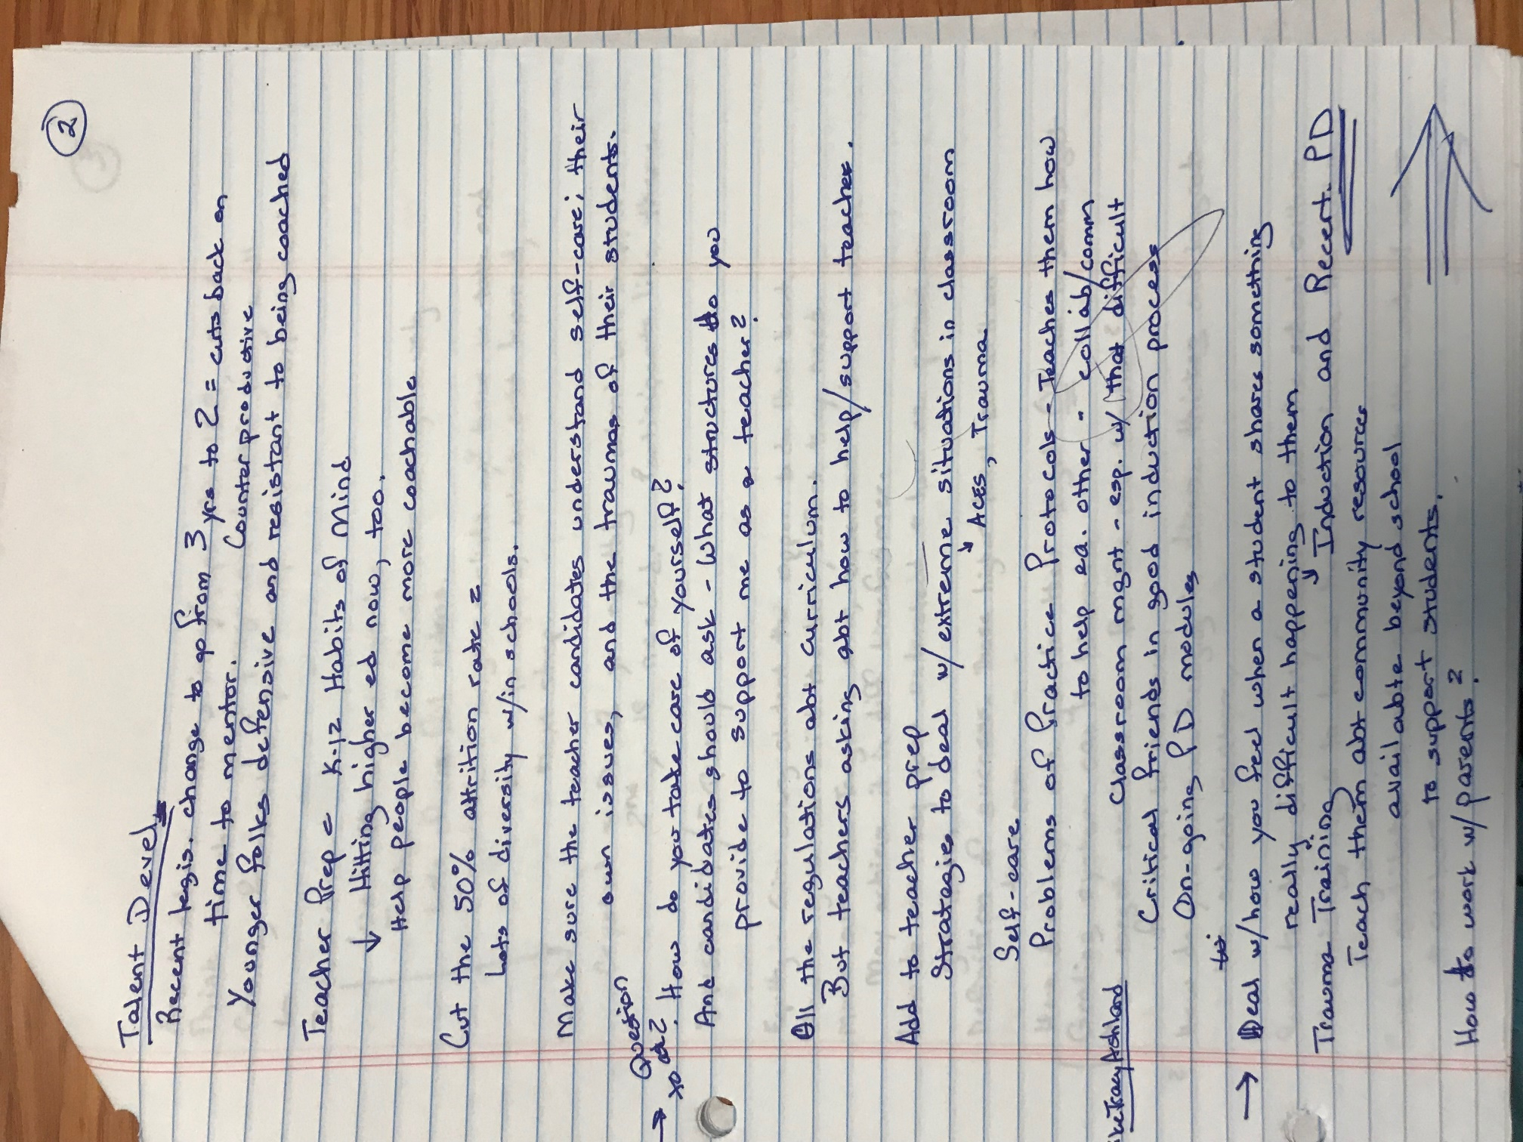
2
Talent Development
Recent legislative change to go from 3 years to 2 = cuts back on time to mentor
Younger folks defensive and resistant to being coached

Teacher Prep = K-12 Habits of Mind
Hitting higher ed now, too.
↓
Help people become more coachable

Cut the 50% attrition rate
Lots of diversity within schools

Make sure the teacher candidates understand self-care; their own issues, and the trauma of their students

→ Question to ask: How do you take care of yourself?
And candidates should ask – what structures do you provide to support me as a teacher?

All the regulations about curriculum
But teachers asking about how to help/support teachers

Add to teacher prep
Strategies to deal with extreme situations in classroom
↓
ACES, trauma
Self-care
Problems of practice protocols – teaches them how to heal each other – collaborate/communicate
Classroom management – especially with that difficult (student)
Critical friends in good induction process
On-going PD modules
→ Deal with how you feel when a student shares something really difficult happening to them
↓
Induction and recertification PD
Trauma training
Teach them about community resources available beyond school to support students

How to work with parents? →
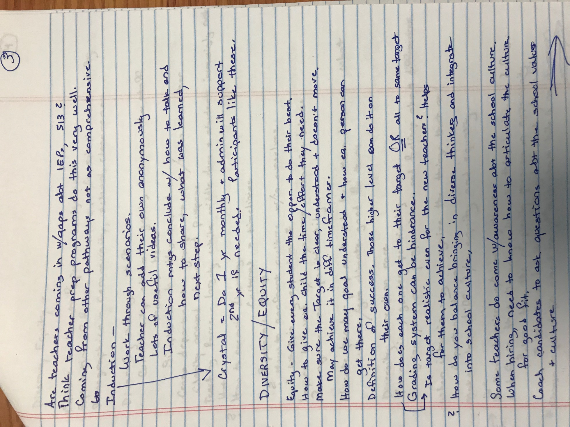
3
Are teachers coming in with gaps about IEP, 513?
Think teacher prep programs do this very well.
Coming from other pathways not as comprehensive,

Induction
Work through scenarios.
Teacher can add their own anonymously
Lots of useful videos
Induction meetings conclude with how to talk and how to share, what was learned, next step.
↓
Crystal = Do 1 year monthly and admin will support
2nd year if needed. Participants like these.

DIVERSITY/EQUITY

Equity – Give every student the opportunity to do their best.

How to give each child the time/effort they need.

Make sure the Target is clear, understood, and doesn’t move.
May achieve it in different timeframe

How do we may goal understood and how each person can get there.

Definition of success. Those higher level can do it on their own.

How does each one get to their target OR all to same target. Grading system can be hindrance.
↓
Is target realistic even for the new teachers? Helps for them to achieve.

? How do you balance bringing in diverse thinkers and integrate into school culture,

Some teachers do come with awareness about the school culture.
When hiring, need to know how to articulate the culture for good fit.
Coach candidates to ask questions about the school values and culture., →
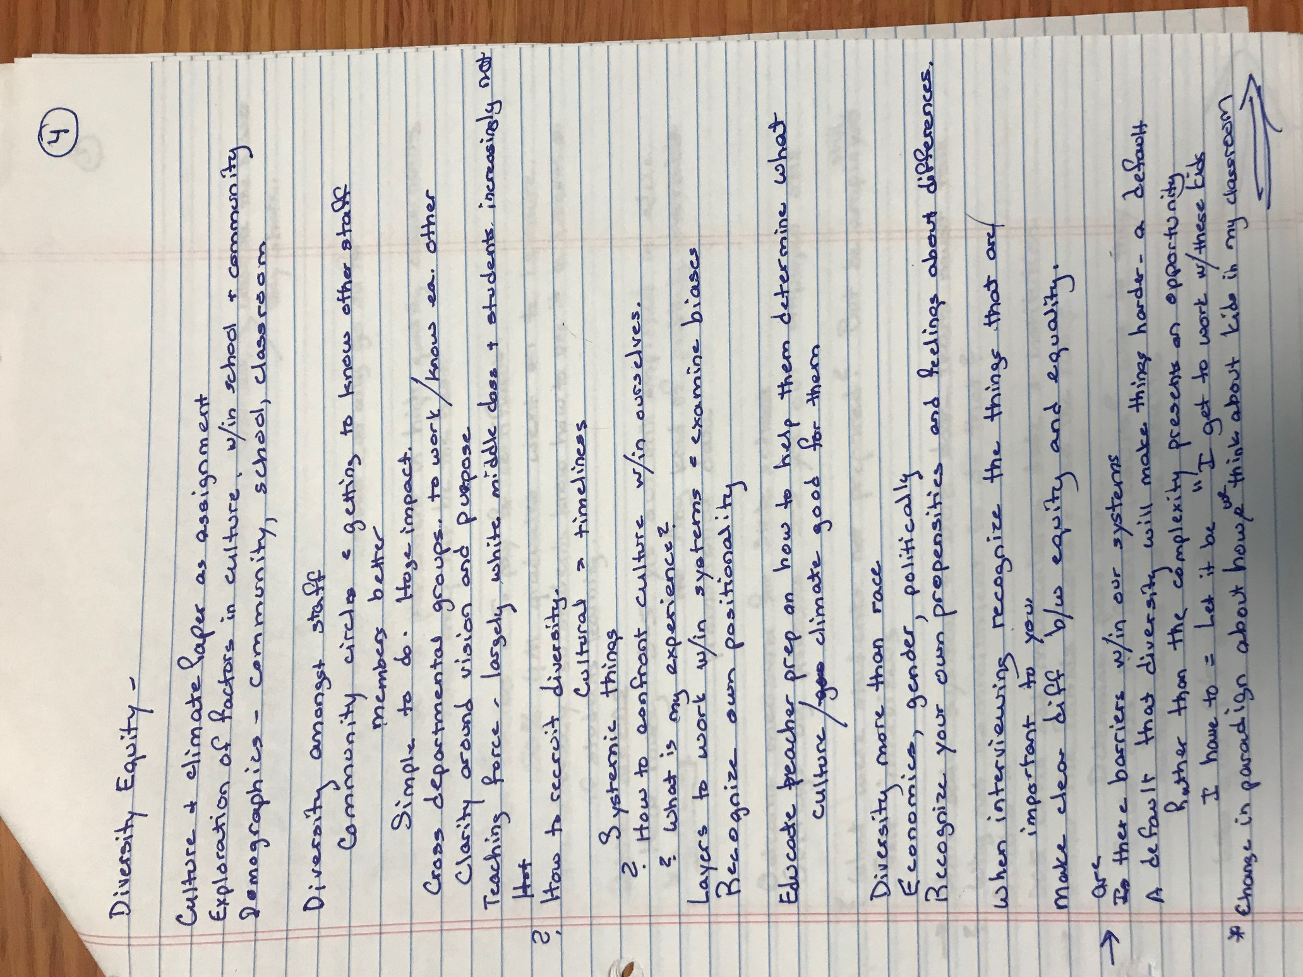
4
Diversity Equity –

Culture and climate paper as assignment
Exploration of factors in culture, within school, and community
Demographics – community, school classroom

Diversity among staff
Community circle = getting to know other staff members better
Simple to do – huge impact

Cross departmental groups to work/know each other
Clarity around vision and purpose
Teaching force – largely white, middle class, and students increasingly not

? How to recruit diversity
Cultural – timeline
Systemic things
? How to confront culture within ourselves
? What is my experience?
Layers to work within systems = examine biases
Recognize own positionality

Educate teacher prep on how to help them determine what culture/climate good for them

Diversity more than race
Economics, gender, politically
Recognize your own propensities and feelings about differences

When interviewing recognize the things that are important to you
Make clear difference between equity and equality

→Is/Are there barriers within our systems
A default that diversity will make things harder – a default rather than the complexity present an opportunity I have to = Let it be “I get to work with these kids
*Change in paradigm about how we think about kids in my classroom
→
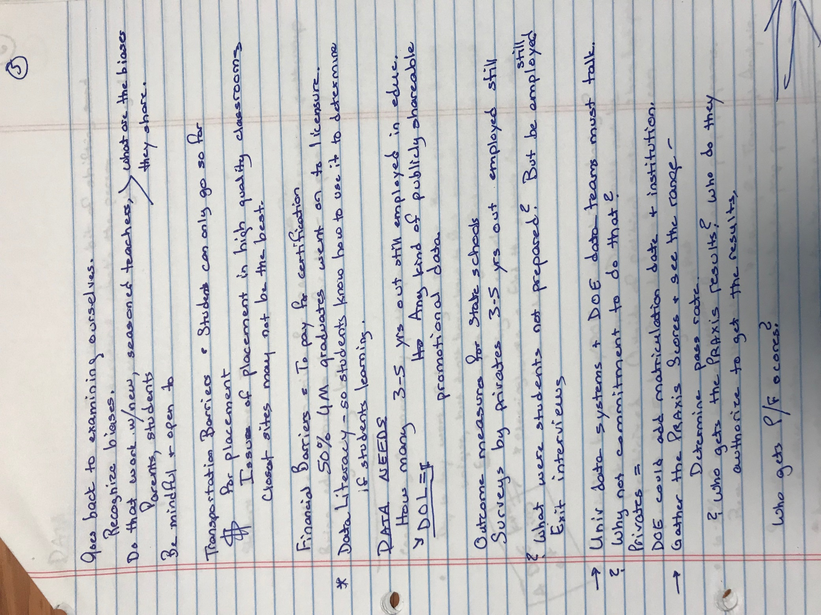
5
Goes back to examining ourselves.
Recognize biases.
Does that work with new, seasoned teachers, parents students > what are the biases they share
Be mindful ← open to

Transportation Barriers = To pay for certification
50% UM graduates went on to licensure
* Data literacy – so students know how to use it to determine if students learning.

DATA NEEDS
How many 3-5 years out still employed in education.
↓DOL=$ Any kind of publicly shareable promotional data

Outcome measure for state schools
Survey by privates 3-5 years out employed still

?What were students not prepared? But be still employed
Exit interviews

→ University data systems and DOE data teams must talk
? Why not commitment to do that?
Privates =
DOE could add matriculation data and institution
→Gather the Praxis scores and see the range
Determine pass rates
?Who gets the Praxis results? Who do they authorize to get the results

Who gets P/F scores?

→
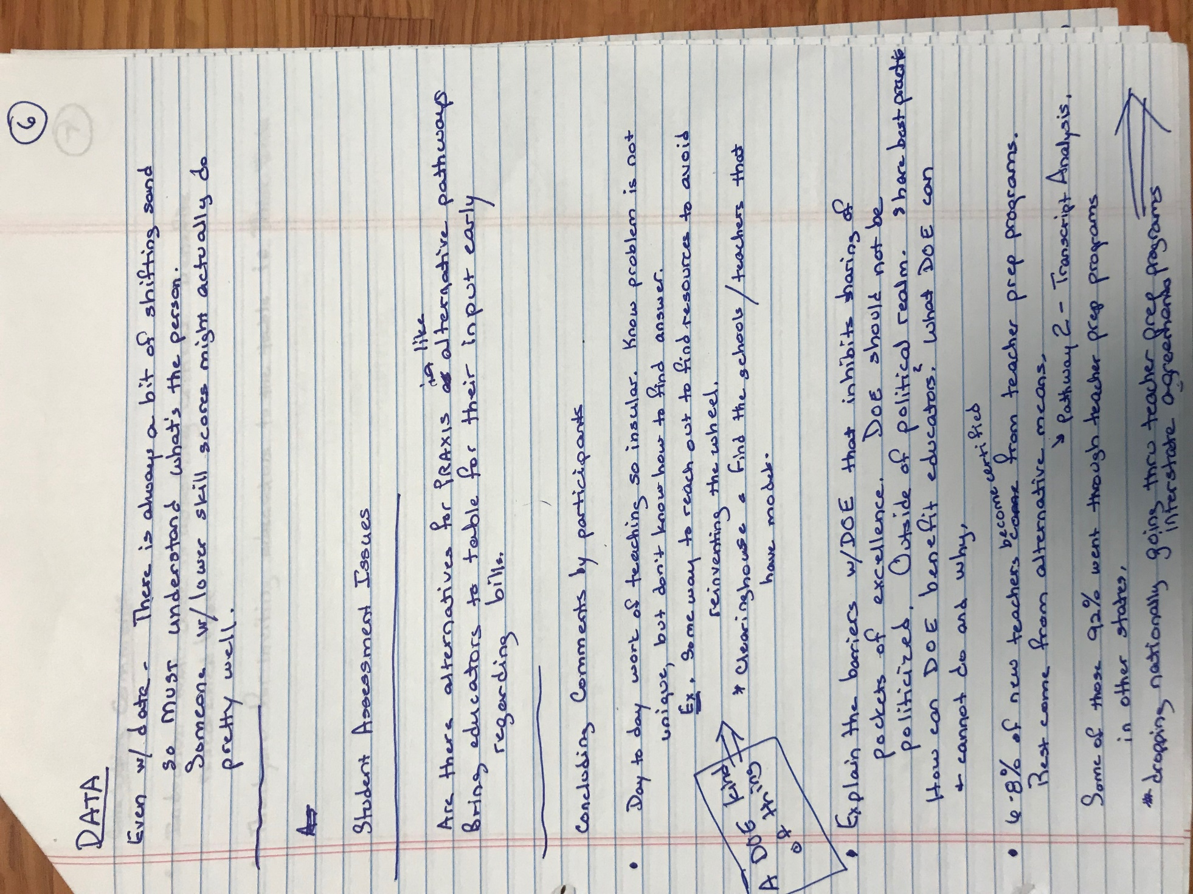
DATA 6
Even with data- There is always a bit of shifting sand so must understand what’s the person. Someone with lower skill scores might actually do pretty well.

----------

Student Assessment Issues
---------------------------------------

Are there alternatives for Praxis like alternative pathways
Bring educators to table for their input early regarding bills

---------------------

Concluding comments by participants

- Day to day work of teaching so insular. Know problem is not unique but don’t know how to find answer. Example: Some way to reach out to find resources to avoid reinventing the wheel.
* Clearing house – find the schools/teachers that have models.

- Explain the barriers with DOE that inhibit the sharing of pockets of excellence. DOE should not be politicized. Outside of political realm. Share best practices. How can DOE benefit educators? What DOE can and cannot do and why.

- 6-8% of new teachers become certified from teacher prep programs. Rest come from alternative means. → Pathway 2- Transcript Analysis.

Some of the 92% went through teacher prep programs in other states

* dropping national going through teacher prep programs, interstate agreements

→
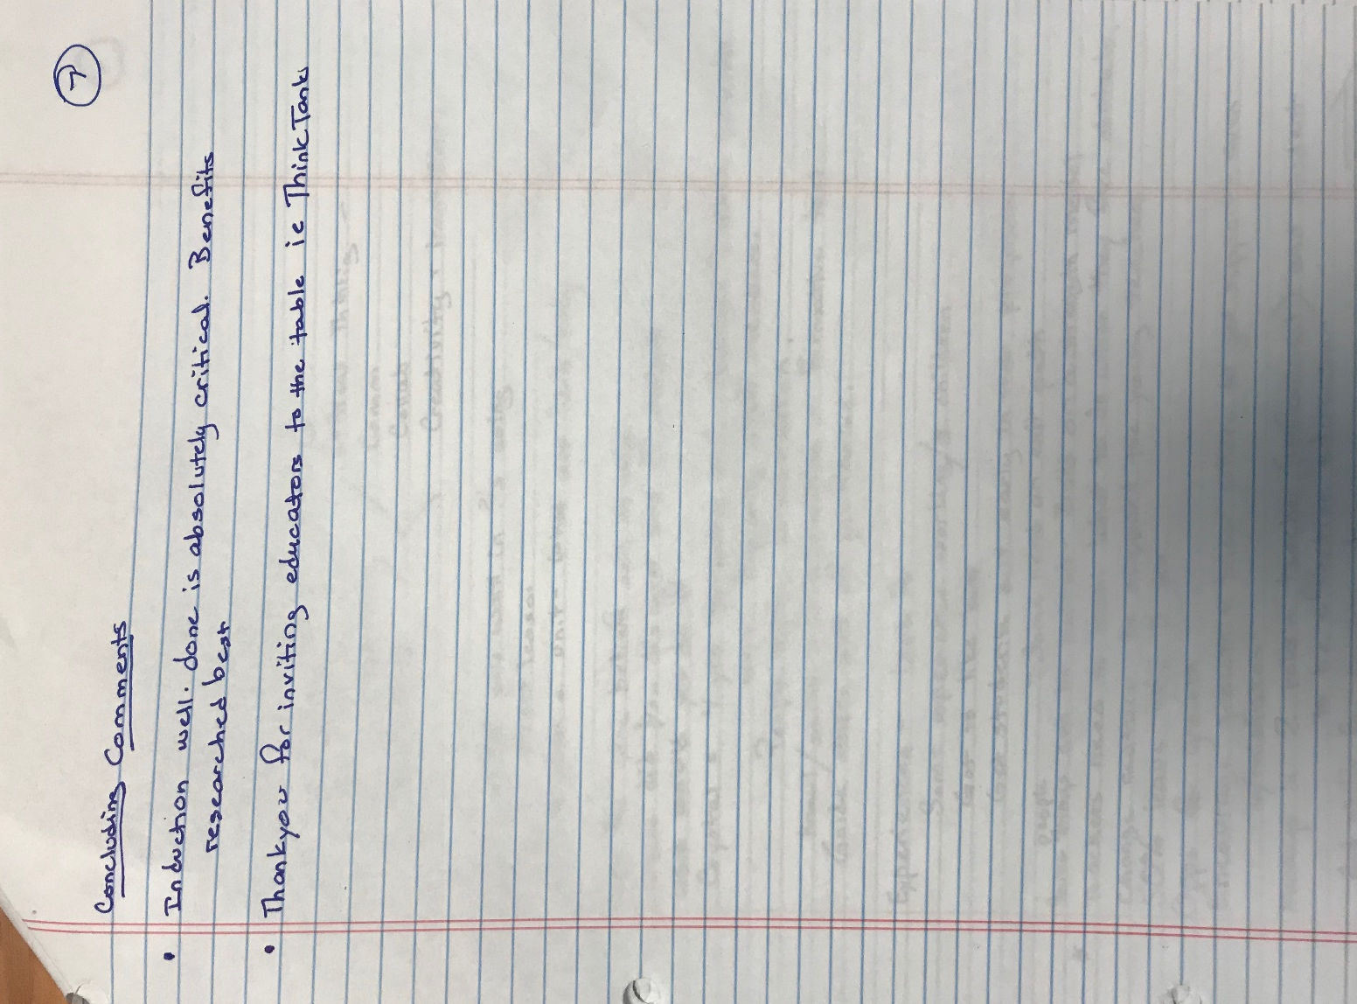
Concluding Comments 7

- Induction well done is absolutely critical. Benefits researched best

- Thank you for inviting educators to the table i.e. Think Tanks

