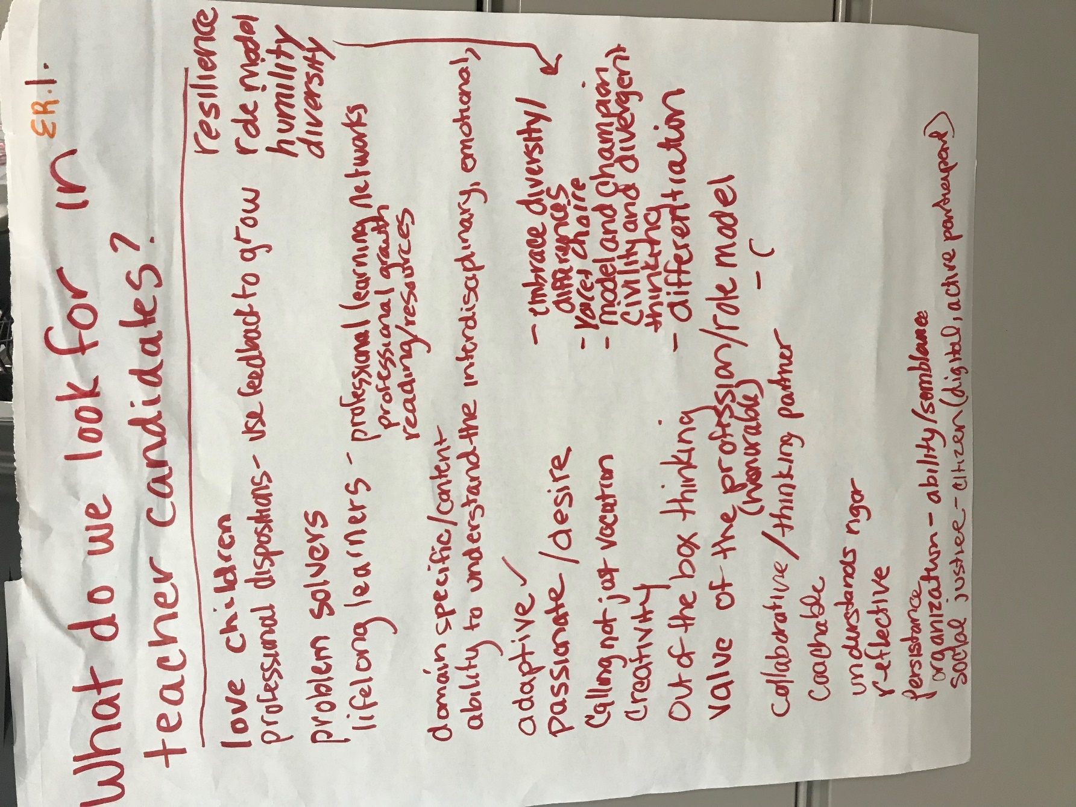

ER. 1
What do we look for in teacher candidates?
- Love children
- Professional dispositions- use feedback to grow
- Problem solvers
- Lifelong learners- professional learning networks, professional growth, reading and resources
- Domain specific/content
- Ability to understand the interdisciplinary, emotional
- Adaptive
- Passionate/desire
- Calling not just vocation
- Creativity
- Out of the box thinking
- Value the profession(honorable)/role model
- Collaborative/thinking partner
- Coachable
- Understands rigor
- Reflective
- Persistence
- Organization- ability/semblance
- Social justice- citizen (digital, active participant)
- Resilience
- Role model
- Humility
- Diversity
- Embrace diversity/differences
- Voice + choice
- Model and champion Civility and divergent thinking
- Differentiation

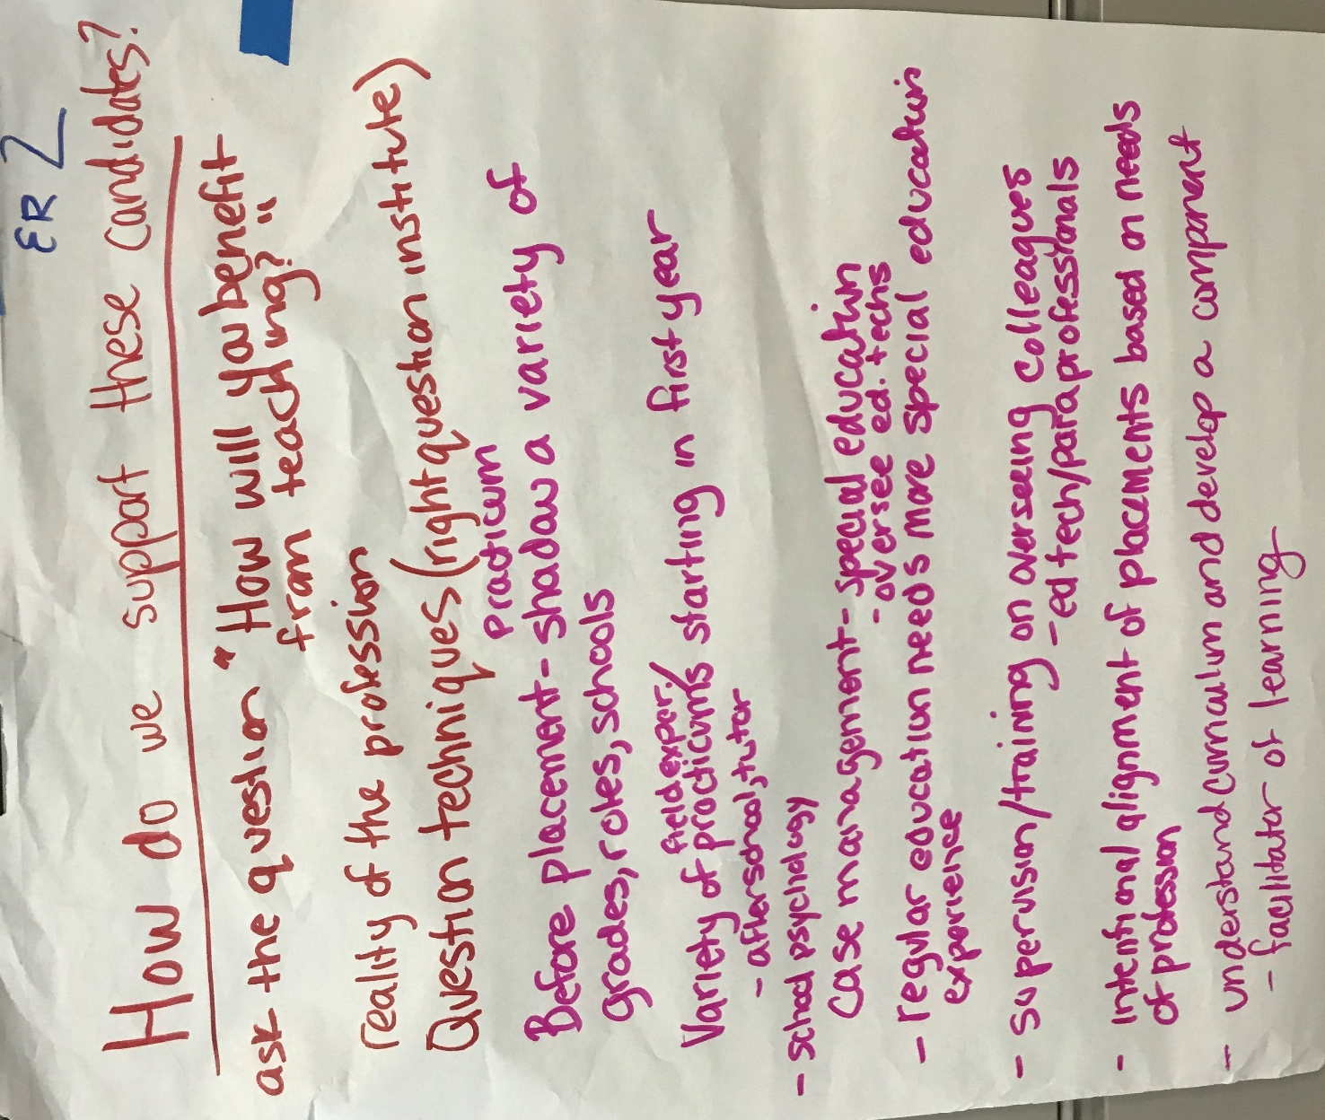

ER. 2
How do we support these candidates?
Ask the question “How will you benefit from teaching?”
Reality of the profession
Question techniques (right question institute)
Before placement – Practicum shadow a variety of grades, roles, schools
Variety of field experience/practicums starting in first year
After school, tutor
School psychology
Case management - special education
oversee ed techs
Regular education needs more special education experience
Supervision/training on overseeing colleagues
Ed tech/paraprofessionals
Intentional alignment of placements based on needs of profession
Understand curriculum and develop a component
Facilitator of learning

ER. 3
In Service
Exemplar – Course in special education case management (Portland Public Schools)
Idea – Alignment for coursework after educators

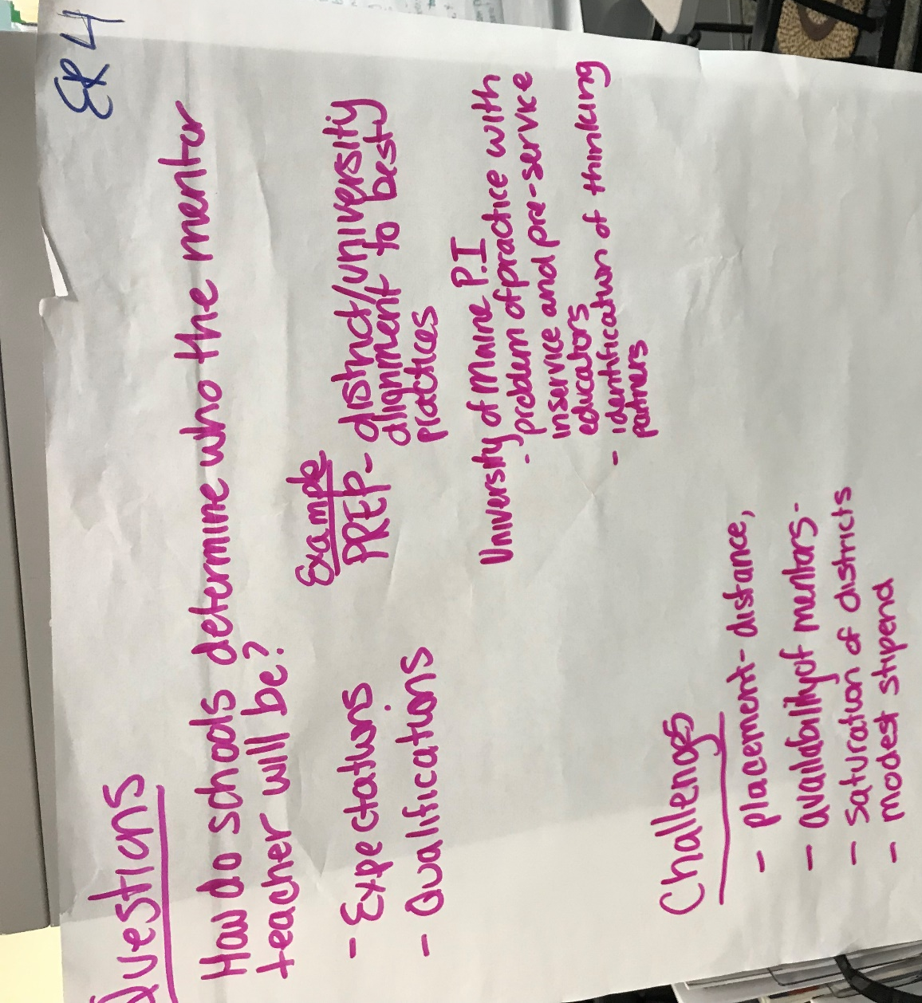

ER. 4
How do schools determine who the mentor teacher will be?
- Expectations
- Qualifications

Example
PREP – District/University alignment to best practices
University of Maine P.I.
- Problem of practice with in-service and pre-service educators
- Identification of thinking partners

Challenges
- Placement – distance
- Availability of mentors
- Saturation of districts
- Modest stipend

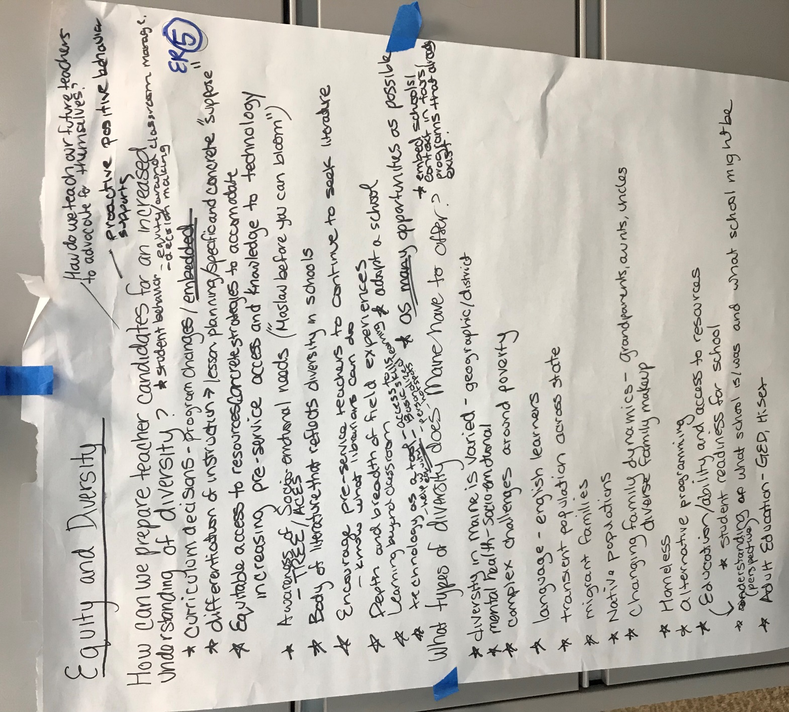

ER. 5
Equity and Diversity
How can we prepare teacher candidates for an increased understanding of diversity?
- Curriculum decisions-program changes/embedded
- Differentiation of instruction-lesson planning/specific concrete “suppose”
- Equitable access to resources- concreate strategies to accommodate
- Increasing pre-service access and knowledge to technology
- Awareness of socio-emotional needs (“Maslow before you can bloom”)
  - TREE/ACES
- Body of literature that reflects diversity in schools
- Encourage pre-service teachers to continue to seek literature
  - Know what librarians can do
- Depth and breadth of field experiences
- Learning beyond classroom
- Technology as a tool- access to , basic skills, personalized learning, hot spots
- Adopt a school
- As many opportunities as possible
- Embden schools/context in tours- programs that already exist
- Proactive positive behavior supports
- How do we teach our future teachers to advocate for themselves?
What types of diversity does Maine have to offer?
- Diversity in Maine is varied- geographic/district
- Mental health- socioemotional
- Complex challenges around poverty
- Language- English learners
- Transient population across state
- Migrant families
- Native populations
- Changing family dynamic- grandparents, aunts, uncles
  - Diverse family make-up
- Homeless
- Alternative programming
- Education/ability and access to resources
- Student readiness for school
- Understanding(perspective) on what school is/was and what school might be
- Adult education- GED, HiSET

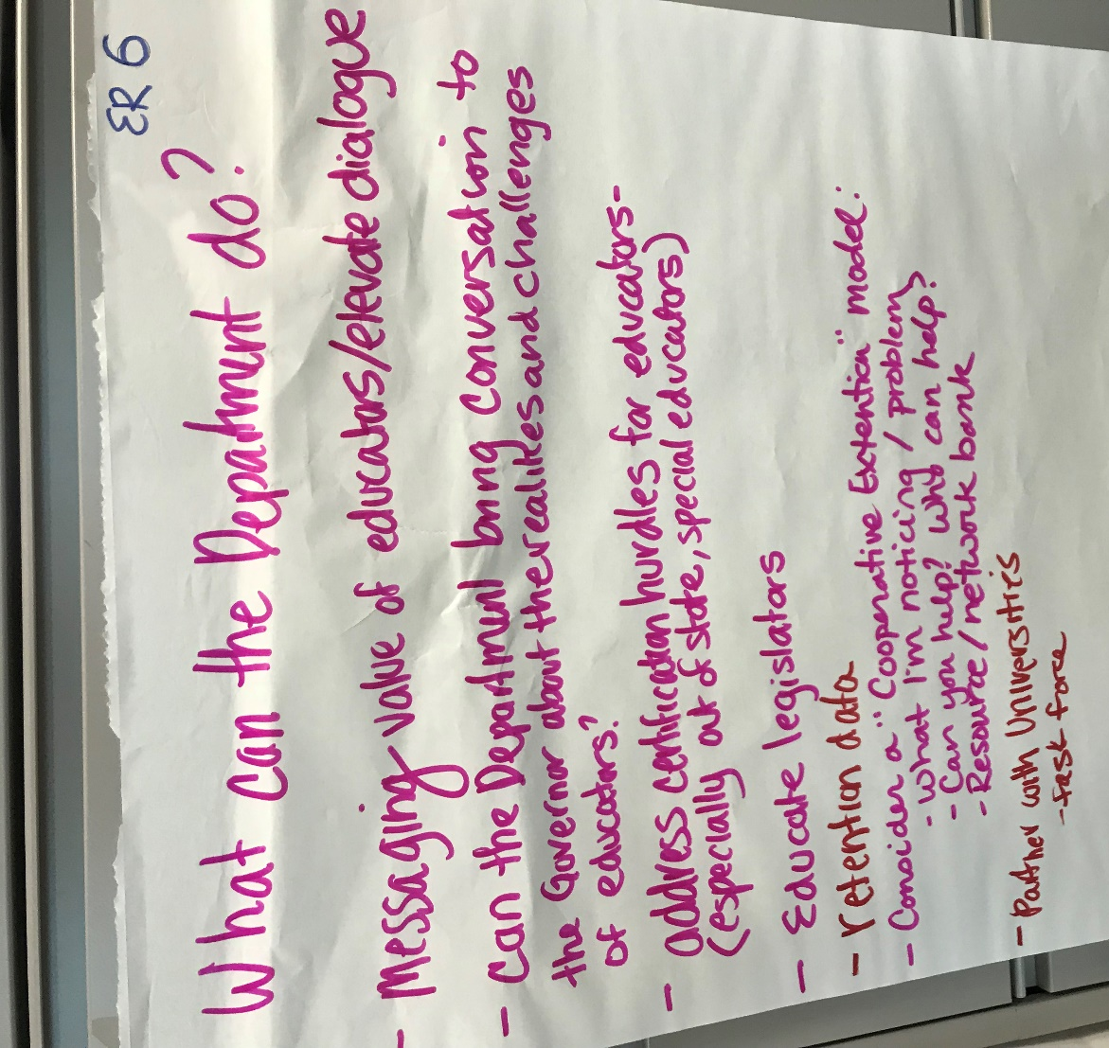

ER. 6
What can the department do?
- Can the department bring conversation to the Governor about the realities and challenges of educators?
- Address certification hurdles for educators – (especially out-of-state, special educators)
- Educate legislators
- Retention data
- Consider a “Cooperative Extension” model
  - What I’m noticing/problem
  - Can you help? Who can help?
  - Resource/network bank
- Partner with Universities
  - Task Force

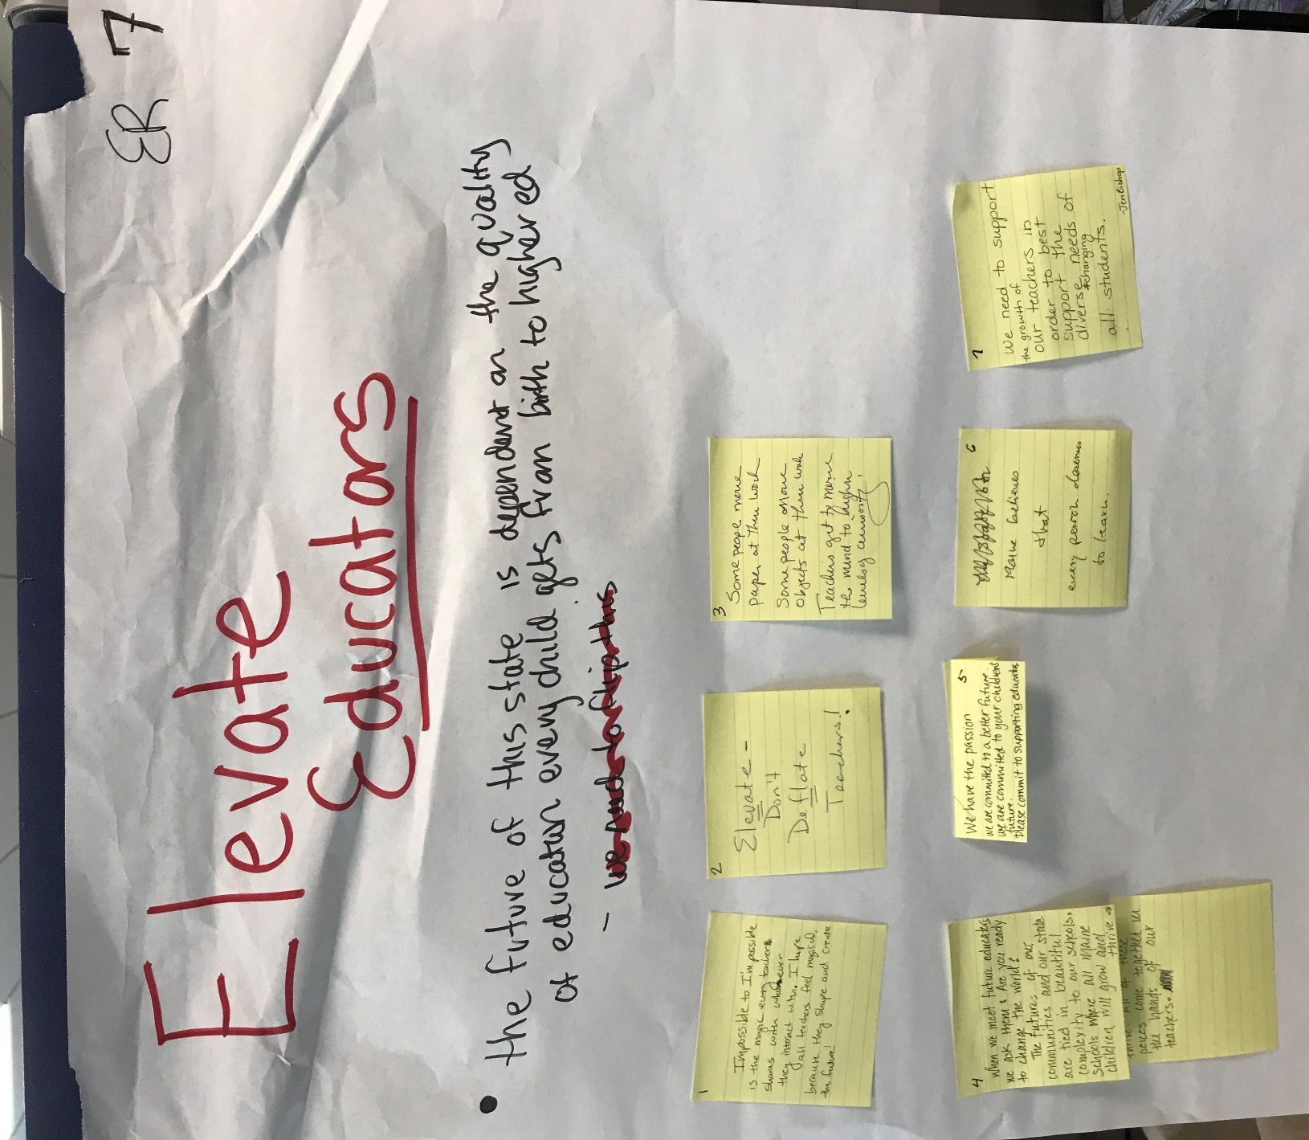

ER. 7
Elevate Educators
- The future of this state is dependent on the quality of education every child gets from birth to higher ed.
Post it notes
- Impossible to I’m possible is the magic every teacher shares with whomever they interact with. I hope all teachers feel magical, because they shape and create the future!
- Elevate- don’t deflate teacher”
- “Some people move paper at their work. Some people move objects at their work. Teachers get to move the mind to higher levels of curiosity.”
- When we meet future educators we ask them: Are you ready to change the world? The future of our communities and our state are tied in beautiful complexity to our schools. Schools where all Maine children will grow and thrive. All of these pieces come together in the hands of our teachers.
- We have the passion. We are committed to a better future. We are committed to our children’s future. Please commit to supporting educators.
- Maine believes that every person deserves to learn.”
- We need to support the growth of our teachers in order to best support the diverse and changing needs of all students.

